1.1 Human vs artificial intelligence
Intelligence -> ability to learn from experience and apply it to new situations
Performance of intelligence (e.g. Maths or language) correlates across multiple tasks
- Spearman's g: accounts for less than 50% variance -> there are still some specialized domains
  - g- factor: general int. (inborn)
  - s-factor: specific individual differences (learned)
- Hierarchical intelligence
  - Psychometric intelligence: Numerical, spatial and linguistic

Other intelligences:
- Musical, bodily-kinaesthetic, interpersonal and intrapersonal

Range of domains related to intelligence depends on the definition

1.2 Levels of computation
Marr's three levels:
- Computational: (goal)
  - Defines the problem that the system is solving, e.g. inputs, outputs and objective
    - Representation of the 3D world from 2D image
- Algorithmic: (method)
  - Explains how the system performs the computation described above
    - The visual system might detect edges, group them into surfaces, and infer depth using cues like shading or motion.
- Implementational: (mechanism)
  - This is the hardware or biological level — describing the actual physical system that carries out the computation.
    - Neurons in the visual cortex fire in patterns that implement edge detection or depth perception

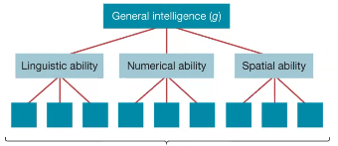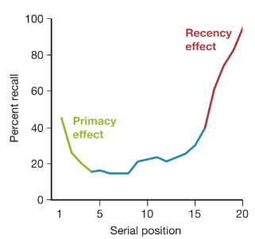

1.3 Learning
Supervised learning
- Goal: learn a function that maps inputs (features) to outputs (lables).
- The function is learned from a training set of inputs and output pairs.
- Objective is to minimize the error between predicted label and true label

Unsupervised learning
- Goal: map inputs to structures such as lower diamensional representations, clusters or probability distributions.
- Learned from a training set of unlabled data
- Unsupervised learning is about exploration, not prediction

Reinforcement learning
- Goal: learn a function (policy), that maps states of enviroment to actions
- Instead of learning from labeled data (like supervised learning), the agent learns through trial and error — receiving rewards or penalties for its actions.

1.4 Human vs Computer memory
Marr's three levels:
- Computational
  - Encode, store, retrieve and use information
- Algorithmic
  - Encode and organize memory
    - Computers: Binary form
      - Images, sounds, and text are all converted into binary code
    - Humans and computers: Associative representations
      - Model parameters or weights that link patterns together
- Implementational
  - Hardware or biological substrate that carries out memory functions
    - Computers: Binary on hardware eg. RAM or harddrive
    - Humans: Associative neural patterns — groups of neurons that activate together
    - Computers and Humans:
      - Volatile memory (temporary, e.g., short-term memory or RAM)
      - Non-volatile memory (long-term storage, e.g., hard drive or long-term neural memory)

2.1 Introduction
Perception means how we take in and interpret information from the world through our senses
- Sight, hearing, touch, taste, and smell.

Inverse problem:
- When the brain recieves sensory information, it then has to figure out what caused that information
- Backward from the effect -> cause
Ex. In vision: light hits retina -> 2d image
    - The inverse problem is figuring out what 3D object in the world caused that pattern of light
    - (Many different objects could produce the same image — your brain has to “guess” which one is most likely.)
  - Ex. In hearing: you hear a sound wave.
    - The inverse problem is inferring what event or object made that sound

2.2 The use of prior information in visual perception
Necker cube: Bistable percept
- Being able to change between 2 solutions

The likelyhood (sensory data, visual)
- 3D world (w) -> 2D projection (µ)
  - Allways noise, fx. tiny change in lighting
    - IID: Independent and identically distributed → each pixel (or data point) has its own random noise, independent of the others.
    - Gaussian: Noise follows normal distribution
  - Acuall 2d sensory data d:
    - d = µ + noise
- Formula:

- : the likelyhood - how likely it is to see this image d given the world w
- : the probability of each pixal or feature given its expected value and noise level
- The product : multiply all of the individuel pixel probability together (assuming independance)

Gaussian densitivity function (PDF, normal distribution)
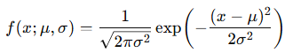

Maximum a Posteriori (MAP):
- "Find the world w that makes the observed data d the most probable, taking into account both the likelyhood and prior belief"

The maximum likelihood Estimate (MLE)
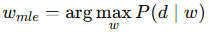
- MLE is like the baysian without any prior - only relying on sensory data
- Take the logarithm:
  - 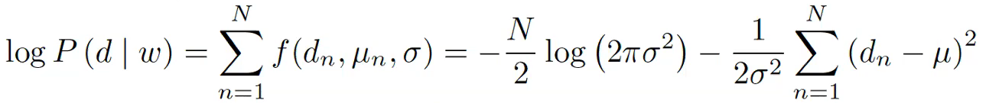
- Find the maximum likelihood estimate by minising the squared error
  - 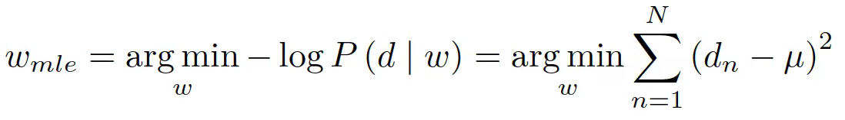
2.3 The use of marginalization in perception
Marginalization
- Another method that the visual system might use to interprete sensory information
- Key idea: Getting rid of Nuisance parameter:
  - Something that affects your observations but you don’t care about directly
    - Fx the direction of the light or viewpoint also changes the image

  - w1 ​ : the thing you care about (e.g. object identity)
  - w2 ​ : the nuisance parameter (e.g. lighting direction)

  - If w2 is continuous:

  - Take all the possible lighting directions, weight each by how probable it is, and average them out
- It gives you a robust estimate of w1
  - No longer depends on one specific lighting condition or viewpoint
- Resistant to uncertainty

How it relates to perception
- Your brain constantly has to make sense of incomplete sensory data. Light, shading, and perspective are ambiguous — there are many possible worlds that could produce the same image
  - Bayesian terms:
    - A prior: what kinds of shapes, objects, or lighting are likely in the world
    - A likelihood: how sensory data would look given those world states.
    - Marginalisation: summing/integrating over unimportant or unknown factors (like lighting, viewpoint, small movements)
      - to get a stable, general interpretation of what’s actually there.

Bayes factor
- Compares how well two models explain the observed data

  - how likely the data is if model Ma were true
- Each model might have its own internal parameters (like weights, lighting, noise variance, etc.).
- You don’t want to judge the model based only on one parameter setting — you want to consider all possible parameter values weighted by their priors.

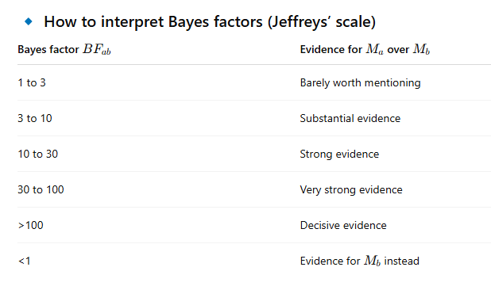

3.1 Linear encoding
Organization of the eye
- Light pass though the cornea and lense
- Photoreceptors on the retina

Photoreceptors
- Cones
  - Color and detail - daylight
  - 3 kinds (S, M, L) - short, medium and long wavelengths (≈ blue, green, red)
  - Different activation across cone types lets you perceive all colors
  - Concentrated in the fovea (the center of your gaze, where you focus)
  - Sparse or absent in the periphery — that’s why peripheral vision has poor color detail
  - Not very sensitive to light — they don’t work well in the dark
- Rods
  - Sensitivity to light - night vision
  - Only one kind — grayscale
  - Located mainly in the periphery (away from the fovea)

Neurons
- Electrical impulses called action potentials
  - Each spike is the same size: so either it fires or not
  - Rate of action potentials
    - What changes is how often that the neuron fires
      - A higher firing rate = stronger signal = higher “activation level.”
    - This firing rate is how neurons encode the intensity of a stimulus (e.g., brightness, loudness, etc.).
- Neurons are specific (receptive fields)
  - Receptive field = the region or feature of input that a neuron responds to
    - In the visual system: which part of the retina or visual field it “looks at.”
    - In auditory cortex: which frequency (pitch) it’s tuned to.
    - In somatosensory cortex: which body part it corresponds to.
  - Examples:
    - Cones respond to specific wavelengths and locations on the retina (e.g., “blue light here”)
    - Face neurons in the temporal cortex respond to the appearance of faces — they have receptive fields for complex patterns
- Photoreceptors code light
  - Convert light into electrical activity
    - Receptive field:
      - Each photoreceptor corresponds to one small spot on the retina
    - Activation level:
Depends on how much light (intensity) and what wavelength (color) hits that spot.
→ Bright light = high activation; dim light = low activation.

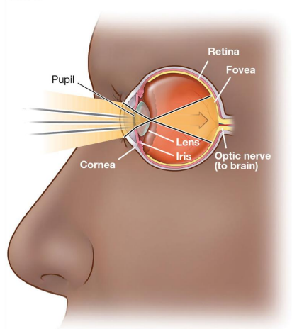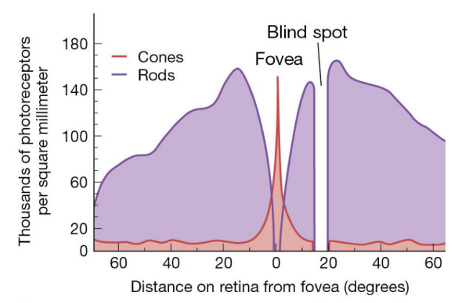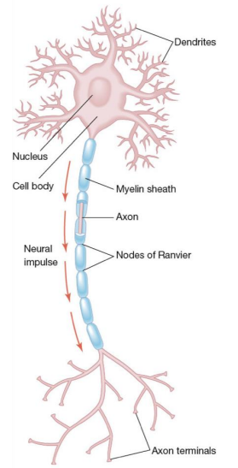

3.2 Lateral inhibition
- First stage of information processing
- Photoreceptors (top row, red/purple cells)
  - Both rods and cones
  - Sense light intensity - bightness
- Bipolar cells (green layer below)
  - Collect signals from photoreceptors and send them toward the brain
  - Also connect sideways to other bipolar cells, providing inhibition
    - Lateral inhibition
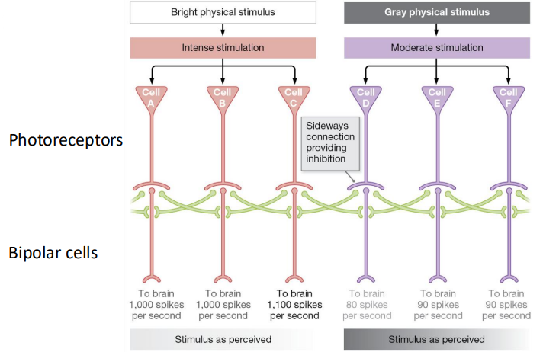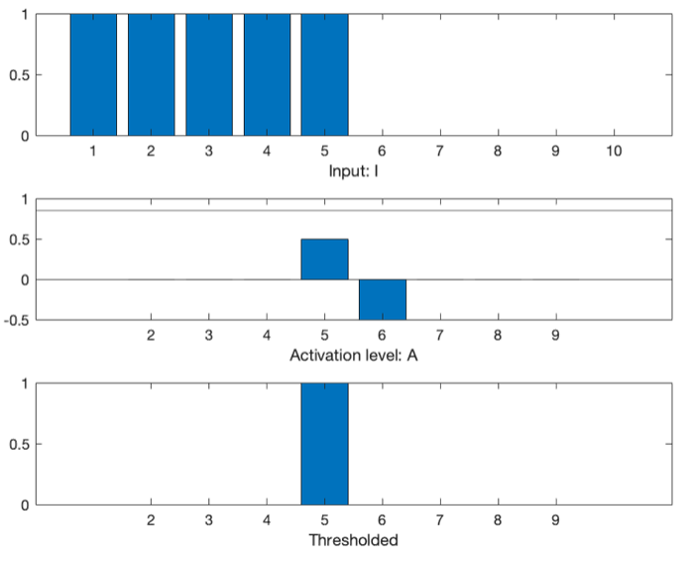

- Mechanism
  - When one photoreceptor is strongly stimulated (by bright light)
  - Excites its own bipolar cell
  - Inhibits its neighbors through lateral connections
- Result
  - The bright area’s response becomes stronger (less inhibited)
  - The surrounding, less-bright areas become weaker (more inhibited)

- Even if the physical light difference is gradual, the perceived difference becomes sharper.
That’s why you see crisp boundaries between objects — your brain is “enhancing edges” automatically

Simple computational model of lateral inhibition
- Row of M cells, each one responding to light from its local photoreceptor
- am cell’s activation
- jm is the input intensity from light falling on photorecepter m (pixel intensity)
- w is a weight representing how strong the neighboring cells inhibit this cell

    - and are the neighboring cells
- Expressing it as a sum with a kernel

    - k(n) is kernal/filter
    - jm+n the input position m+ n - i.e. the cell itself and its neighbors

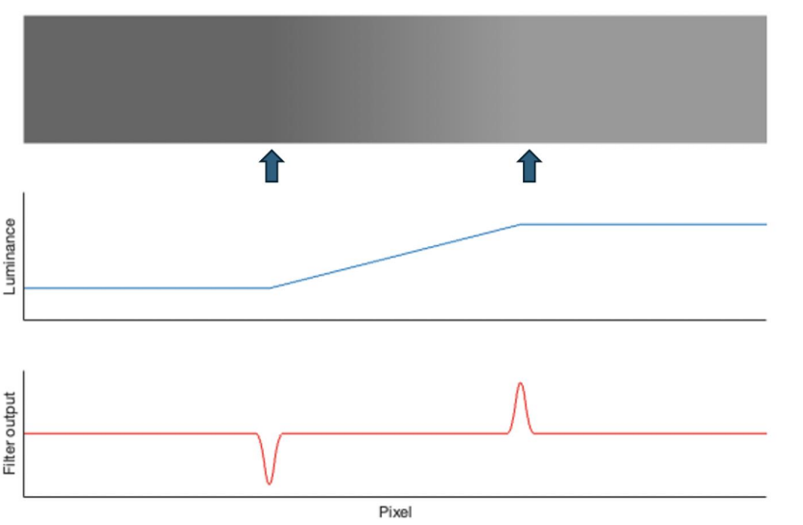
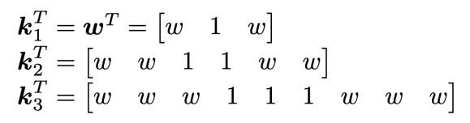

Mech bands
- Amplifies differences at the edges to make boundaries appear more distinct than they actually are
- Part of how our sensory systems process and enhance visual information — especially when detecting edges or changes in intensity.
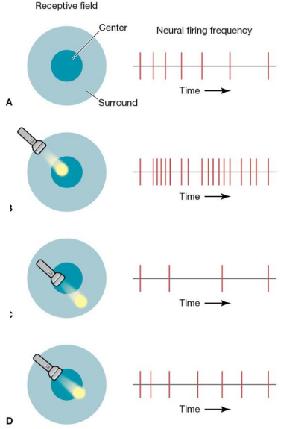

Kernal scaling
- The kernels are used to weight the surrounding pixels when computing the activation for each photoreceptor
- Smaller kernals:
  - Immediate surrondings, fine scale edges
- Larger kernals:
  - Broader features or smoother transitions

Receptive fields
Region of the visual field (2D image) where a neuron in the visual cortex responds to a stimulus
  - Center-surround receptive fields
    - Where is the dot
    - Helps neurons detect contrast by comparing the brightness of the center to the surrounding region
  - Activation Level
    - How bright is the dot
    - High firing occurs when the center is strongly activated, while the surround inhibits the neuron

- In the primary visual cortex, certain neurons act as edge detectors
  - Receptive field:
    - This refers to the area of the visual field where a neuron can be activated. These neurons are sensitive to edges of different orientations (horizontal, vertical, diagonal)
  - Activation level
    - The firing rate of the neuron indicates how strongly or clearly it detects the edge in its receptive field.
  - Localized edge:
    - The neuron’s receptive field detects edges at specific orientations (e.g., 90-degree edges) in the visual input.
  - Activation level:
    - High firing rate means the edge is clear and strong in the neuron’s receptive field
    - Low firing rate means the edge is weak or absent
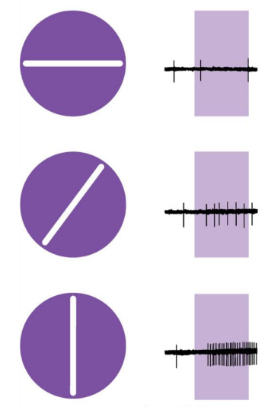

3.3 Principal componant analysis (PCA) in linear encoding
A modest proposal
- The perceptual system is optimized to represent information relavant for survival
  - The dynamic rang of neurons match the dynamiic range of stimuli
  - Predators have binocullar vision
  - Information is represented in an efficient way in the human brain

Joint pixel probabilities
- An image can be represented as a vector of pixel intensities (e.g., grayscale values).
We can then describe the probability distribution of all pixel values together.
An image is parameterized as a vector j of pixels
  - For each color channel
  - For now, we just look at luminance, grayscale
- How do we parameterize P(j)
  - As a joint probability
  - This captures the likelihood of observing any specific pattern of pixel values.
  - Pixels are not independant
    - Nearby pixels tend to have similar brightness
  - The dependencies between pixels capture the structure or texture of the image
- Gaussian variables
  - Zero covarience -> independence
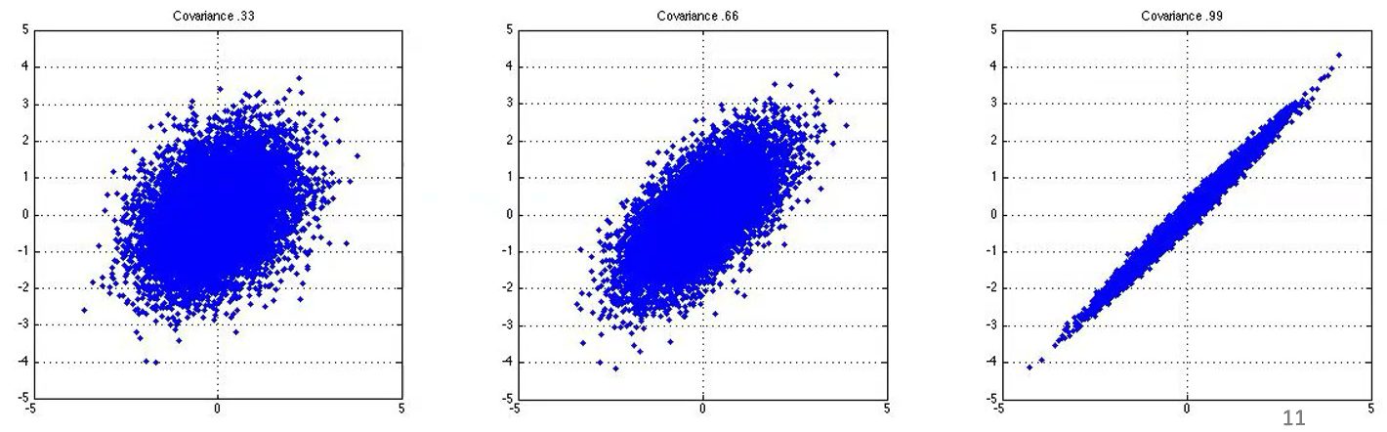

Principal componant analysis PCA
- PCA finds the main directions of variation in your data — called the principal components (PCs).
These directions capture the most important patterns in the dataset.
- Compute the principal components (PCs)
  - Each PC is a vector (direction) in your data space
  - They are found as the eigenvectors of the covariance matrix of the data
  - The corresponding eigenvalues tell you how much variance each component explains
  - The PCs are orthogonal (uncorrelated) — together they form a new rotated coordinate system
- Project the data onto the PCs:
  - You multiply your data matrix by the PCs to get scores (new coordinates).
  - This gives the representation of each data point in terms of the main variation directions.
- PCA rotates the data so that:
  - The first PC captures the direction of maximum variance
  - The second PC captures the next highest variance, orthogonal to the first
  - You can keep only a few PCs to simplify the data while preserving most of its structure
    - Pick the number of PCs that together explain around 90–95% of the variance
      - This keeps most information while reducing noise and redundancy
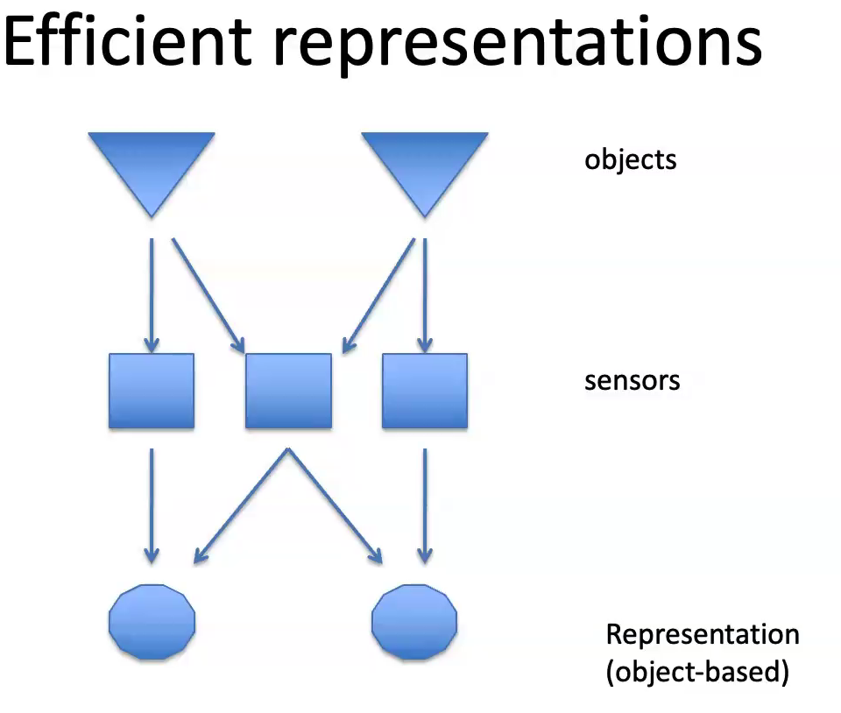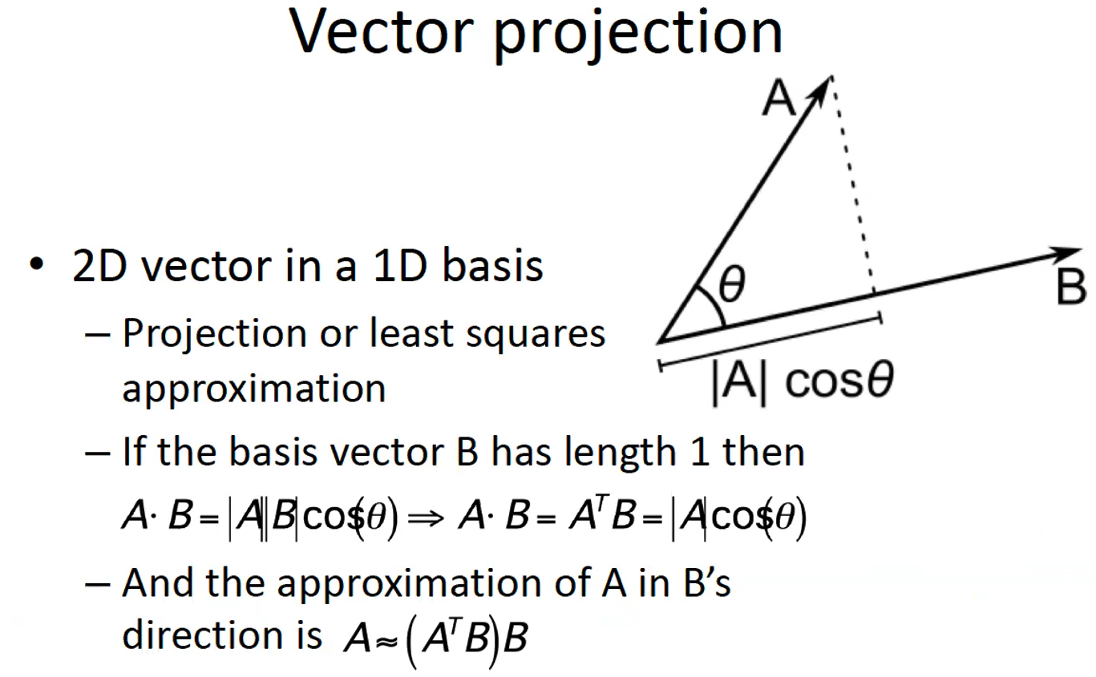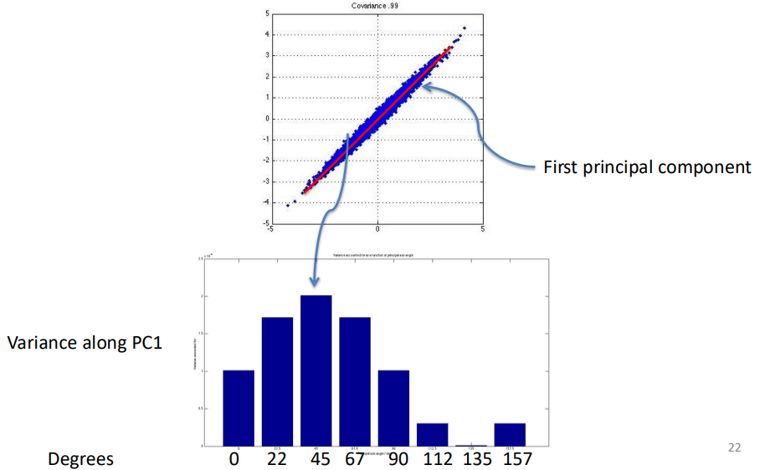

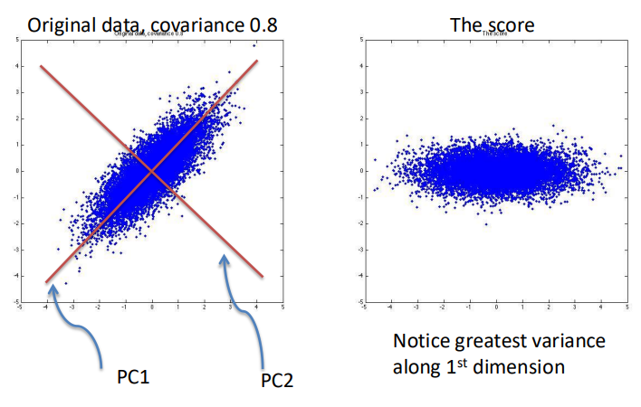

Defining concepts
- Defining concepts (like “dog”) is an ancient philosophical problem
- We often try to define things using crisp predicates (clear yes/no features)
  - Dogs are hairy → but what about hairless chihuahuas?
- The point: real-world categories are fuzzy, not perfectly defined by strict rules
- It becomes even harder for abstract ideas (like love or world peace)
- In short: concepts can’t always be cleanly defined — they exist on a spectrum

Prototypes and graded mambership
- Categories aren’t all-or-nothing but have graded membership
- Not all category members are equally “typical.”
  - For example: a robin feels like a very typical bird, but a penguin or bat does not
  - Similarly, apples feel more like typical fruits than olives or pumpkins
- This graded nature of categories means:
  - Some members are “more birdy” (closer to the prototype) than others
  - Even some non-members (e.g. bats) may feel “somewhat birdy.”
- This supports the idea that concepts are fuzzy and based on resemblance to a mental prototype, rather than on strict rules or definitions.

Prototypes vs. Exemplers
- Prototype theory:
  - We form a single average or idealized representation of a category (the prototype)
  - For example, when children learn what a “dog” is, they can recognize new dogs after only a few examples — they generalize around a mental average dog
  - It’s efficient because you don’t need to store every example
- Exempler theory:
  - Instead of one average, we store many individual examples (exemplars)
  - When we see something new (like an apple), we compare it to all the examples we’ve encountered
  - It’s more detailed but less efficient — we can’t remember every single exemplar we’ve seen
- We may start with exemplar learning (using specific remembered examples) and gradually build prototypes as we encounter more data
- So, humans likely use both — exemplars early on, and prototypes later for fast recognition

Chapter 4 - Human Category Learning
Defining concepts
- Defining concepts (like “dog”) is an ancient philosophical problem
- We often try to define things using crisp predicates (clear yes/no features)
  - Dogs are hairy → but what about hairless chihuahuas?
- The point: real-world categories are fuzzy, not perfectly defined by strict rules
- It becomes even harder for abstract ideas (like love or world peace)
- In short: concepts can’t always be cleanly defined — they exist on a spectrum

Prototypes and graded mambership
- Categories aren’t all-or-nothing but have graded membership
- Not all category members are equally “typical.”
  - For example: a robin feels like a very typical bird, but a penguin or bat does not
  - Similarly, apples feel more like typical fruits than olives or pumpkins
- This graded nature of categories means:
  - Some members are “more birdy” (closer to the prototype) than others
  - Even some non-members (e.g. bats) may feel “somewhat birdy.”
- This supports the idea that concepts are fuzzy and based on resemblance to a mental prototype, rather than on strict rules or definitions.

Prototypes vs. Exemplers
- Prototype theory:
  - We form a single average or idealized representation of a category (the prototype)
  - For example, when children learn what a “dog” is, they can recognize new dogs after only a few examples — they generalize around a mental average dog
  - It’s efficient because you don’t need to store every example
- Exempler theory:
  - Instead of one average, we store many individual examples (exemplars)
  - When we see something new (like an apple), we compare it to all the examples we’ve encountered
  - It’s more detailed but less efficient — we can’t remember every single exemplar we’ve seen
- We may start with exemplar learning (using specific remembered examples) and gradually build prototypes as we encounter more data
- So, humans likely use both — exemplars early on, and prototypes later for fast recognition
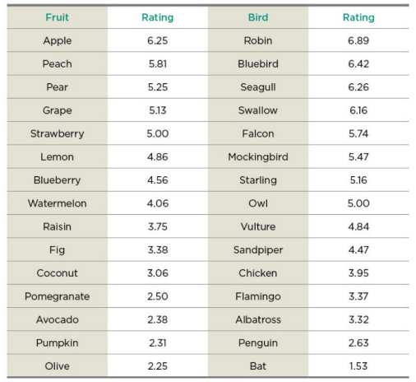

Week 8 - Moter Control
High vs low level process in cognition
- Different layers of processing that the brain (and AI systems) use to generate actions.
- High level:
  - Overall goal or intention
  - Symbolic or abstract level
  - Cognitive abilites like planing + reasoning
  - AI implimentations dont resemble neurons
Low level
  - Mechanics such as joint rotations and muscle movements, visual processing
  - Details of sensory processing
  - Computer vision benefits from detailed understanding of the visual system

Why moter control is this hard?
- Motor noise is signal-dependent
  - As you produce more force, the noise increases
  - High force = high noise
    - The harder a muscle works, the more variable and noisy it becomes
      - If you push harder, your movements become shakier and less precise
      - The nervous system must plan movements knowing that noise increases with force
  - Big muscle groups have lower variability
    - The elbow and shoulder (large muscles) → less noisy
    - Small muscles (thumb, fingers) → more noisy
      - This is why fine motor tasks (writing, threading a needle) are challenging.
      - Machine can fx lift but not write n stuff
  - Every movement you make is affected by noise
    - Motor neurons, muscle fibers, biological sensors
    - The brain must constantly compensate for this
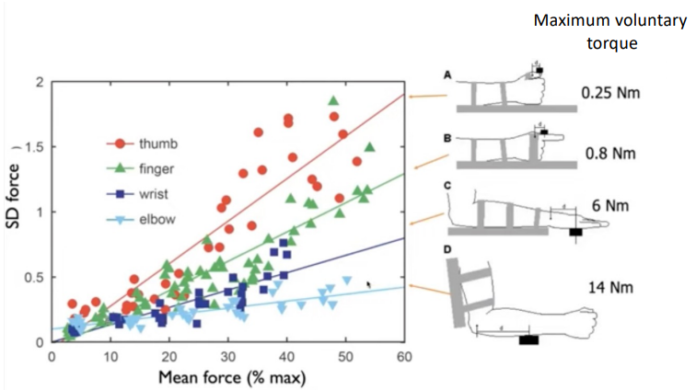

- Why motor control is so difficult?
  - Uncertainty
    - You never know exactly what the environment will do
      - You don’t know exactly where the ball will land on the racket
  - Noise (sensory + motor)
    - Sensory signals (vision, proprioception) are noisy
    - Motor commands to muscles are noisy
      - The brain must act despite this.
  - Multiple degrees of freedom
    - The human body has: 200 Joints, 600 Muscles, infinete possible movement paths
    - Bernstein problem
  - Complex dynamics
    - Moving one part affects others
      - Raising your arm shifts your balance
      - Swinging a racket changes shoulder forces
  - Time delays
    - Your brain receives delayed sensory information
      - (~100–200 ms delay in visual-motor loop)
    - So you must predict the future, not react to the present
  - Time-varying properties
    - Muscles are not constant: Fatigue, temp., elasticity
    - The brain must adapt on the fly
- Motor control is difficult because you must control a complex body with noisy muscles and delayed, uncertain sensory information in a constantly changing environment.
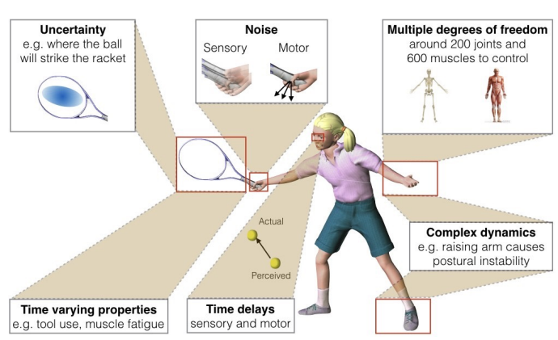

Principles of Moter control
- Bridge between high-level goals and low-level muscle commands
  - Fx: Highlevel: “I want to pick up the cup.”
  - Loelevel: activating specific muscles, in a precise sequence, with correct timing and force
- Redundancy: infinite possible solutions
  - The body has more degrees of freedom than required for the task
  - The brain must somehow choose ONE movement out of infinite possibilities.
- Curse of dimensionality
  - This is the mathematical reason motor control is so hard
  - If you have 600 muscles, and each muscle can be: Contracted or relaxed
    - 2600 possible muscle states at any moment
- How the CNS solves this: Representing State and Context
  - The CNS avoids the impossible search over all muscle combinations by using current body state and task context to narrow down only the relevant motor commands.
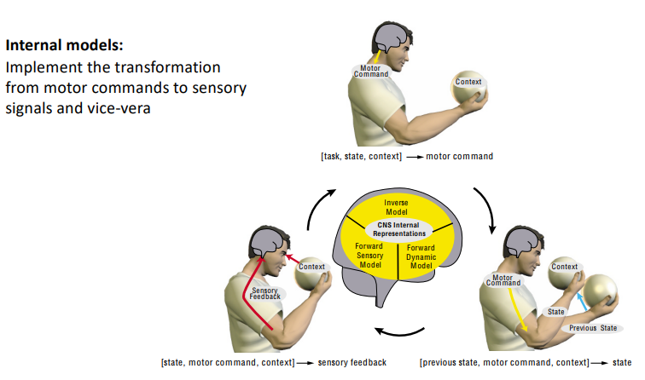

Internal models
- Internal models are the brain’s internal simulations used to predict
  - What will happen when you move
  - What sensory feedback you should expect
    - They allow the brain to control the body without having to wait for slow, noisy sensory signals
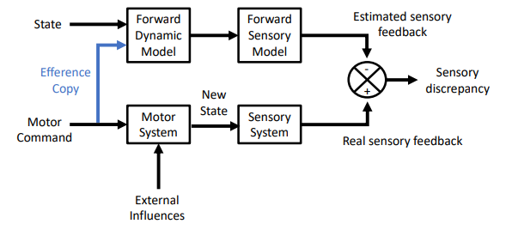
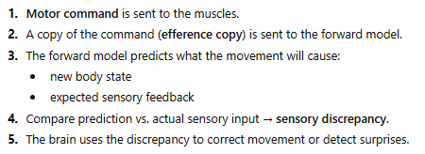

- Two types of internal models
  - Forward models
    - Sensory information is slow and noisy
      - Forward models compensate for sensorimoter delays (prediction)
    - Estimating current and future states of the external enviroment and own body (before recieving sensory feedback), by using the motor command
    - Predicting sensory consequences of actions
      - Distinguish external influences from self-produced effects -> self-monitoring
      - Increase sensitivity to unexpected events
    - Predict the outcome of a motor command
      - They take in: Current state, Moter command, context
      - And produce: Predicted state, predicted sensory feedback
    - This is how you can catch a ball or play piano without watching your hands
      - Forward models let the brain predict the effects of its own actions so it can move smoothly and detect unexpected changes.
  - Inverse models
    - Feedback error learning model
      - Feedback corrections teach the inverse model over time
    - Compute the required motor command for a desired action
      - "If I want my hand to go there, what muscles must I activate?”
    - This solves the problem of converting high-level goals into low-level muscle activations
- Internal models let the brain predict the consequences of actions and choose the right motor commands, forming a fast loop that stabilizes and controls movement.
Bayes Rule in action: FORWARD models
- The brain combines sensory data with prior knowledge to form a belief about the world, and then acts based on that belief

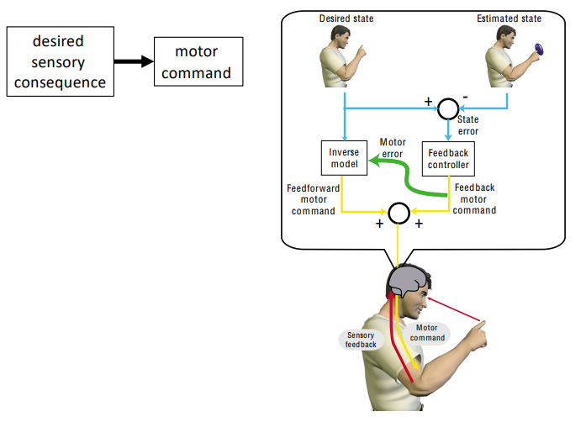
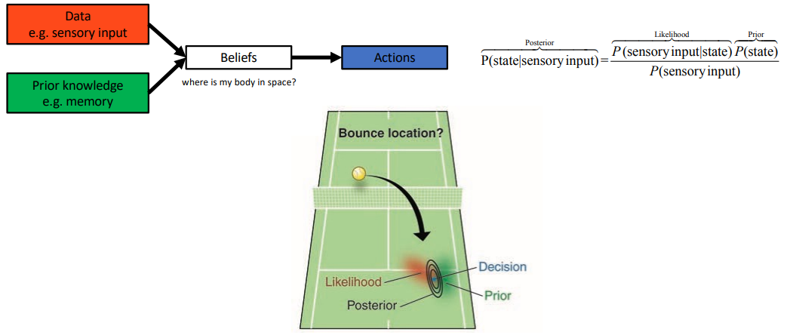
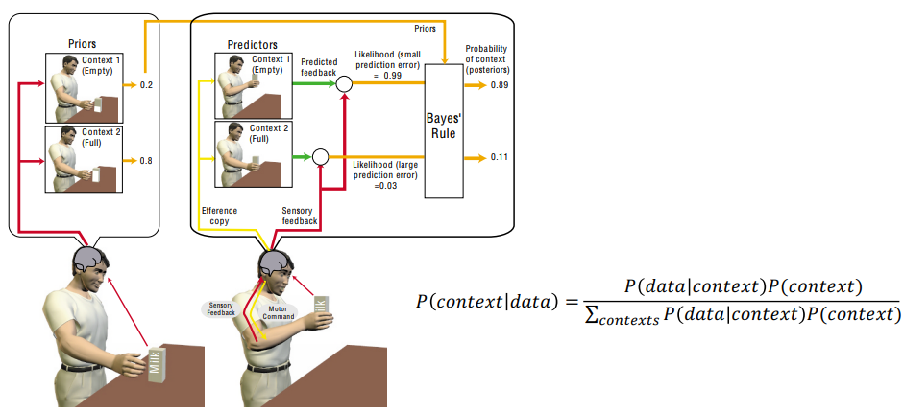

Moter control as decision making
- Once the brain has a posterior belief (an estimate of the state or context), it must choose an action.
Motor control = making decisions based on uncertain information.
- How do we choose which action to take? How to move the body?
  - The posterior tells the brain what it thinks is true right now
    - Where your arm is
    - How heavy the object is
    - Where the ball will land
- Decision theory applies to movement
  - Decision theory = choosing the action that is best given what you believe
- Goal: minimize expected cost (or maximize reward)
- Motor control is a decision-making process: the brain uses its posterior beliefs to choose the action that minimizes expected cost or maximizes expected reward.

What is the ”ideal” cost for goal-directed movements?
- The cost is the thing the brain tries to minimize when selecting movements (the loss function)
What is the “ideal” cost?
  - Make biological sense
    - Survival , energy efficiency, accuracy, avoiding injury
  - Be easy for the brain to compute
    - The CNS (Central Nervous System) must evaluate it quickly and without huge computation
  - Generalize across the whole body
    - The same principles should apply to: Eyes, head, legs, arms
  - Generalize across different tasks
    - Pointing, grasping, drawing, walking — same underlying cost principles
  - Reproduce real human behavior
    - If you use the correct cost, the model predicts how people actually move
- What costs does the brain actually seem to use?
  - Maximize accuracy
    - Hit the target, avoid errors, get the hands to correct location
  - Minimize effort (energy)
    - Use as little force as necessary, Avoid fattigue
      - This is why humans naturally
        - choose smooth paths, avoid jerky, high-energy motions
  - Different tasks balance these costs differently
    - EX: Eating with a fork
      - Accuracy > Effort, (You move slowly and carefully)
    - EX: Walking
      - Effort > Accuracy, (You pick an energy-efficient gait)
    - The brain constantly makes these trade-offs depending on the context
- The ideal cost for movement balances accuracy and effort, and the brain chooses actions that minimize this cost in a way that generalizes across tasks and body systems

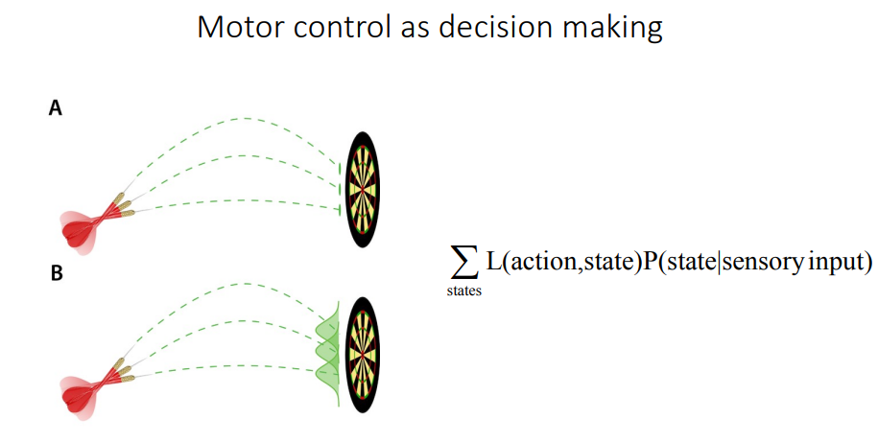
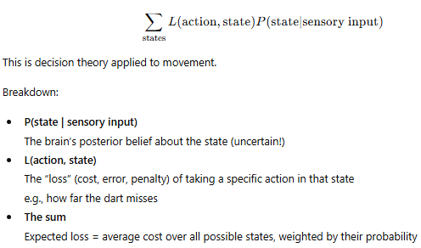

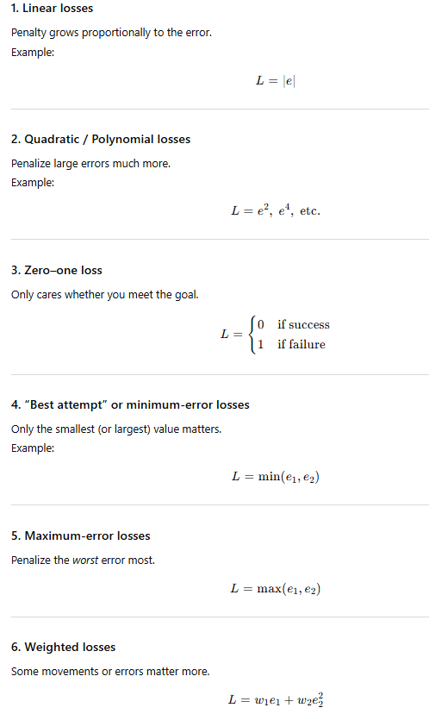

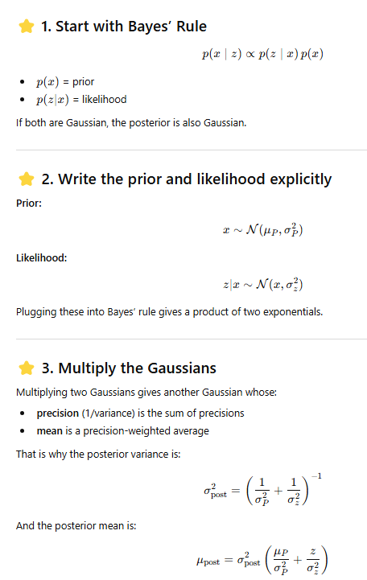
Week 9 - Social Cognition 1
Why Social Cognition Is More Complicated Than Motor Control
- Motor control is already hard because the brain must deal with:
  - Fx. Sensory noise, moter noise, delays, uncertaincy about the world, complex dynamics, many degres of fredom
- But social cognition adds an entirely new layer of difficulty layered on top of all of this.
  - When interacting with another person, the brain must not only control its own movements and interpret its own sensory information — it must also:
    - Infer another person’s thoughts, infer their beliefs, infer their goals, infer their intentions, infer how they interpret your actions, deal with the fact that they are also uncertain
- Social cognition is harder than motor control because you must predict not just the physical world, but the hidden mental states and intentions of another person — who is also predicting you.
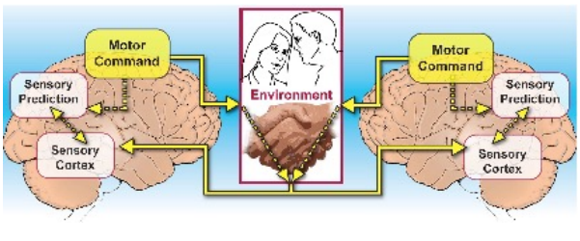

What Makes Humans Social?
- Humans have language
  - Language allows: detailed communication, sharing plans, emotions, and knowledge, teaching and learning, coordinating with large groups, forming shared beliefs
  - Other animals communicate, but human language is symbolic and generative, meaning we can talk about things that:
    - Are not present, abstract, never happend, might happen in the future
  - Language greatly increases the complexity and depth of social interaction.
- Humans create and transmit culture
  - Culture is knowledge stored outside individuals, and humans are exceptional at passing it on.
    - Ex. Science, art, religions, social norms
    - We can learn from people who died generations before us
- Humans can reflect on themselves and others
  - Humans have metacognition, meaning we can think about our own thinking
    - Fx. Why do I feel this way?, What is she thinking about me?
      - This allows: strategic interaction, empathy, long-term planning, self-regulation
- Control (or delusion of control) over our social mechanisms
  - We believe we consciously control our social behavior
  - But much of it is unconscious (e.g., body language, social biases, emotional reactions).
- Humans are highly social because we have language, culture, and the ability to reflect on thoughts—our own and others’—which enables deep, complex, and cumulative social interaction.

What ‘hardware’ enables humans to be social?
- Humans’ exceptional social abilities are supported by biological hardware—particularly the size and structure of the neocortex
  - Humans have a proportionally much larger neocortex
    - The largest neocortex relative to body size, the most complex cortical folding, the greatest number of cortical neurons
    - Because humans rely heavily on social interaction, evolution favored a larger neocortex
  - What is the neocortex?
    - Outermost layer of the brain, largest part of the cerebral cortex, includes brain areas essential for social cognition
      - Examples of functions supported by the neocortex: language, empathy, emotion regulation, thinking about other people’s thoughts
  - Social Brain Hypothesis
    - Species that live in larger, more complex social groups have larger neocortices
      - Monkeys → smaller neocortex, smaller group sizes
      - Humans → largest neocortex and the largest social groups (100–150 individuals)
        - Dunbar’s number (~150), which suggests the cognitive limit on stable human social relationships.
  - Humans are “hardwired” to be social
    - Babies are born with social preferences (face recognition, joint attention)
    - Humans automatically simulate others’ emotions
    - Our hardware supports:
      - Reading facial expressions, predicting intentions, learning social norms
- Humans are highly social because evolution gave us an unusually large and powerful neocortex, which supports advanced social abilities like language, empathy, emotion regulation, and Theory of Mind, making us hardwired for social interaction.
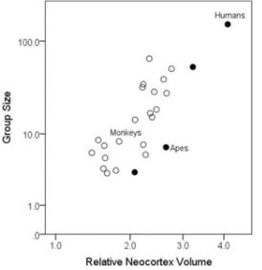

Social Cognition
- Social cognition refers to all the mental processes that allow us to:
  - Undrstand other people, interact with them, predict their behavior, respond appropriately in social situations
- Social cognition = the brain’s “mindreading” and social interaction system
  - Recognizing emotions, interpreting facial expressions, understanding intentions, reasoning about beliefs and goals, learning social norms, empathy
- Why is social cognition important?
  - Human brains are shaped through social interaction
  - Humans are social by design; our brains literally develop through other people.
- Social cognition helps explain disorders
  - Studying social cognition gives insight into conditions like:
    - Autism Spectrum Disorder (difficulties with Theory of Mind, joint attention, social cues)
    - Schizophrenia (distortions in beliefs about others’ intentions, paranoia)
  - Understanding social cognition is essential for both neuroscience and clinical psychology.
- Social cognition is the collection of mental processes that let us understand and interact with others, and it is crucial because human brains develop socially and social disorders reveal how these processes work.

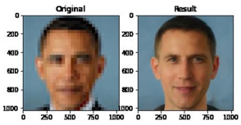

Why understanding social cognition is important for AI
- Building social robots and virtual assistants
  - It must understand how humans think, feel, and behave socially
- Predicting human behavior in real time
  - Ai system fx: Social robots, autonomous vehicles need to anticipate human actions fx will the pedestrian step into the street
  - Motor prediction alone is not enough; social environments require reasoning about other minds.
- AI inherits human biases
  - The image on the slide is an example showing how AI models may unintentionally alter or misinterpret human features — a reminder of the need for bias awareness.
    - Crucial for fx ethics, fairness…
- Understanding social cognition helps us build AI that interacts naturally with humans, predicts social behavior safely, and avoids replicating human biases.

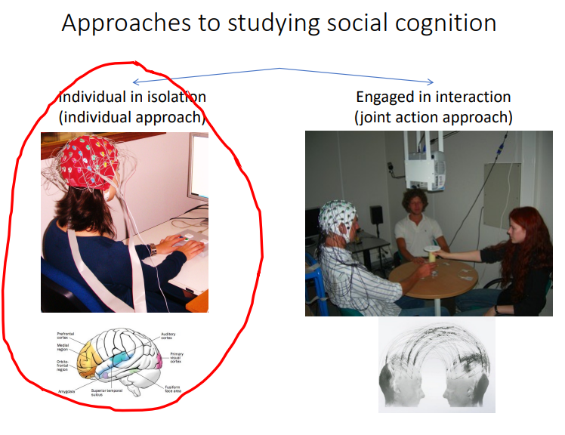

Social cognition mechanisms
- Prejudice is not just a social or moral issue — it is a cognitive mechanism shaped by evolution, learning, and culture.
- There is widespread agreement about what an “untrustworthy face” looks like
  - People across cultures tend to: trust faces with certain features, distrust faces with others
  - There is no evidence that these facial features actually predict trustworthiness.
    - This means prejudice is not based on reality — it is based on shared beliefs, not actual accuracy
    - False stereotypes, snap judgements, biased decision making
- Prejudice comes from cultural norms and innate tendencies
  - Innate biases
    - Humans evolved to favor: family (kin selection), one’s own group (in-group bias), familier people
    - These biases were useful in ancestral environments.
  - Cultural norms
    - Society, media, and institutions reinforce: stereotypes, categories, “us vs. them” thinking, privileged vs. marginalized groups
    - So prejudice is partly inherited from evolution and partly learned from culture.
- Even children form prejudices — without experience
  - Children show preferences for: people in their own group, people associated with positive outcomes
- Why do we have prejudice?
  - Prejudice evolved as a quick heuristic for unfamiliar situations
    - When you have little information and need to make fast decisions, the brain: categories people quickly, uses group-based stereotypes, relies on shortcuts (heuristics)
    - This was usefull for survival: detect danger, avoid threats, form alliences, navigate unknown social groups
    - Modern day it often becomes inaccurate, harmful, discriminatory
- Prejudice is an evolved cognitive shortcut that helps us make quick judgments with limited information, but it often leads to inaccurate and culturally reinforced biases about other people.

Automatic vs. Deliberate social mechanisms
- Automatic social mechanisms
  - These happen without thinking, without awareness, and very fast.
    - Unconsiuos, effortless,
  - We automatically make assumptions about people
    - Just by looking at someone, we instantly judge: emotions, intentions, trustworthiness
    - This happens in milliseconds, long before conscious reasoning.
  - We automatically mirror people
    - Humans unconsciously copy: facial expressions, posture, gestures, tone of voice
    - This “mirroring” makes social interaction smoother and reinforces social bonds.
- Deliberate (conscious) social processes
  - These require awareness, reflection, and effort.
    - They involve: planning, reasoning about social situations, understanding others’ beliefs, strategic communication, negotiating shared goals
    - These processes are uniquely developed in humans
  - Why deliberate processes matter
    - They enable complex group actions, (e.g., teamwork, coordination, problem-solving)
    - They allow sophisticated communication, (e.g., language, teaching, long-term social strategies)
- Automatic mechanisms handle everyday social coordination.
- Deliberate mechanisms support higher-level social cognition.
  - Automatic social processes happen unconsciously and guide quick judgments and mirroring, while deliberate social processes require conscious thought and enable complex, uniquely human social behaviors.

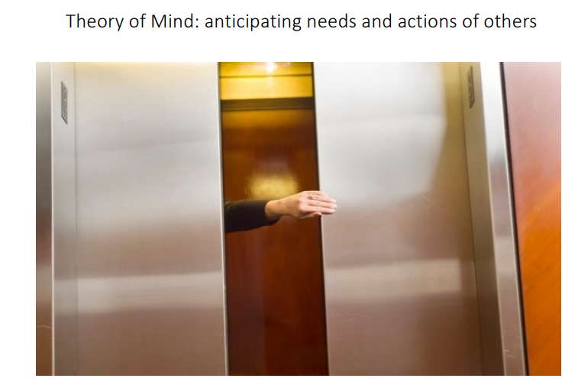

Social Cognition Mechanisms
- Social learning: learning by observing others
  - Humans learn a massive amount from simply watching other people.
  - This includes emotional, behavioral, social, and cognitive learning.
    - Gaze following
      - Humans automatically look where someone else is looking
      - This tells us: where their attention is, what they care about, whether there is something important or threatening in the environment
      - Gaze following is foundational for: joint attention (shared focus), language learning, predicting intentions
    - Mirroring
      - We unconsciously copy other people’s facial expressions, posture, and gestures.
      - Mirroring helps us understand others’ emotions, when we imitate a sad or happy face, we feel some of that emotion too, creates empathy and bonding, smooths social interactions
    - Prejudice vs. Experience
      - We can learn social categories in two ways:
        - Prejudice
          - Automatic biases learned from culture and social norms (not from personal experience)
        - Experience
          - Direct interactions teach us who is actually trustworthy, kind, cooperative, etc.
- Mentalizing / Theory of Mind
  - This is the ability to understand that:
    - Other people have thoughts, beliefs, desires
    - These mental states can differ from your own
  - This allows us to:
    - Predict behavior, understand intentions, cooperate, deceive, empathize
- Social cognition relies on social learning (like gaze following, mirroring, and bias formation) and on mentalizing (Theory of Mind), which together allow humans to interpret, predict, and respond to other people’s behavior.

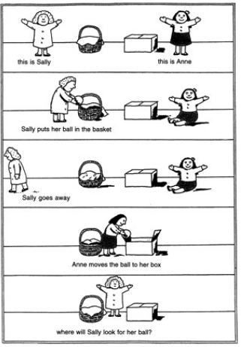

Explicit vs. Implicit Theory of Mind
- What is Theory of Mind (ToM)?
  - Ability to predict and explain other peoples behavior in terms of ental state (destress, desires, intentions)
- Explicit Theory of Mind
  - This is conscious, deliberate, and often requires: language, logical reasoning, executive function (working memory, inhibition, planning)
  - Ex. Sally-Anne test
    - Children usually pass it around age 4–5 because the test requires them to
      - Reflect on a story, verbally reason about belief states, explicitly describe what someone else knows
  - This is a high-level, reflective form of ToM.
- Implicit Theory of Mind
  - Implicit ToM is: Fast, automatic, unconscious
  - Research shows that even infants (as young as 12–18 months) show signs of implicit ToM.
    - Toddlers spontaneously track where others are looking or what they think.
    - Babies look longer when someone acts against their (false) belief → they expected the agent to act based on their belief.
  - This means children implicitly understand mental states before they can explicitly talk about them.
- Autistic individuals may show differences in explicit ToM tasks but sometimes have preserved or partially preserved implicit ToM behaviors.
- Explicit ToM is conscious, language-based reasoning about beliefs (developing around age 4–5), while implicit ToM is early, automatic understanding of others' mental states that appears in infants long before they can verbally explain it.

Artifical Theory of mind
- AI systems can learn to understand and predict the behavior of other agents—similar to how humans use Theory of Mind (ToM)
- AI doesn’t “understand minds” the way humans do, but it can infer patterns from observing behavior
  - Observing the actions of other agents, recognizing patterns, predicting future behavior based on those patterns
- ToMnet (by DeepMind) is an example of a system designed to mimic Theory of Mind
  - Network 1: Learns tendencies (long-term traits)
    - It watches an agent’s past actions and learns patterns like: Does this agent prefer certain goals?, Does it behave consistently? Does it like taking shortcuts?
  - Network 2: Infers current mental state
    - Based on the current situation, this network infers: What the agent currently believes, What the agent currently wants, What the agent might be attending to
  - Network 3: Predicts the agent’s next action
    - Using inputs from network 1 and 2, this final network predicts: What the agent will do next, Which goal it will pursue, How it will behave in the current moment
- Limitations
  - It struggles in new environments
    - AI is strongly tied to its training data. If the environment changes drastically, predictions often fail.
  - It struggles with agents very different from those it was trained on
- Artificial Theory of Mind systems like ToMnet can learn to predict others’ actions by observing behavior, but they remain limited to familiar environments and struggle to generalize to new or very different kinds of agents.

Do LLMs have ToM
- When an LLM gives a correct answer on a Theory of Mind task, does it really understand mental states the way humans do?
  - Probably not
- LLMs sometimes appear to have ToM
  - LLMs can: answer false-belief tasks, explain others’ intentions, describe emotions, make predictions about people’s actions
  - Passing a ToM test ≠ having Theory of Mind
  - LLMs generate answers based on patterns in language, not mental-state simulation.
- Human ToM tests may not work for AI
  - These may be reliable proxies for assessing general abilities in humans, but not in AI systems
  - In humans, ToM test performance reflects underlying cognitive mechanisms.
  - In AI, ToM-like answers might come from pattern matching, not true reasoning.
  - So they may produce correct output for the wrong reasons
- Melanie Mitchell’s argument
  - We need new scientific methods to measure mechanisms of understanding in AI.
  - Mitchell suggests that AI may be doing “surface-level imitation,” not deep mental modeling.
- LLMs can sometimes answer Theory of Mind questions correctly, but this does not mean they possess real mental-state understanding — it only means they can reproduce linguistic patterns, so new methods are needed to assess genuine AI understanding.
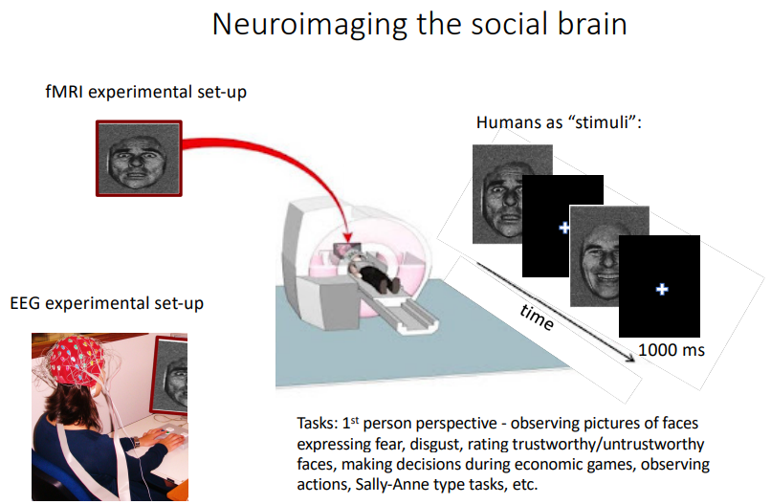

How do we study the brain basis of these social mechanisms?
- To understand which parts of the brain perform social functions, researchers use controlled experiments combined with brain-imaging methods.
  - Use experimental tasks that trigger specific social mechanisms
    - Researchers design tasks that activate particular social processes, such as:
      - Mirroring (e.g., watching someone move, then measuring motor cortex activation)
      - Mentalizing / Theory of Mind (e.g., reading stories about beliefs)
      - Emotion recognition (e.g., looking at emotional faces)
      - Joint attention (e.g., gaze-following tasks)
    - For each task, the goal is to reliably trigger the social mechanism.
  - Use control conditions to compare brain activity
    - To understand which brain areas are specifically involved in the social process, the task must be compared to a non-social control condition.
      - Example: Social task: watching someone grasp an object, Control task: watching an object move on its own
      - Then researchers compare the brain activity patterns: Which areas are active in social >>> non-social? Those areas are likely involved in the social mechanism.
  - Identify brain areas/mechanisms that are “activated”
    - Researchers use tools like: ex. EEG
    - They look for: higher activity during the social condition, areas consistently engaged across people and studies
    - This reveals the neural basis of mechanisms such as: empathy, mentalizing, mirroring, emotional processing, prejudice
  - Brain mechanisms give deeper insight into social cognition
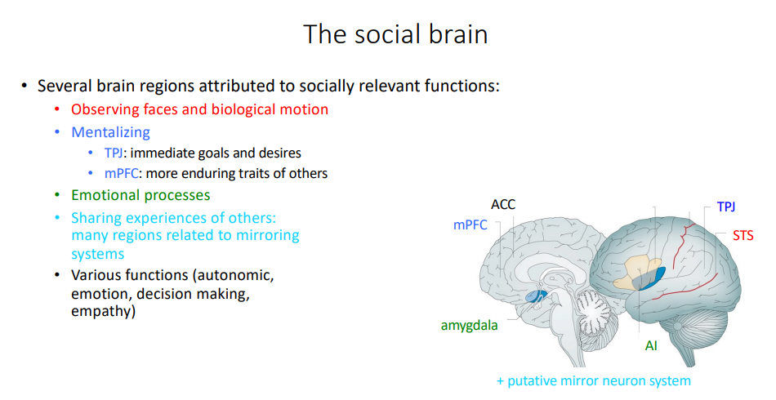

How does a brain give rise to social cognition?
- Early theories about which brain regions support social abilities, and how scientists discovered them.
- Brothers (1990): The “Social Brain” Hypothesis
  - A specific, restricted set of brain regions is specialized for social cognition.
  - According to this view:
    - Some brain regions handle language
    - Some handle vision
    - And some specifically support understanding others
    - These social regions were later referred to as “the social brain.”
- Evidence from lesion studies in monkeys
  - A major source of evidence came from damaging (lesioning) specific brain areas in monkeys and observing their behavior.
    - Legions to the amygdala, orbital frontal cortex altered monkeys’ social behaviour, made
them socially isolated, etc.
    - This set of regions known as “the social brain”
    - Regions thought to be dedicated to social functions
- Some brain regions appear to be specifically involved in social processing.
When they are damaged, social cognition is selectively impaired.

Are ‘social brain’ areas only social?
- No — the so-called “social brain” regions also do non-social things.
- Amygdala is associated with processing of fearful social information, but also associated with positively/negatively valuable stimuli that are not social
- pSTS implicated in perception of people’s gaze direction, as well as processing of biological motion
  - Function: to predict complex movement trajectories
- Are “social brain areas” only for social cognition?
  - The brain is not modular in the sense of having totally isolated “social-only” regions
  - Many areas contribute to multiple functions (both social and non-social).
  - Social cognition reuses general-purpose mechanisms such as:
    - Attention, motion prediction, value evaluation, reward processing
- So-called “social brain” regions—like the amygdala and pSTS—play big roles in social cognition, but they also process non-social information, meaning they are not exclusively dedicated to social functions.

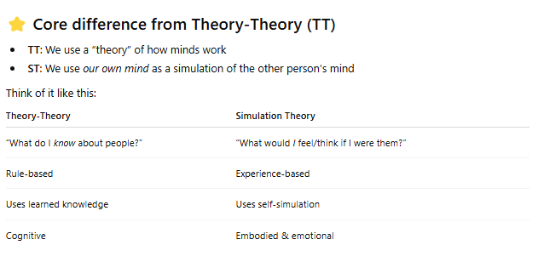

The social brain
- What is the main function of the social brain
  - To make predictions during social interactions
    - Infer their current mental state
    - Predict their future behavior
  - This is exactly like the motor control system predicting the consequences of your own movements —
but here, the predictions are about another person’s mind.
- How to express this using Bayesian inference
  - The slide asks you to treat social interaction the same way we treated motor control and sensory estimation:
    - Identify prior
    - Identify likelihood
    - Identify posterior
  - This time, instead of a milk carton’s weight, you estimate someone’s hidden intentions.
    - Scenario:
      - You see a person walking toward a closed door while carrying a heavy box.
    - Prior
      - Your expectation before observing anything:
      - “People carrying heavy objects often need help opening doors.”
    - Likelihood
      - How likely their current action is if they have a certain intention:
      - If their intention is to go through the door, it is very likely they will pause or look at the door handle while carrying the box.
      - If their intention is to put the box down, this action is unlikely.
    - Posterior
      - Your updated belief after seeing the action:
      - “They probably want to go through the door and need help opening it.”

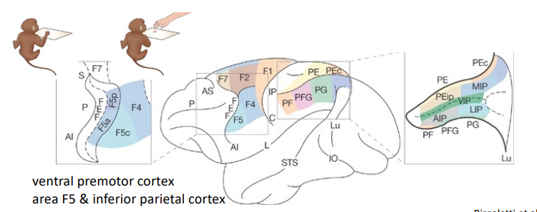

Theory-Theory (TT)
- Theory-Theory (TT) is one of the major explanations for how humans understand other people’s thoughts, emotions, and intentions
- We understand other minds by applying an internal “theory” of how minds work — similar to how scientists form theories about the world.
  - We don’t directly experience other minds.
  - We infer them using knowledge and past experience.
- Children innately develop theories about other people and their mental states, and try to verify them in reality (like scientists)
- We hold a basic theory of psychology, which we use to infer mental states of others
- We do not “experience” the mental state of others ourselves, but infer them based on our previous experiences
- We understand and predict others’ mental states by inferentially applying a body of implicit knowledge/experience

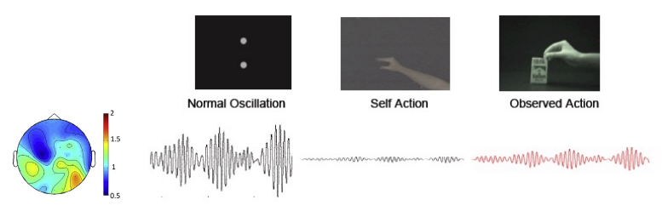

Simulation Theory (ST)
- We understand other people’s minds by simulating their mental states inside our own mind.
- Instead of using a “theory,” we use our own cognitive and emotional systems to internally recreate what the other person is thinking or feeling.
- We simulate others’ actions and beliefs
  - If we see someone: fx feeling bad, we internally activate similar representations in our own brain.
- We experience other people’s mental states
  - ST suggests we actually feel: a tiny version of their emotion, a small echo of their intention
  - This is why empathy feels like “catching” someone else’s emotion
- We understand others by using our own cognitive processes

Mirror Neurons: Neuroscience Support for Simulation Theory
- Mirror neurons
  - Mirror neurons were discovered in the ventral premotor cortex (area F5) of monkeys
  - These neurons fire: when the monkey performs an action (e.g., grasping a peanut)
  - And when the monkey sees someone else perform the same action (e.g., a human or monkey grasping a peanut)
  - The same neurons respond to execution and observation.
- What mirror neurons tell us
  - Mirror neurons provide a neural mechanism for:
    - Linking action observation and action execution
      - Seeing someone act activates parts of your own movement system.
    - You understand others’ actions by internally reenacting them.
- Possible function: understanding motor actions
  - Mirror neurons may help you: recognize actions, anticipate others’ movements, infer goals behind an observed action
  - We use our own motor system to interpret others’ motor behavior.
- Mirror neurons fire both when performing an action and when watching someone else perform it, supporting the idea that we understand others’ actions by internally simulating them—exactly as Simulation Theory proposes.

Do mirror neurons exist in humans?
- This remains debated.
  - In monkeys, mirror neurons have been directly recorded (single-cell recordings).
  - In humans, we cannot easily record single neurons except in rare medical cases.
  - Therefore, we do not know if humans have the exact same type of mirror neurons
    - What we can measure in humans is regions of the brain that behave like mirror neurons -> Mirror Neuron System (MNS)
- Individual neurons not found in humans, but engagement of corresponding brain areas – referred to as the mirror neuron system (using fMRI)
  - We do not know if the MNS brain areas contain mirror neurons
- Activated by action execution, observation, imitation
- Mirror neurons in monkeys fire only for goal-directed actions but in humans MNS has less strict
constraints
- Humans show brain activity consistent with a Mirror Neuron System, but we cannot confirm individual mirror neurons; the system activates for action execution, observation, and imitation, and appears more flexible than the monkey mirror system.

EEG mu-rhythm: common coding of perception & action
- What is the mu-rhythm?
  - The mu-rhythm is a brain wave measured over the sensorimotor cortex:
    - Frequency: 10 Hz and 20 Hz via EEG (electroencephalography)
    - Most visible when a person is not moving and the motor system is at rest
  - It reflects the idling state of the motor cortex.
- What happens during action?
  - When you move, the mu-rhythm becomes suppressed (its power decreases).
    - The motor cortex is active
    - The brain is preparing or executing movement
- What happens when you watch someone else move?
  - The mu-rhythm is also suppressed when you observe another person’s action.
    - Watching an action activates your motor system
    - Your brain simulates the action internally
    - Similar neural processes occur in self-action and observed action
- The EEG mu-rhythm decreases both when you perform an action and when you watch someone else perform it—showing that the same motor regions are involved in action execution and action perception.

Human mirroring systems
- The classical mirror neuron system refers specifically to motor-related areas that respond to:
  - Doing an action
  - Watching someone else do the action
- But humans have much broader mirroring systems that go far beyond motor actions
  - Emotions, pain, touch
  - This means humans simulate not just actions, but also feelings and sensations.
- Humans have widespread mirroring systems that simulate not only actions but also others’ emotions, pain, touch, and experiences, with different brain areas activating depending on what is being observed.

Problem with single-person neuroscience
- Many regions that are part of “the social brain” have numerous functions, which are not always related to the processing of social stimuli
- Social cognition is fundamentally different when people engage in reciprocal interaction with adaptive others
- Social interaction is a dynamic process, operating at various time-scales, which cannot be captured using static stimuli

Joint action approach
- Perception and action in a social context
- One person’s action output = another person’s perceptual input (and vice-versa)
- Joint action: any form of social interaction whereby two or more individuals coordinate their actions in space and time to bring about a change in the environment

AI & Human Cognition
- How AI mimics human cognition
  - AI and human brains often solve similar problems, but in different ways. The slide highlights two key parallels:
    - High-level vs. low-level skills
      - AI often performs very well on high-level, abstract tasks, like: Chess, recognizing patterns
      - But AI performs poorly on low-level, sensorimotor tasks that humans do easily, such as: Walking, gabing objects
- Applying AI to understand human cognition
  - AI isn’t only about mimicking the brain—it’s also used as a tool to study the brain
    - Ex. Using machine learning to analyze EEG, fMRI, or behavior data
    - AI helps researchers interpret complex data and generate explanations of how the brain works.
- When should we use a data-driven machine learning approach?
  - We want to make predictions
  - We don’t have a strong hypothesis (exploratory analysis)
  - We have a lot of data
  - We want to discover general principles of cognition
- AI both mimics aspects of human cognition and provides powerful tools for analyzing brain data, especially when we need predictions, have large datasets, or lack a clear hypothesis.

Week 10 - Social Cognition part II
Social interaction involves a combination of only single-mind cognitive processes?
- What the question is asking
  - Challenging the idea that “Social interaction = just two separate individuals using their own individual cognitive processes.”
- No. Social interaction is not just a combination of single-mind processes.
Real interaction includes dynamic, real-time coupling between two people that creates new cognitive processes that do not exist in isolation.

Representations
- Representations are ways information is stored, expressed, or understood—either externally (words, pictures) or internally (in the mind).
- Words
  - Example: “Map”
    - A word is a symbolic representation
    - It refers to something, but does not visually show it.
    - Words rely on language knowledge.
- Pictures
  - Example: an actual map image
    - A picture resembles what it represents.
    - You don’t need language to understand it.
    - It conveys more concrete visual information
- Mental representation
  - These are the internal structures in your mind that store knowledge.
    - Concepts (e.g., “country,” “distance,” “ocean”)
    - Rules (e.g., "if you go north, it gets colder")
    - Memories
  - They are not directly observable, but inferred from behaviour and neuroscience.
- Representations are ways information is expressed—through words, pictures, or internal mental structures like concepts, rules, and images.
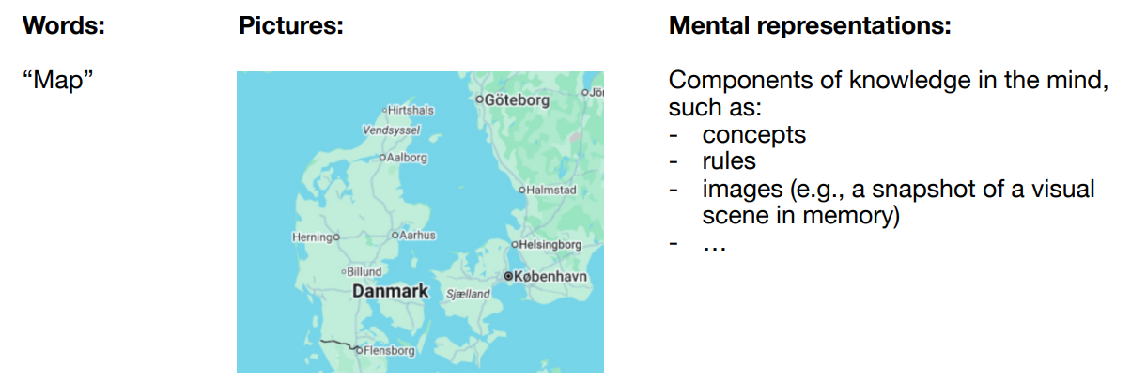

Group-level aspects of social cognition
- Social cognition is not just about individuals, but also about groups, and that group cognition has different levels.
- Lower-level group processes
  - These involve real-time coordination, not just thinking.
    - Ex. Playing music together, walking in sync, two people looking at the sae object
  - These processes require actual interaction, not just mental representations.
  - They emerge when two bodies + two minds coordinate in time.
- Higher-level group processes
  - These are representational — they rely on shared mental representations across multiple individuals.
    - Ex. Group memory, remembering events together, common knowlagde in group
    - Ex. Conversational alignment, adopting each other’s speech patterns, tone, vocabulary
  - Still require interaction, but involve shared mental structures, not just moment-to-moment coordination.
- Large-scale social cognition
  - This refers to very big groups (hundreds, thousands, millions).
At this scale, new emergent properties appear that individuals do not possess.
  - Ex. Crowd dynamics, how groups move (e.g., waves in stadiums)
  - Ex. National, cultural, generational memory, cultural traditions, shared history
  - These processes behave like complex systems, not like individual cognition.
- Group-level social cognition includes low-level coordination, higher-level shared representations, and large-scale societal dynamics—each involving cognitive processes that only emerge when multiple people interact.

Why is collective cognition important for AI?
- AI is no longer interacting with individuals only — it is now participating in group-level social cognition, whether we want it to or not.
- That means AI must learn to function within human groups, not just with single users.
- Collective cognition matters for AI because AI is already interacting with groups, shaping collective behavior, and influencing society at large — so it must understand and support group-level human processes, not disrupt them.
- Collective cognition is important for AI because deepfakes can manipulate whole groups and societies, so AI must help detect and counter this misinformation at scale.

What is special about social interaction?
- Social interaction is more than the sum of two individual minds. Something additional emerges from the interaction dynamics.
  - Participatory Sense-Making (De Jaegher & Di Paolo, 2007)
- What makes social interaction special?
  - Interaction dynamics influence the individuals involved
    - When two people interact, their coordination patterns (timing, rhythm, turn-taking, mutual adaptation) can change their behavior, their intentions, and even their understanding.
    - This influence is not just “inside the head.” It comes from the interaction process itself.
- Interaction is not everything — individual minds still matter
  - Avoid the error of considering only the interaction and ignoring the individual elements in it
    - Interaction dynamics matter
    - But individual skills, perceptions, mental states also matter
  - individual cognition ↔ interaction dynamics
- Social interaction is special because it creates new, emergent patterns of coordination and meaning that arise only through the interaction itself—not simply from each person’s individual mind.

Action coordination
- Some complex collective behaviors—like a flock of birds moving as one—can emerge from very simple individual rules, without any leader or central control.
  - Reynolds’ (1987) Boids model, a classic simulation of flocking
- The three simple rules
  - Collision avoidance
    - Avoid bumping into nearby birds
  - Velocity matching
    - Try to match direction and speed with neighbors
  - Flock centering (cohesion)
    - Move toward the center of nearby birds.
- Even though each bird follows only simple rules, the entire flock behaves in a highly coordinated, seemingly intelligent way—turning, expanding, contracting, and flowing like a single organism.
- It shows that:
  - Some group-level behaviors do not require high-level mental representations.
  - Coordination can arise from local interactions and simple rules.
  - Not all social phenomena are based on “understanding” or “mindreading”—some are grounded in automatic coordination dynamics.
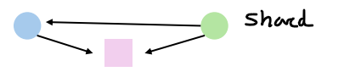
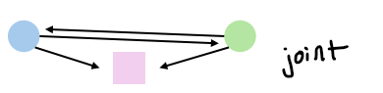

Joint action
- Joint action
  - Its the overall phenomenon of achieving something together
  - “any form of social interaction where two or more individuals coordinate their actions in space and time to bring about a change in the environment.”
    - Fx. Carrying a table
  - Joint action is more than just acting next to someone — it involves shared goals and coordinated efforts.
- What processes suport join action?
  - Individual and shared representations
    - Individuals form internal representations of goals, plans, and each other’s abilities, allowing them to align their understanding of the task.
  - Monitoring, prediction, and adaptation
    - Partners continuously monitor each other’s behavior, predict upcoming actions, and adapt their own movements to stay coordinated.
  - Coordination smoothers
    - People use behaviors that increase predictability—such as synchronizing, adjusting timing, or implicitly taking on roles—to make joint action flow more smoothly.
- Shared attention
  - One of the individuals is aware of herself and the other as being attentive towards the same external entity (=gaze-following)
- Joint attention
  - Shared attention + the mutual knowledge of both individuals as being attentive towards the same external entity, accomplished via communicative cues. Fx saying “Look!”
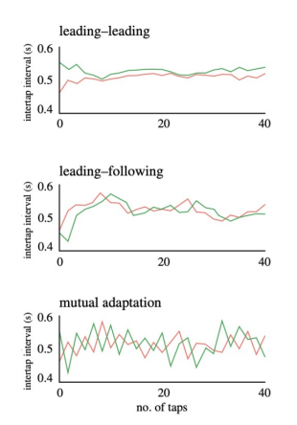

Action coordination
- Action coordination
  - Its the mechanism that makes joint action possible.
  - How individuals adjust their actions to those of another person in time and space
  - This is the moment-to-moment adjustment that allows joint action to work smoothly
    - If your partner speeds up while walking together, you automatically speed up too
- Intentional action coordination
  - Intentional coordination occurs when people deliberately work toward a shared goal, using fully developed joint-action structures such as agreed-upon plans and active monitoring of each other.
    - Two people carrying a table coordinate when to lift, turn, and set it down.
      - Prediction
        - We anticipate our partner’s next action so that our own movements can stay aligned with theirs.
        - We continuously update these predictions based on what actually happens during the interaction.
      - Adaptation
        - We adjust our timing or movement to match the partner’s rhythm or behavior.
        - This helps maintain smooth coordination even when someone speeds up, slows down, or makes an error.
      - Implicit negotiation of leader–follower roles
        - Partners automatically settle into roles where one becomes slightly more stable (leader) and the other more flexible (follower).
        - Leaders provide a predictable reference, while followers adapt more to keep the joint action synchronized.
- Unintentional action coordination
  - Unintentional coordination happens spontaneously without explicit planning, relying on minimal shared representations and reduced monitoring or prediction, yet still producing coordinated behavior.
    - Two people walking side by side naturally fall into the same rhythm without planning it.
      - Shows that social coordination is not always intentional or representational.
      - Simple coupling of perception and Joint actionJoint actionJoint action can create complex group behavior.
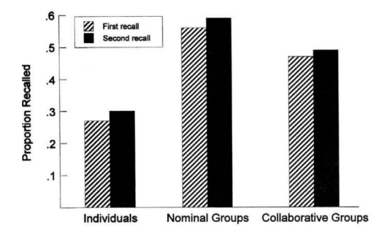

Group memory
- What group memory is
  - Group memory is an emergent property, meaning it arises from combining different individuals’ recollections in a shared social context.
  - People recall more effectively together because they trigger each other’s memories, fill in gaps, and co-construct a shared account.
- Experimental setup: Recalling the last project meeting together
  - Three people first study words or pictures individually.
  - Later, they attempt to recall the items together as a group.
  - Performance of the collaborative group is compared with:
    - Individuals recalling alone, and Nominal groups (pooled individual recall without actual collaboration).
- Collaborative inhibition
  - Collaboration surprisingly leads to worse recall than nominal groups—this is called collaborative inhibition.
    - Free-riding (motivational explanation)
      - Some group members put in less effort because others can “pick up the slack.”
      - This factor is minor—increasing motivation did not remove the effect.
    - Retrieval blocking (cognitive explanation)
      - Hearing others’ recall strategies disrupts your own recall process, blocking access to your internal retrieval cues.
      - Your memory search is shifted away from the cues you would normally use when recalling alone.

- How group characteristics shape group memory
  - Appropriateness in a social setting
    - Group members recall events differently depending on what is considered socially appropriate to mention in that context.
      - Example: leaving out embarrassing details when talking to parents.
  - Who speaks and whose memories dominate
    - The order of speaking and the social status of group members influence which recollections receive more attention and become part of the shared memory.
      - Example: people often adopt the memory version of the most confident or influential speaker.
  - Purpose of the recollection
    - The goal of the conversation affects how events are reconstructed.
      - Example: reassuring parents that everything is fine vs. telling friends an exciting or dramatic version of the same story.
- Mutual enhancement
  - Groups tend to focus on information that everyone already knows, because it feels validating and socially smooth.
  - This leads to repetition of shared information and neglect of unique details held by individual members.
- Long-term effects
  - These group dynamics shape what people later remember individually, meaning that shared conversations can reshape personal memories over time.
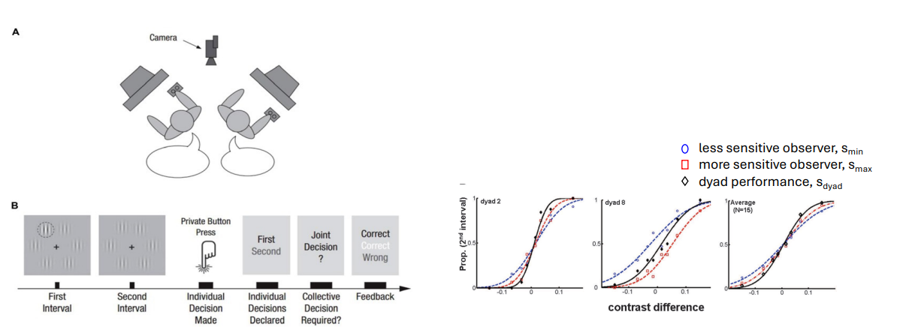
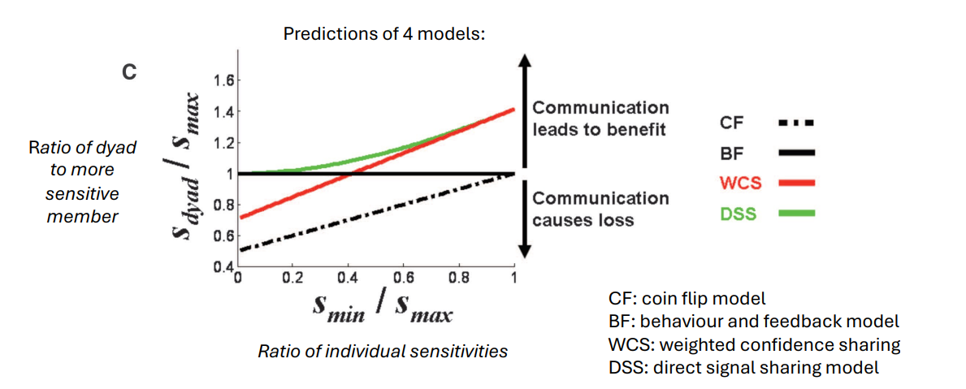

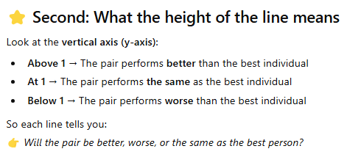
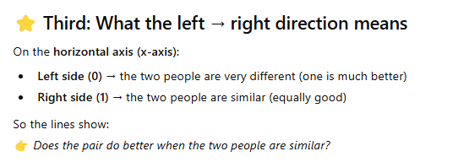

dyad = two participants working together to make a joint decision.

Group decision-making does not always guarantee better performance than individual decision-making, although improvements are sometimes possible. In the experiment shown, pairs of participants each viewed visual stimuli and first made individual judgments about which interval contained a higher contrast pattern. They then made a joint decision before receiving feedback. By comparing the accuracy of the less sensitive observer, the more sensitive observer, and the dyad’s combined performance, researchers assessed whether collaboration enhanced decision quality. Results show that dyads can sometimes outperform individuals, but this benefit depends on how effectively partners share and integrate their perceptual information. When communication or integration is poor, joint performance may not exceed—and may even fall below—that of the better individual.
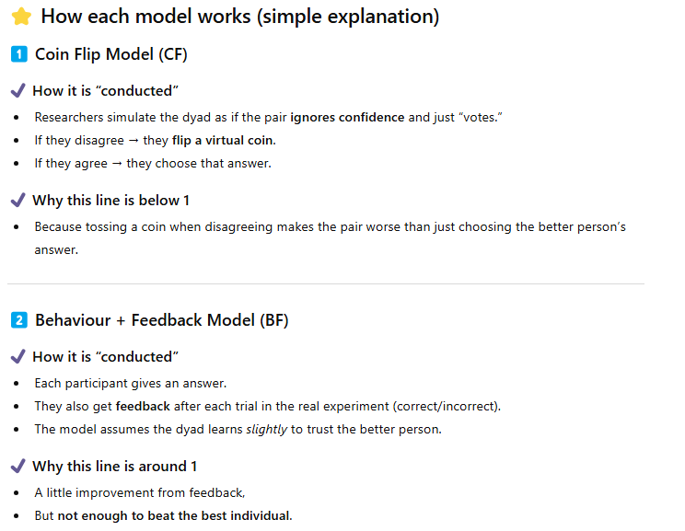
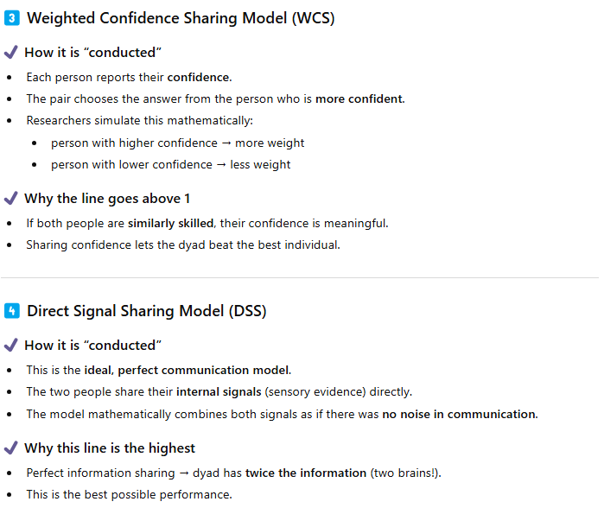
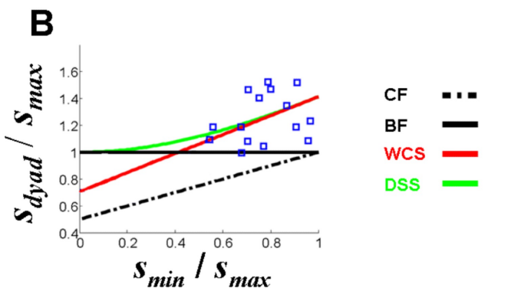
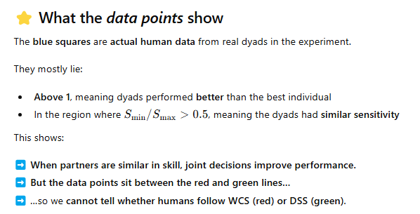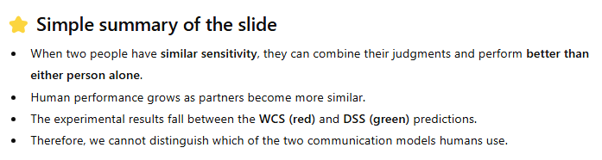

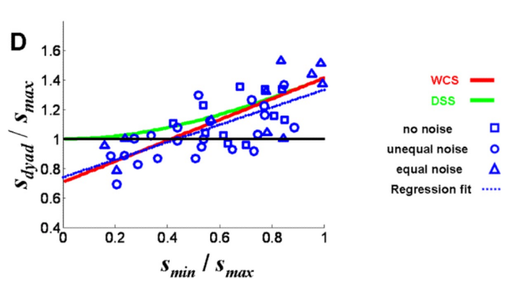
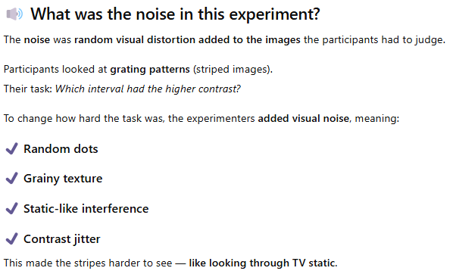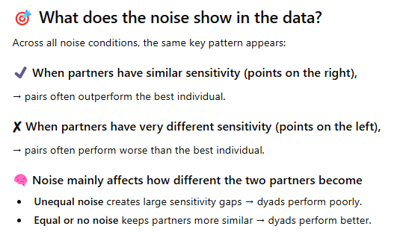

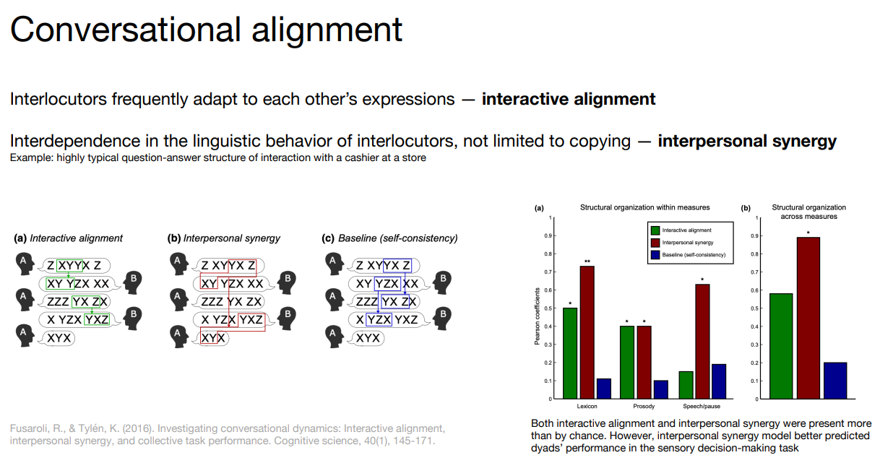
Conversational Alignment
- When two people talk, their speech patterns automatically start aligning.
- Interactive Alignment
  - People unconsciously copy each other’s words, syntax, rhythm, or phrasing.
    - A cashier says: “Would you like a bag?”
    - You respond using the same structure:
“Yes, I’d like a bag.”
      - A says something like Z XYYY Z.
      - B responds using XY YZX, borrowing elements from A.
      - This is local copying — word or structure repetition from the previous turn.
- Interpersonal Synergy
  - Not just copying. Instead, people’s speech fits together dynamically to create a joint structure of the
    - A: “Okay, if we leave early in the morning, we could probably avoid traffic.”
    - B: “Right, and if we avoid traffic, we’d get to the coast before noon.”
    - A: “If we're there by noon, then we’d have enough time to rent kayaks.”
    - B: “Perfect — and renting kayaks earlier means we can also catch the sunset from the water later.”
      - They are not repeating each other’s words or sentence structure.
      - Each turn follows logically from the previous one.
      - Together, they build a shared chain of meaning that neither one created alone.
      - Their contributions interlock like puzzle pieces
- Baseline (Self-consistency)
  - Shows what each person’s speech would look like if we did NOT interact with another person
    - No alignment with the partner
    - No synergy
    - Each person just stays internally consistent with their own speaking patterns
  - What happens in baseline (self-consistency)
    - Speaker A’s utterances early in the conversation are compared to Speaker A’s later utterances.
    - Speaker B’s early speech is compared to Speaker B’s later speech.
      - This checks how predictable or structured their speech is without the influence of the other person.

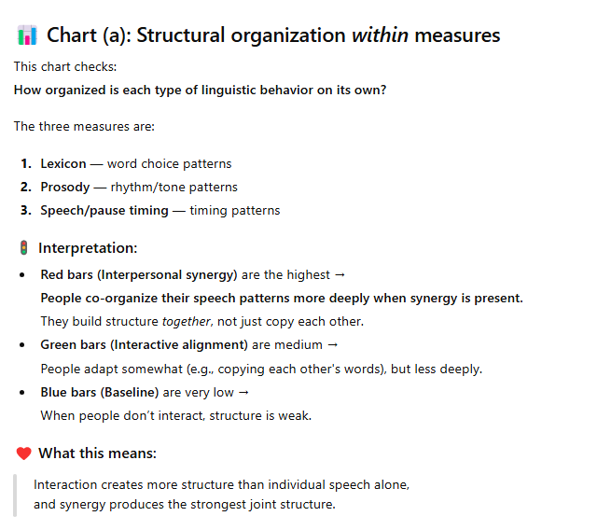
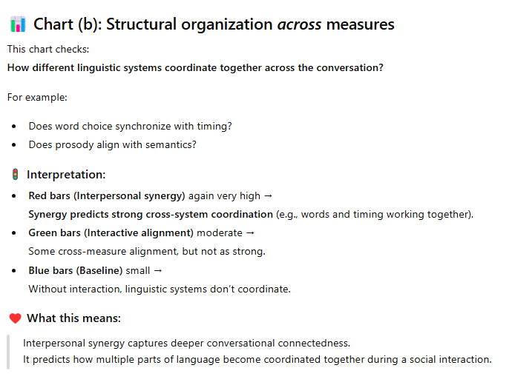
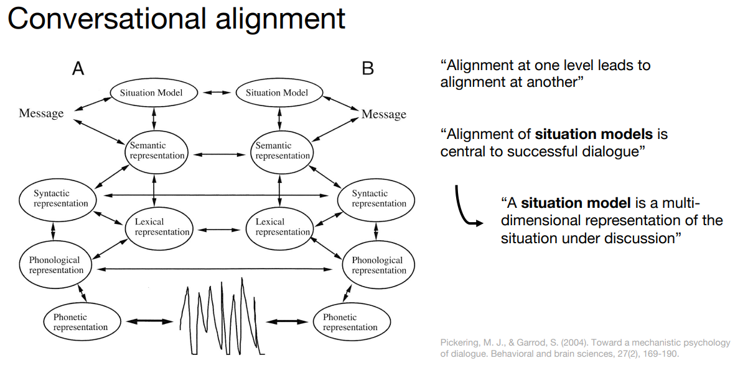
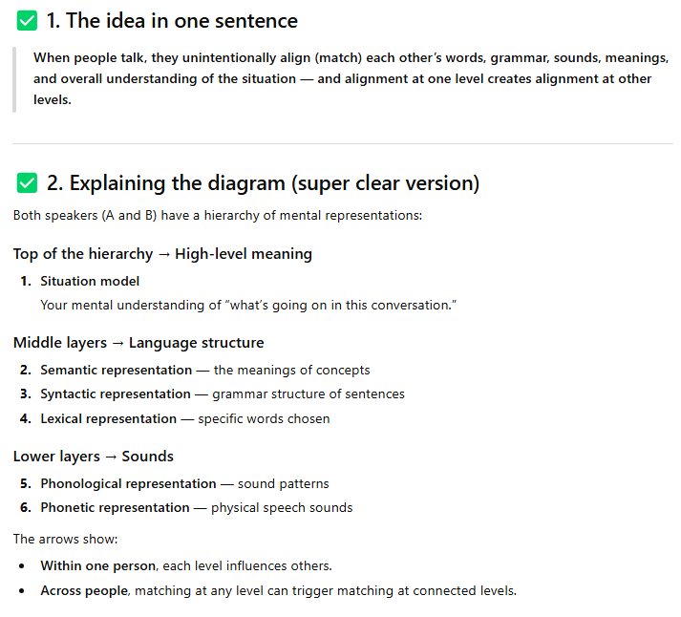
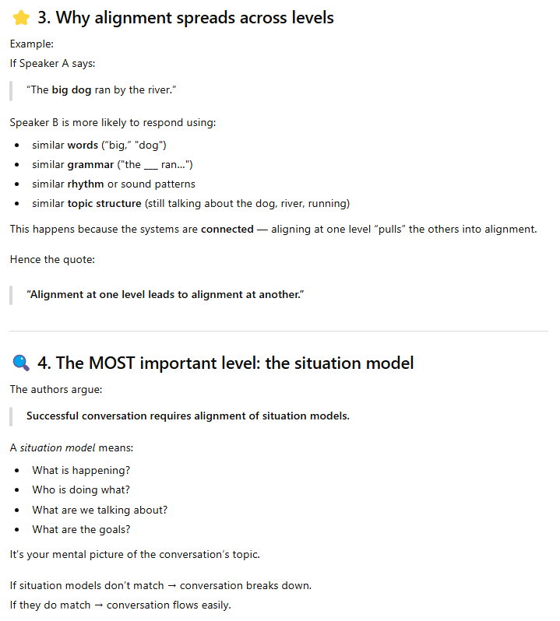
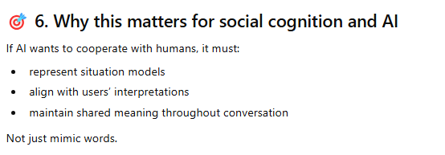
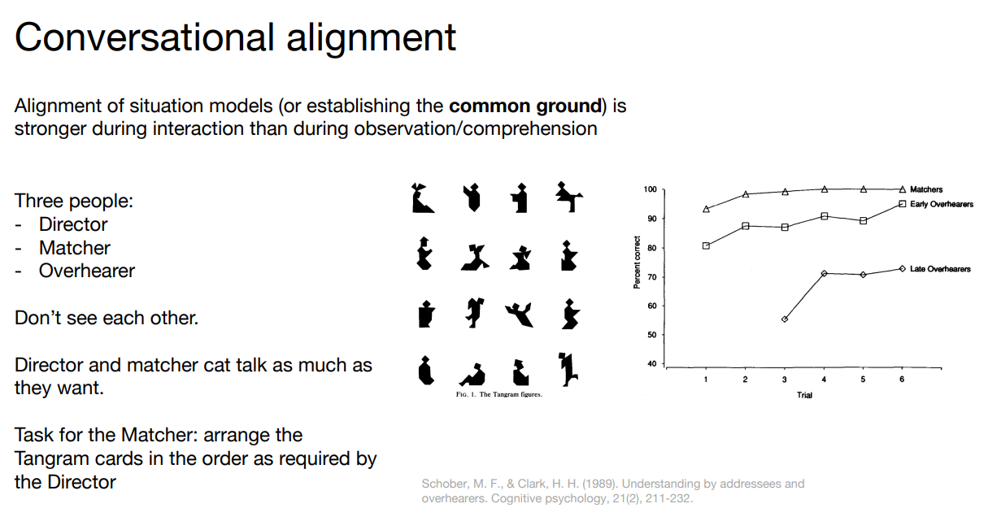
There are three roles:
- Director
- Has a set of Tangram shapes.
- Must describe them so the Matcher can arrange them in the correct order.

- Matcher
- Hears the Director’s descriptions.
- Must arrange their own Tangram cards to match the Director’s order.
- Can speak freely with the Director → full interaction.

- Overhearer
- Listens to the conversation.
- Does not participate and cannot ask questions.
- Only observes passively.
None of them can see each other or see each other’s cards.

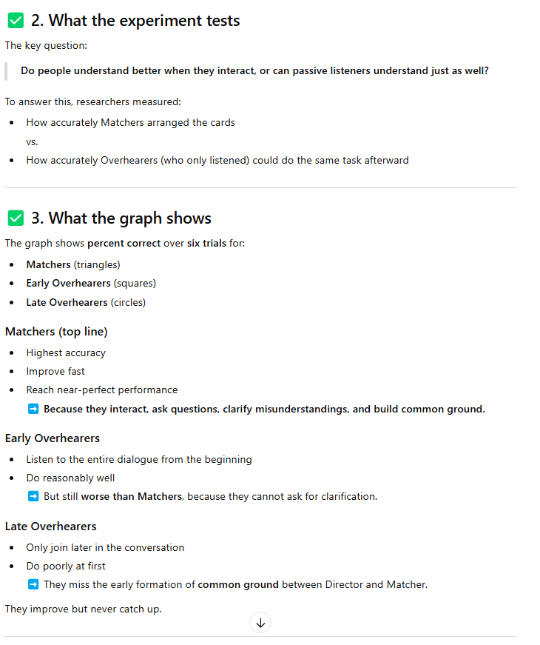
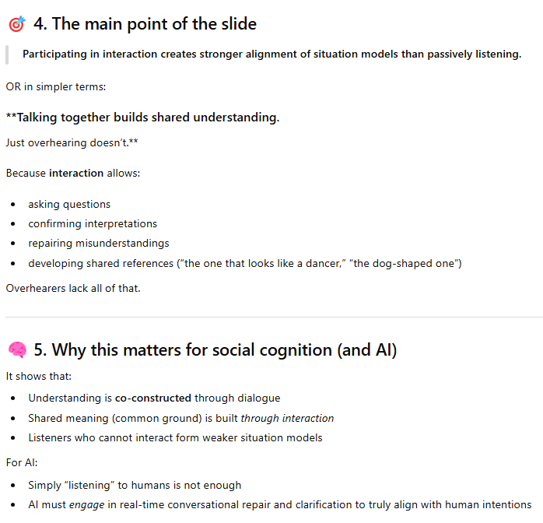
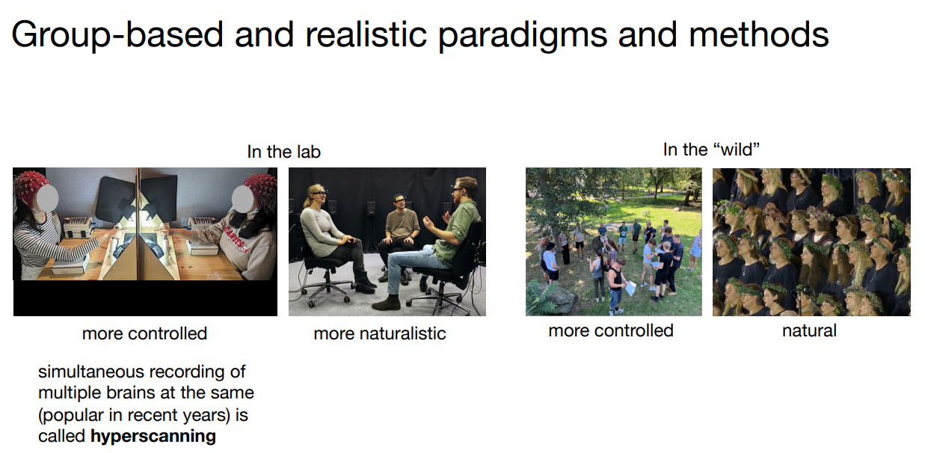
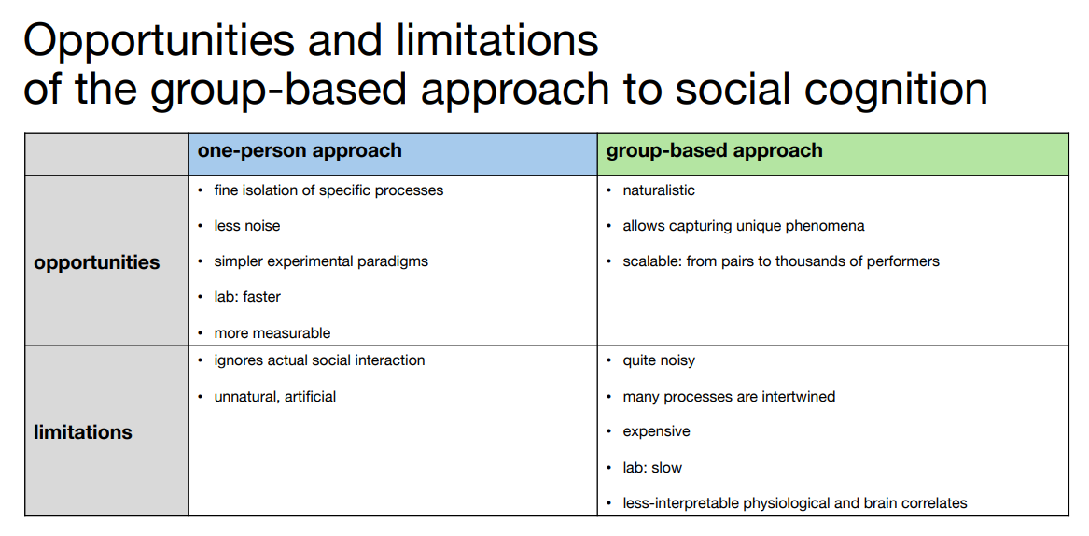

Week 11- Embodied Cognition
Traditional Views of Cognition
- Cognision as a computational process restricted to the brain
- The brain is an abstract information processor
  - The brain is viewed as manipulating symbols and representations, like a computer running code.
  - What connects the brain to the real world (body, movement, environment) is seen as theoretically unimportant.
The brain is the “seat” of cognition
  - All thinking, memory, reasoning, and decision-making are located only in the brain.
- Perception and action are just input/output
  - Seeing and moving are treated like:
    - Input = keyboard
    - Output = screen
  - They are considered peripheral, not central to thinking itself
- Experiments focus on internal representations
  - Researcheres try to:
    - Reveal what’s inside the “mental representations”
    - Discover the algorithms that turn input → processing → output

Mind-body dualism: the sharp contrast to embodied cognition
- Mind–Body Dualism (Opposite of Embodied Cognition)
  - The mind and the body are separate things
  - The mind (mental phenomena) are non-physical
  - Mental processes (thinking, feeling) do not depend on the body
- René Descartes (1600s)
  - The body is like a machine (physical, divisible)
  - The mind is: non-physical, indivisible, completly different from the body
- Under dialism: You could, in theory, understand the mind without caring about the body at all.
- Mind–body dualism claims that the mind is a non-physical entity separate from the physical body, whereas embodied cognition argues that thinking is fundamentally shaped by the body and its interactions with the world.

Challenging this traditional approach: Maurice Merleau-Ponty 1962
- Main idea
  - We don’t just “have” bodies — we are our bodies in the world.
    - The body is how we exist in the world
    - Being alive means:
      - Being physically involved in an environment
      - Having goals and projects
      - Being constantly engaged through action
  - Thinking, acting, and perceiving are all inseparably connected through the body.
- Merleau-Ponty argued that cognition is not just computation inside the brain, but arises from the body’s ongoing, goal-directed engagement with the world.

Challenging the Traditional View (Andy Clark, 1998)
- The brain’s main job is not abstract thinking — it is to control a moving, acting body in a real world
  - The brain evolved to guide action, not just to think
  - Cognision is shaped by:
    - Movement
    - Perception
    - Interaction with the enviroment
  - You can’t understand the brain properly if you study it in isolation from the body and the world
- Andy Clark argues that the brain is fundamentally a control system for an active body interacting with the real world, not a detached thinking machine.

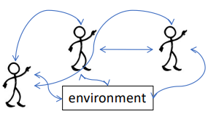

Challenging this traditional approach
- Cognitive processes unfold continuously in real-time
  - Thinking is not step-by-step in separate stages
    - Instead, perception, thinking, and action are happening all at the same time, continuously
    - Ex. When you catch a ball, you don’t: first fully see it, then think, then act.
    - You see–think–move simultaneously.
- In continuous interaction with the environment
  - Your mind is always responding to what’s around you, and the environment is also changing because of what you do.
    - Ex. When walking on ice: the slippery ground changes how you move, your movement changes your balance, your balance changes how you think about your next step.
- The cognitive system includes brain, body, environment, and interactions
  - Cognition is not just the brain.
    - Brain, body, enviroment, and all the feedback loops between them
- Embodied cognition argues that thinking emerges from the continuous real-time interaction between the brain, the body, and the environment, not from the brain alone.

Embodied cognition
- The body is not just a tool for the mind — it is a core part of how the mind works.
- The body shapes the mind
  - Your movements, posture, and interaction with the environment directly influence how you:
    - Think, learn, perceive, remember, solve problems, communicate
    - So thinking is not only in the brain — it is spread across brain, body, and world
- If you move differently, you think differently
  - Changing how you move can change how you think
  - Changing your physical situation can change your decisions
    - Ex. People judge distances differently when wearing a heavy backpack vs. when they are not — the body changes perception and thinking.
- The mind is not just a computer
  - Traditional views treat the brain like a computer running abstract code.
  - Mental processes are not only computations — they are also shaped by action, perception, and physical interaction.
- Embodied cognition is the view that thinking emerges from the continuous interaction between the brain, the body, and the environment, not from brain computation alone.

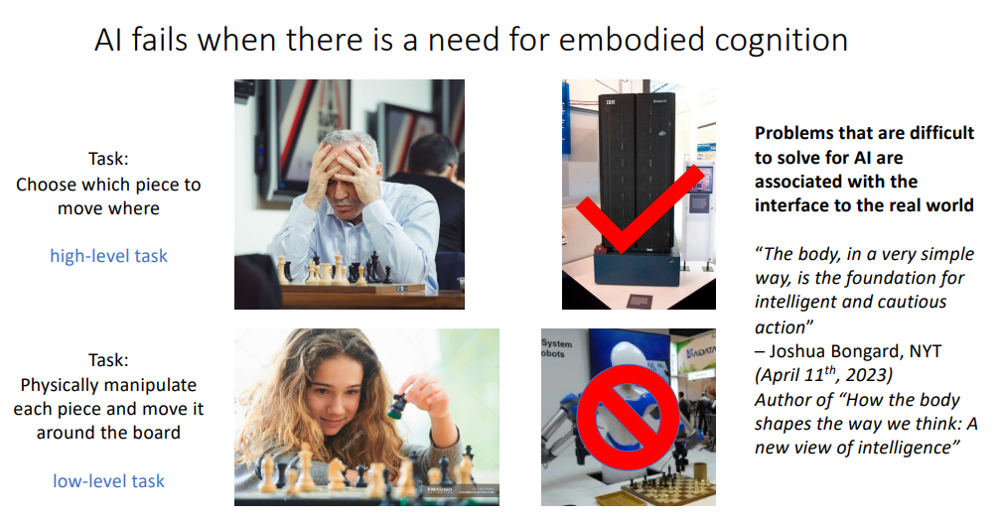

Why AI fails when embodied cognition is required
- What AI is good at (top row – high-level task)
  - Task: Choosing which chess move to make
    - AI can generate millions of board positions and calc optimal stategies
- What AI struggles with (bottom row – low-level task)
  - Task: Physically picking up a chess piece and moving it.
    - Requires: vision (recognizing the piece), motor control (grasping, lifting, placing), real-time adjustment (force, angle, balance)
  - This depends on embodied cognition → tight coupling of perception, body, and environment.
  - Robots often fail here even when they are super intelligent at the strategy level.
- This shows that
  - Real intelligence is not just thinking
  - It is thinking + sensing + moving + adapting in real space
- AI can outperform humans at abstract decision-making, but often fails at physical interaction because it lacks the embodied coupling between perception, body, and environment that human intelligence relies on.

Artificial Intelligence as Representation
- AI is based on internal representations and symbol processing, similar to how a computer manipulates data.
- Classical AI is about symbol processing
  - AI systems were designed to:
    - Store abstract symbols (like words, numbers, rules)
    - Apply formal rules to manipulate them
      - Ex. “If A and B, then C” → logic-based reasoning.
- AI is built from separate internal modules
  - Intelligence is broken into independent sub-systems, like:
    - Vision, language, memory, problemsolving
  - Each module:
    - Works with its own internal representations
    - Does not rely on the body or environment
- These systems focus on narrow skills, not full human intelligence
  - AI is trained for specific tasks, not general human intelligence:
    - Image recognition, translation, chess
  - It does not try to replicate the full embodied human mind.
- There is no meaningful connection to the real world
  - Traditional AI
    - Does not learn by acting, does not have a body, does not interact physically with the environment
  - It only processes the data fed to it
- Can human intelligence really be broken into these separate sub-parts?
  - This directly challenges the embodied cognition view, which says:
    - Intelligence comes from continuous interaction between brain, body, and world
    - —not from isolated internal representations alone.
- Even modern ML still mostly learns passively
  - Most AI today (including deep learning):
    - Learns by absorbing huge datasets
    - Not by actively exploring the real world
  - This is still non-embodied learning.
- Traditional AI treats intelligence as internal symbol-based representation and rule processing, separated into specialized modules, with little or no meaningful interaction with the physical world—an approach that embodied cognition strongly challenges.
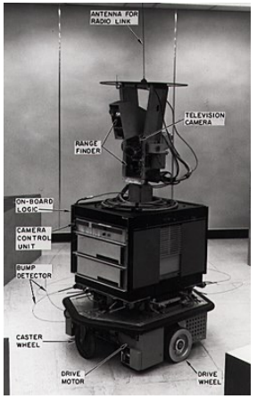

First Mobile Robotic AI (1966–1972)
- What the robot could do
  - Move around a room
  - Avoid obstacles of different shapes and colors
  - Follow a repeating loop:
    - sense → model → plan → act
  - It could reason about its actions
  - It combined:
    - Computer vision (camera)
    - Natural language processing (NLP)
- How it actually worked (important for embodied cognition):
  - Even though the robot had a body, it did not think in an embodied way:
    - Camera senses the environment
    - A computer builds a symbolic model of the world (abstract representation)
    - The program creates a plan using symbols
    - The robot executes the plan
  - So the intelligence still lived in symbols, rules, internal representations
    - Not the body it self
- Early mobile robots like Shakey could navigate and plan actions using vision and symbolic reasoning, but their intelligence was still based on internal representations rather than true embodied interaction with the environment.

Bidirectional interaction means the brain, body, and environment are constantly influencing each other in both directions at the same time.

Rodney Brooks’ Robots = AI Without Internal Representations
- This approach challenges the traditional idea that a robot must first build an internal model of the world before it can act
  - Insted of Sense → Build a model → Plan → Act
  - Sense → Act (directly)
    - The robot does NOT store a detailed map or symbolic representation of the world.
    - Perception is directly connected to action.
    - The robot’s behavior emerges from continuous interaction with the environment.
- Continuous Feedback Loop
  - The robot operates in a real-time loop:
    - The body moves
    - This changes what the sensors detect
    - The new sensory input immediately changes movement
    - And the cycle continues
  - This is a fully embodied, bidirectional interaction with the environment.
- Robot Alan
  - Allen has three simple behavior modules that all compete to control the robot:
    - Avoid
      - If an obstacle is detected → stop, turn, and move away
    - Wander
      - Sends the robot in a random direction
    - Explore
      - Steers the robot toward a chosen target
  - These behaviors:
    - Work in parallel, compete with eachother, And whichever is strongest at the moment controls the robot’s movement
    - There is no central planner, no world map, and no symbolic reasoning.
- Why This Matters for Embodied Cognition
  - Intelligent-looking behavior can emerge without thinking in symbols
  - The body + sensors + environment together create behavior
  - Cognition can be distributed across action, perception, and environment
- Rodney Brooks’ robots don’t think about the world first—they act directly based on what their sensors detect, and intelligence emerges from continuous interaction between body and environment.

BigDog (Boston Dynamics) — Intelligence Through the Body
- BigDog shows that complex, intelligent behavior does not require a large “thinking brain.” Instead, much of its intelligence comes from how its body, sensors, and environment interact in real time.
- What BigDog Can Do
  - Walk on uneven forest ground
  - Recover from slips and pushes
  - Carry heavy loads
  - Adapt instantly to unexpected terrain changes
    - This means it solves complex physical problems on the fly.
- “Very Little Brain” — What That Means
  - BigDog does not:
    - Build symbolic maps of the world
    - Plan long action sequences like a human or chess AI
    - Store detailed representations of the environment
  - Instead, it is built with:
    - Sensors → detect force, balance, slope, contact with ground
    - Actuators (motors) → immediately adjust leg movement
    - Fast feedback loops → perception directly shapes motion
      - So control is low-level, fast, and reactive, not abstract and symbolic.
- Constant Interaction With the Environment
  - BigDog is:
    - Always responding to terrain
    - Always adjusting balance
    - Always correcting its movement
      - This is a perfect example of bidirectional interaction:
        - The robot changes the environment → the environment changes the robot’s movement → the robot adapts again.
- Why this matters for embodied cognition
  - BigDog supports the idea that:
    - Intelligence can emerge from physical interaction, not just computation
    - The body itself is part of the cognitive system
    - You don’t always need internal “thinking models” to act intelligently
- BigDog shows that intelligent, adaptive behavior can emerge from real-time body–environment interaction, not from symbolic thinking or internal world representations.

Claims of Embodied Cognition:
- Cognition Is Situated
  - This claim says that thinking does not happen in isolation inside the brain—it happens in real-world situations, through continuous interaction with the environment.
    - What “situated” means
      - Cognition happens in real environments, not in a vacuum
      - It always involves perception and action
        - You see, hear, touch → this shapes your thinking
        - You move and act → this changes the environment
    - Continuous interaction loop
      - Perception feeds cognition: sensory information constantly updates your thinking
      - Action feeds back into the world: what you do physically changes the situation
      - Thinking is therefore dynamic and ongoing, not just internal
    - Examples of situated cognition
      - Driving – your thinking depends on traffic, road conditions, other drivers
      - Holding a conversation – your words depend on what the other person just said
      - Spatial navigation – your thinking depends on landmarks and movement
    - Limitations
      - Some mental activities seem not directly connected to the environment, such as:
        - Planning, Remembering the past, Daydreaming, Imagining future events
      - These are called “offline” cognition, because they happen without immediate perception–action coupling. This challenges the idea that all cognition is always situated.
  - Situated cognition means that thinking is shaped by real-time interaction between the brain, body, and environment—but this view struggles to fully explain offline thinking like imagination and planning.
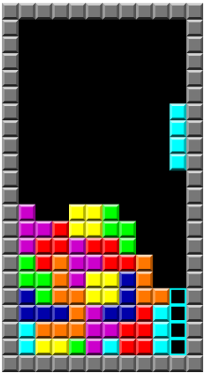

- Cognition is time-pressured
  - Real agents must act in real time
    - Humans and animals can’t pause the world to think
    - When you’re walking, driving, talking, or catching a ball, you must:
      - Perceive, Decide, Act -> Immediatly
      - Unlike traditional AI, which can think “offline” at its own speed
  - Traditional AI vs embodied agents
    - Traditional AI:
      - Builds slow, detailed internal models
      - Computes at its own pace
    - Embodied agents (humans, robots)
      - Must act before full information is available
      - Use fast prediction + adaptation instead of slow reasoning
  - Example: Tapping or playing music
    - When people tap/music together:
      - They do not build full mental models of each other
      - Instead, they: Predict next beat, Adjust immediatly -> this is embodied real-time cognition
  - Why forward models exist in the brain
    - Your brain uses forward models in motor control because:
      - Sensory feedback is slow
      - You can’t wait for feedback to move
    - So the brain:
      - Predicts what will happen next
      - Acts before feedback arrives
    - This shows cognition is shaped by time constraints.
  - The claim that cognition is time-pressured means that real cognitive agents must perceive, decide, and act under strict real-time constraints, relying on fast prediction and adaptation rather than slow, detailed internal modeling.

- Offloading cognition onto the environment
  - Instead of doing all the thinking in our head, we use the physical world to help us think and solve problems.
  - Simple explaination
    - Instead of: Mentally calculating everything
    - We: Act on the world to simplify the problem, and let perception guide the next step
    - So thinking becomes a loop between mind, body, and environment, not just “in the brain”.
  - Example Tetris:
    - In tetris we
      - Players rotate and move pieces physically instead of mentally simulating all possibilities
      - The screen becomes external memory.
      - The game state does the cognitive work for you.
    - You’re not solving the puzzle purely in your head — you’re thinking with your actions.
  - Other clear examples of cognitive offloading
    - Writing a to-do list → offloads memory to paper or a phone
    - Using GPS instead of remembering routes → offloads navigation to technology
  - Cognitive offloading shows that thinking is not confined to the brain but is distributed across the brain, body, and environment, with the world serving as an external memory and problem-solving resource.

- The environment is part of the cognitive system
  - This is the strongest and most radical claim of embodied cognition:
  - Cognition is not just in the head
    - Thinking does not happen only inside the brain.
    - Instead, it is distributed across:
      - Mind, Body, Environment
    - In other words, your environment participates in your thinking process.
  - To study cognition, we must study the whole organism-in-context
    - The mind alone cannot explain human thought.
    - Cognition emerges from the interaction between:
      - Agent, task, environment
        - Therefore, it makes no sense to study the “mind” as an isolated thing.
    - Example: Understanding how someone solves a puzzle requires studying
      - Needs: Person, puzzle itself, actions used to manipulate pieces, feedback from the world
      - The unit of analysis becomes the whole system.
  - This is radical: Where does the mind end?
    - If the environment is part of the cognitive system, then:
      - The “cognitive system” changes every time you move to a new place or interact with new objects.
      - Your mind literally extends into tools, notebooks, phones, other people, spatial layouts, etc.
    - Difficult questions with this theory?
      - How do we define the boundaries of the cognitive system?
        - If a notebook, calculator, smartphone, or map improves thinking:
          - Is it part of your cognitive system?
          - If you put the notebook away, does your mind shrink?
      - How do we find general principles of cognition?
        - If cognition depends on:
          - Task, Environment, body
        - Then the cognative mechanisms may be
          - Situationall, context dependent, dynamic rather then static
  - Simple analogy
    - Think of a blind person using a cane:
      - The cane becomes part of the perceptual system.
      - They don’t feel the cane; they feel the world through the cane.
    - This illustrates how the environment becomes part of the cognitive loop
  - Cognition is not confined to the brain — it extends into the body and the environment, forming a single integrated system that must be studied as a whole.
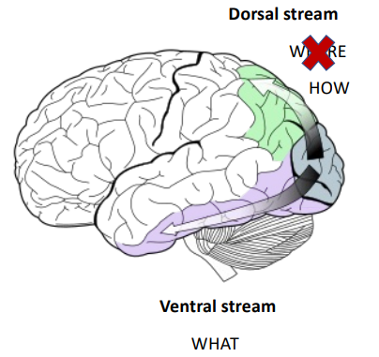

- Cognition is for Action
  - The main purpose of the brain is not just to think, but to guide action.
  - The brain evolved to control movement
    - The brain’s primary job is to produce flexible, adaptive movement.
    - Other abilities like: vision, memory, attention, planning
      - Exist to mainly support perception and action
        - So instead of “We think, then act”
        - Embeded cognition suggests that “We think in order to act.”
  - Example: Vision is for action, not just for seeing
    - Traditional view of vision:
      - Vision builds a detailed internal picture of the world.
      - This picture is sent to “higher” brain areas.
      - Then the brain decides what to do.
    - Embodied view:
      - Vision is directly linked to action, not just to recognition.
  - Two visual pathways in the brain
    - Ventral stream = “WHAT” pathway
      - Identifies and recognizes objects.
      - Example:
        - “This is a cup.”
        - “That is a face.”
    - Dorsal stream = “HOW” pathway (formerly called “where”)
      - Controls how we act on objects
      - Used for: Reaching, grasping, catching, visually guided movement
      - It does not care much about object identity — it cares about:
        - Relevance for the task
        - Size, shape, position for action
    - So your brain processes:
      - What something is (ventral)
      - How to act on it (dorsal)
  - Key embodied takeaway
    - Perception is not mainly for building mental pictures.
    - It is for guiding real-time action in the world.
    - The brain prioritizes task-relevant visual information, not neutral descriptions.
  - Cognition exists primarily to guide adaptive action, and perception—especially vision—is tightly linked to real-time motor control rather than just internal representation.

- Offline cognition is body-based
  - Even when we are not physically moving or interacting with the world, our thinking still relies on the body’s systems—especially perception and action systems.
  - So cognition is still embodied, even when it happens “in the head.”
  - We use the body internally to think
    - We often simulate actions instead of actually doing them
      - Example: Counting on your fingers without moving them
        - You don’t physically move your fingers
        - But your brain runs the finger-movement program as mental imagery
    - So the motor system is still active, just covertly (silently).
  - “Offline” does NOT mean “disembodied”
    - Even when cognition is: Abstract, detached from the environment, happening in imagination
      - It still uses sesorimoter systems
    - Example:
      - Mental imagery → visual and motor areas activate
      - Working memory → uses perceptual formats
      - Reasoning & problem solving → often based on simulated actions or spatial manipulation
    - So instead of:
      - “Thinking is purely symbolic and abstract”
      - Embodied cognition says:
        - “Thinking reuses perception and action systems internally.”
  - Internal offloading instead of environmental offloading
    - Earlier claims said we offload cognition onto the environment (e.g., Tetris, writing notes).
This claim adds that we also offload onto the body and brain’s motor systems.
    - So there are two kinds of offloading:
      - External → onto the world
      - Internal → onto perception & motor control systems
  - Final idea (important philosophical shift)
    - Traditional view:
      - The mind exists to control the body
    - Embodied view:
      - The body (and its control systems) also serves the mind
      - Meaning: the body is not just a tool for action—it is a tool for thinking.
  - Even when cognition is “offline” (imagery, memory, reasoning), it remains embodied because it relies on covert simulations in perceptual and motor systems rather than abstract symbols alone.

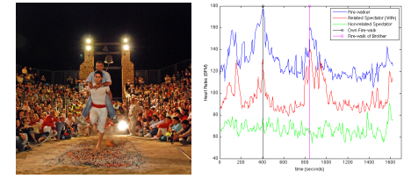

Examples of embodied cognition from social cognition lectures?
- Joint action & action coordination
  - “Action coordination is cognition.”
  - What this means:
    - When two people move together (clapping, dancing, carrying a table), their thinking is happening through movement, not just in the head.
    - You don’t first fully think → then move.
      - You think by adjusting your body in real time to the other person’s body.
  - Why this is embodied:
    - Your perception + motor system + partner’s movements are all part of the cognitive process.
    - Cognition is happening in the interaction, not just in the brain.
  - Example: Walking side-by-side and naturally syncing your pace without discussing it.
- Emotional contagion via facial mimicry
  - We “catch” emotions by copying facial expressions.
  - What happens
    - You see someone smile → your face automatically mimics the smile → your brain receives feedback from your facial muscles → you start to feel happier.
  - Why this is embodied:
    - The emotion is not just recognized mentally.
    - It is created through bodily movement (facial muscles).
    - The body helps generate the emotion, not just express it.
  - Example: Being around stressed people makes your body tense up and you start feeling stressed too.
- Mirroring systems / mirror neurons
  - Understanding others begins at the level of motor simulation.
  - What this means
    - When you see someone: fx kick a ball
    - Your own motor system activates as if you were doing the action yourself.
  - Why this is embodied
    - Social understanding is built from motor control and perception, not abstract reasoning alone.
    - You understand others through your own body’s action system.
  - Example: You flinch when someone else almost falls.
- These social cognition examples show that thinking about others is grounded in perception, movement, and bodily simulation, not just abstract mental representations.

Psychophysiology as embodiment
- Psychophysiology as embodiment means that mental processes (like thinking, emotion, attention, stress) are directly linked to measurable signals from the body—not just the brain.
- Psychophysiology studies how things like:
  - Heart rate, sweating, muscle tension, breathing
    - Relate to thoughts, emotions, and mental disorders.
- The key embodied cognition idea here is:
  - Cognition has a physiological basis in the whole body, not only in the brain.
- So instead of seeing the body as just a “container” for the mind, psychophysiology shows that:
  - Your body state actively reflects and shapes your mental state.
  - Example
    - Increased heart rate + sweating → anxiety or fear
    - Slowed breathing → calm focus
- Psychophysiology supports embodied cognition by showing that the body is part of how the mind works, not just something the mind controls.
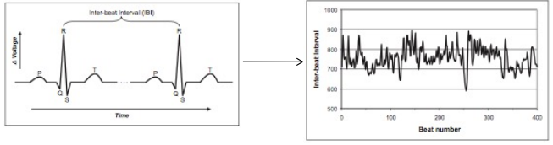
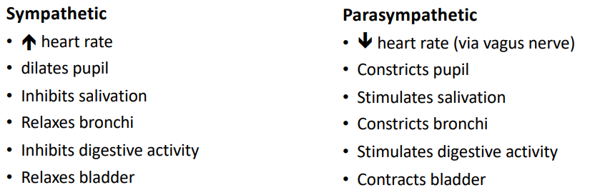

Psychophysiology as Embodiment
- Mental states show up in the body
  - “Mental stress can present itself as bodily pain, chest pain, digestive problems, etc.”
  - This means
    - Psychological states are not just in the mind.
    - They have direct physical expressions in the body (e.g., anxiety → stomach aches, stress → tight chest)
  - This supports embodied cognition by showing that body and mind are inseparable.
- Social relationships are embodied
  - It says that our bodies synchronize with the bodies of people we are socially connected to.
  - Example: Heart-rate synchrony HR
    - When two people interact, their heart rhythms become similar.
    - This synchronization is linked to: Bonding, affiliation, shared emotional states, group cohesion
      - Found in multiple relationships: Parents and infants, Romantic partners
  - Social understanding and group belonging are not just mental concepts—they’re physically expressed and coordinated in the body.
- Why this matters for embodied cognition
  - It supports the claim that:
    - Cognition is distributed across bodies, not just inside individual brains.
    - Our bodies participate in social cognition, shaping:
      - Empathy, group coordination, emotional bonding, communication
    - Social cognition is partly physiological—your body “thinks along with” other bodies.
- Summary
  - Stress and emotions appear physically in the body.
  - Social relationships create physiological synchronization (like heart-rate alignment).
  - This shows that thinking, feeling, and social connection are embodied, not only mental.

Physiological “Correlates” of Psychological States
- A physiological correlate means:
  - A measurable body signal that reliably changes when a certain mental or emotional state changes.
  - These signals don’t prove exactly what someone is thinking—but they give strong indirect evidence about attention, emotion, and arousal.
- Electrodermal Response (EDA / GSR)
  - (Skin conductance)
  - What it measures:
    - How much your skin sweats microscopically
  - What it reflects
    - Arosal, excitement, motivational activation, stress
  - Key idea
    - When you’re emotionally activated (nervous, excited, alert), your skin becomes more conductive → EDA increases.
  - Example: Public speaking or horror movie → EDA goes up
- Electrocardiography (ECG)
  - Heart Rate (HR)
    - (Heart activity)
    - Reflects: Attention, cognative effort, task engagement
    - Example: Solving a hard problem → heart rate often increases slightly
  - Heart Rate Variability (HRV)
    - (How much the time between heartbeats changes)
    - Reflects: Emotional arousal + regulation, attentional control
    - Important distinction:
      - High HRV → good emotional regulation, calm flexibility
      - Low HRV → stress, cognitive overload, poor regulation
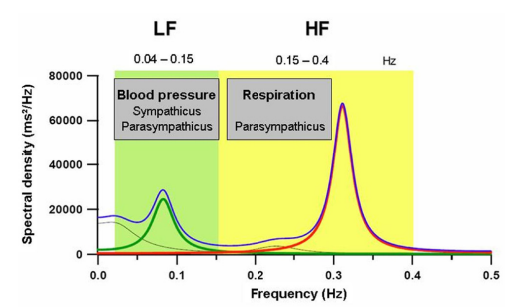
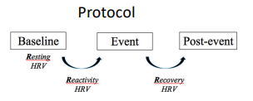

- Facial Electromyography (EMG)
  - (Tiny muscle activity in the face)
  - What it measures:
    - Micro-movements in facial muscles that people can’t control consciously
  - What it reflects:
    - Emotional valence (whether emotion is positive or negative)
  - Examples: Smile muscles activate → positive emotion
- Why this matters for embodied cognition
  - Mental states are not invisible or abstract
  - They have direct bodily signatures
  - Cognition and emotion are physiological processes, not just brain computations
    - This strongly supports the embodied cognition view that: Thinking, feeling, and attention are grounded in the body.
- Psychophysiology shows that psychological states like attention, arousal, and emotion have reliable bodily correlates such as skin conductance, heart activity, and facial muscle activation.

Heart rate variability (HRV)
- HRV is the tiny natural variation in time between your heartbeats.
- Even if your heart rate is, say, 70 beats per minute, the time between each beat is not perfectly equal—and that variability is healthy.
  - “A healthy heart is not a metronome.”
  - A metronome is perfectly regular; a healthy heart is slightly irregular in a flexible way.
- What does HRV measure exactly?
  - It measures the change in heart period between consecutive beats, using:
    - Instantaneous heart rate, or
    - R–R intervals (the time between two R-peaks on an ECG heartbeat)
  - So instead of just counting beats per minute, HRV looks at: How much the timing between beats goes up and down.
- Why does breathing affect HRV? (RSA)
  - Your heart rate naturally syncs with your breathing. This is called:
    - Respiratory Sinus Arrhythmia (RSA)
      - When you inhale → heart rate increases
      - When you exhale → heart rate decreases
    - This helps your body optimize oxygen uptake, making breathing and circulation more efficient.
  - So HRV is strongly shaped by: Breathing rhythm, Autonomic nervous system activity (stress vs relaxation)
- How to interpret HRV psychologically
  - In psychology and embodied cognition:
    - Higher HRV → Better emotion regulation, flexibility, calm focus
    - Lower HRV → Stress, anxiety, high cognitive load, poor regulation
  - So HRV is used as a biological marker of mental and emotional state.
- What the graphs show
  - Left image: Shows how the R–R interval is measured between heartbeats on an ECG.
  - Right image: Shows how those intervals change over time—this up-and-down pattern is HRV.
    - The more dynamic and flexible that line is (within a healthy range), the better the nervous system is regulating the body.

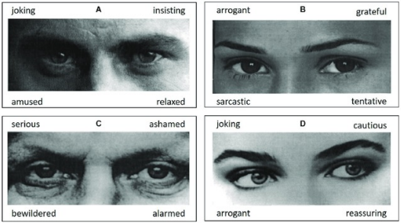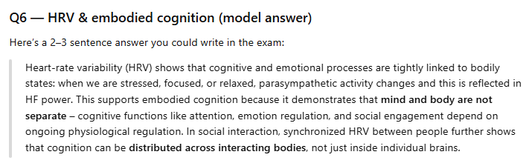

HRV: Sympathetic vs. Parasympathetic
- Your body has two automatic control systems that constantly balance each other:
- Sympathetic = “Go / Stress / Action”
  - Fight-or-flight system
  - It: Speeds up your heart, Widens your pupils (to see better), Stops saliva & digestion, Opens airways (more oxygen), Relaxes the bladder
  - This system dominates when: Stressed, Anxious, Exercising, Under time presure
  - It lowers HRV (your heartbeat becomes more rigid and fast)
- Parasympathetic = “Rest / Calm / Recovery”
  - This is your rest-and-digest system, mainly through the vagus nerve.
  - It: Shows down heart rate, shrinks pupils, increases saliva, activates digestion, contracts bladder
  - This system dominates when you are: Calm, Relaxed, safe, socially comfortable
  - It increases HRV (your heartbeat becomes more flexible and variable).
- How this explains HRV
  - High HRV → Parasympathetic is strong → Good regulation
  - Low HRV → Sympathetic is dominating → Stress mode
- Why the slide says “push–pull”
  - Your heart gets both signals at the same time:
    - Sympathetic = push (speed up)
    - Parasympathetic = pull (slow down)
  - HRV measures how dynamically the heart responds to this push–pull system.
- HRV reflects the balance between the sympathetic (stress) and parasympathetic (calm) nervous systems, with higher HRV indicating better physiological and emotional regulation.

Heart rate variability (HRV)
- What “frequency-domain HRV” means
  - Instead of only asking “How much does the heartbeat vary?”
  - We also ask: “At what speeds (frequencies) is the heartbeat varying?”
  - To do this, researchers take the heartbeat signal and run a power spectral density (PSD) analysis. This splits HRV into slow waves and fast waves.
- The two important frequency bands
  - LF = Low Frequency (0.04–0.15 Hz)
    - Reflects both: Sympathetic (stress) + Parasympathetic (calm)
    - Strongly linked to: Blood pressure regulation
    - This means: “Mixed stress + regulation signal”
  - HF = High Frequency (0.15–0.40 Hz)
    - Reflects parasympathetic only
    - Strongly linked to: Breathing (respiration)
      - When you inhale → HR speeds up
      - When you exhale → HR slows down
      - This creates the HF peak in the graph
    - HF = calm, vagal control, recovery
- What the graph is showing
  - On the graph:
    - X-axis = Frequency (Hz) → how fast the heart rhythm fluctuates
    - Y-axis = Power → how strong that rhythm is
  - You see:
    - A small peak in LF → blood pressure control
    - A big peak in HF → breathing-driven parasympathetic activity
- What is LF/HF ratio?
  - High LF/HF → more sympathetic dominance (stress)
  - Low LF/HF → more parasympathetic dominance (calm)
- What the protocol at the bottom means
  - The experiment usually goes like this:
    - Baseline → resting HRV
    - Event → stress task (math, social stress, pain, etc.)
    - Post-event → recovery phase
    - They mesure:
      - Reactivity → how HRV changes during stress
      - Recovery → how fast HRV returns to normal
- Frequency-domain HRV separates heart rate variability into low-frequency (mixed sympathetic–parasympathetic) and high-frequency (parasympathetic, respiration-linked) components to study stress, regulation, and recovery.

HRV and cognition
- HRV & Emotional Arousal (stress/anxiety)
  - HF-HRV goes down when you’re stressed, under time pressure, or emotionally strained
  - HRV lower in individuals who worry more, and in anxiety disorders, PTSD, etc.
  - Meaning: Low HRV = body stuck more in “stress mode.”
- HRV & Emotion Regulation (handling your emotions)
  - People with higher HRV at rest can provide more appropriate emotional responses, and better regulate negative emotions
- HRV & Attention (focus and learning)
  - HF-HRV is linked to attentional control:
    - HF-HRV associated with attentional control: high anxiety individuals (with low HFHRV) have poorer attentional control
    - High HF-HRV → better learning performance
  - Higher HRV supports better concentration and cognitive performance.

HRV and emotion recognition
- What Polyvagal Theory means here
  - Polyvagal theory says that the autonomic nervous system (ANS) evolved not just for survival (fight/flight), but also for social engagement.
  - Because HRV reflects how flexible your ANS is, it can act as a biological marker of how well you respond to social and emotional cues
    - Higher HRV = better social-emotional sensitivity
- What the face images show
  - The pictures are from the “Reading the Mind in the Eyes” test
  - You only see the eyes and must choose what emotion or mental state the person is showing (e.g., amused, cautious, ashamed, sarcastic)
  - This test measures emotion recognition and social perception, not basic vision
- Key result of the study
  - Resting HF-HRV is positively correlated with test performance
    - People with higher HF-HRV are better at recognizing others’ emotions
    - People with lower HF-HRV are worse at decoding subtle social cues
- People with higher resting HRV are better at reading emotions from others’ faces, supporting the idea that bodily physiology is deeply linked to social cognition.

