Project 3: Packet Tracer to Simulate IP and Network Applications
Due on 11-23-2025 Midnight

Total points: 100pts

1. install Cisco Packet Tracer, according to the instruction file (Packet_tracer_install_instruction.pdf).

2. Download the appropriate Packet Tracer file
In this exercise you will use a preconfigured Packet Tracer file (project3.pkt) with the following network topology.

When you first open the Packet Tracer file, you may notice that some of the link lights are amber and then eventually turn to green. Like a real network, the Ethernet switches are running the Spanning Tree Protocol (STP) to prevent any loops in the Ethernet LAN. We will talk about this… later.

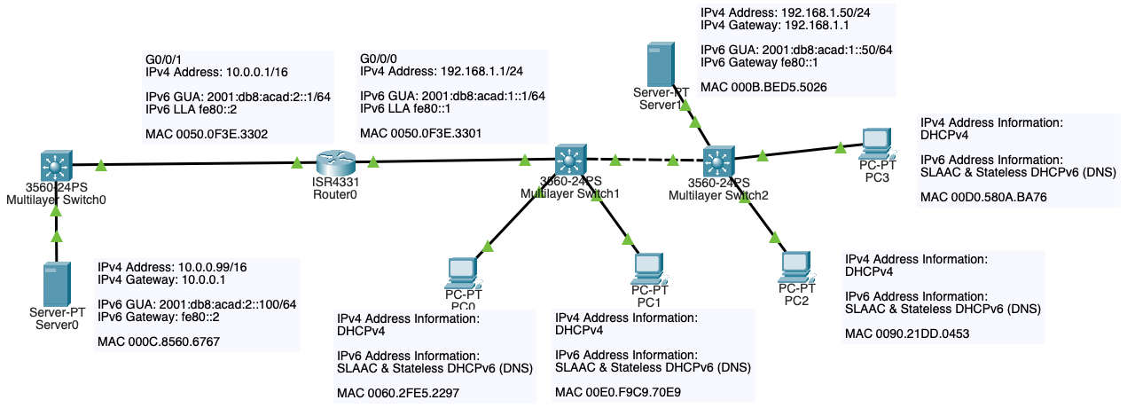

3. Examining the connections
Examine the network topology and find the following devices:
- 4 Client Computers: PC0, PC1, PC2, PC3
- 2 Server Computers: Server0, Server1
- 3 Ethernet switches: Multilayer Switch0, Multilayer Switch1, Multilayer Switch2
- 1 Router: Router0

Examine their connections. For example, PC0 is connected to Multilayer Switch1's FastEthernet 0/1 (Fa0/1) port.

Interface/Port names:
- Fa = FastEthernet = 100 Mbps (100 million bits per second)
- Gig = GigabitEthernet = 1 Gbps (1 billion bits per second)
  - G = Gi = Gig = GigabitEthernet
- 0/0, 0/1, 0/2, … 0/0/0, 0/0/1 = These are interface numbers. Each switch or router will have a unique number associated with location of that port interface on the device.

If you wand-over a device, such as Multilayer Switch1, you can view various ports or interfaces.

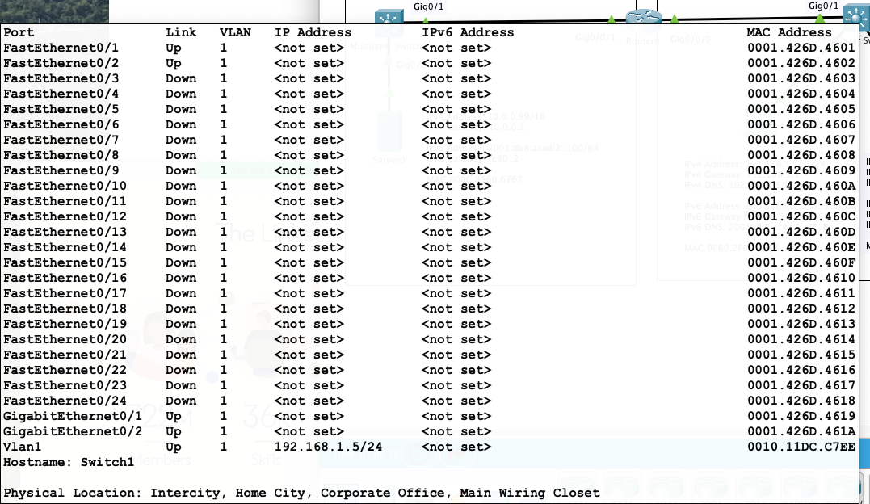

Important Note: You will notice in the information above that each switch port has an Ethernet MAC address. The MAC addresses on the switch ports are NOT involved in the forwarding of Ethernet frames between devices on the LAN. When PC0 sends an Ethernet frame to PC1, only the Ethernet MAC addresses of PC0 and PC1 are part of the Ethernet frame (we will introduce MAC addresses in the link layer, you can finish the project 4 without knowing details of MAC addresses).

You can see the physical view of any device by selecting that device and then clicking on the "Physical" tab. Click on "Zoom In" to get a closer look.

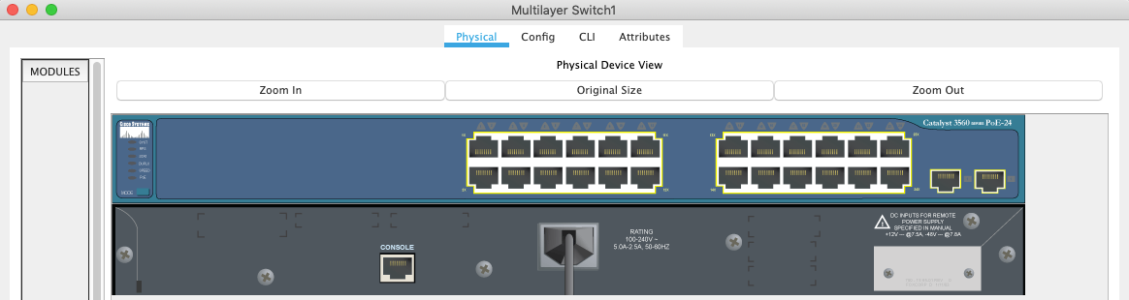

Although you can't see the actual connections in "logical mode", you can imagine PC0's Ethernet NIC connected to Multilayer Switch1's FastEthernet 0/1 (Fa0/1) port.

4. Configure the DHCPv4 Server
Device: Server1

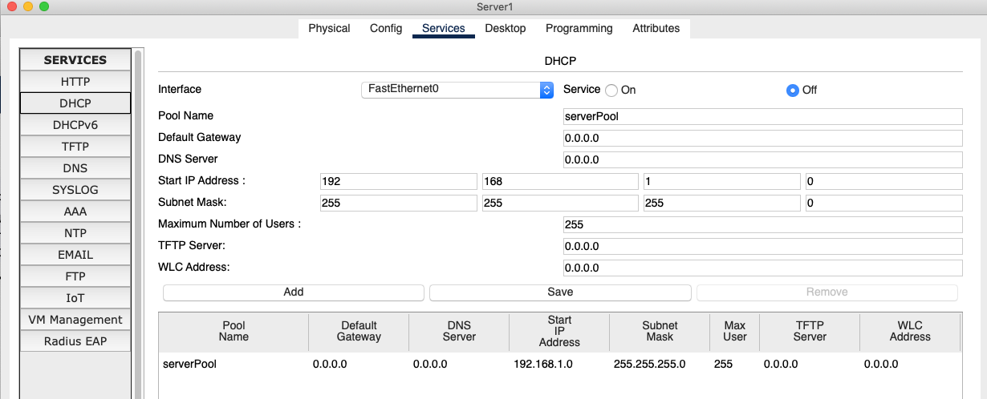

- Select: Services
- Select: DHCP
- Modify:
  - Default Gateway: 192.168.1.1
  - DNS Server: 192.168.1.50
  - Start IP Address: 192. 168.1.100
  - Maximum Number of Users: 100
- Select: Save
- Select: Service On

5. Client DHCP Configuration
Each device should be configured as:

- IP Configuration: DHCP

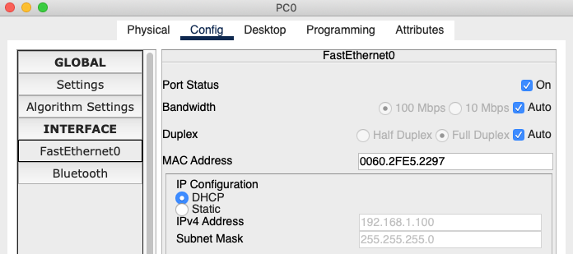

- Gateway/DNS IPv4: DHCP

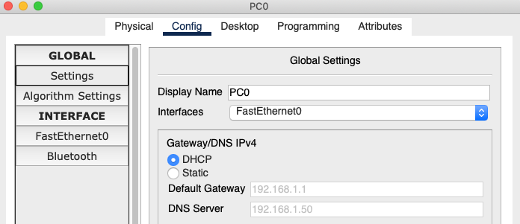

6. Verify IP Information on Clients

Each device should receive the following IPv4 address information from the DHCPv4 Server (Server1):
- A unique IPv4 address starting at 192.168.1.100
- Default Gateway address of 192.168.1.1
- DNS Server address of 192.168.1.50
This information can be verified on each device using the command: ipconfig /all. Your actual IPv4 address may differ but should be in the proper range.

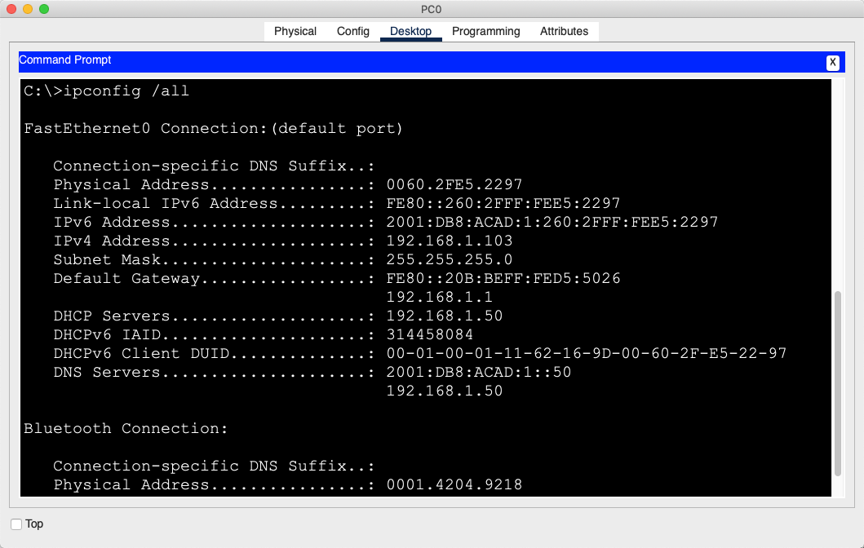

NOTE: Address range 169.254.x.x
- If the address is 169.254.x.x, the DHCP server did not respond in time and the PC gave itself this (unusable) address.
- PC > Desktop > Command Prompt > ipconfig /renew

IPv6 address information is also displayed. The IPv6 configurations on the router and DHCPv6 server were done for you. The following information discusses how this information was obtained by the client hosts.
- Link-Local IPv6 Address: This address begins with fe80:: and is automatically created by the host, PC0.
- IPv6 Address: This is the IPv6 Global Unicast Address. The prefix (network portion) 2001:db8:acad:1 was obtained automatically from the router's ICMPv6 Router Advertisement message. PC0 used its own Ethernet MAC address and the EUI-64 process to create its own Interface ID (host portion) :260:2fff:fee5:2297.
- Default Gateway: This address was obtained automatically from the router's ICMPv6 Router Advertisement message. It is the router's IPv6 link-local address.
- Default Gateway: This address was obtained from the stateless DHCPv6 server, Server1.This information can be verified on each device.
- IP Configuration: DHCP

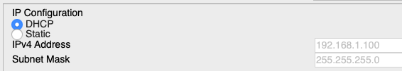

- Gateway/DNS IPv4: DHCP

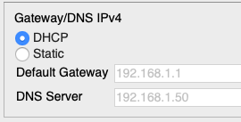

7. Configure the HTTP Server

Device: Server0

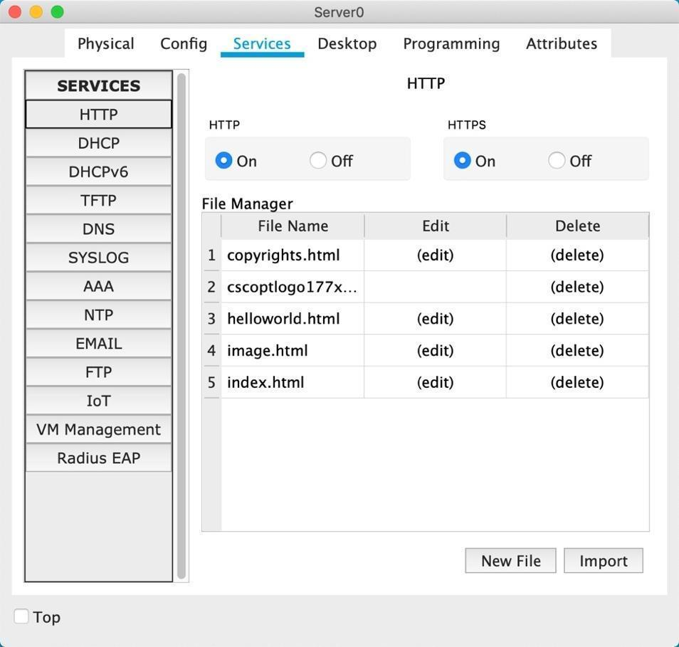

- Select Server0 (IPv4 10.0.0.99)
- Select Services
- Make sure HTTP and HTTPS are enabled.
- Select (edit) after index.html.

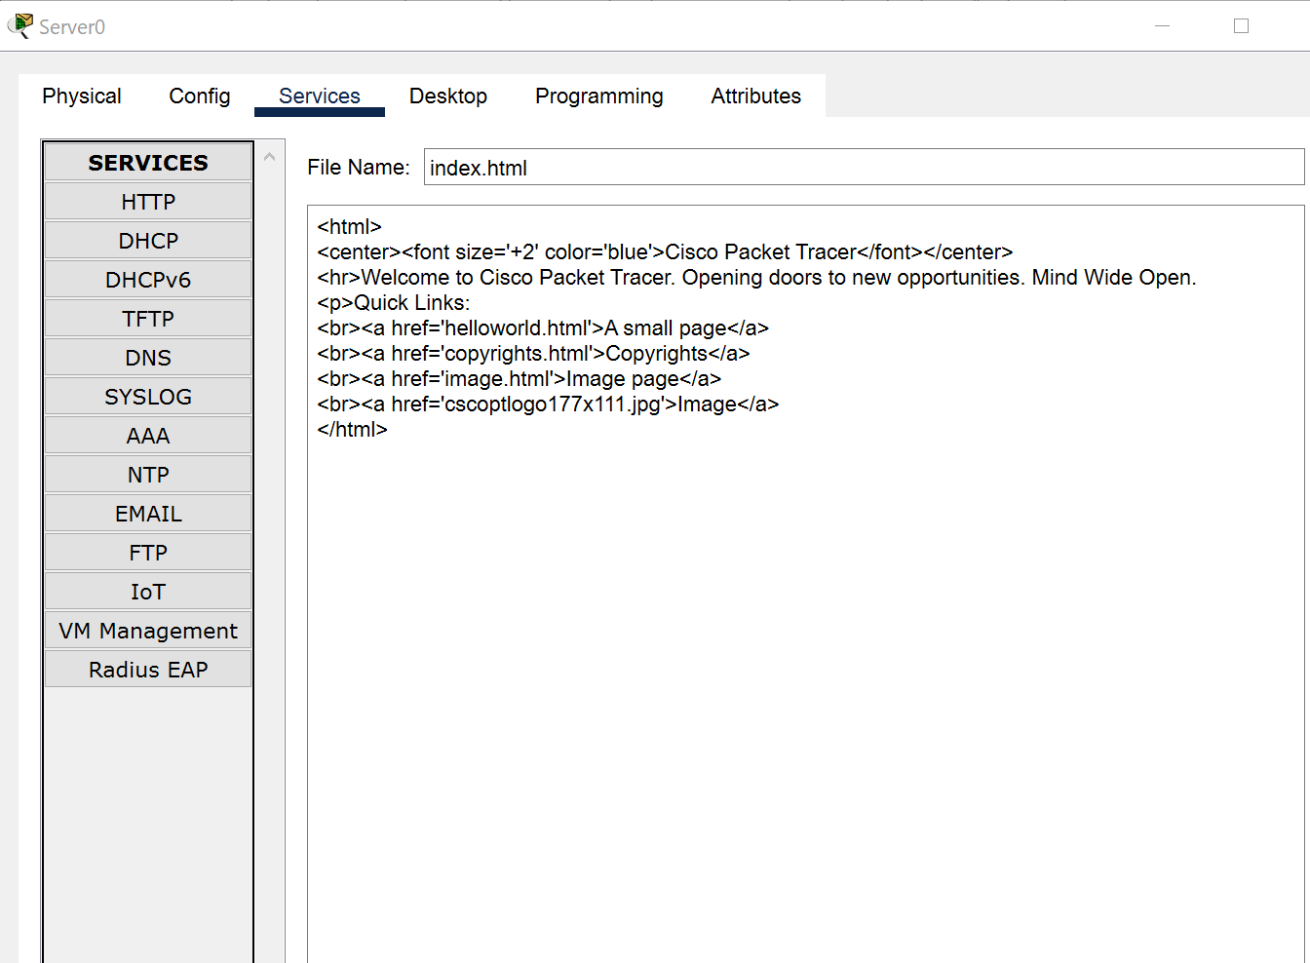

- Modify "<hr>Welcome to Cisco Packet Tracer. Opening doors to new opportunities. Mind Wide Open." To your own web page title (e.g., Welcome to CSE3300/5299!). Be sure not to remove the <hr>
- Select Save
- You will receive a message "There is already a file with the same name, overwrite?"
- Select Yes

8. Configure the DNS Server

Device: Server1
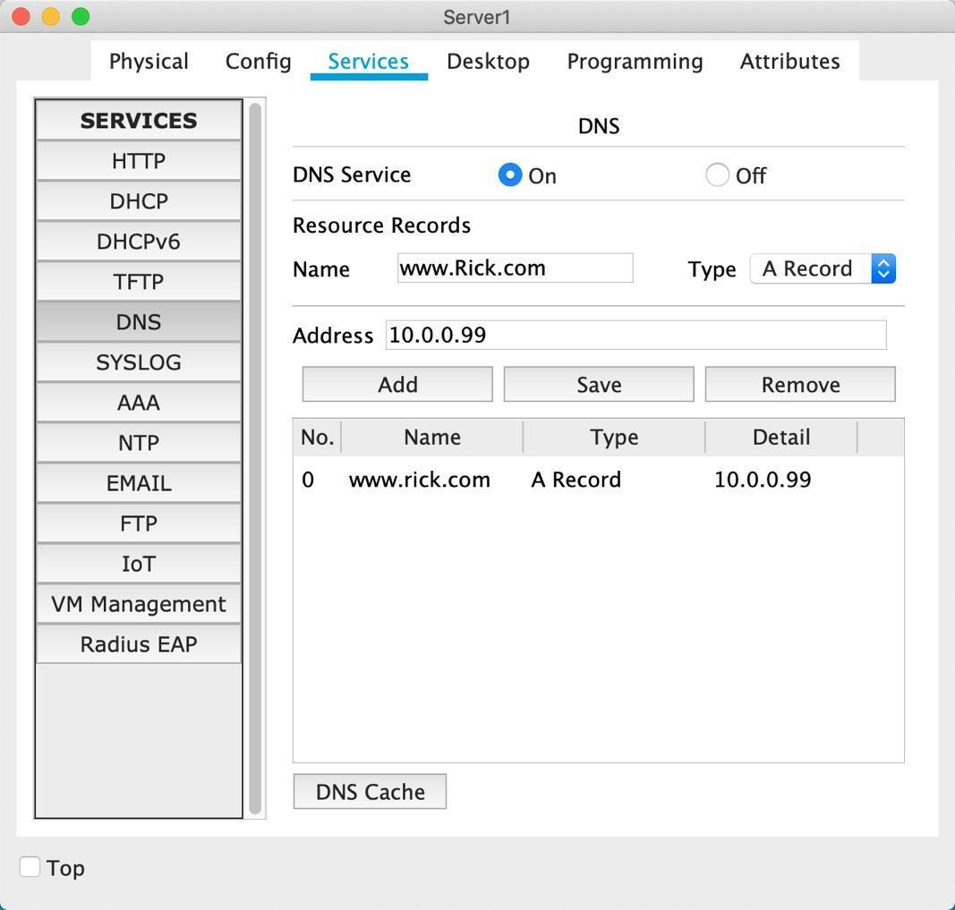

- Select Services
- Enable DNS Service: On
- Name: Create your own domain name - URL (e.g., www.Rick.com)
- Address: 10.0.0.99 (This is the address of your HTTP web server)
- Select: Add

9. Verify DHCP, DNS and HTTP
NOTE: In this section you will use several commands to verify your configuration. Copy and paste the output of the commands to answer questions.
From PC3
- Desktop > Command Prompt

Please follow the above steps and then answer the following 11 questions.
Submission: Submit your answers to 11 questions in a pdf file.
Question 1: For FastEthernet0, verify the IPv4 address, subnet mask and default gateway using ipconfig. (10 pts)

Question 2: For FastEthernet0, verify the address of the IPv4 DNS server using ipconfig /all (10 pts)

Question 3: Verify connectivity to the DNS server by pinging the IPv4 address of the DNS server. (10 pts)

Note: The first ping may timeout due to the PC having to do an ARP request and wait for an ARP reply for the default gateway (The Address Resolution Protocol (ARP) is a networking protocol used on LANs to translate IP addresses to MAC addresses).

Question 4: Verify connectivity to the default gateway by pinging the IPv4 address of the default gateway (10 pts)

Note: The first ping may timeout due to the PC having to do an ARP request and wait for an ARP reply for the default gateway.

Question 5: Verify connectivity to the web server by pinging the IPv4 address of the web server (5pts)

Note: The first ping may timeout due to the PC having to do an ARP request and wait for an ARP reply for the default gateway.

Question 6: Verify that the DNS server resolves the domain name (URL) that you configured on the DNS server by pinging the URL. (5pts)

Question 7: Verify that you can now access the HTTP service on the web server and the name is resolved by the DNS server. Upload an image of using the Desktop > Web Browser to access the web page you created. (10 pts)

For example:
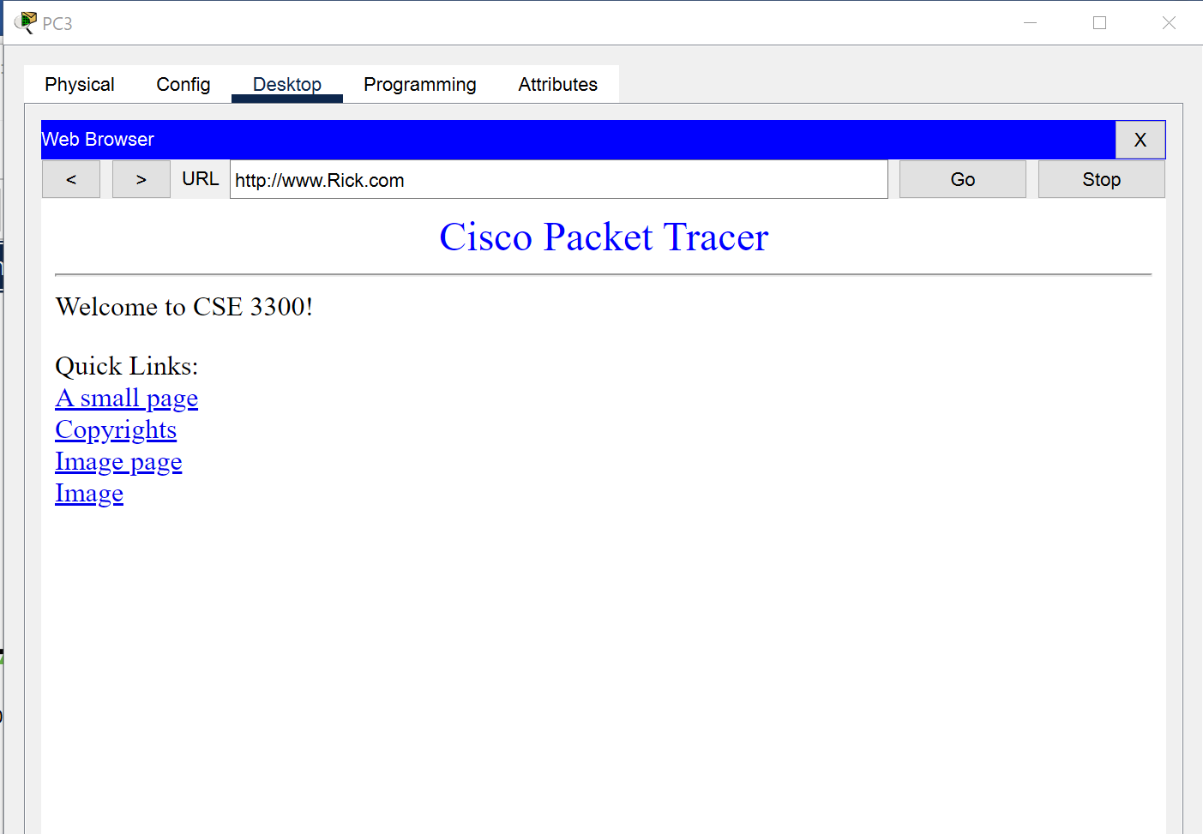

Question 8: What is the IPv4 network address for PC0 through PC3? Include the subnet mask or prefix length. (10 pts)

Question 9: What is the IPv4 address of the default gateway used by devices PC0 through PC3? (10 pts)

Question 10: When the user on PC1 types in www.YourURL.com, which device does PC1 ask for the IPv4 address associated with that URL? (10 pts)

Question 11: How did PC1 learn the IPv4 address of the DNS server? (10 pts)

