


数据结构实验报告
题目：二叉排序树

学 院 计算机学院
专 业 软件工程
年级班别 19级软件工程（1）班
学 号 3119005028
学生姓名 魏耀辉
指导教师 李小妹
编 号
成 绩 _________________________

2021年01月
报告：
报告内容： □详细 □完整 □基本完整 □不完整
设计方案： □非常合理 □合理 □基本合理 □较差
算法实现： □全部实现 □基本实现 □部分实现 □实现较差
测试样例： □完备 □比较完备 □基本完备 □不完备
文档格式： □规范 □比较规范 □基本规范 □不规范

答辩：
□理解题目透彻，问题回答流利
□理解题目较透彻，回答问题基本正确
□部分理解题目，部分问题回答正确
□未能完全理解题目，答辩情况较差

总评成绩：
□优 □良 □中 □及格 □不及格

- 设计任务及运行环境、工具
[运行环境]
运行设备：DESKTOP-F0N08OH
操作系统：Windows 10专业版
版本号：20H2
安装日期：2020年12月11日
操作系统版本：19042.685
编辑及编译：CLion 2020.3 x64
[问题描述]
二叉排序树的ADT实现，包括有二叉排序树的初始化、二叉排序树的摧毁、二叉排序树的前序，中序，后序遍历、二叉排序树元素的插入、二叉排序树元素的删除、二叉排序树叶子结点的计算、二叉排序树深度计算、二叉排序树元素值查找
[基本要求]
利用动态存储结构实现
- 抽象数据类型定义及操作简要描述

[数据类型的定义]

1.结构体定义
typedef int TElemType;

typedef struct BSTNode{
TElemType data;
struct BSTNode *lchild;
struct BSTNode *rchild;
}BSTNode,*BSTree;

typedef enum Status{
ERROR,
SUCCESS
}Status;
2.抽象数据类型的定义

ADT BST

{
数据对象：D＝{ a_{i} | a_{i}∈event, i=1,2,...,n, n≥0 }
数据关系：R1＝{ <a_{i-1}, a_{i}>|a_{i-1}, a_{i}∈D, i=2,...,n }
基本操作：
Status InitBSTree(BSTree *T);
初始条件：无
操作结果：初始化一棵二叉排序树，并为根节点赋值
Status EmptyBSTree(BSTree T);
初始条件：无
操作结果：判断二叉排序树是否为空
Status DestroyBiTree(BSTNode* T);
初始条件：二叉排序树存在
操作结果：摧毁一棵二叉排序树
Status PreOrderTraverse(BSTree T, Status (*visit)(TElemType e));
初始条件：二叉排序树存在
操作结果：先序遍历二叉排序树
Status InOrderTraverse(BSTree T, Status (*visit)(TElemType e));
初始条件：二叉排序树存在
操作结果：中序遍历二叉排序树
Status PostOrderTraverse(BSTree T, Status (*visit)(TElemType e));
初始条件：二叉排序树存在
操作结果：后序遍历二叉排序树
Status visit(TElemType e);
初始条件：无
操作结果：遍历函数
Status InsertBSTree(BSTree T,TElemType e);
初始条件：二叉排序树存在
操作结果：将元素e插入到二叉排序树
int Leaves(BSTree T);
初始条件：二叉排序树存在
操作结果：计算二叉排序树叶子数量
int BSTreeDepth(BSTree T);
初始条件：二叉排序树存在
操作结果：计算二叉排序树深度
Status Search(BSTree T,TElemType e);
初始条件：二叉排序树存在
操作结果：查找二叉排序树中元素e是否存在
Status DeleteBST(BSTree *T,TElemType e);
初始条件：二叉排序树存在
操作结果：将元素e从二叉排序树中删除
Status DeleteNode(BSTree* T);
初始条件：二叉排序树存在
操作结果：将元素e从二叉排序树中删除

}ADT BST

- 基本操作的实现
[数据类型的实现]

Status InitBSTree(BSTree *T)
{
TElemType data;
(*T)=(BSTNode*)malloc(sizeof(BSTNode));
if(T==NULL)
{
printf("Initialize failed!\n");
return ERROR;
}
else
{
printf("Please input the root's value:");
scanf("%d",&data);
(*T)->data=data;
(*T)->lchild=NULL;
(*T)->rchild=NULL;
printf("Initialize successfully!\n");
return SUCCESS;
}
}

Status EmptyBSTree(BSTree T)
{
if(!T)
{
return ERROR;
}
else
{
return SUCCESS;
}

}

Status DestroyBiTree(BSTNode* T)/*摧毁二叉树*/
{
if(T->lchild)
{
DestroyBiTree(T->lchild);
}
if(T->rchild)
{
DestroyBiTree(T->rchild);
}
free(T);
T=NULL;
return SUCCESS;
}
Status PreOrderTraverse(BSTree T, Status (*visit)(TElemType e))/*前序遍历二叉树*/
{
if(visit==NULL)return ERROR;
if(T)
{
visit(T->data);
PreOrderTraverse(T->lchild,visit);
PreOrderTraverse(T->rchild,visit);
return SUCCESS;
}
return ERROR;
}
Status InOrderTraverse(BSTree T, Status (*visit)(TElemType e))/*中序遍历二叉树*/
{
if (visit==NULL) return ERROR;
if (T)
{
InOrderTraverse(T->lchild, visit);
visit(T->data);
InOrderTraverse(T->rchild, visit);
return SUCCESS;
}
return ERROR;
}
Status PostOrderTraverse(BSTree T, Status (*visit)(TElemType e))/*后序遍历二叉树*/
{
if (visit==NULL) return ERROR;
if (T)
{
PostOrderTraverse(T->lchild,visit);
PostOrderTraverse(T->rchild,visit);
visit(T->data);
return SUCCESS;
}
return ERROR;
}

Status visit(TElemType e)/*遍历函数*/
{
printf("%d ",e);
return SUCCESS;
}
Status InsertBSTree(BSTree T,TElemType e)
{
BSTree s,p=T;
s=(BSTree)malloc(sizeof(BSTNode));
if(s==NULL)
{
printf("Insert failed!\n");
return ERROR;
}
s->data=e;
s->lchild=NULL;
s->rchild=NULL;
while(T)
{
if(p->data==e)
{
printf("The value has existed!\n");
return ERROR;
}
if(p->data>e)
{
if(p->lchild)
{
p=p->lchild;
}
else
{
p->lchild=s;
printf("insert successfully!\n");
return SUCCESS;
}
}
if(p->data<e)
{
if(p->rchild)
{
p=p->rchild;
}
else
{
p->rchild=s;
printf("insert successfully!\n");
return SUCCESS;
}
}
}
return ERROR;
}

int Leaves(BSTree T)
{
if(T==NULL)
{
return 0;
}
else if(T->lchild==NULL&&T->rchild==NULL)
{
return 1;
}
else
{
return Leaves(T->lchild)+Leaves(T->rchild);
}
}

int BSTreeDepth(BSTree T)
{
int depthLeft,depthRight;
if(T==NULL)
{
return 0;
}
else
{
depthLeft=BSTreeDepth(T->lchild);
depthRight=BSTreeDepth(T->rchild);
return 1+(depthRight>depthLeft?depthRight:depthLeft);
}
}

Status Search(BSTree T,TElemType e)
{
BSTree p=T;
while(T)
{
if(p->data==e)
{
printf("Search successfully,the value existed!\n");
return SUCCESS;
}
if(p->data>e)
{
if(p->lchild)
{
p=p->lchild;
}
else
{
printf("Search failed,the value isn't existed!\n");
return ERROR;
}
}
if(p->data<e)
{
if(p->rchild)
{
p=p->rchild;
}
else
{
printf("Search failed,the value isn't existed!\n");
return ERROR;
}
}
}
return ERROR;
}

Status DeleteBST(BSTree *T,TElemType e)
{
if(!*T)return ERROR;
else
{
if(e==(*T)->data )
{
DeleteNode(T);
return SUCCESS;
}
else if(e<(*T)->data)
{
return DeleteBST(&(*T)->lchild,e);
}
else
{
return DeleteBST(&(*T)->rchild,e);
}
}
}

Status DeleteNode(BSTree *T)
{
BSTree q,s;
if((*T)->rchild==NULL)
{
q=*T;
(*T)=(*T)->lchild;
free(q);
}
else if((*T)->lchild==NULL)
{
q=*T;
*T=(*T)->rchild;
free(q);
}
else
{
q=*T;
s=(*T)->lchild;
while(s->rchild)
{
q=s;
s=s->rchild;
}
(*T)->data=s->data;
if(q!=*T)
{
q->rchild=s->lchild;
}
else
{
q->lchild=s->lchild;
}
free(s);
}
return SUCCESS;
}
4.程序清单及测试结果
[代码清单]
BST.h
#ifndef BST_H_INCLUDED
#define BST_H_INCLUDED

typedef int TElemType;

typedef struct BSTNode{
TElemType data;
struct BSTNode *lchild;
struct BSTNode *rchild;
}BSTNode,*BSTree;

typedef enum Status{
ERROR,
SUCCESS
}Status;

Status InitBSTree(BSTree *T);/*初始化二叉排序树*/

Status EmptyBSTree(BSTree T);/*判断二叉排序树是否为空*/

Status DestroyBiTree(BSTNode* T);/*销毁一颗二叉排序树*/

Status PreOrderTraverse(BSTree T, Status (*visit)(TElemType e));/*先序遍历二叉排序树*/

Status InOrderTraverse(BSTree T, Status (*visit)(TElemType e));/*中序遍历二叉排序树*/

Status PostOrderTraverse(BSTree T, Status (*visit)(TElemType e));/*后序遍历二叉排序树*/

Status visit(TElemType e);/*遍历函数*/

Status InsertBSTree(BSTree T,TElemType e);/*插入一个元素到二叉排序树中*/

int Leaves(BSTree T);/*计算二叉排序树叶子数量*/

int BSTreeDepth(BSTree T);/*计算二叉排序树深度*/

Status Search(BSTree T,TElemType e);/*搜索二叉排序树是否有该值*/

Status DeleteBST(BSTree *T,TElemType e);/*删除二叉排序树中某结点*/

Status DeleteNode(BSTree* T);/*删除结点函数*/

void print();/*菜单函数*/
#endif // BST_H_INCLUDED

BST.c
#include<stdio.h>
#include"BST.h"
#include<stdlib.h>

Status InitBSTree(BSTree *T)
{
TElemType data;
(*T)=(BSTNode*)malloc(sizeof(BSTNode));
if(T==NULL)
{
printf("Initialize failed!\n");
return ERROR;
}
else
{
printf("Please input the root's value:");
scanf("%d",&data);
(*T)->data=data;
(*T)->lchild=NULL;
(*T)->rchild=NULL;
printf("Initialize successfully!\n");
return SUCCESS;
}
}

Status EmptyBSTree(BSTree T)
{
if(!T)
{
return ERROR;
}
else
{
return SUCCESS;
}

}

Status DestroyBiTree(BSTNode* T)/*摧毁二叉树*/
{
if(T->lchild)
{
DestroyBiTree(T->lchild);
}
if(T->rchild)
{
DestroyBiTree(T->rchild);
}
free(T);
T=NULL;
return SUCCESS;
}
Status PreOrderTraverse(BSTree T, Status (*visit)(TElemType e))/*前序遍历二叉树*/
{
if(visit==NULL)return ERROR;
if(T)
{
visit(T->data);
PreOrderTraverse(T->lchild,visit);
PreOrderTraverse(T->rchild,visit);
return SUCCESS;
}
return ERROR;
}
Status InOrderTraverse(BSTree T, Status (*visit)(TElemType e))/*中序遍历二叉树*/
{
if (visit==NULL) return ERROR;
if (T)
{
InOrderTraverse(T->lchild, visit);
visit(T->data);
InOrderTraverse(T->rchild, visit);
return SUCCESS;
}
return ERROR;
}
Status PostOrderTraverse(BSTree T, Status (*visit)(TElemType e))/*后序遍历二叉树*/
{
if (visit==NULL) return ERROR;
if (T)
{
PostOrderTraverse(T->lchild,visit);
PostOrderTraverse(T->rchild,visit);
visit(T->data);
return SUCCESS;
}
return ERROR;
}

Status visit(TElemType e)/*遍历函数*/
{
printf("%d ",e);
return SUCCESS;
}
Status InsertBSTree(BSTree T,TElemType e)
{
BSTree s,p=T;
s=(BSTree)malloc(sizeof(BSTNode));
if(s==NULL)
{
printf("Insert failed!\n");
return ERROR;
}
s->data=e;
s->lchild=NULL;
s->rchild=NULL;
while(T)
{
if(p->data==e)
{
printf("The value has existed!\n");
return ERROR;
}
if(p->data>e)
{
if(p->lchild)
{
p=p->lchild;
}
else
{
p->lchild=s;
printf("insert successfully!\n");
return SUCCESS;
}
}
if(p->data<e)
{
if(p->rchild)
{
p=p->rchild;
}
else
{
p->rchild=s;
printf("insert successfully!\n");
return SUCCESS;
}
}
}
return ERROR;
}

int Leaves(BSTree T)
{
if(T==NULL)
{
return 0;
}
else if(T->lchild==NULL&&T->rchild==NULL)
{
return 1;
}
else
{
return Leaves(T->lchild)+Leaves(T->rchild);
}
}

int BSTreeDepth(BSTree T)
{
int depthLeft,depthRight;
if(T==NULL)
{
return 0;
}
else
{
depthLeft=BSTreeDepth(T->lchild);
depthRight=BSTreeDepth(T->rchild);
return 1+(depthRight>depthLeft?depthRight:depthLeft);
}
}

Status Search(BSTree T,TElemType e)
{
BSTree p=T;
while(T)
{
if(p->data==e)
{
printf("Search successfully,the value existed!\n");
return SUCCESS;
}
if(p->data>e)
{
if(p->lchild)
{
p=p->lchild;
}
else
{
printf("Search failed,the value isn't existed!\n");
return ERROR;
}
}
if(p->data<e)
{
if(p->rchild)
{
p=p->rchild;
}
else
{
printf("Search failed,the value isn't existed!\n");
return ERROR;
}
}
}
return ERROR;
}

Status DeleteBST(BSTree *T,TElemType e)
{
if(!*T)return ERROR;
else
{
if(e==(*T)->data )
{
DeleteNode(T);
return SUCCESS;
}
else if(e<(*T)->data)
{
return DeleteBST(&(*T)->lchild,e);
}
else
{
return DeleteBST(&(*T)->rchild,e);
}
}
}

Status DeleteNode(BSTree *T)
{
BSTree q,s;
if((*T)->rchild==NULL)
{
q=*T;
(*T)=(*T)->lchild;
free(q);
}
else if((*T)->lchild==NULL)
{
q=*T;
*T=(*T)->rchild;
free(q);
}
else
{
q=*T;
s=(*T)->lchild;
while(s->rchild)
{
q=s;
s=s->rchild;
}
(*T)->data=s->data;
if(q!=*T)
{
q->rchild=s->lchild;
}
else
{
q->lchild=s->lchild;
}
free(s);
}
return SUCCESS;
}

void print()
{
{
printf("******************************************************************************\n");
printf("* Welcome to the menu of Binary Search Tree made by WYH *\n");
printf("******************************************************************************\n");
printf("* 1.Initialize the Binary Search Tree *\n");
printf("* 2.Destroy the Binary Search Tree *\n");
printf("* 3.PreOrder Traverse the Binary Search Tree *\n");
printf("* 4.InOrder Traverse the Binary Search Tree *\n");
printf("* 5.PostOrder Traverse the Binary Search Tree *\n");
printf("* 6.Insert a value to the Binary Search Tree *\n");
printf("* 7.Delete a value from the Binary Search Tree *\n");
printf("* 8.Calculate the leaves of the Binary Search Tree *\n");
printf("* 9.Calculate the depth of the Binary Search Tree *\n");
printf("* 10.Search a value in the Binary Search Tree *\n");
printf("* 11.Exit *\n");
printf("******************************************************************************\n");
printf("-------------------------please select a number-------------------------------\n");
printf("The number you choose is : ");
}
}

main.c
#include <stdio.h>
#include <stdlib.h>
#include "BST.h"
int main()
{
int number;
BSTree T;
BSTNode *s=NULL;
T=s;
print();
while(1)
{
system("CLS");
print();
scanf("%d",&number);
if(number>=1&&number<=11)
{
switch(number)
{
case 1:
{
InitBSTree(&T);
system("PAUSE");
break;
}
case 2:
{

if(!T)
{
printf("Please initialize the Binary Search Tree first!\n");
}
else
{
DestroyBiTree(T);
{
printf("Destroy the Binary Search Tree successfully!\n");
}
T=NULL;

}
system("PAUSE");
break;
}
case 3:
{
if(!T)
{
printf("Please initialize the Binary Search Tree first!\n");
}
else
{
printf("The PreOrderTraversal is:");
PreOrderTraverse(T,visit);
}
system("PAUSE");
break;
}
case 4:
{
if(!T)
{
printf("Please initialize the Binary Search Tree first!\n");
}
else
{
printf("The InOrderTraversal is:");
InOrderTraverse(T,visit);
}
system("PAUSE");
break;
}
case 5:
{
if(!T)
{
printf("Please initialize the Binary Search Tree first!\n");
}
else
{
printf("The PostOrderTraversal is:");
PostOrderTraverse(T,visit);
}
system("PAUSE");
break;
}
case 6:
{
if(!T)
{
printf("Please initialize the Binary Search Tree first!\n");
}
else
{
printf("Input the value you want to insert:");
TElemType rootvalue;
scanf("%d",&rootvalue);
InsertBSTree(T,rootvalue);
}
system("PAUSE");
break;
}
case 7:
{
if(!T)
{
printf("Please initialize the Binary Search Tree first!\n");
}
TElemType elem;
printf("Please input the value you want to delete:");
scanf("%d",&elem);
if(Search(T,elem))
{
DeleteBST(&T,elem);
printf("The value was deleted successfully!\n");
}
system("PAUSE");
break;
}
case 8:
{
if(!T)
{
printf("Please initialize the Binary Search Tree first!\n");
}
else
{
int leaves;
leaves=Leaves(T);
printf("The leave's quantity of the Binary Search Tree is %d\n",leaves);
}
system("PAUSE");
break;
}
case 9:
{
if(!T)
{
printf("Please initialize the Binary Search Tree first!\n");
}
else
{
int depth;
depth=BSTreeDepth(T);
printf("The depth of the Binary Search Tree is %d\n",depth);
}
system("PAUSE");
break;
}
case 10:
{
if(!T)
{
printf("Please initialize the Binary Search Tree first!\n");
}
else
{
TElemType data1;
printf("Please input the value you want to search!\n");
scanf("%d",&data1);
Search(T,data1);
}
system("PAUSE");
break;
}
case 11:
{
printf("ByeBye~\n");
system("PAUSE");
goto end;
}

}
}
else
{
printf("Error input\n");
system("PAUSE");
}
}
end:
return 0;
}
[测试结果]
测试一棵根节点为23，右孩子为3，左孩子为43的二叉排序树
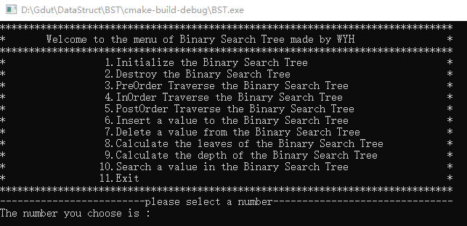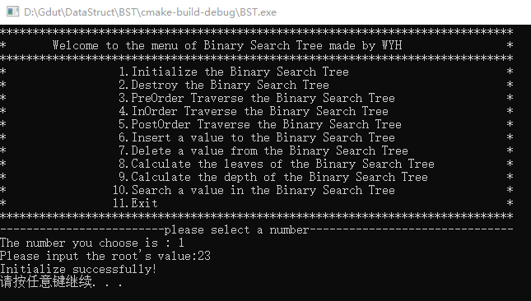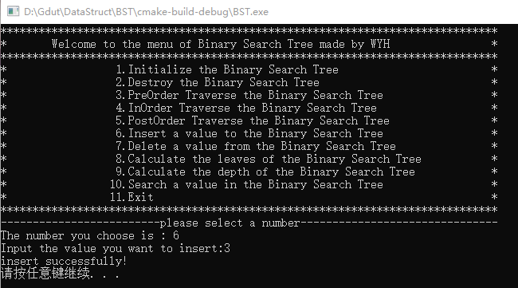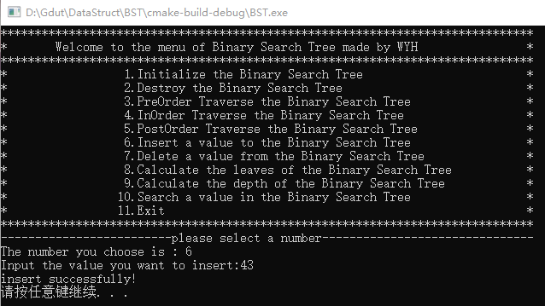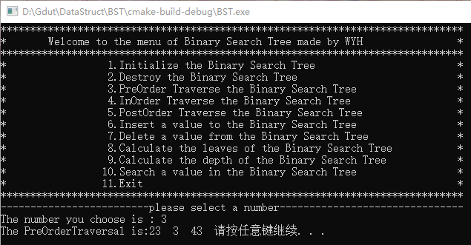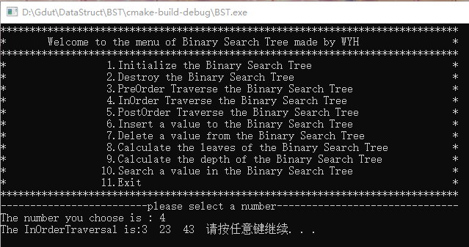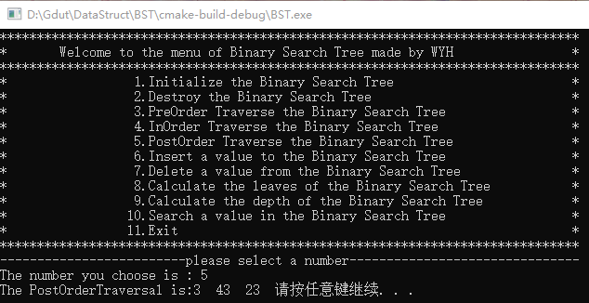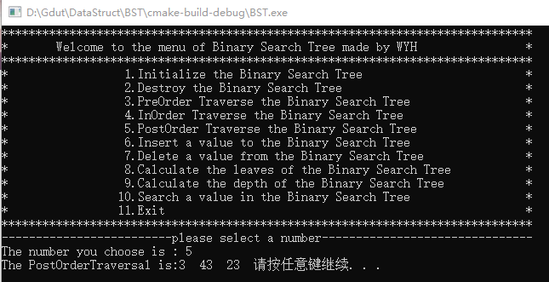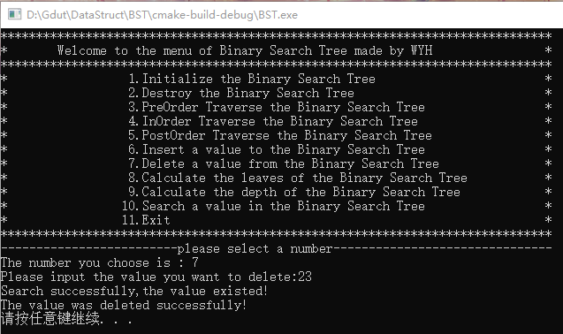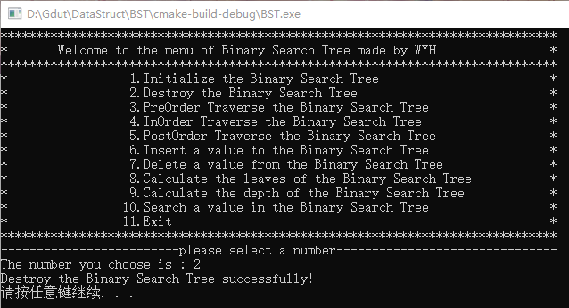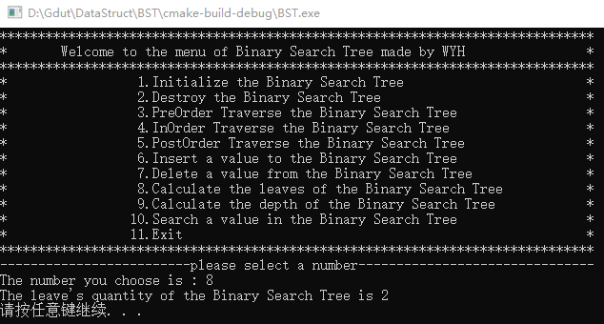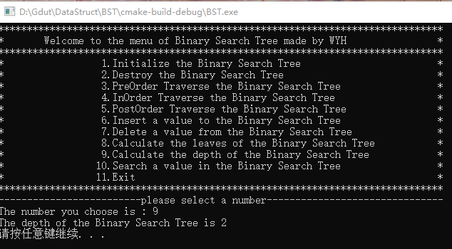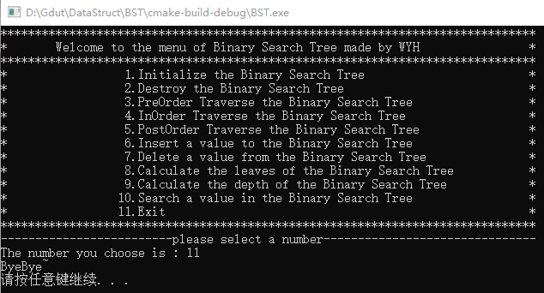
5.实验总结和体会
1、本程序设计了菜单选项，使操作者能一目了然所有的二叉排序树操作，不需要将特定的操作选项背下来。
2、设计了一定的防误输入设置，但健壮性一般，有待后期改善。
3、本次二叉排序树的实验设计让我更加熟悉二叉排序树的生成和其他的操作，以及实现的原理算法。

