

**instituto POLITECNICO NACIONAL**

**ESCUELA SUPERIOR DE COMPUTO**

**CARRERA: INGIENERIA EN INTELIGENCIA ARTIFICIAL**

**UNIDAD DE APRENDIZAJE: aprendizaje maquina**

**El mundo del wumpus parte 2**

**ALUMNO(S): CHÁVEZ TORREBLANCA ÁNGEL ALEXIS**

**GRUPO: 5BM2**

**PROFESOR: García Mendoza consuelo varinia**

**ESTADO INICIAL.**

**TOMA DE DECISIONES**

$$A_{1,1}⇒A_{1,1}$$

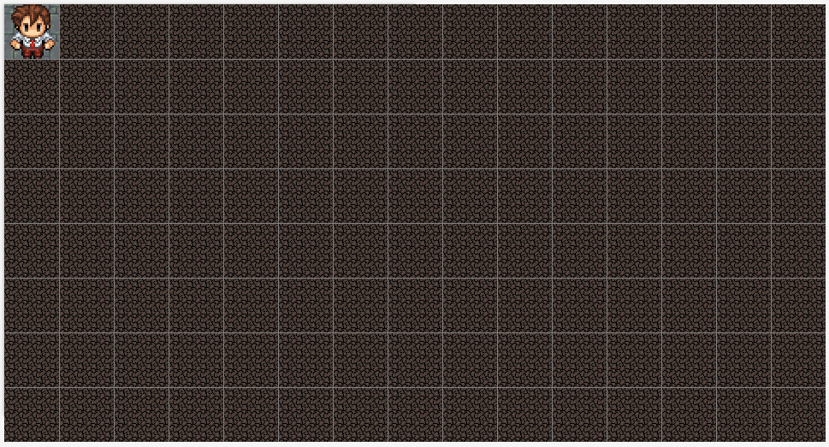

**PROCESO DE INFERENCIA.**

$$¬S_{1,1}→¬W_{1,2}∨¬W_{2,1}$$

$$¬B_{1,1}→¬P_{1,2}∨¬P_{2,1}$$

$$¬R_{1,1}→¬G_{1,2}∨{¬G}_{2,1}$$

**REPRESENTACIÓN DEL CONOCIMIENTO.**

|  |  |  |  |  |  |  |  |
| --- | --- | --- | --- | --- | --- | --- | --- |
| **CASILLA** | **VISIT (V)** | **STENCH (S)** | **BREEZE (B)** | **GLITTER (R)** | **WUMPUS (W)** | **PIT (P)** | **GOLD (G)** |
| **1,1** | 1 | 0 | 0 | 0 | 0 | 0 | 0 |
| **1,2** | 0 |  |  |  | 0 | 0 | 0 |
| **1,3** | 0 |  |  |  |  |  |  |
| **1,4** | 0 |  |  |  |  |  |  |
| **2,1** | 0 |  |  |  | 0 | 0 | 0 |
| **2,2** | 0 |  |  |  |  |  |  |
| **2,3** | 0 |  |  |  |  |  |  |
| **2,4** | 0 |  |  |  |  |  |  |
| **3,1** | 0 |  |  |  |  |  |  |
| **3,2** | 0 |  |  |  |  |  |  |
| **…** | 0 |  |  |  |  |  |  |

**MOVIMIENTO 1.**

**TOMA DE DECISIONES**

$$A_{1,1}⇒A_{2,1}$$

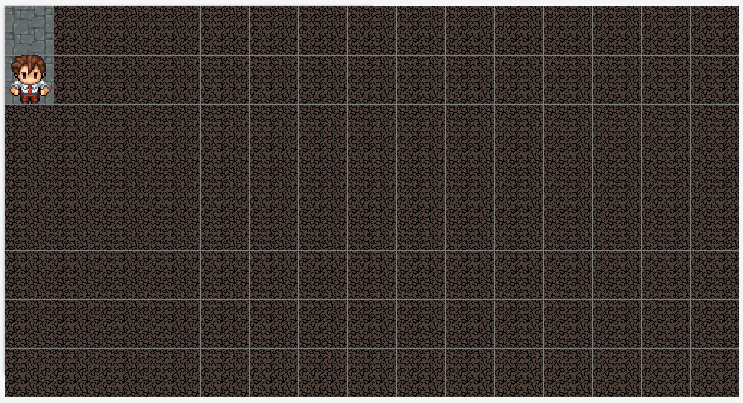

**PROCESO DE INFERENCIA.**

$$¬S_{2,1}→¬W_{2,2}∨¬W_{3,1}$$

$$¬B_{2,1}→¬P_{2,2}∨¬P_{3,1}$$

$$¬R_{2,1}→¬G_{2,2}∨{¬G}_{3,1}$$

**REPRESENTACIÓN DEL CONOCIMIENTO.**

|  |  |  |  |  |  |  |  |
| --- | --- | --- | --- | --- | --- | --- | --- |
| **CASILLA** | **VISIT (V)** | **STENCH (S)** | **BREEZE (B)** | **GLITTER (R)** | **WUMPUS (W)** | **PIT (P)** | **GOLD (G)** |
| **1,1** | 1 | 0 | 0 | 0 | 0 | 0 | 0 |
| **1,2** | 0 |  |  |  | 0 | 0 | 0 |
| **1,3** | 0 |  |  |  |  |  |  |
| **1,4** | 0 |  |  |  |  |  |  |
| **2,1** | 1 | 0 | 0 | 0 | 0 | 0 | 0 |
| **2,2** | 0 |  |  |  | 0 | 0 | 0 |
| **2,3** | 0 |  |  |  |  |  |  |
| **2,4** | 0 |  |  |  |  |  |  |
| **3,1** | 0 |  |  |  | 0 | 0 | 0 |
| **3,2** | 0 |  |  |  |  |  |  |
| **…** | 0 |  |  |  |  |  |  |

**MOVIMIENTO 2.**

**TOMA DE DECISIONES**

$$A_{2,1}⇒A_{3,1}$$

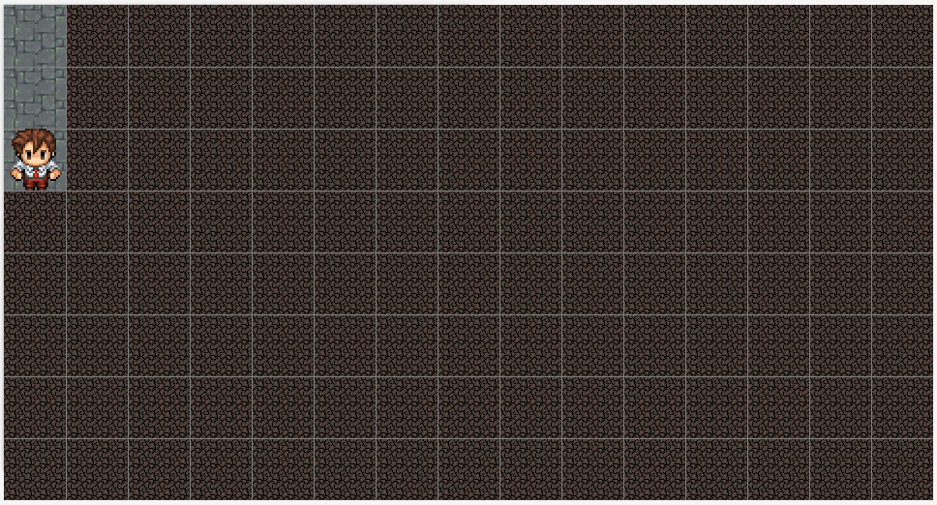

**PROCESO DE INFERENCIA.**

$$¬S_{3,1}→¬W_{3,2}∨¬W_{4,1}$$

$$¬B_{3,1}→¬P_{3,2}∨¬P_{4,1}$$

$$¬R_{3,1}→¬G_{3,2}∨{¬G}_{4,1}$$

**REPRESENTACIÓN DEL CONOCIMIENTO.**

|  |  |  |  |  |  |  |  |
| --- | --- | --- | --- | --- | --- | --- | --- |
| **CASILLA** | **VISIT (V)** | **STENCH (S)** | **BREEZE (B)** | **GLITTER (R)** | **WUMPUS (W)** | **PIT (P)** | **GOLD (G)** |
| **1,1** | 1 | 0 | 0 | 0 | 0 | 0 | 0 |
| **1,2** | 0 |  |  |  | 0 | 0 | 0 |
| **2,1** | 1 | 0 | 0 | 0 | 0 | 0 | 0 |
| **2,2** | 0 |  |  |  | 0 | 0 | 0 |
| **3,1** | 1 | 0 | 0 | 0 | 0 | 0 | 0 |
| **3,2** | 0 |  |  |  | 0 | 0 | 0 |
| **4,1** | 0 |  |  |  | 0 | 0 | 0 |
| **4,2** | 0 |  |  |  |  |  |  |
| **5,1** | 0 |  |  |  |  |  |  |
| **5,2** | 0 |  |  |  |  |  |  |
| **…** | 0 |  |  |  |  |  |  |

**MOVIMIENTO 3.**

**TOMA DE DECISIONES**

$$A_{3,1}⇒A_{4,1}$$

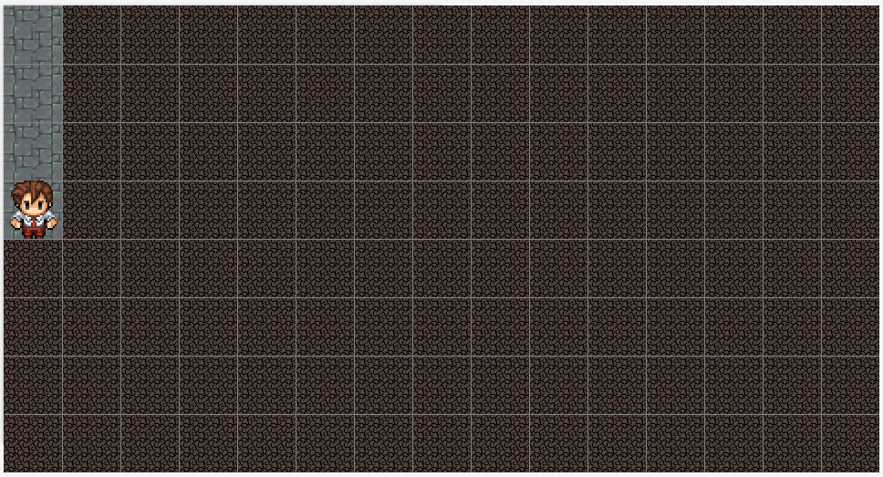

**PROCESO DE INFERENCIA.**

$$¬S_{1,1}→¬W_{4,2}∨¬W_{5,1}$$

$$¬B_{1,1}→¬P_{4,2}∨¬P_{5,1}$$

$$R_{4,1}→G_{4,2}∧G_{5,1}$$

**REPRESENTACIÓN DEL CONOCIMIENTO.**

|  |  |  |  |  |  |  |  |
| --- | --- | --- | --- | --- | --- | --- | --- |
| **CASILLA** | **VISIT (V)** | **STENCH (S)** | **BREEZE (B)** | **GLITTER (R)** | **WUMPUS (W)** | **PIT (P)** | **GOLD (G)** |
| **1,1** | 1 | 0 | 0 | 0 | 0 | 0 | 0 |
| **1,2** | 0 |  |  |  | 0 | 0 | 0 |
| **2,1** | 1 | 0 | 0 | 0 | 0 | 0 | 0 |
| **2,2** | 0 |  |  |  | 0 | 0 | 0 |
| **3,1** | 1 | 0 | 0 | 0 | 0 | 0 | 0 |
| **3,2** | 0 |  |  |  | 0 | 0 | 0 |
| **4,1** | 1 | 0 | 0 | 1 | 0 | 0 | 0 |
| **4,2** | 0 |  |  |  | 0 | 0 | ? |
| **5,1** | 0 |  |  |  | 0 | 0 | ? |
| **5,2** | 0 |  |  |  |  |  |  |
| **…** | 0 |  |  |  |  |  |  |

**MOVIMIENTO 4.**

**TOMA DE DECISIONES**

$$A_{4,1}⇒A_{4,2}$$

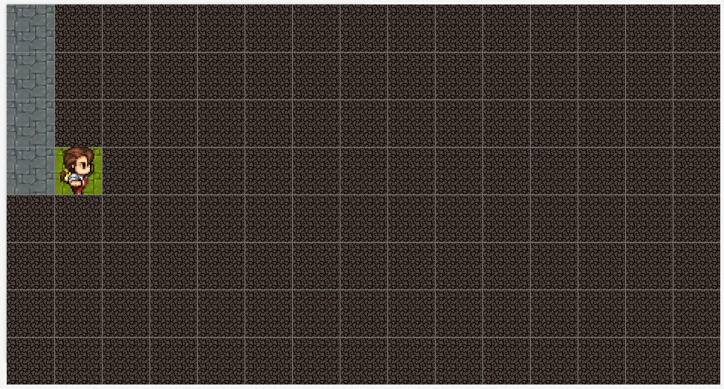

**PROCESO DE INFERENCIA.**

$$¬S_{4,2}→¬W_{3,2}∨¬W_{4,3}∨{¬W}_{5,2}$$

$$¬B_{4,2}→¬P_{3,2}∨¬P_{4,3}∨{¬P}_{5,2}$$

$$¬R_{4,2}→¬G_{3,2}∨¬G_{4,3}∨{¬G}_{5,2}$$

**REPRESENTACIÓN DEL CONOCIMIENTO.**

|  |  |  |  |  |  |  |  |
| --- | --- | --- | --- | --- | --- | --- | --- |
| **CASILLA** | **VISIT (V)** | **STENCH (S)** | **BREEZE (B)** | **GLITTER (R)** | **WUMPUS (W)** | **PIT (P)** | **GOLD (G)** |
| **1,1** | 1 | 0 | 0 | 0 | 0 | 0 | 0 |
| **1,2** | 0 |  |  |  | 0 | 0 | 0 |
| **2,1** | 1 | 0 | 0 | 0 | 0 | 0 | 0 |
| **2,2** | 0 |  |  |  | 0 | 0 | 0 |
| **3,1** | 1 | 0 | 0 | 0 | 0 | 0 | 0 |
| **3,2** | 0 |  |  |  | 0 | 0 | 0 |
| **4,1** | 1 | 0 | 0 | 1 | 0 | 0 | 0 |
| **4,2** | 1 | 0 | 0 | 0 | 0 | 0 | 1 |
| **4,3** | 0 |  |  |  | 0 | 0 | 0 |
| **5,1** | 0 |  |  |  | 0 | 0 | ? |
| **5,2** | 0 |  |  |  | 0 | 0 | 0 |
| **…** | 0 |  |  |  |  |  |  |

**MOVIMIENTO 5.**

**TOMA DE DECISIONES**

$$A_{4,2}⇒A_{4,3}$$

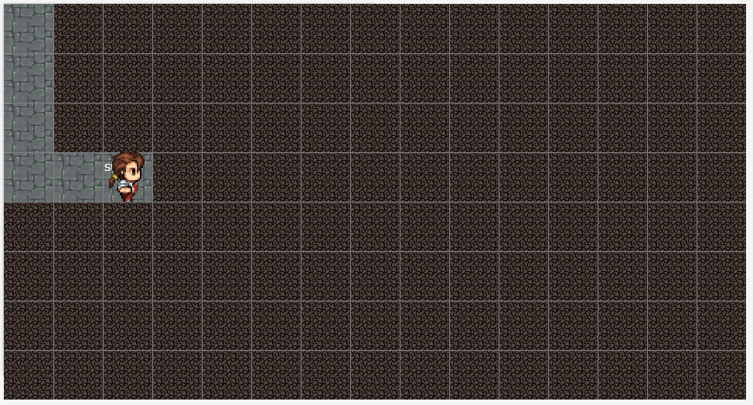

**PROCESO DE INFERENCIA.**

$$S_{4,3}→W_{3,3}∧W_{4,4}∧W_{5,3}$$

$$¬B_{4,3}→¬P_{3,3}∨¬P_{4,4}∨¬P_{5,3}$$

$$¬R_{4,3}→¬G_{3,3}∨{¬G}_{4,4}∨{¬G}_{5,3}$$

**REPRESENTACIÓN DEL CONOCIMIENTO.**

|  |  |  |  |  |  |  |  |
| --- | --- | --- | --- | --- | --- | --- | --- |
| **CASILLA** | **VISIT (V)** | **STENCH (S)** | **BREEZE (B)** | **GLITTER (R)** | **WUMPUS (W)** | **PIT (P)** | **GOLD (G)** |
| **1,1** | 1 | 0 | 0 | 0 | 0 | 0 | 0 |
| **1,2** | 0 |  |  |  | 0 | 0 | 0 |
| **2,1** | 1 | 0 | 0 | 0 | 0 | 0 | 0 |
| **2,2** | 0 |  |  |  | 0 | 0 | 0 |
| **3,1** | 1 | 0 | 0 | 0 | 0 | 0 | 0 |
| **3,2** | 0 |  |  |  | 0 | 0 | 0 |
| **3,3** |  |  |  |  | ? | 0 | 0 |
| **4,1** | 1 | 0 | 0 | 1 | 0 | 0 | 0 |
| **4,2** | 1 | 0 | 0 | 0 | 0 | 0 | 1 |
| **4,3** | 1 | 1 | 0 | 0 | 0 | 0 | 0 |
| **4,4** | 0 |  |  |  | ? | 0 | 0 |
| **5,1** | 0 |  |  |  | 0 | 0 | ? |
| **5,2** | 0 |  |  |  | 0 | 0 | 0 |
| **5,3** | 0 |  |  |  | ? | 0 | 0 |
| **…** | 0 |  |  |  |  |  |  |

**MOVIMIENTO 6.**

**TOMA DE DECISIONES**

$$A_{4,3}⟹A_{4,2}⇒A_{5,2}$$

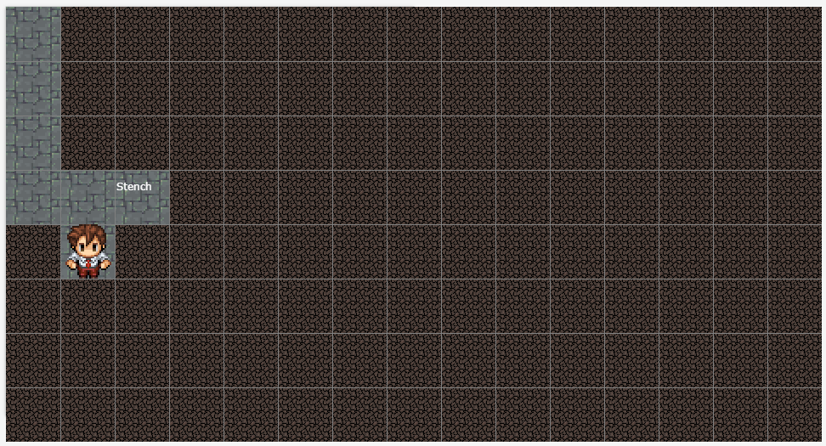

**PROCESO DE INFERENCIA.**

$$¬S_{5,2}→¬W_{5,1}∨{¬W}_{6,2}∨¬W_{5,3}$$

$$¬B_{5,2}→¬P_{5,1}∨¬P_{6,2}∨¬P_{5,3}$$

$$¬R_{5,2}→¬G_{5,1}∨{¬G}_{6,2}∨{¬G}_{5,3}$$

**REPRESENTACIÓN DEL CONOCIMIENTO.**

|  |  |  |  |  |  |  |  |
| --- | --- | --- | --- | --- | --- | --- | --- |
| **CASILLA** | **VISIT (V)** | **STENCH (S)** | **BREEZE (B)** | **GLITTER (R)** | **WUMPUS (W)** | **PIT (P)** | **GOLD (G)** |
| **1,1** | 1 | 0 | 0 | 0 | 0 | 0 | 0 |
| **1,2** | 0 |  |  |  | 0 | 0 | 0 |
| **2,1** | 1 | 0 | 0 | 0 | 0 | 0 | 0 |
| **2,2** | 0 |  |  |  | 0 | 0 | 0 |
| **3,1** | 1 | 0 | 0 | 0 | 0 | 0 | 0 |
| **3,2** | 0 |  |  |  | 0 | 0 | 0 |
| **3,3** |  |  |  |  | ? | 0 | 0 |
| **4,1** | 1 | 0 | 0 | 1 | 0 | 0 | 0 |
| **4,2** | 1 | 0 | 0 | 0 | 0 | 0 | 1 |
| **4,3** | 1 | 1 | 0 | 0 | 0 | 0 | 0 |
| **4,4** | 0 |  |  |  | ? | 0 | 0 |
| **5,1** | 0 |  |  |  | 0 | 0 | 0 |
| **5,2** | 1 |  |  |  | 0 | 0 | 0 |
| **5,3** | 0 |  |  |  | 0 | 0 | 0 |
| **6,2** | 0 |  |  |  | 0 | 0 | 0 |
| **…** | 0 |  |  |  |  |  |  |

**MOVIMIENTO 7.**

**TOMA DE DECISIONES**

$$A_{5,2}⇒A_{6,2}$$

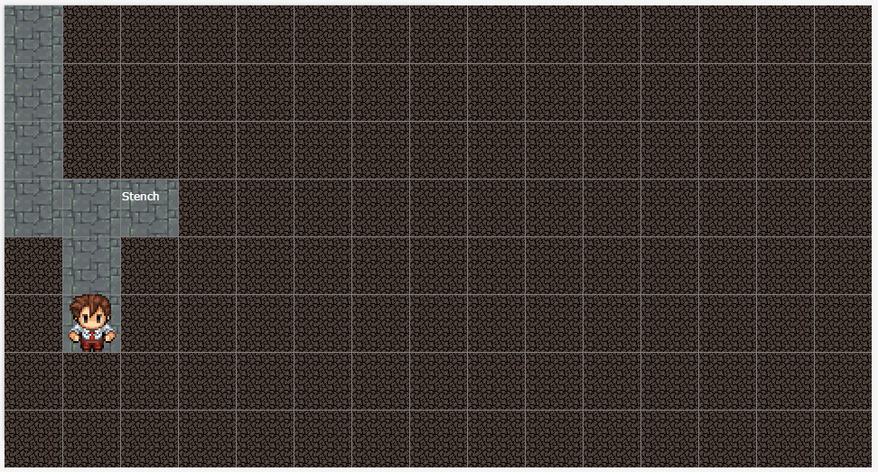

**PROCESO DE INFERENCIA.**

$$¬S_{6,2}→¬W_{6,1}∨{¬W}_{6,3}∨¬W_{7,2}$$

$$¬B_{6,2}→¬P_{6,1}∨¬P_{6,3}∨¬P_{7,2}$$

$$¬R_{6,2}→¬G_{6,1}∨{¬G}_{6,3}∨{¬G}_{7,2}$$

**REPRESENTACIÓN DEL CONOCIMIENTO.**

|  |  |  |  |  |  |  |  |
| --- | --- | --- | --- | --- | --- | --- | --- |
| **CASILLA** | **VISIT (V)** | **STENCH (S)** | **BREEZE (B)** | **GLITTER (R)** | **WUMPUS (W)** | **PIT (P)** | **GOLD (G)** |
| **1,1** | 1 | 0 | 0 | 0 | 0 | 0 | 0 |
| **1,2** | 0 |  |  |  | 0 | 0 | 0 |
| **2,1** | 1 | 0 | 0 | 0 | 0 | 0 | 0 |
| **2,2** | 0 |  |  |  | 0 | 0 | 0 |
| **3,1** | 1 | 0 | 0 | 0 | 0 | 0 | 0 |
| **3,2** | 0 |  |  |  | 0 | 0 | 0 |
| **3,3** |  |  |  |  | ? | 0 | 0 |
| **4,1** | 1 | 0 | 0 | 1 | 0 | 0 | 0 |
| **4,2** | 1 | 0 | 0 | 0 | 0 | 0 | 1 |
| **4,3** | 1 | 1 | 0 | 0 | 0 | 0 | 0 |
| **4,4** | 0 |  |  |  | ? | 0 | 0 |
| **5,1** | 0 |  |  |  | 0 | 0 | 0 |
| **5,2** | 1 |  |  |  | 0 | 0 | 0 |
| **5,3** | 0 |  |  |  | 0 | 0 | 0 |
| **6,1** |  |  |  |  |  |  |  |
| **6,2** | 1 |  |  |  | 0 | 0 | 0 |
| **6,3** | 0 |  |  |  | 0 | 0 | 0 |
| **7,2** | 0 |  |  |  | 0 | 0 | 0 |
| **…** | 0 |  |  |  |  |  |  |

**MOVIMIENTO 8.**

**TOMA DE DECISIONES**

$$A_{6,2}⇒A_{7,2}$$

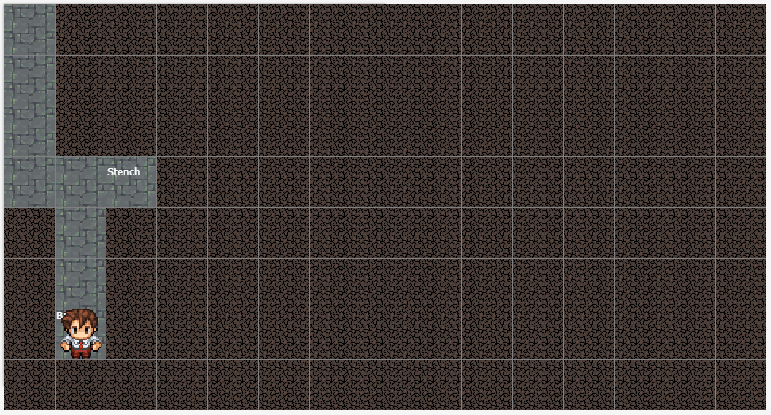

**PROCESO DE INFERENCIA.**

$$¬S_{7,2}→¬W_{7,1}∨{¬W}_{7,3}∨¬W_{8,2}$$

$$B_{7,2}→P_{7,1}∧P_{7,3}∧P_{8,2}$$

$$¬R_{7,2}→¬G_{7,1}∨{¬G}_{7,3}∨{¬G}_{8,2}$$

**REPRESENTACIÓN DEL CONOCIMIENTO.**

|  |  |  |  |  |  |  |  |
| --- | --- | --- | --- | --- | --- | --- | --- |
| **CASILLA** | **VISIT (V)** | **STENCH (S)** | **BREEZE (B)** | **GLITTER (R)** | **WUMPUS (W)** | **PIT (P)** | **GOLD (G)** |
| **1,1** | 1 | 0 | 0 | 0 | 0 | 0 | 0 |
| **1,2** | 0 |  |  |  | 0 | 0 | 0 |
| **2,1** | 1 | 0 | 0 | 0 | 0 | 0 | 0 |
| **2,2** | 0 |  |  |  | 0 | 0 | 0 |
| **3,1** | 1 | 0 | 0 | 0 | 0 | 0 | 0 |
| **3,2** | 0 |  |  |  | 0 | 0 | 0 |
| **3,3** |  |  |  |  | ? | 0 | 0 |
| **4,1** | 1 | 0 | 0 | 1 | 0 | 0 | 0 |
| **4,2** | 1 | 0 | 0 | 0 | 0 | 0 | 1 |
| **4,3** | 1 | 1 | 0 | 0 | 0 | 0 | 0 |
| **4,4** | 0 |  |  |  | ? | 0 | 0 |
| **5,1** | 0 |  |  |  | 0 | 0 | 0 |
| **5,2** | 1 |  |  |  | 0 | 0 | 0 |
| **5,3** | 0 |  |  |  | 0 | 0 | 0 |
| **6,1** |  |  |  |  |  |  |  |
| **6,2** | 1 |  |  |  | 0 | 0 | 0 |
| **6,3** | 0 |  |  |  | 0 | 0 | 0 |
| **7,1** | 0 |  |  |  | 0 | ? | 0 |
| **7,2** | 1 | 0 | 1 | 0 | 0 | 0 | 0 |
| **7,3** | 0 |  |  |  | 0 | ? | 0 |
| **8,2** | 0 |  |  |  | 0 | ? | 0 |
| **…** | 0 |  |  |  |  |  |  |

**MOVIMIENTO 9.**

**TOMA DE DECISIONES**

$$A_{7,2}⇒A_{6,2} ⇒A_{6,1}$$

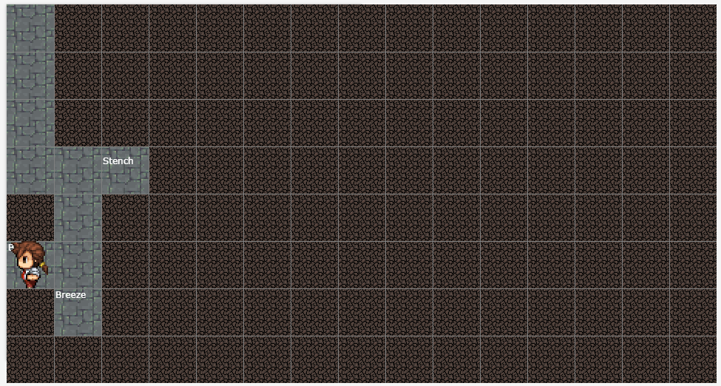

**PROCESO DE INFERENCIA.**

$$¬S_{6,1}→¬W_{7,1}∨{¬W}_{5,1}$$

$$B_{6,1}→P_{7,1}∧P_{5,1}$$

$$B_{6,1}∨ B_{7,2}→P_{7,1}$$

$$¬R_{6,1}→¬G_{7,1}∨{¬G}_{5,1}$$

**REPRESENTACIÓN DEL CONOCIMIENTO.**

|  |  |  |  |  |  |  |  |
| --- | --- | --- | --- | --- | --- | --- | --- |
| **CASILLA** | **VISIT (V)** | **STENCH (S)** | **BREEZE (B)** | **GLITTER (R)** | **WUMPUS (W)** | **PIT (P)** | **GOLD (G)** |
| **1,1** | 1 | 0 | 0 | 0 | 0 | 0 | 0 |
| **1,2** | 0 |  |  |  | 0 | 0 | 0 |
| **2,1** | 1 | 0 | 0 | 0 | 0 | 0 | 0 |
| **2,2** | 0 |  |  |  | 0 | 0 | 0 |
| **3,1** | 1 | 0 | 0 | 0 | 0 | 0 | 0 |
| **3,2** | 0 |  |  |  | 0 | 0 | 0 |
| **3,3** |  |  |  |  | ? | 0 | 0 |
| **4,1** | 1 | 0 | 0 | 1 | 0 | 0 | 0 |
| **4,2** | 1 | 0 | 0 | 0 | 0 | 0 | 1 |
| **4,3** | 1 | 1 | 0 | 0 | 0 | 0 | 0 |
| **4,4** | 0 |  |  |  | ? | 0 | 0 |
| **5,1** | 0 | 0 | 0 | 0 | 0 | 0 | 0 |
| **5,2** | 1 |  |  |  | 0 | 0 | 0 |
| **5,3** | 0 |  |  |  | 0 | 0 | 0 |
| **6,1** | 1 | 0 | 1 | 0 | 0 | 0 | 0 |
| **6,2** | 1 |  |  |  | 0 | 0 | 0 |
| **6,3** | 0 |  |  |  | 0 | 0 | 0 |
| **7,1** | 0 |  |  |  | 0 | 1 | 0 |
| **7,2** | 1 | 0 | 1 | 0 | 0 | 0 | 0 |
| **7,3** | 0 |  |  |  | 0 | 0 | 0 |
| **8,2** | 0 |  |  |  | 0 | 0 | 0 |
| **…** | 0 |  |  |  |  |  |  |