Recognition of Sketching based on Machine Learning

To: Dr. CHAN Kwai Hung
PAN FENG (2005 8934) - Representative
WU ZEZHEN (2005 9008)
XIE CHUYANG (2005 8892)
ZHANG MINYU (2005 8843)
ZHANG ZICHUAN (2005 8933)

Class: CCIT 4080 - CL06
Submission Date: 21 April 2019

Contents

Abstract ································· p. 4
1. Introduction ································· p. 5
1.1 Project Description ································· p. 5
1.2 Project Objectives ································· p. 5
1.3 Project Development Process ································· p. 5
2. Detailed Requirement Specifications ································· p. 6
2.1 Functional Requirements ································· p. 6
2.2 Non-functional Requirements ································· p. 6
2.2.1 System Requirement ································· p. 6
2.2.2 Availability ································· p. 6
2.2.3 Reliability ································· p. 6
2.2.4 Usability ································· p. 6
2.2.5 Efficiency ································· p. 6
2.2.6 Reusability ································· p. 7
3. Detailed Design Specifications ································· p. 8
3.1 Dataset ································· p. 8
3.2 Loading data ································· p. 8
3.3 Training data ································· p. 8
3.4 UI ································· p. 8
4. Evaluation ································· p. 9
4.1 Test methodology ································· p. 9
4.2 Test cases and data ································· p. 9
4.3 Test result and analysis ································· p. 9
5. Conclusion ································· p. 10
5.1 Critical Review ································· p. 10
5.2 Further Studies & Development ································· p. 10
5.3 Learnings ································· p. 10
Appendices ································· p. 11
References ································· p. 12

Abstract

The purpose of this report is to describe our final year project of the course Project on Knowledge Projects Development, named Pictionary: Recognition of Sketching based on Machine Learning. This is a final report which summarizes the project including Detailed Requirement Specifications, Detailed Design Specifications, Evaluation and Overall Impression.
This report firstly clarifies that the project is designed to recognize the sketching. Before explaining the details, The goal of this project is to help preschool children study and explore how to represent an item by sketching. The development details like the programming language, IDE and some external tools are Python, TensorFlow, Pygame, Keras and Visual Studio Code (VS Code). During the test, our software runs smoothly and it is able to give the result.
In the conclusion part, this report critically summarizes the strengths and weaknesses of the project. At the same time, this report includes further studies and development. Finally, this report writes about the learning gains and problems of G32 members.

1. Introduction
1.1 Project Description
Pictionary: Recognition of Sketching based on Machine Learning, is a powerful intelligent platform, which is designed to recognize the sketching. When the user draws an image on the sketching panel, the system will start working to do the matching and display the image of the recognized result which the user drawn. For example, this software will work like this: if users draw an apple on the drawing board, then the system will output an apple image real-timely.
Python is used as the developing language of the software and all the coding is based on Visual Studio Code, which is the Integrated Development Environment. Also, the intelligent function is developed with Keras, an application programming interface of Tensorflow, and the sketching panel is developed with Pygame.

1.2 Project Objectives
Machine learning has great potential for preschool education and a scarce market. To make a business value of Pictionary in the field of preschool education. Our ideal goal is that preschool students can learn and explore new things by using this software. Pictionary has two advantages over traditional text learning. Firstly, drawing images are easier to remember than reading. Secondly, the machine recognition with a vivid display of results enables the preschool student to learn independently. We always adhere to the project objective during the whole process.

1.3 Project Development Process
In the horizontal workload, including finding dataset, data loading (Initialization), model training and user interface (UI) are properly assigned to all group members. On the vertical timeline process, we arrange a day to discuss the Final Group Project together each week and prepare for a phased presentation each two weeks. It should also be noticed that the Logbook is used to record the whole project development process. The Logbook can be found in SOUL2.0 submission platform.

2. Detailed Requirement Specifications
2.1 Functional Requirements
Our system requires users to be able to use the mouse or the touchpad on their laptops to draw the sketches as the input data. The system would start to match the user sketch with our existing dataset and display the reference outcome. If the user wants to clean the current sketches and continue drawing other items, press “Q” to clear the board and repeat the whole process. The user also could click to close the window to quit the system if user wants to end.
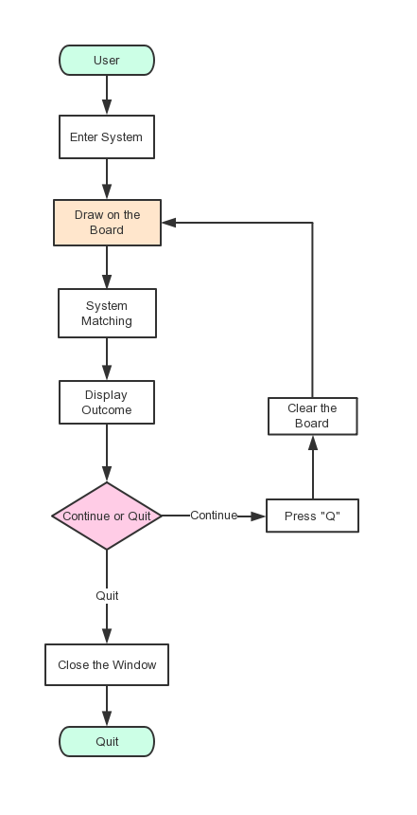
Figure 2.1.1 Flow diagram
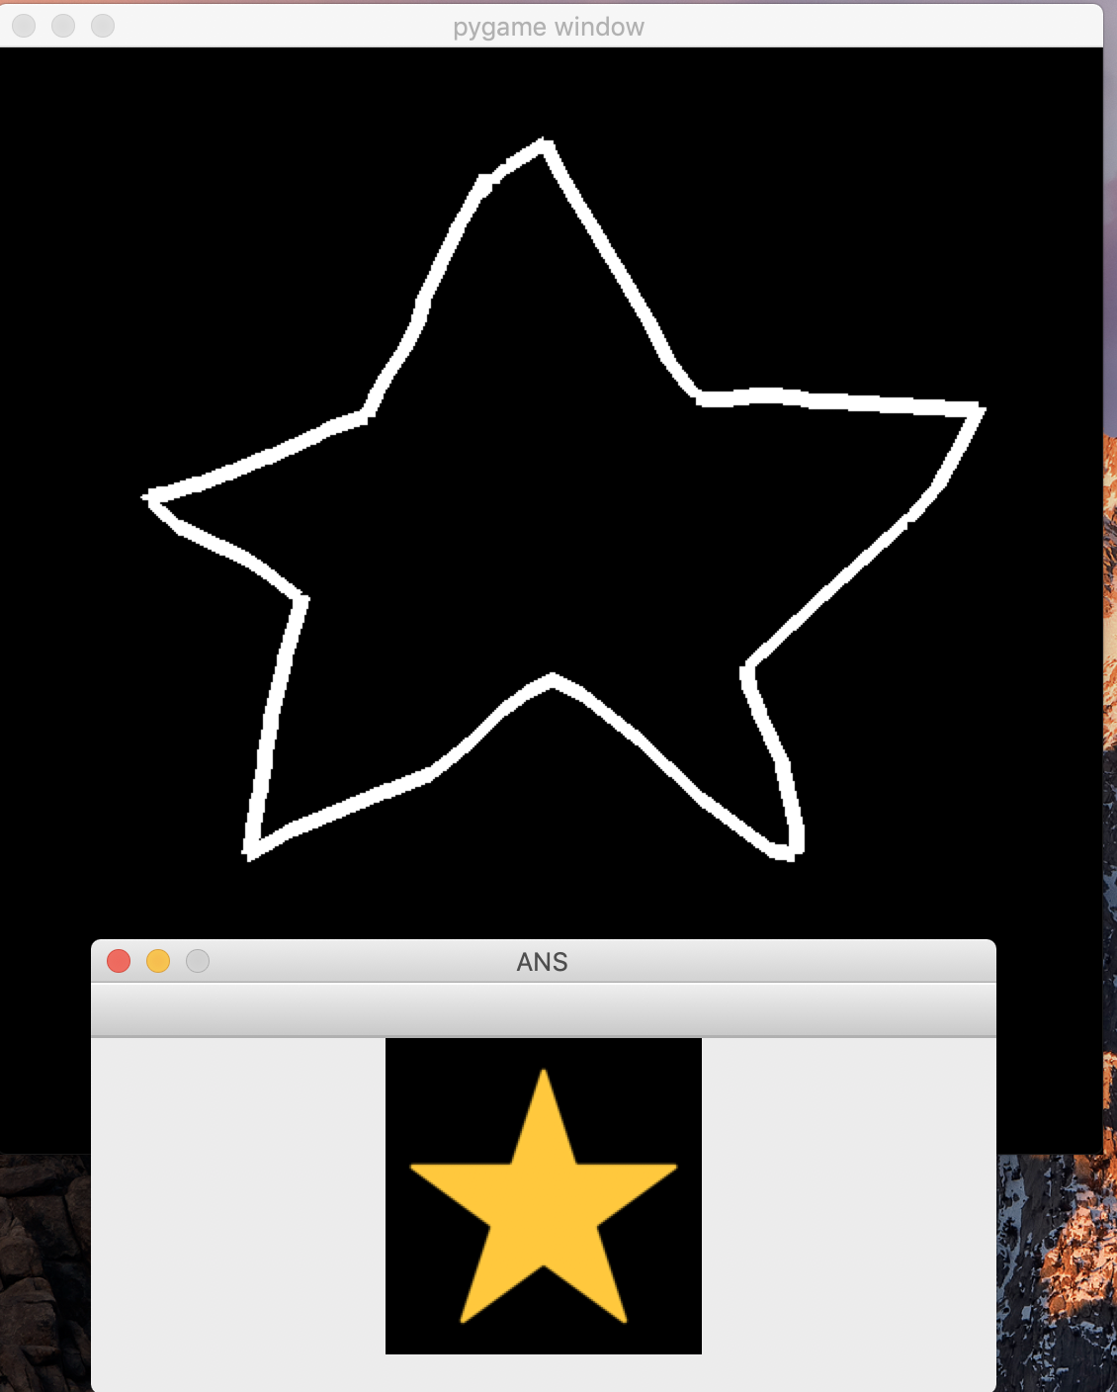
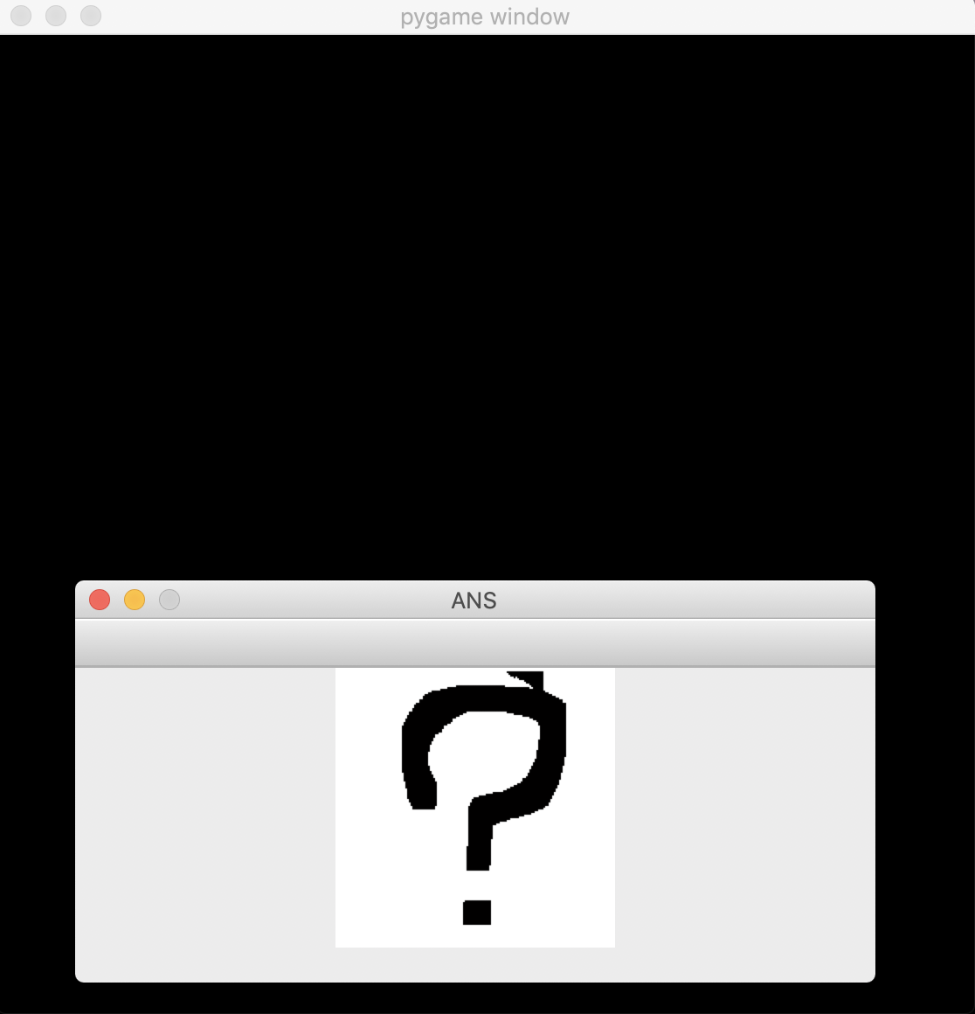
Figure 2.1.2 Prototype diagram(1) Figure 2.1.3 Prototype diagram(2)

2.2 Non-functional Requirements
2.2.1 System Requirement

In our project, this system needs to use the machine learning technique in order to learn from the plenty of given training dataset and can predict results when new data arrives. In view of feasibility, the system needs to choose a proper neural network as our learning framework. Convolutional neural networks are the most advanced network in image recognition and have the ability to study interpretable representations of data (Acquarelli et al., 2017). Compared with other machine learning method of frameworks, tensorflow, a convolutional neural network, is a suitable choice when developing the recognition of images and sounds. Unlike other deep and feedforward neural networks, convolutional neural networks have fewer parameters to consider, making it a proper deep learning structure.

To introduce the tensorflow and implement a sketching platform like a game, normally, Python is the best choice of language to write this program. As it has many advantages which other languages do not have. Python ensures developers are available to call many functions from various of libraries in a simplified way and it is one of the most commonly used language nowadays. For data training, we called different functions from Keras. Keras is the library that provides powerful blocks to build deep learning networks (Ketkar, 2017), it has well-developed modularity, every single configurable modules can be freely grouped together and we can use them to build our own models. Also, it has good extensibility and it is easy to add new modules, simply by writing new classes or functions that mimic existing modules.

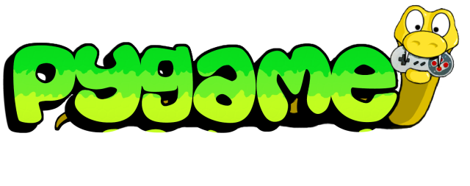
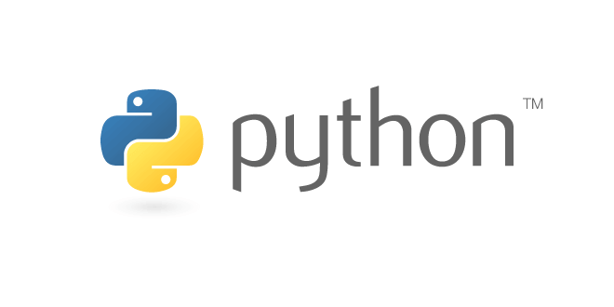
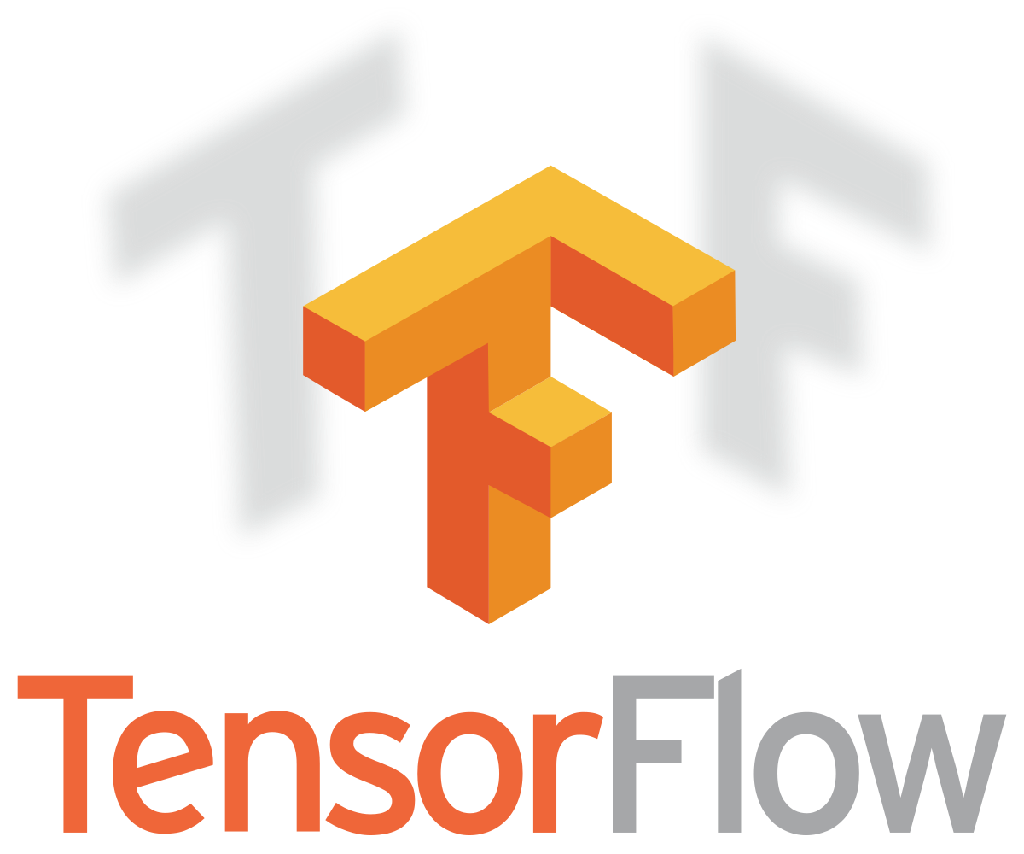
Figure 2.2.1 Python Figure 2.2.2 Pygame

Figure 2.2.3 Visual Studio Code Figure 2.2.4 TensorFlow

As for the user interface, we imported the Pygame , which is a python game developing library contains many useful functions for the UI design and the graphics aspects are completely reduced to the game logic itself. Pygame is a free framework which offers many sound and visual elements for Python (Kelly, 2016).

2.2.2 Availability
The users can be accessible to the software system when they try to enter it. Because the Pictionary do not require the Internet, the software can run normally all the time. Whenever the users enter the system, it can work well.

2.2.3 Reliability
The software system can operate normally with the minimize failure. The normal operation of our software system can be assurable.

2.2.4 Usability
Pictionary is easy for users to learn and use. Our software system has well-developed user interface and the users can operate it easily in the very short time.

2.2.5 Efficiency
The platform can make response according to the users instructions or operations as fast as possible. Our software system is real-time response and display the outcome immediately when user input data.

2.2.6 Reusability
The executed running file can be directly run in Windows or user can compile the *.py file with an environment already installed python, numpy, matplotlib, keras, openCV, pandas, h5py and scipy.

3. Detailed Design Specifications
3.1 Dataset
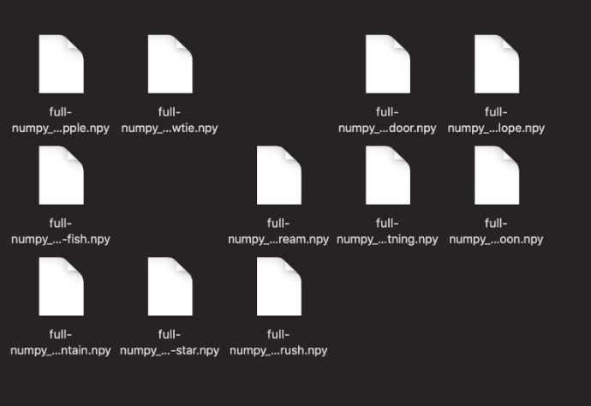
Machine learning is a classifier based on the training dataset. To have a acceptable accuracy of classification, having a large amount of data for training is necessary. During the research, we found that Google open sourced a dataset called ‘Quick,Draw’, which is available on the Github. It is a collection of 50 million drawings across 345 Figure 3.1: Our data files categories. The dataset contains three different file-types. In our project, we choose ten categories of sketching data: apple, bowtie, door, envelope, fish, ice cream, lightning, mountain, star and brush, which are Numpy bitmap files.

3.2 Loading data
Loading data is the initialization of the training CNN model. In order to load data, Daniel wrote a “LoadData.py” to read the *.npy files from ./data, then program will manipulate the storing of features and labels in pickle files. After that, the dataset is ready for CNN training.

3.3 Training data
The data training based on the previous initialization, the features and labels files, that “LoadData.py” executed. The program “QD_trainer.py” will load data from pickle files to get the features and labels and augment them, then send all the data into the Keras model for training. Checking with the loss rate and accuracy rate from the specific log directory on tensorboard, obviously, the accuracy rises from 0.92 to 0.98 when the training time increase from 0 to 5. The loss rate also decreases from 0.23 to 0.07 along with the training time.

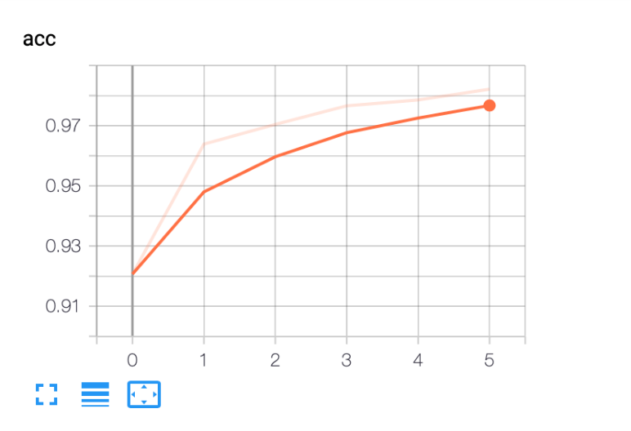
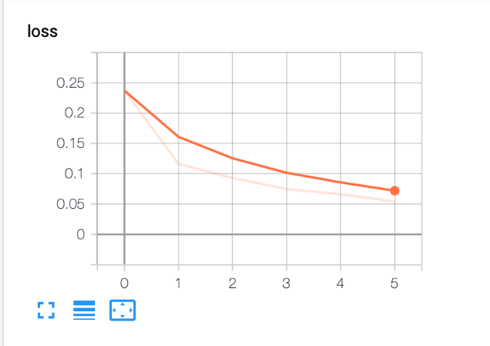

Figure 3.2: The training accuracy Figure 3.3: The training loss rate

3.4 UI and assumption
For the UI design, we introduce Pygame, which is a cross-platform package with a set of Python modules for Python Game Development. In the program, the system will real-timely check whether the user press the mouse down or not, if there is a mouse event activated, the system will perform different works with MOUSEBUTTONDOWN, MOUSEBUTTONUP and MOUSEMOTION to implement sketching function by mouse.
After get the input data, the system will put the ordered image into keras model to predict and recognize the painting and generate a emoji image refer to the results.

4. Evaluation
4.1 Test methodology
The test methodology is inviting testers in random to draw the items on our system panel to detect whether the program can recognize them accurately. The test was invited in student common room at KEC (Kowloon East Campus). There are 100 people were invited for our system on 12th of April 2019.

4.2 Test cases and data
In order to achieve a more accurate result, the testers were asked to draw the items that our system have been trained, which are apple, bowtie, door, fish, ice cream, mountain, brush, star, lightning and envelope. Each of item we asked 10 testers to draw.

4.3 Test result and analysis
Totally there are 56 cases were succeeded during the test. The item star has the highest rate of success, which is 100%. Our program can recognize the item that testers draw successfully. The success rate of envelope is 70%. The program cannot recognize the sketches of three testers. For the whole framework of envelope, it is very similar to door. This may be a cause that the program cannot recognize them. The success rate of lightning is 60%. For those four fail cases, our program recognized all of them to star. It may both star and lightning have a couple of sharp angles. The success rate of apple is 40%. Our program may recognize them to star or door. We also tried some tests after the invitation of testers, then we found that the success rate will increase obviously if we draw the sketch full of the panel. It may be due to the raw sketches need to be enlarged to the same size as the entire panel during the program recognition. For the failure case of other items, our program will recognize them as different items randomly. However, the success rate of our Keras training model is very high, which maintains to nearly 97%. Analyzing the reasons of it, we thought it is due to the noise of image data when our program achieves the image data. The sketches are distorted when our program acquires those image data, so our program cannot recognize them clearly.
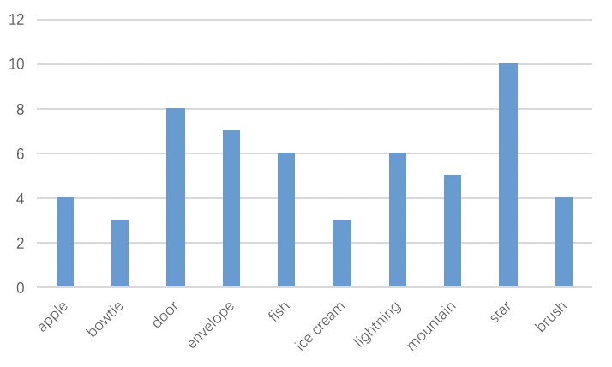

Figure 4.1: The number of our program successfully recognized the tester's drawing

5. Conclusion
5.1 Critical Review
We completed all workload consists of Dataset, Data Loading, Data Training and UI design. The final year project namely Pictionary: Recognition of Sketching based on Machine Learning is completed finally. During our tests, this software has been able to reach our original project objective. In more than half a year of the course Project on Knowledge Projects Development learning, we follow and finish the whole project development process, which is recorded and visible in the Logbook.

5.2 Further Studies & Development
The ideal outcome of the final year project Pictionary is to make it commercialization in the field of preschool education. Although we have finished the whole development, we have certain parts left unfinished before the product being put on the market. As for the platform, the PC terminal is sufficient, but not extensive and convenient. We decided to port the Pictionary to the mobile application in the future through the Android APP based on Android Studio and IOS APP based on Swift. The multi-platform will better expand the market and facilitate the use of preschool students anytime and anywhere. As for the product quality, we will continue to improve and test the software in order to improve accuracy.

5.3 Learnings
From the beginning, self-learning ability has always been one of the important skills during the whole development of the project. We have been learning and practicing new knowledge, including the Python programming language, TensorFlow, IDE, Visual Studio Code, etc. In such learning process, we not only had a better grasp of the Programming language, but also got new ideas and could discovered new problems. These innovative thought could improve our Final Group Project. We took a day to discuss the Project together each week. We were constantly discovering and solving problems and completing our own works step by step. Finally, this persistence make us successfully completed our Final Group Project - Pictionary: Recognition of Sketching based on Machine Learning.

References

Acquarelli, J., Laarhoven, T. V., Gerretzen, J., Tran, T. N., Buydens, L. M., & Marchiori, E. (2017). Convolutional neural networks for vibrational spectroscopic data analysis. Analytica Chimica Acta,954, 22-31.

Kelly, S. (2016). Basic Introduction to PyGame. Python, PyGame and Raspberry Pi Game Development,59-65.

Ketkar, N. (2017). Introduction to Keras. Deep Learning with Python,97-111.

