High brand equity can be a very valuable quality for organisations and a source of competitive advantage. Brand-loyal customers are a valuable source of revenue for a company **(E-marketing book).** Greenaer must develop a strong source of brand loyal customers and regularly interact with these customers. The challenge is to make the Greenaer brand a household brand.

Greenaer will be made into two subsidiaries: Greenaer E-bike and Greenaer Tours. Greenaer Tours is the focus of this product description. Greenaer Tours will provide guided and self-guided e-bike tours in Dublin and Wicklow. The Dublin tour will be branded “Discover Dublin” and the Wicklow tour will be branded “Explore the Garden of Ireland”. This justifies the product’s name as e-bike tours is the sole service of Greenaer Tours. Greenaer values combining environmentally friendly activities with a healthy, active lifestyle.

The “Later Life Leisure Tourists” and “Travel Cyclists” have been identified as Greenaer’s target markets. “Later Life Leisure Tourists” have been identified as individuals over the age of 55 from Ireland, the United Kingdom and Germany. This age group have been recognised as the most suitable to Greenaer as they tend to have the highest discretionary income. “Later Life Leisure Tourists” have identified heritage and culture as a key feature during tourist activities. The “Discover Dublin” tour has been tailor-made around these features. The Glasnevin Cemetery, Phoenix Park and Áras an Uachtaráin have all been included in this route. Through identifying the most suitable target market for Greenaer Tours, the “Discover Dublin” route was created.

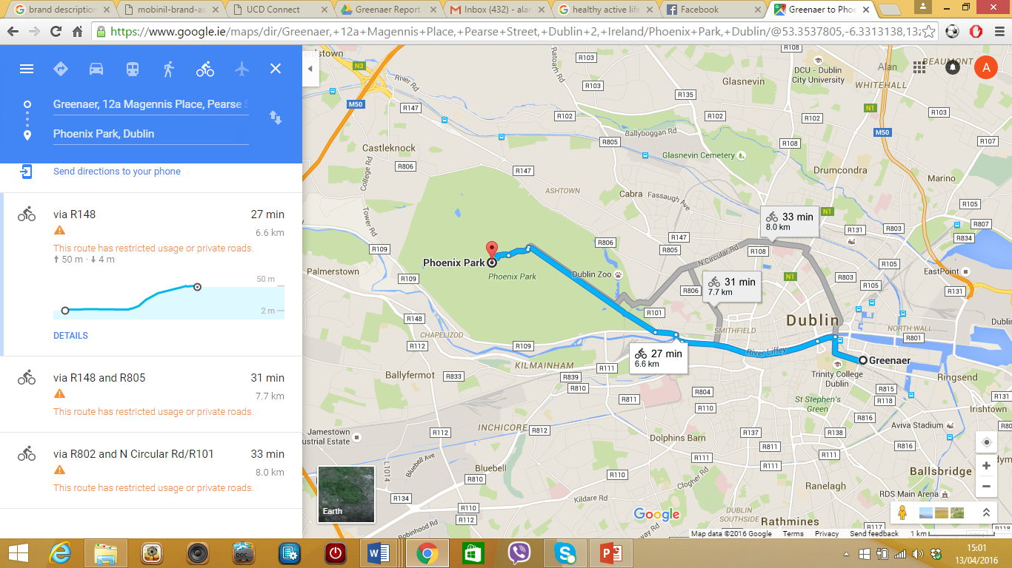

The “Travel Cyclists” are classified as active cyclists who are open to the possibility of visiting Ireland in the near future. This target market will again consist of Irish, British and German cyclists. The “Travel Cyclists” market consists of physically active individuals. While on vacation, this target market will be more likely to participate in e-bike tours as it is a method of staying active and experiencing Irish landscape and culture. The “Travel Cyclists” market will consist generally of individuals and families. INSERT STOPS. The “Explore the Garden of Ireland” route will entail of family-orientated features. Glendalough will be a main tourist attraction of the “Explore the Garden of Ireland” route. Glendalough consists of family picnic areas and beautiful scenery, thus, attracting a large portion of the active “Travel Cyclists” in Western Europe.

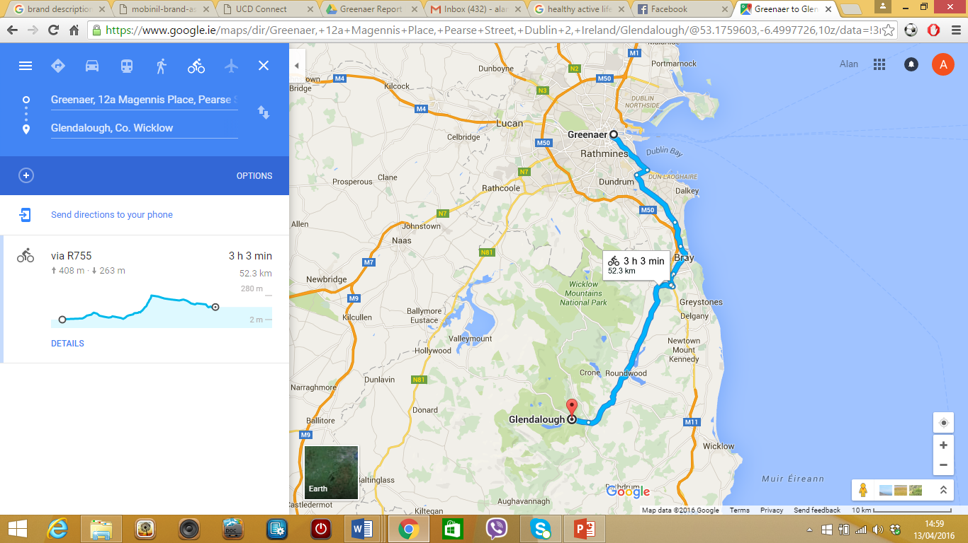

The German market has been targeted because 18% of the German population have previously cycled while travelling and would consider visiting Ireland.