Git repo name: <https://github.com/MagicScorpion/itms528>

Submit any changes or files to this repo.

|  |  |  |
| --- | --- | --- |
| Task | Description | Status |
| Task 1 | Create a database with at least 7 tables and 1000+ entries, 5 users. Use MySQL Workbench, and MySQL | Completed |
| Task 2 | Implementation of NIST Special Publication 800-53 control AC-2 ACCOUNT MANAGEMENT https://nvd.nist.gov/800-53/Rev4/control/AC-7 |  |
| Task 3 | Implementation of NIST Special Publication 800-53 control AC-5 SEPARATION OF DUTIES https://nvd.nist.gov/800-53/Rev4/control/AC-5 |  |
| Task 4 | Implementation of NIST Special Publication 800-53 control AC-8 SYSTEM USE NOTIFICATION https://nvd.nist.gov/800-53/Rev4/control/AC-8 |  |
| Task 5 | Implementation of NIST Special Publication 800-53 control AC-7 UNSUCCESSFUL LOGON ATTEMPTS https://nvd.nist.gov/800-53/Rev4/control/AC-7 | Completed |
| Task 6 | Implementation of NIST Special Publication 800-53 control AT-4 SECURITY TRAINING RECORDS https://nvd.nist.gov/800-53/Rev4/control/AT-4 |  |
| Task 7 | Implementation of NIST Special Publication 800-53 control AU-8 TIME STAMPS https://nvd.nist.gov/800-53/Rev4/control/AU-8 |  |
| Task 8 | Implementation of NIST Special Publication 800-53 CA-5 PLAN OF ACTION AND MILESTONES https://nvd.nist.gov/800-53/Rev4/control/CA-5 |  |
| Task 9 | Perform project management tasks. Creation of Project Management Plan (PMP), project schedule, Earned Value Management System (EVMS) reporting. Templates to be provided. *Also data must be encrypted at rest and in transit. Create a system to implement this. |  |

1. Database name: itms528
2. Table name: “current_employee_names__salaries__and_position_titles”

**Task1:** Create a database with at least 7 tables and 1000+ entries, 5 users. Use MySQL Workbench, and MySQL **(Completed)**

Our database has 8 columns with 31080 entries:

I have added 6 users (password is same as user id)

1. alex/alex
2. andy/andy
3. aneesh/aneesh
4. dhruvesh/dhruvesh
5. manish/manish
6. prathamesh/prathamesh

The roles are as per below:

1. alex : DBA

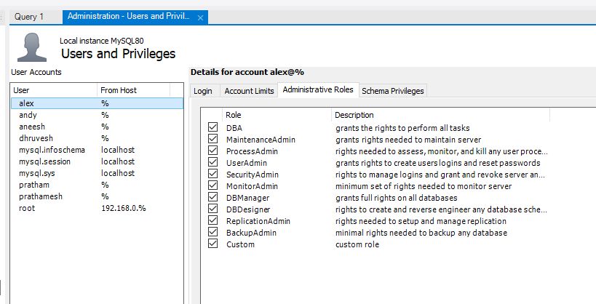

1. andy : db manager

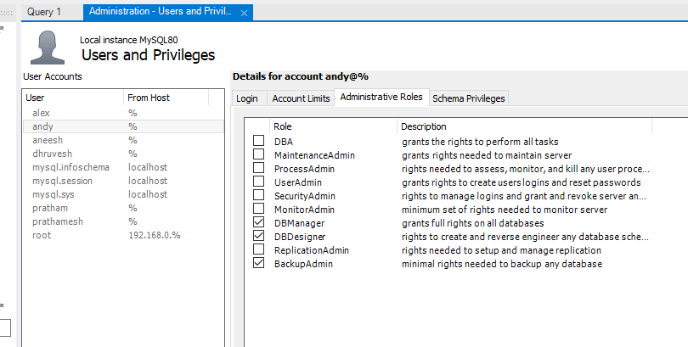

1. Aneesh : UserAdmin

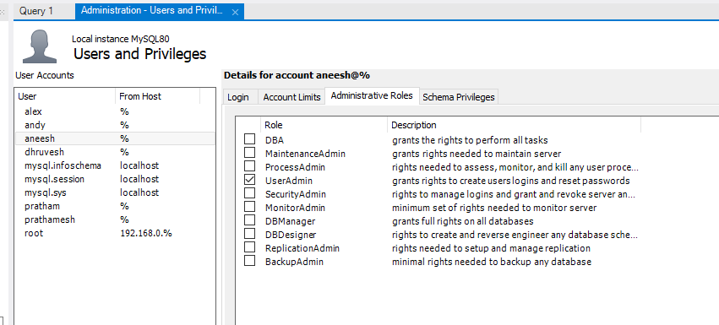

1. Dhruvesh : ProcessAdmin

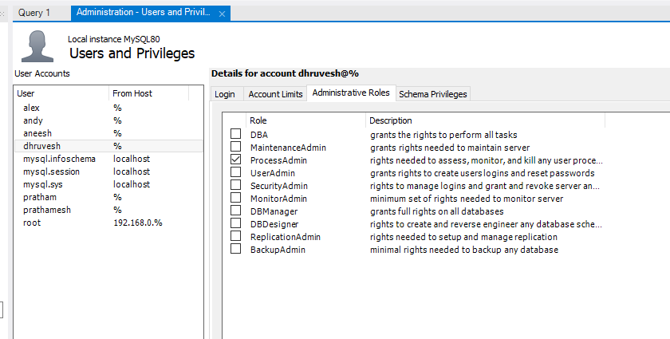

1. Manish: MaintenanceAdmin

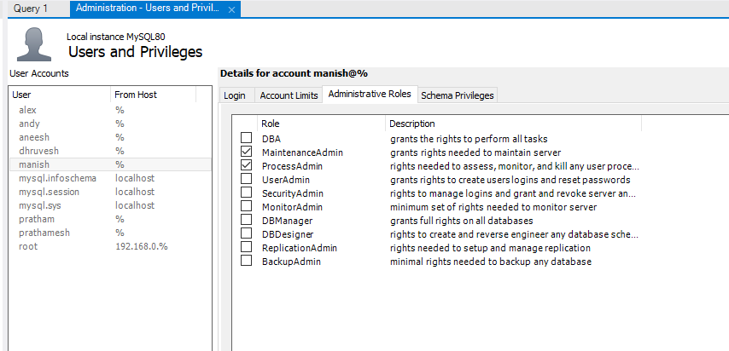

1. Prathamesh: SecurityAdmin

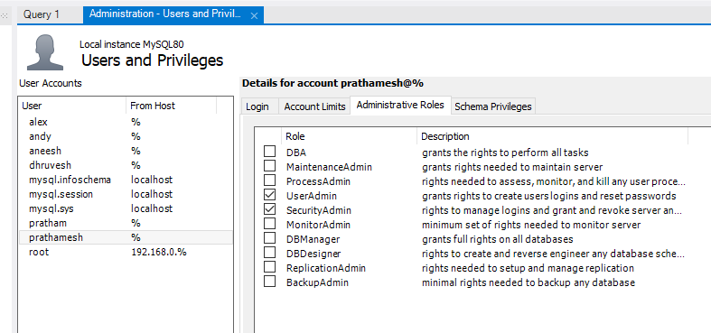

Table: current_employee_names__salaries__and_position_titles  
  
Columns:

|  |  |
| --- | --- |
| Name | text |
| Job Titles | text |
| Department | text |
| Full or Part-Time | text |
| Salary or Hourly | text |
| Typical Hours | text |
| Annual Salary | text |
| Hourly Rate | text |

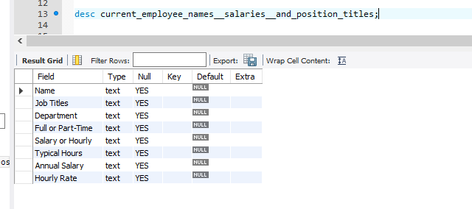

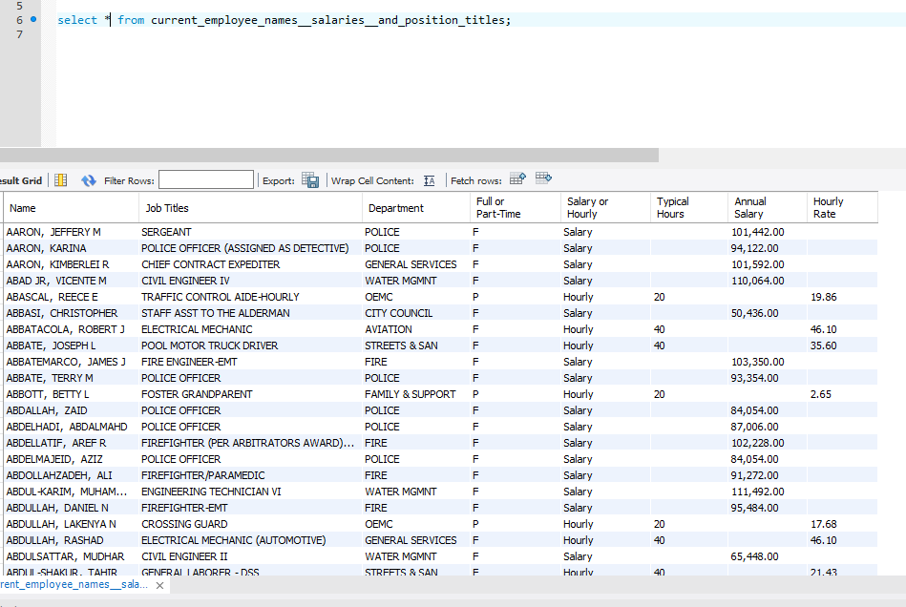

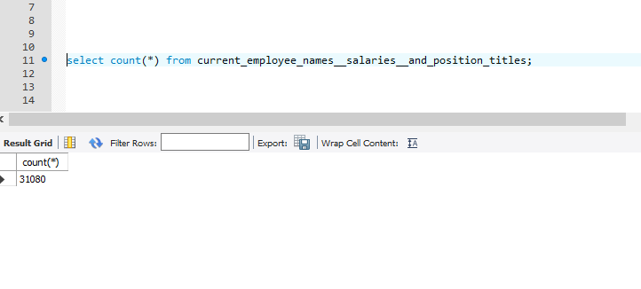

**Task 5:** Implementation of NIST Special Publication 800-53 control AC-7 UNSUCCESSFUL LOGON ATTEMPTS <https://nvd.nist.gov/800-53/Rev4/control/AC-7> (Completed)

To implement unsuccessful login attempts, you need to install the following plugins.

# Installing the plugin

INSTALL PLUGIN CONNECTION_CONTROL SONAME 'connection_control';

INSTALL PLUGIN CONNECTION_CONTROL_FAILED_LOGIN_ATTEMPTS SONAME 'connection_control';

# To view the variables

show variables like 'connection_control%';

# Set the limit

set global connection_control_failed_connections_threshold=3;

set global connection_control_min_connection_delay = 4000;