第一次实验

1.1

#include<iostream>

using namespace std;

int main()

{

int k = 0;

int i = k + 1;

cout << i++ << endl;

i = 1;

cout << i++ << endl;

cout << "Welcome to C++" << endl;

return 0;

}

1.2

// project.1.2.cpp : 此文件包含 "main" 函数。程序执行将在此处开始并结束。

//

#include <iostream>

int main()

{

double π = 3.14;

std::cout << "该程序用于计算圆锥的体积" << std::endl;

double r, h, V;

std::cout << "请输入圆锥的半径:r = ";

std::cin >> r;

std::cout << "请输入圆锥的锥高:h = ";

std::cin >> h;

V = 0.333333 * π*(r * r) * h;

std::cout << "圆锥的体积为：V = "<<V<<std::endl;

}

// 运行程序: Ctrl + F5 或调试 >“开始执行(不调试)”菜单

// 调试程序: F5 或调试 >“开始调试”菜单

// 入门使用技巧:

// 1. 使用解决方案资源管理器窗口添加/管理文件

// 2. 使用团队资源管理器窗口连接到源代码管理

// 3. 使用输出窗口查看生成输出和其他消息

// 4. 使用错误列表窗口查看错误

// 5. 转到“项目”>“添加新项”以创建新的代码文件，或转到“项目”>“添加现有项”以将现有代码文件添加到项目

// 6. 将来，若要再次打开此项目，请转到“文件”>“打开”>“项目”并选择 .sln 文件

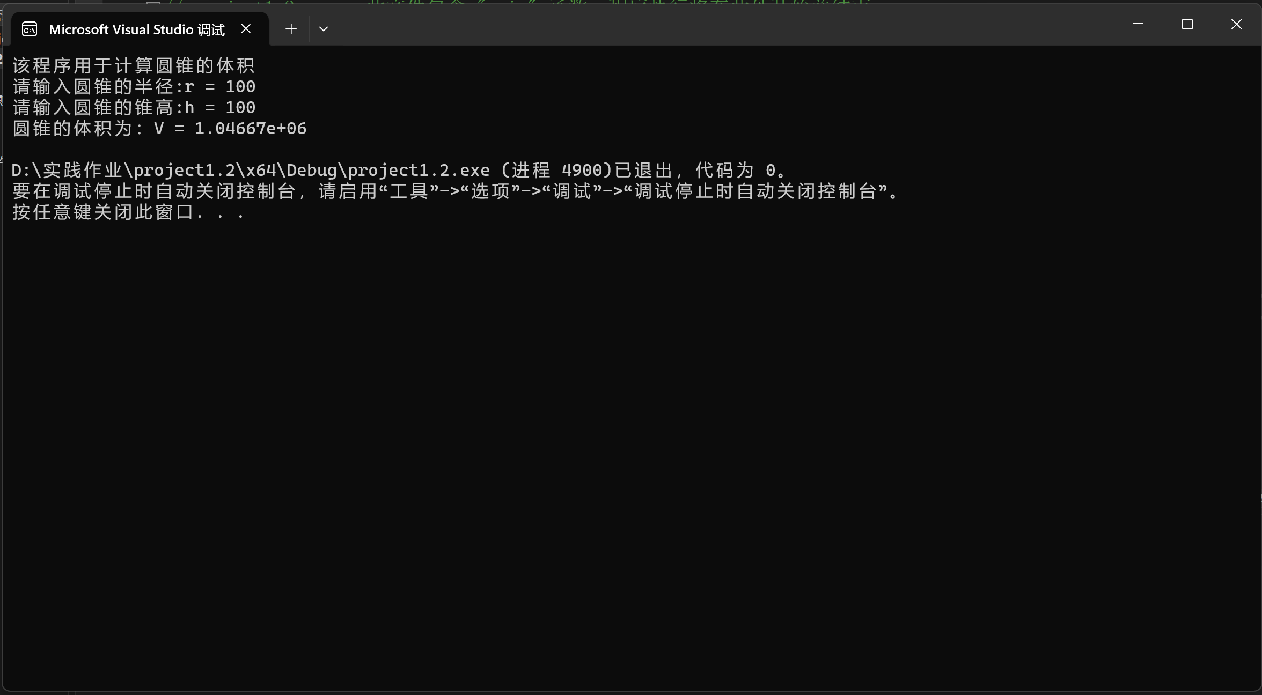

1.3

#include<iostream>

using namespace std;

int main()

{

cout << "bool length:" << sizeof(bool) << endl;

cout << "char length:" << sizeof(char) << endl;

cout << "unsighed char length:" << sizeof(unsigned char) << endl;

cout << "wchar_t length:" << sizeof(wchar_t) << endl;

cout << "int length:" << sizeof(int) << endl;

cout << "signed int length:" << sizeof(signed int) << endl;

cout << "unsigned int length:" << sizeof(unsigned int) << endl;

cout << "short int length:" << sizeof( short int) << endl;

cout << "long int length:" << sizeof(long int) << endl;

cout << "unsigned short length:" << sizeof(unsigned short) << endl;

cout << "unsigned long length:" << sizeof(unsigned long) << endl;

cout << "float length:" << sizeof(float) << endl;

cout << "double length:" << sizeof(double) << endl;

cout << "long double length:" << sizeof(long double) << endl;

return 0;

}

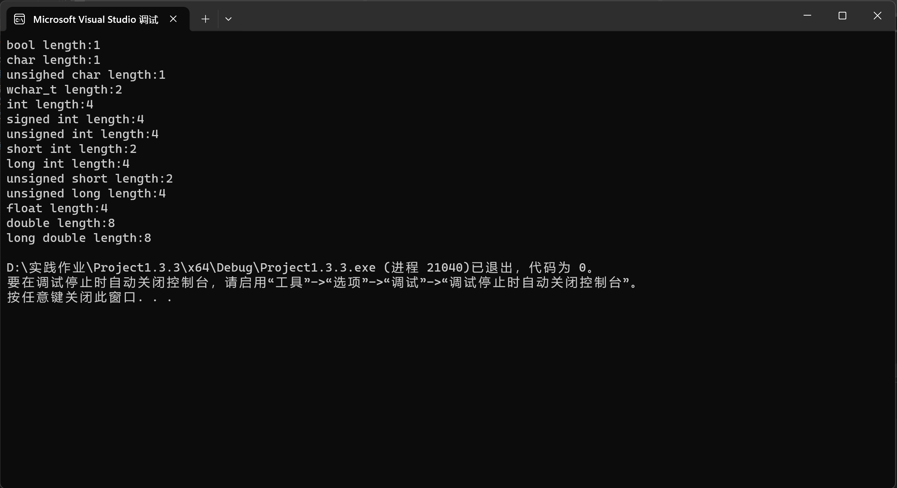

1.4

#include <iostream>

#include <iomanip>

using namespace std;

int main()

{

unsigned int testUnint = 65534;//oxfffe

cout << "output in unsigned int 1 type:" << testUnint << endl;//oct

cout << "output in unsigned int 1 type:" << oct << testUnint << endl;

cout << "output in char type:!" << static_cast<char>(testUnint) << endl;

cout << "output in short type:" << static_cast<short>(testUnint) << endl;//为什么结果为-2?:

cout << "output in int type:" << static_cast<int>(testUnint) << endl;

cout << "output in double type:" << static_cast<double>(testUnint) << endl;

cout << "output in double type:" << setprecision(4) << static_cast<double>(testUnint) << endl;

cout << "output in Hex unsigned int type:" << hex << testUnint << endl; //16进制输出

double x = 6.23;

cout << "output in int type:!" << static_cast<int>(x) << endl;

system("pause");

return 0;

}

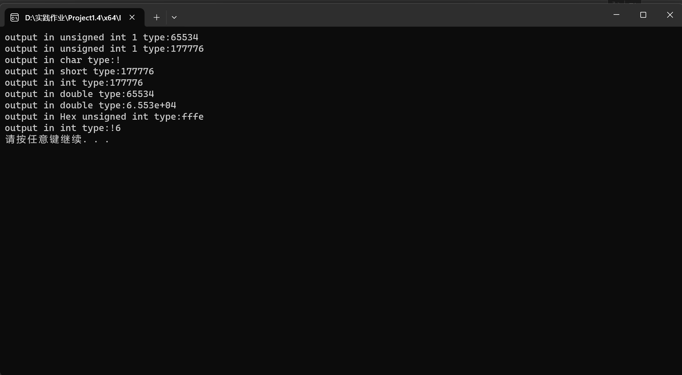

1.5

#include<iostream>

#include<iomanip>

int main()

{

float F, t;

std::cout << "该程序用于将华氏度转化为摄氏度。" << std::endl;

std::cout << "请输入华氏度：F = ";

std::cin >> F;

t = (F - 32) / 1.8;

std::cout << std::fixed << std::setprecision(2) << "对应的摄氏度为：t = " << t << std::endl;

}

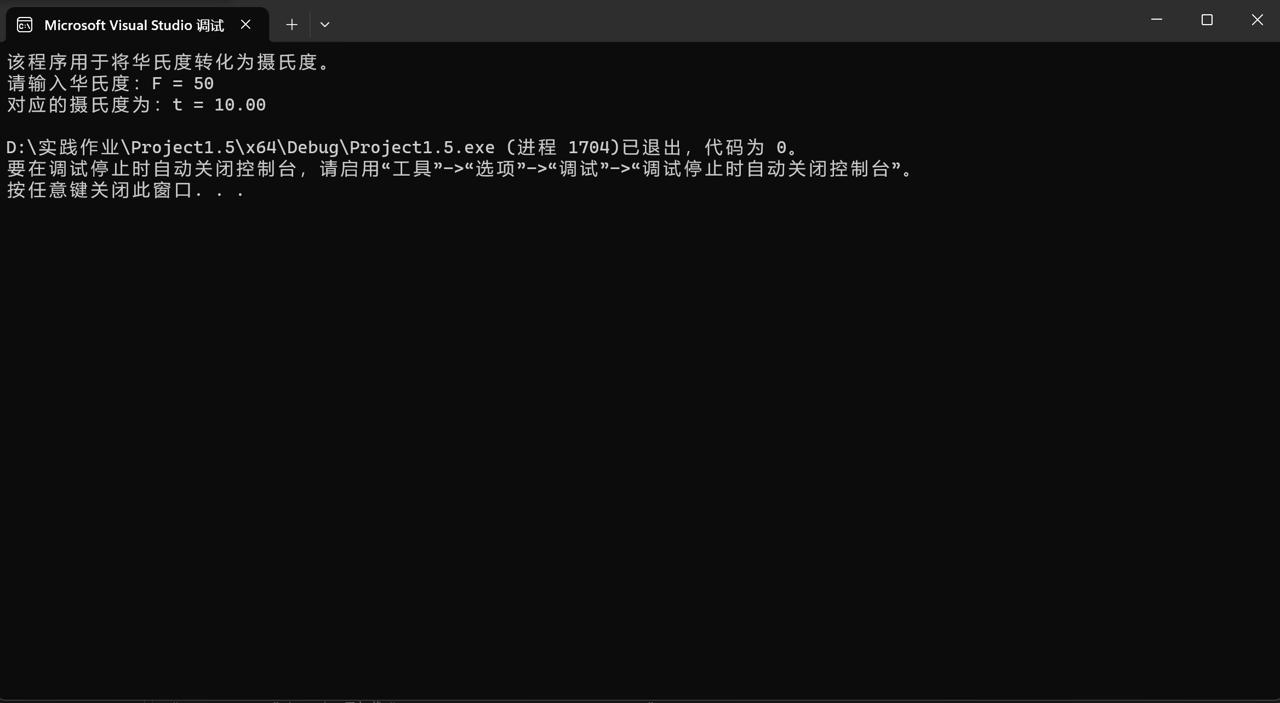

**遇到的问题与解决方法：**

**有一些基础的标识符，变量类型忘记了，进制转换的语法不太熟悉**

**解决方法是和同学交流以及查资料**

**体会：**

**第一次打这么多代码，连续两三个小时有点疲倦；**

**学习一些函数等基础知识之后去上手敲代码利于我更好的理解和记忆。**

第二次实验

2.1

#include <iostream>

int main()

{

char ch;

std::cout << "请输入一个字母：";

std::cin >> ch;

if (ch >= 'a' && ch <= 'z')

{

ch -= 32;

std::cout << ch << std::endl;

}

else if (ch >= 'A' && ch <= 'Z')

{

ch += 1;

std::cout << static_cast<int>(ch) << std::endl;

}

return 0;

}

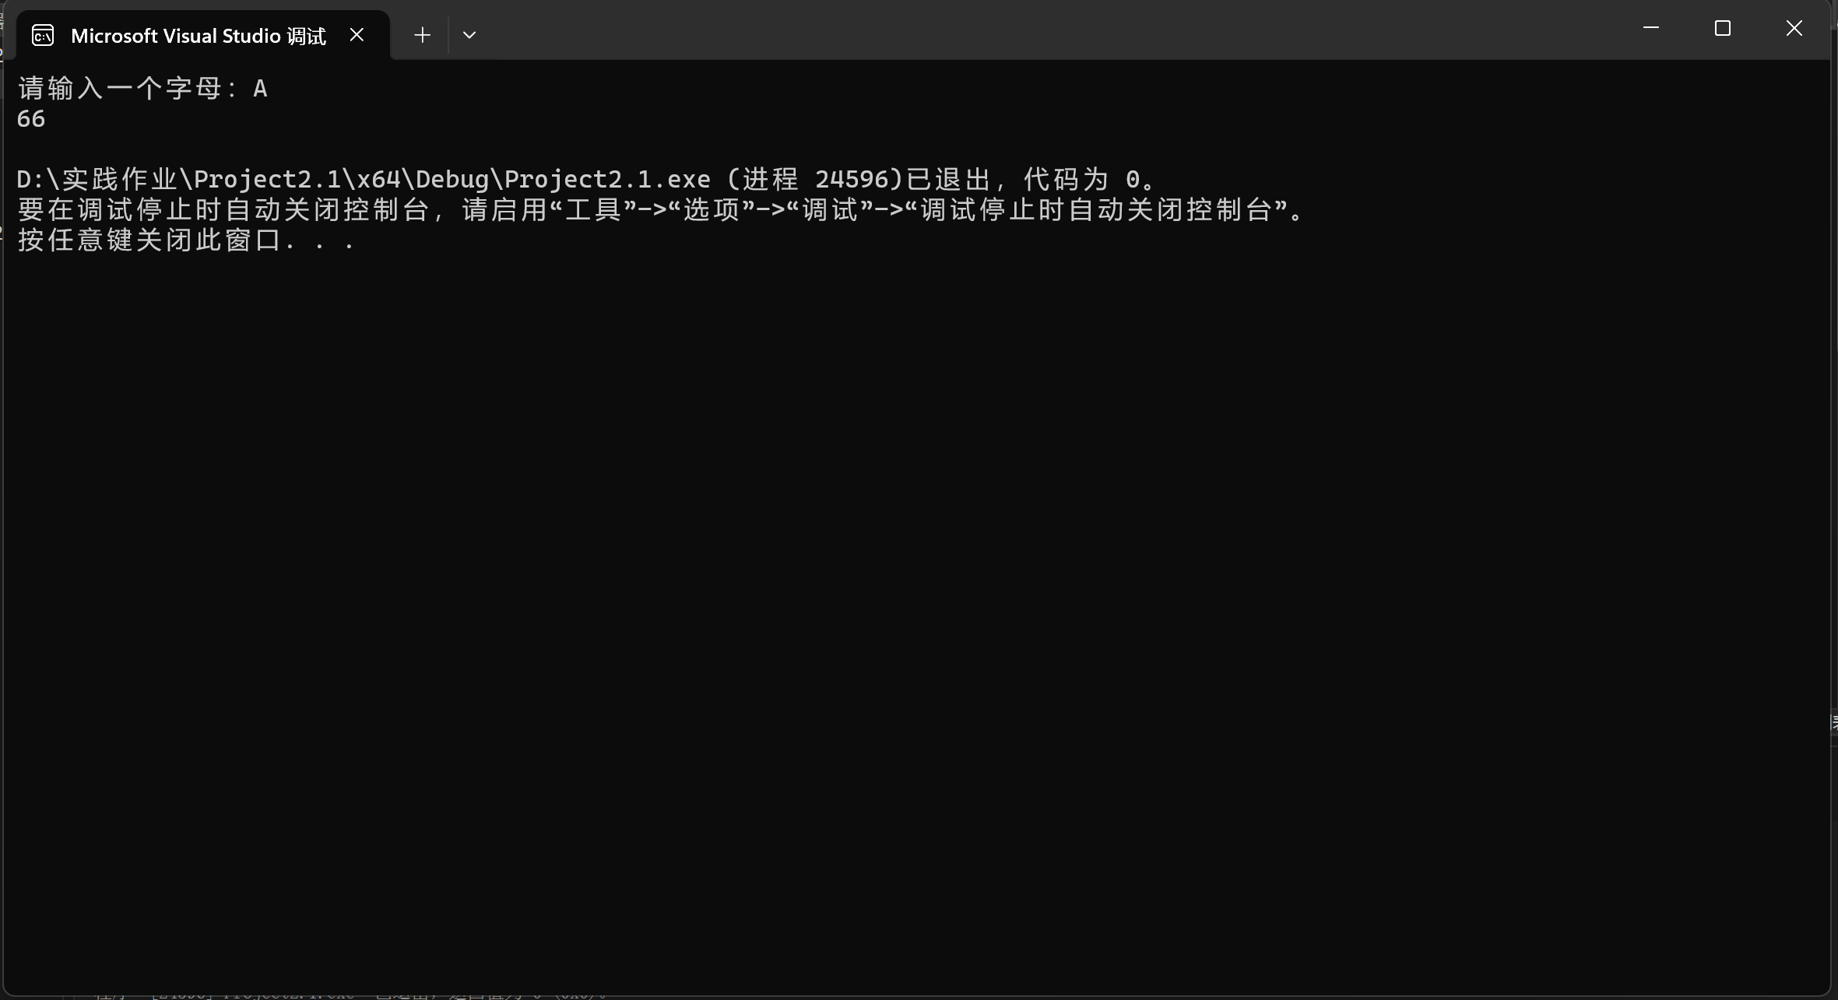

2.2

#include<iostream>

int main()

{

float x, y;

std::cout << "请输入一个0到10的实数（不包含）：x = ";

std::cin >> x;

if (0 < x < 1)

{

y = 3 - 2 * x;

}

else if (1 <= x < 5)

{

y = 2 / (4 * x) + 1;

}

else if (5 <= x < 10)

{

y = x * x;

}

std::cout << y;

return 0;

}

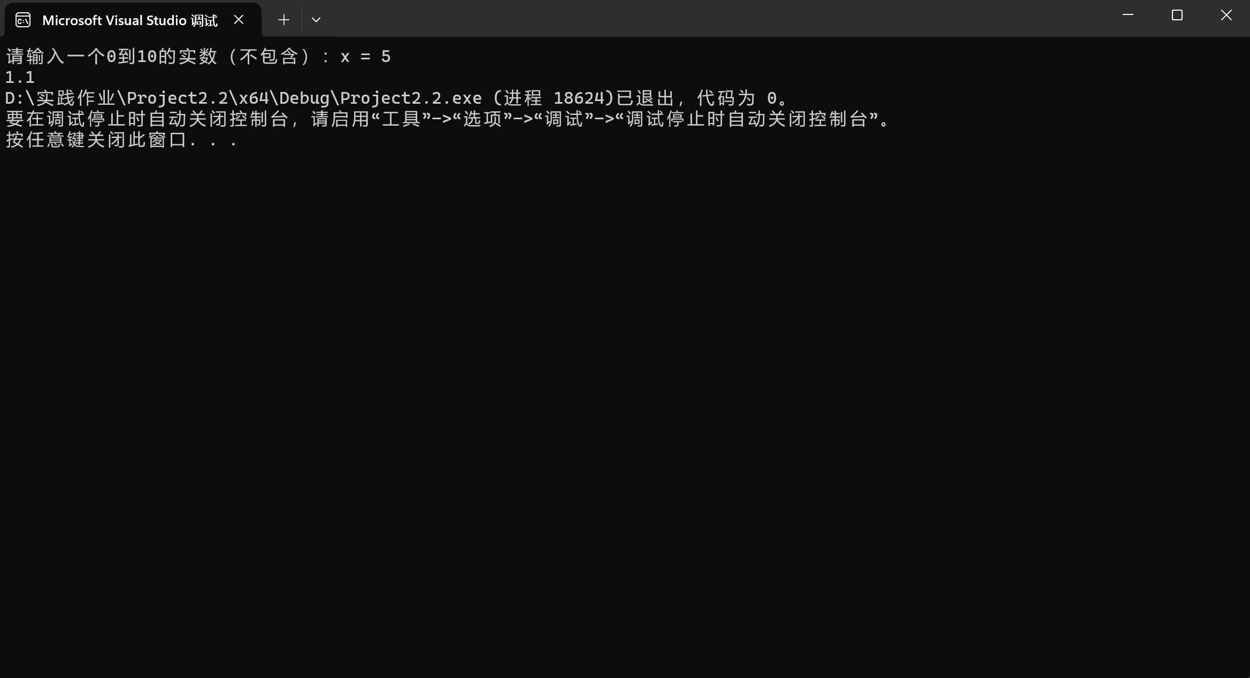

2.3

#include<iostream>

int main()

{

float a, b, c;

float C;

std::cout << "请输入三角形的三边长" << std::endl;

std::cout << "a = ";

std::cin >> a;

std::cout << "b = ";

std::cin >> b;

std::cout << "c = ";

std::cin >> c;

if (a + b <= c || a + c <= b || b + c <= a)

{

std::cout << "这不是三角形";

}

else

{

C = a + b + c;

std::cout << "三角形的周长C = " << C << std::endl;

if (a == b || a == c || b == c)

{

std::cout << "该三角形是等腰三角形" << std::endl;

}

else

std::cout << "该三角形不是等腰三角形" << std::endl;

}

}

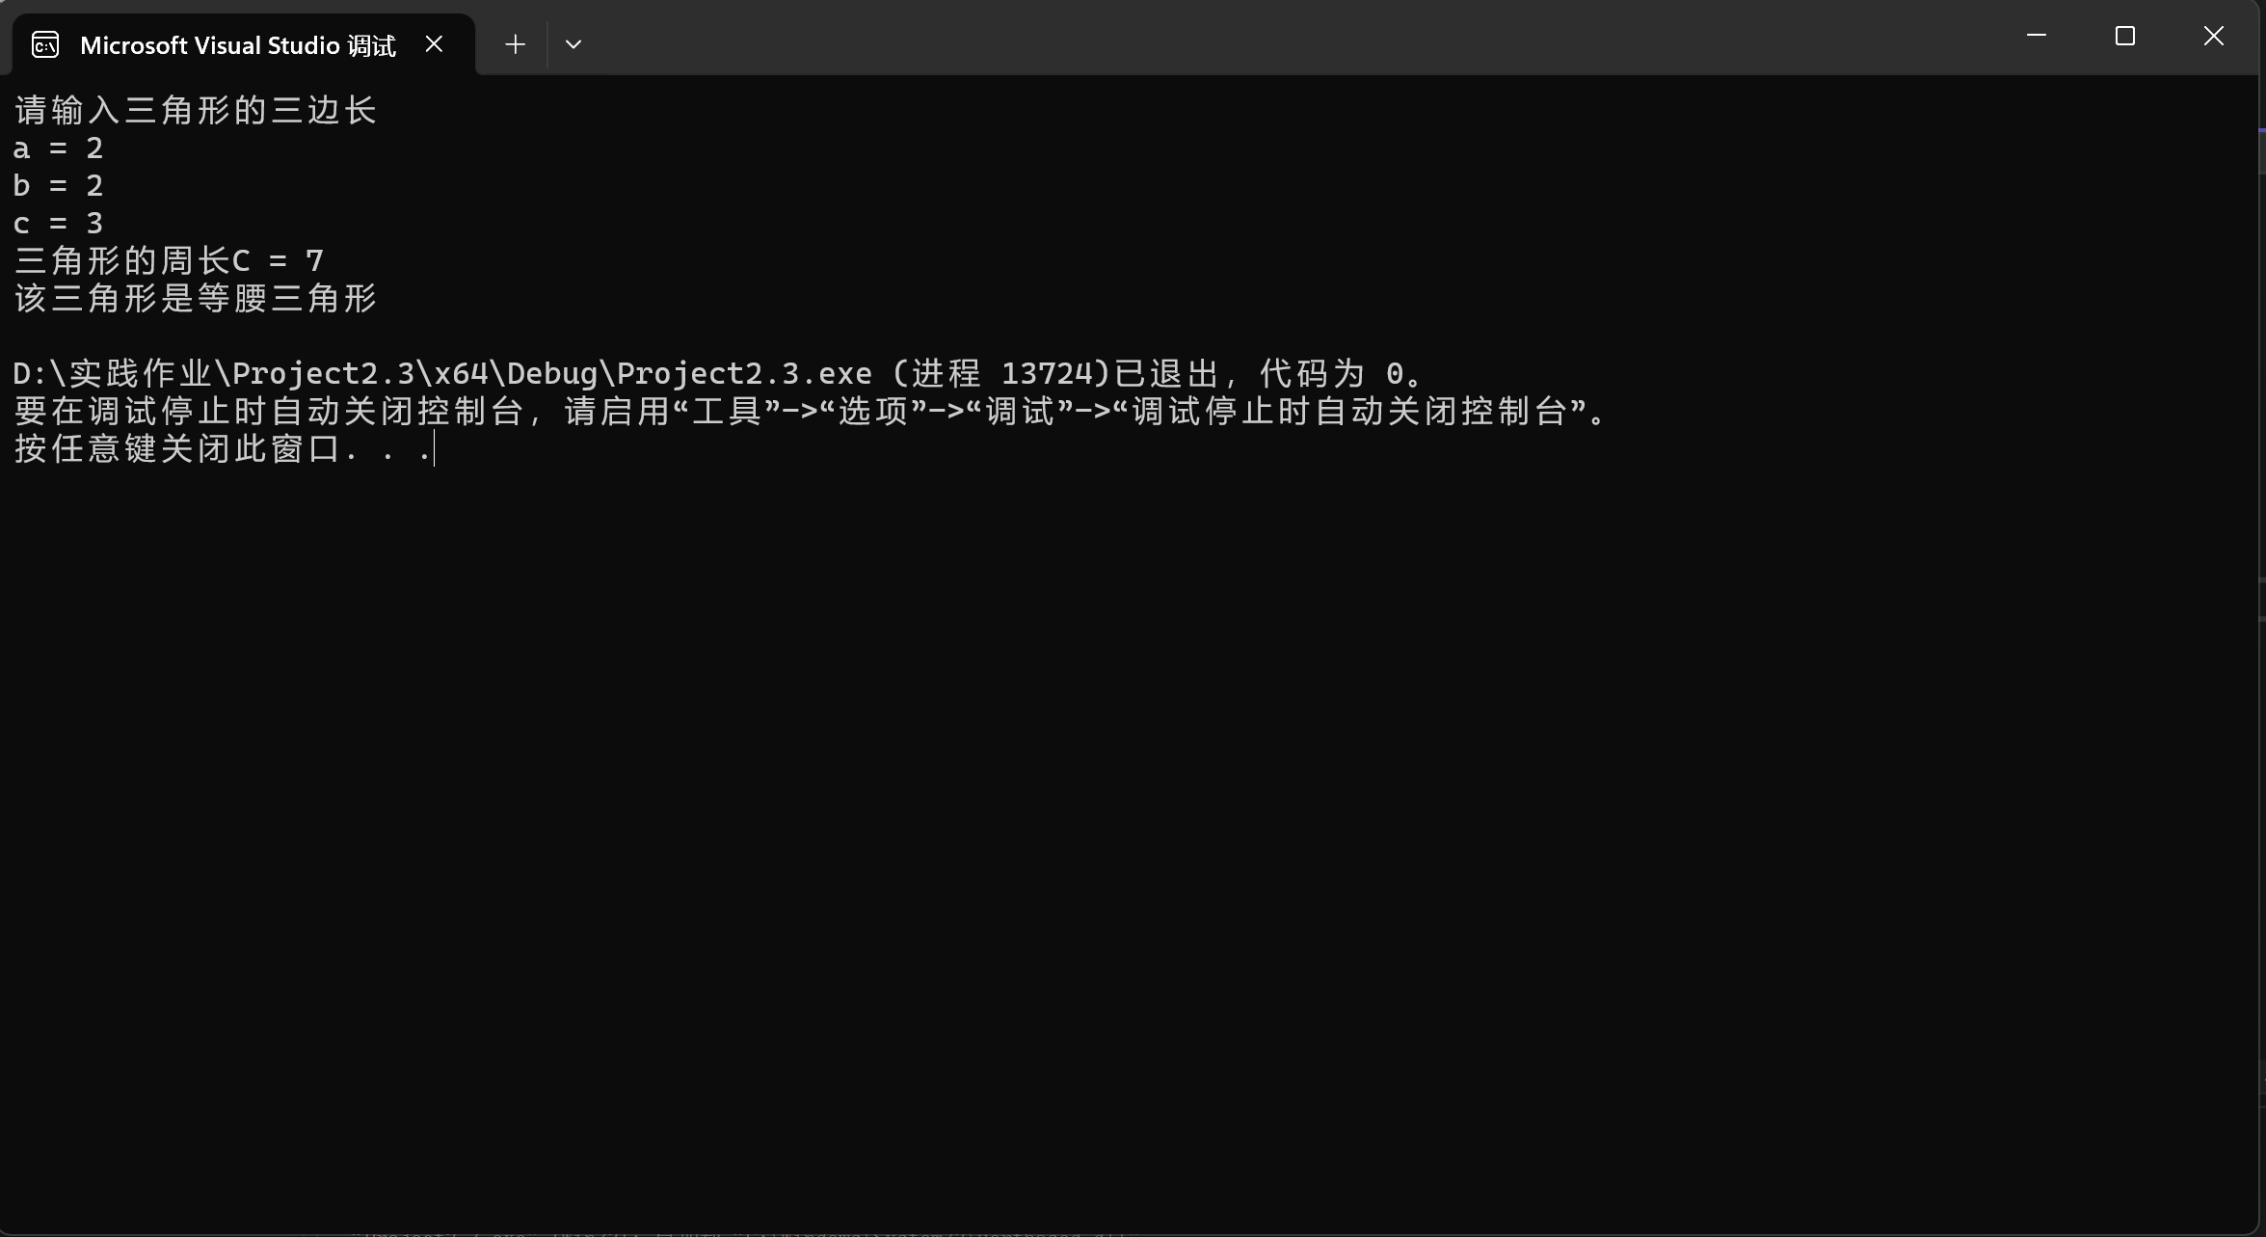

2.4

#include<iostream>

int main()

{

int x, y;

char ch;

std::cout << "该程序可以实现（+ - * / %）运算，请输入两个数" << std::endl;

std::cout << "x = ";

std::cin >> x;

std::cout << "y = ";

std::cin >> y;

std::cout << "请输入你想要的运算：" << std::endl;

std::cin >> ch;

switch (ch)

{

case '+':

std::cout<<x + y;

break;

case '-':

std::cout << x - y;

break;

case '*':

std::cout << x * y;

break;

case '/':

if (y == 0)

{

std::cout << "除数为0，运算非法";

}

else

{

std::cout << x / y;

}

break;

case '%':

if (y == 0)

{

std::cout << "除数为0，运算非法";

}

else

{

std::cout << x % y;

}

break;

default:

std::cout << "运算符非法";

}

}

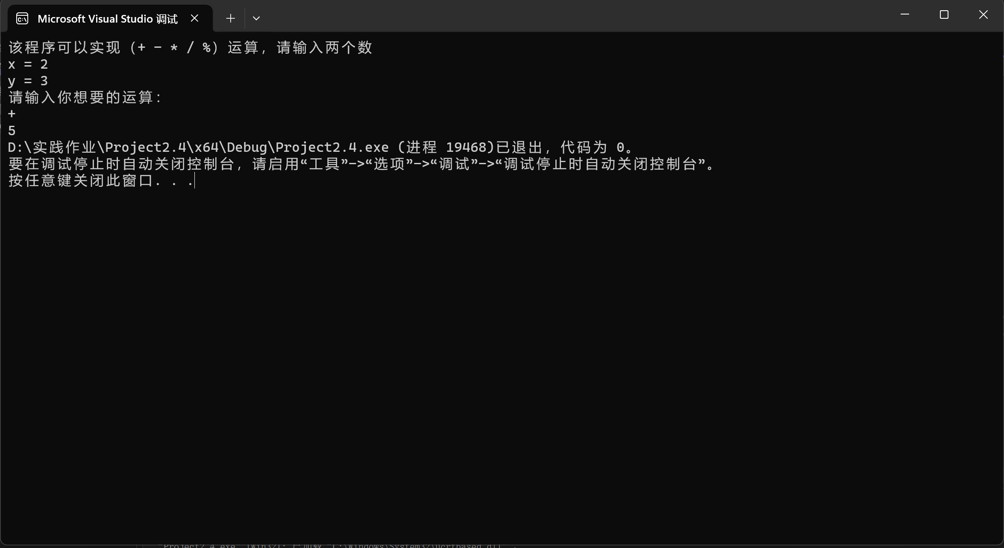

2.5

#include<iostream>

int main()

{

char ch;

std::cout << "请输入一行字符：" << std::endl;

int letter = 0, space = 0, digit = 0, others = 0;

while ((ch = getchar()) != '\n')

{

if ((ch >= 'A' && ch <= 'Z') || (ch >= 'a' && ch <= 'z'))

letter++;

else if (ch >= '0' && ch <= '9')

digit++;

else if (ch == ' ')

space++;

else

others++;

}

std::cout << "letternum is " << letter << std::endl;

std::cout << "spacenum is " << space << std::endl;

std::cout << "digitnum is " << digit << std::endl;

std::cout << "othersnum is " << others << std::endl;

}

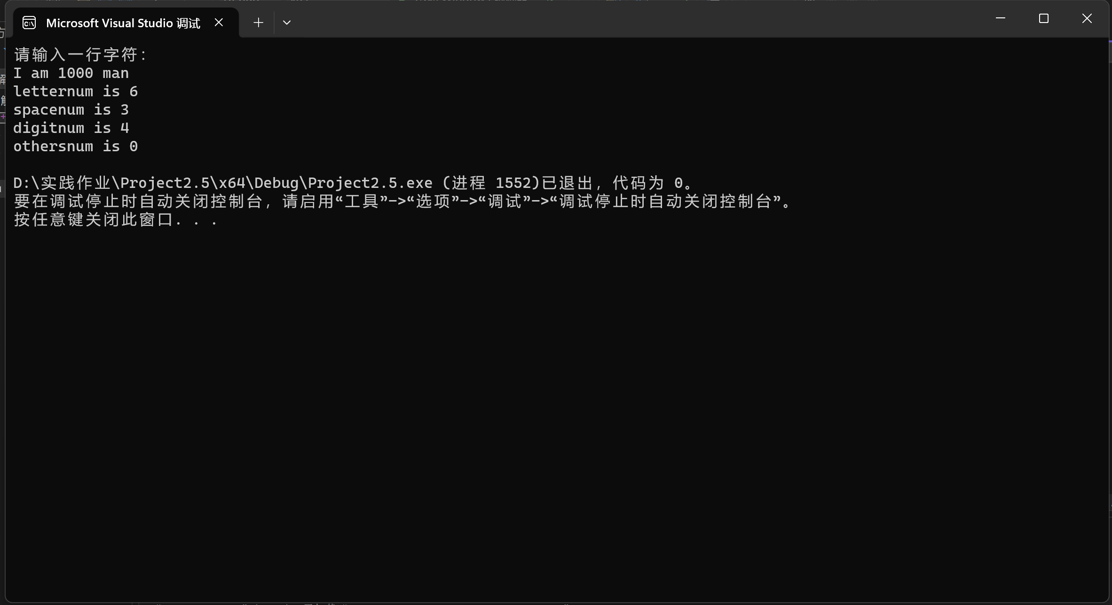

2.6

#include<iostream>

int main()

{

std::cout << "该程序用于获取两数的最大公约数和最小公倍数" << std::endl;

std::cout << "请输入两个数： " << std::endl;

int x = 0;

int y = 0;

int i = 2;

int t1 = 1;

int t2 = 1;

std::cin >> x;

std::cin >> y;

for (i; i <= (x < y ? x : y); i++)

{

if (x % i == 0 && y % i == 0)

{

t1 = i;

}

}

t2 = x * y / t1;

std::cout << "最大公约数为： " << t1 << std::endl;

std::cout << "最小公倍数为： " << t2 << std::endl;

}

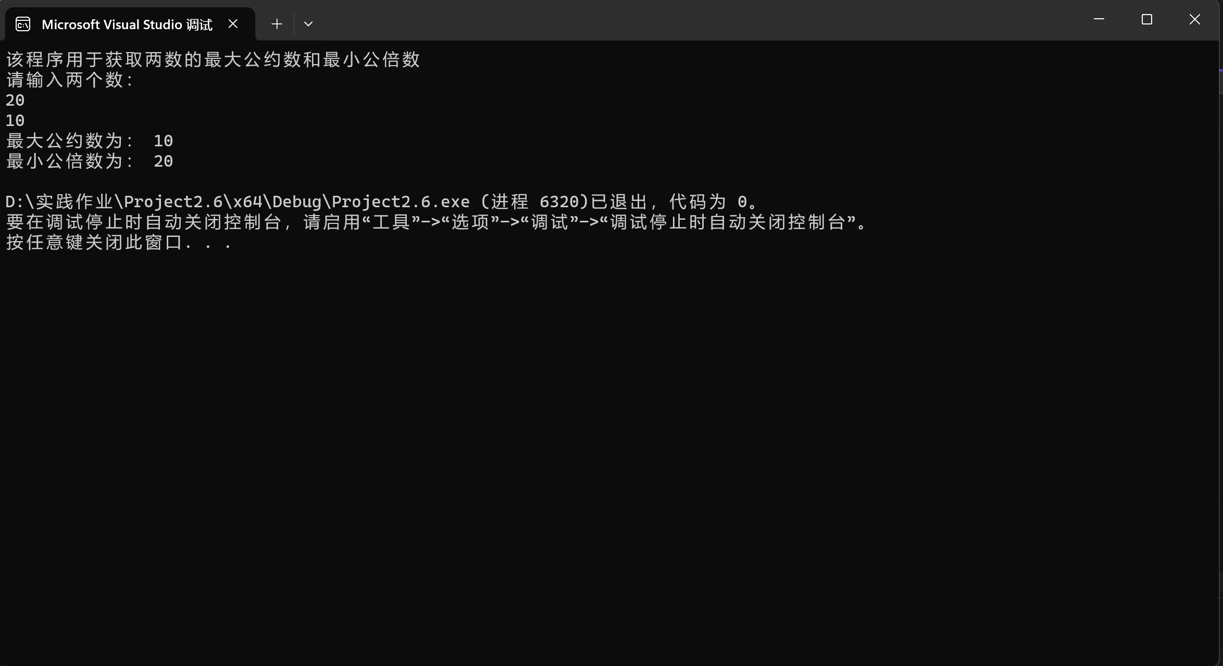

2.7

#include<iostream>

int main()

{

for (int i=1; i<=5;i++)

{

for (int j = 0;j < i;j++)

std::cout << "*";

std::cout << "\n";

}

}

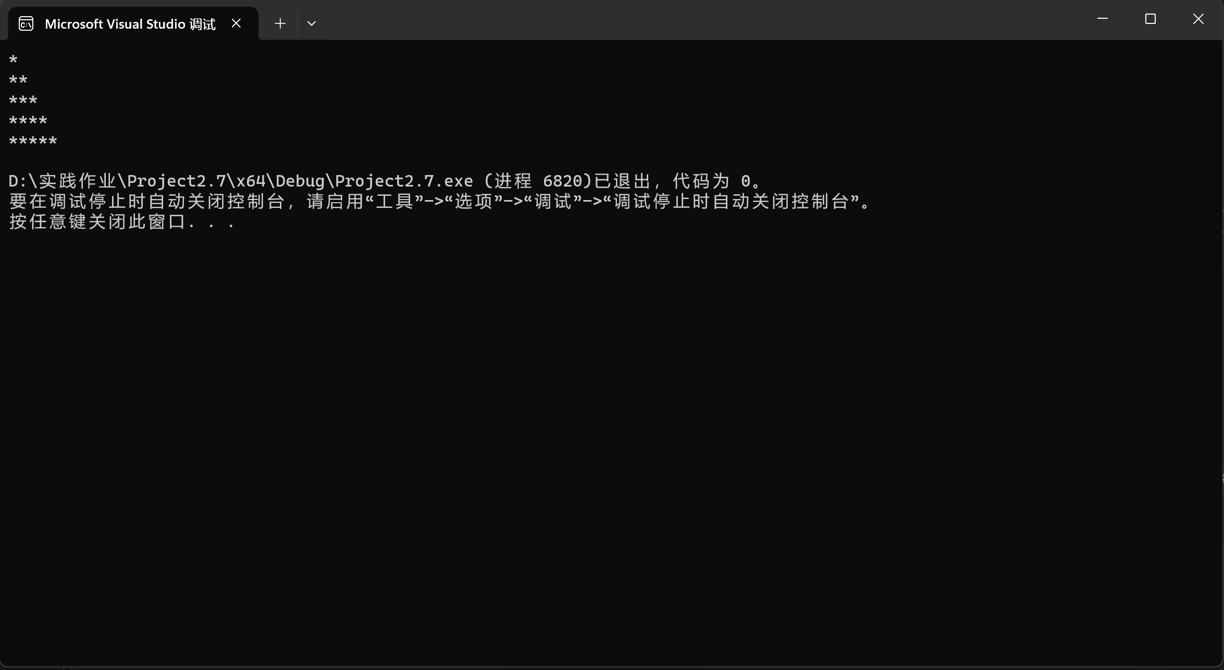

2.8

#include<iostream>

#include<cmath>

int main()

{

double a;

double x = 0.0;

double x1 = 0.0;

std::cout << "该程序用于求得一个数的平方根" << std::endl;

std::cout << "请输入一个数： ";

std::cin >> a;

if(a<0)

std::cout << "错误，负数没有平方根" << std::endl;

else if(a==0)

std::cout << "该数的平方根是0。" << std::endl;

else

{

x1 = a;

while (fabs(x1 - x) > 1 / 10000)

{

x = x1;

x1 = 0.5 * (x + a / x);

}

std::cout << "该数的平方根为： " << x;

}

}

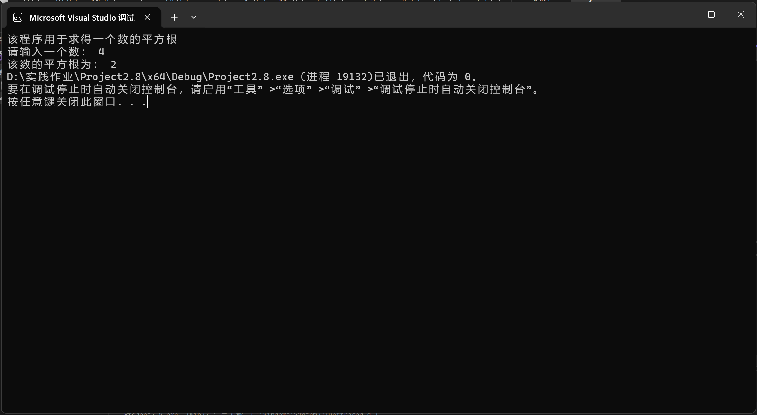

2.9

#include<iostream>

int main()

{

int num = 2, sum = 2, day = 1;

double aver;

while (sum <= 100)

{

num = num * 2;

sum = sum+num;

day++;

}

aver = (sum-num) * 0.8 / (--day);

std::cout << aver;

}

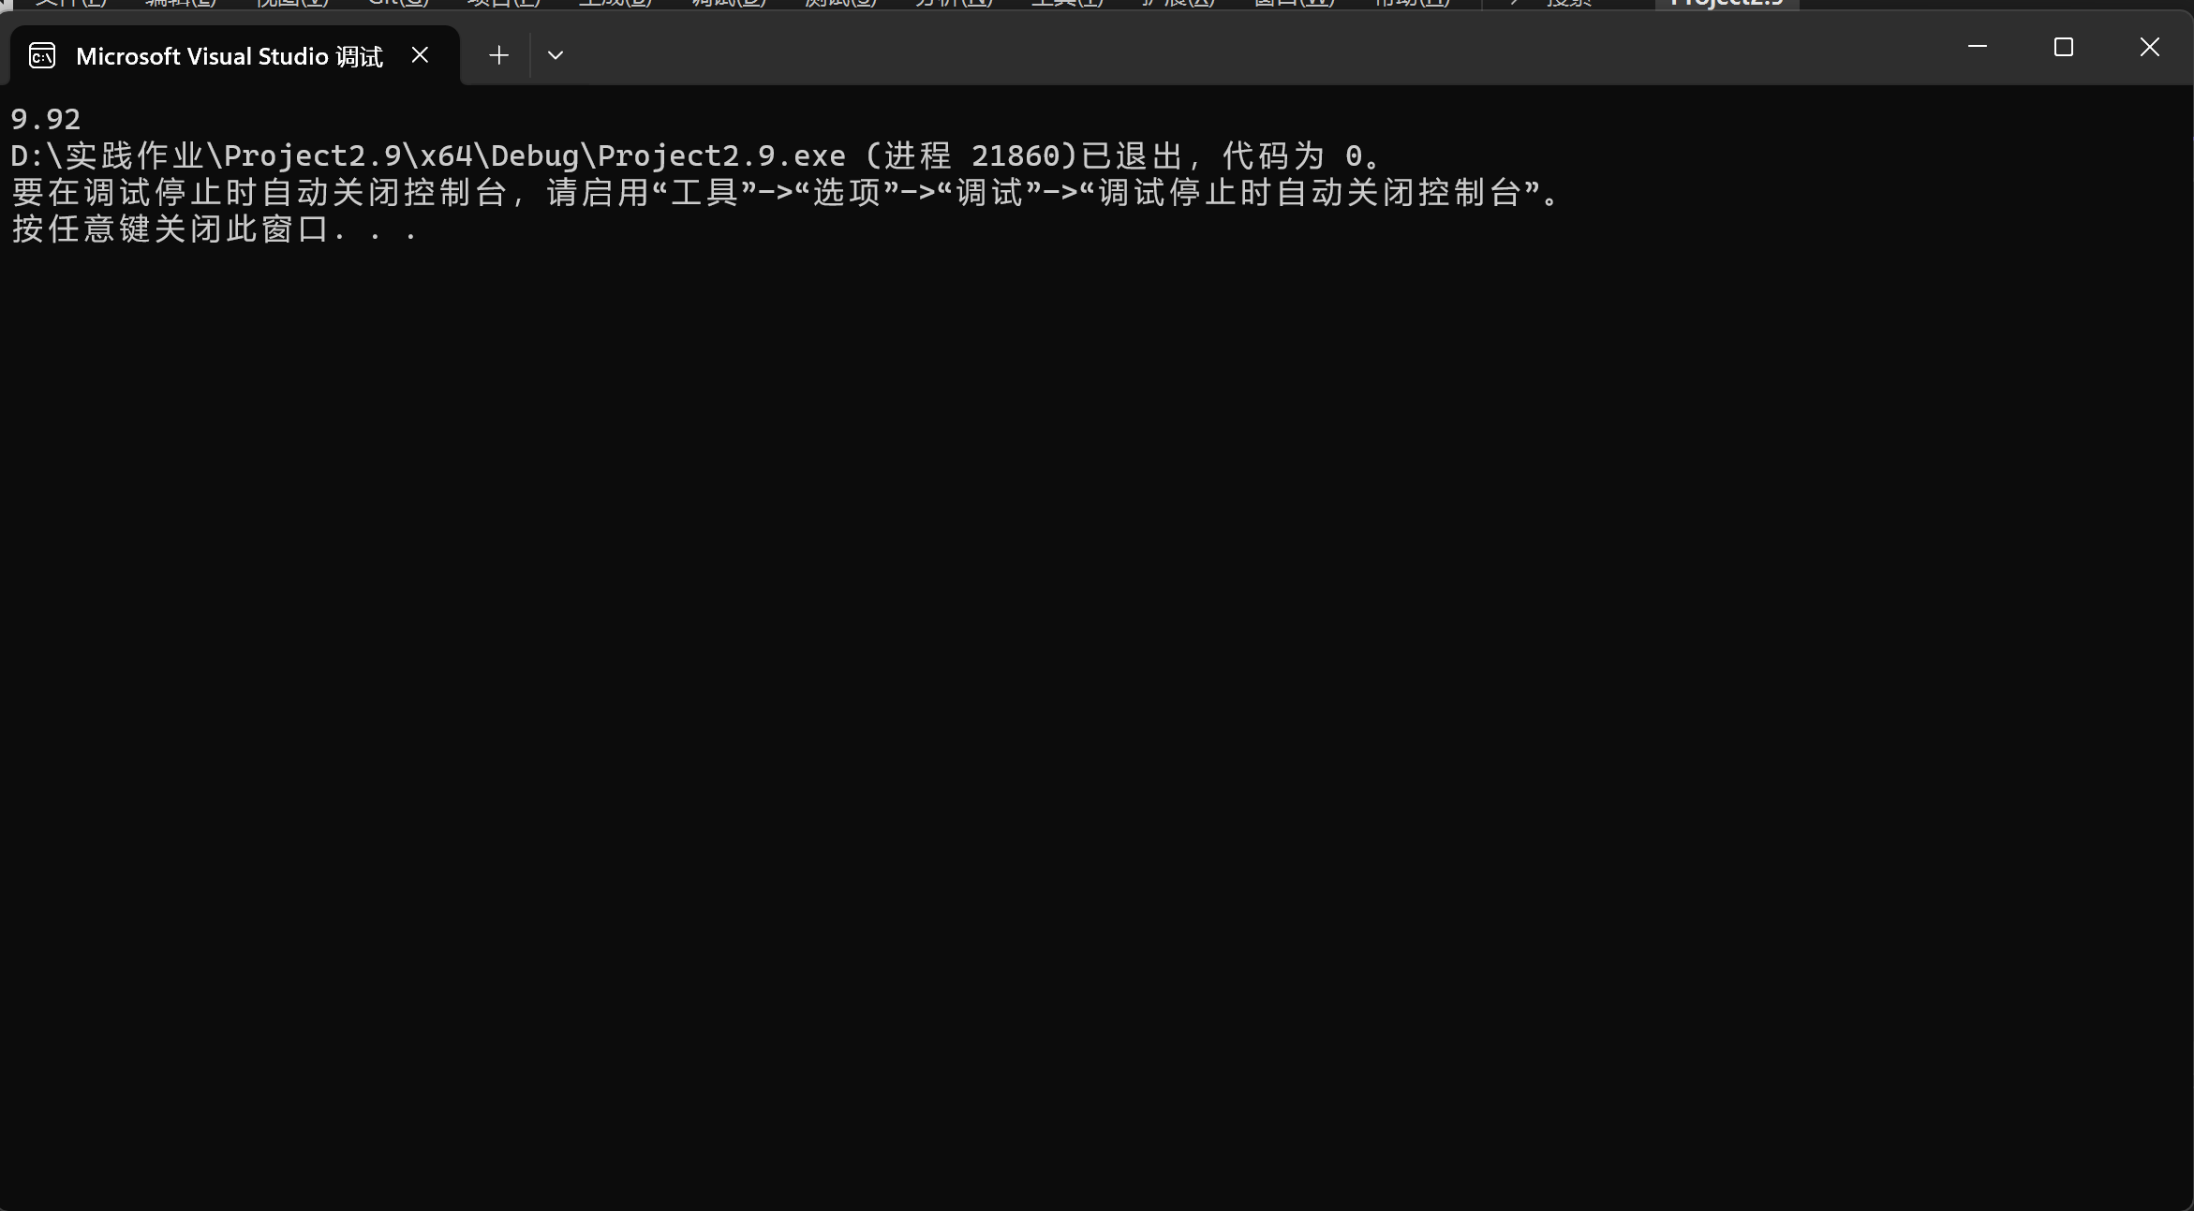

**遇到的问题与解决方法：**

**许多基础算法不熟悉，当i=0是i<n还是i<n+1常犯错误，不注意细节**

**解决方法是多动手敲代码，熟悉基础算法，和同学交流以及查资料**

**体会：**

**刷题刷得不够，代码能力有待增强，结合基础知识去独立思考可以训练我的写代码能力。**