User Manual

Our game is designed to be a simple turn-based strategy game that anyone can play with little to no experience with strategy games in the past. The game should ideally last around 20-30 minutes. At any point you can press ESC to pause the game and change the volume settings.

Sailing

During sailing mode you can use your ship to move between islands. You can also randomly encounter enemy colleges’ ships if you sail around in their territory (the territory you are currently in is displayed at the top of the screen). If you sail to a college’s island you can challenge their boss ship. If you successfully defeat a college’s boss you will sack the island and will no longer encounter hostile ships there. Some islands house departments rather than colleges. These islands are neutral and so can always be used to repair or even apply unique upgrades to your ship.

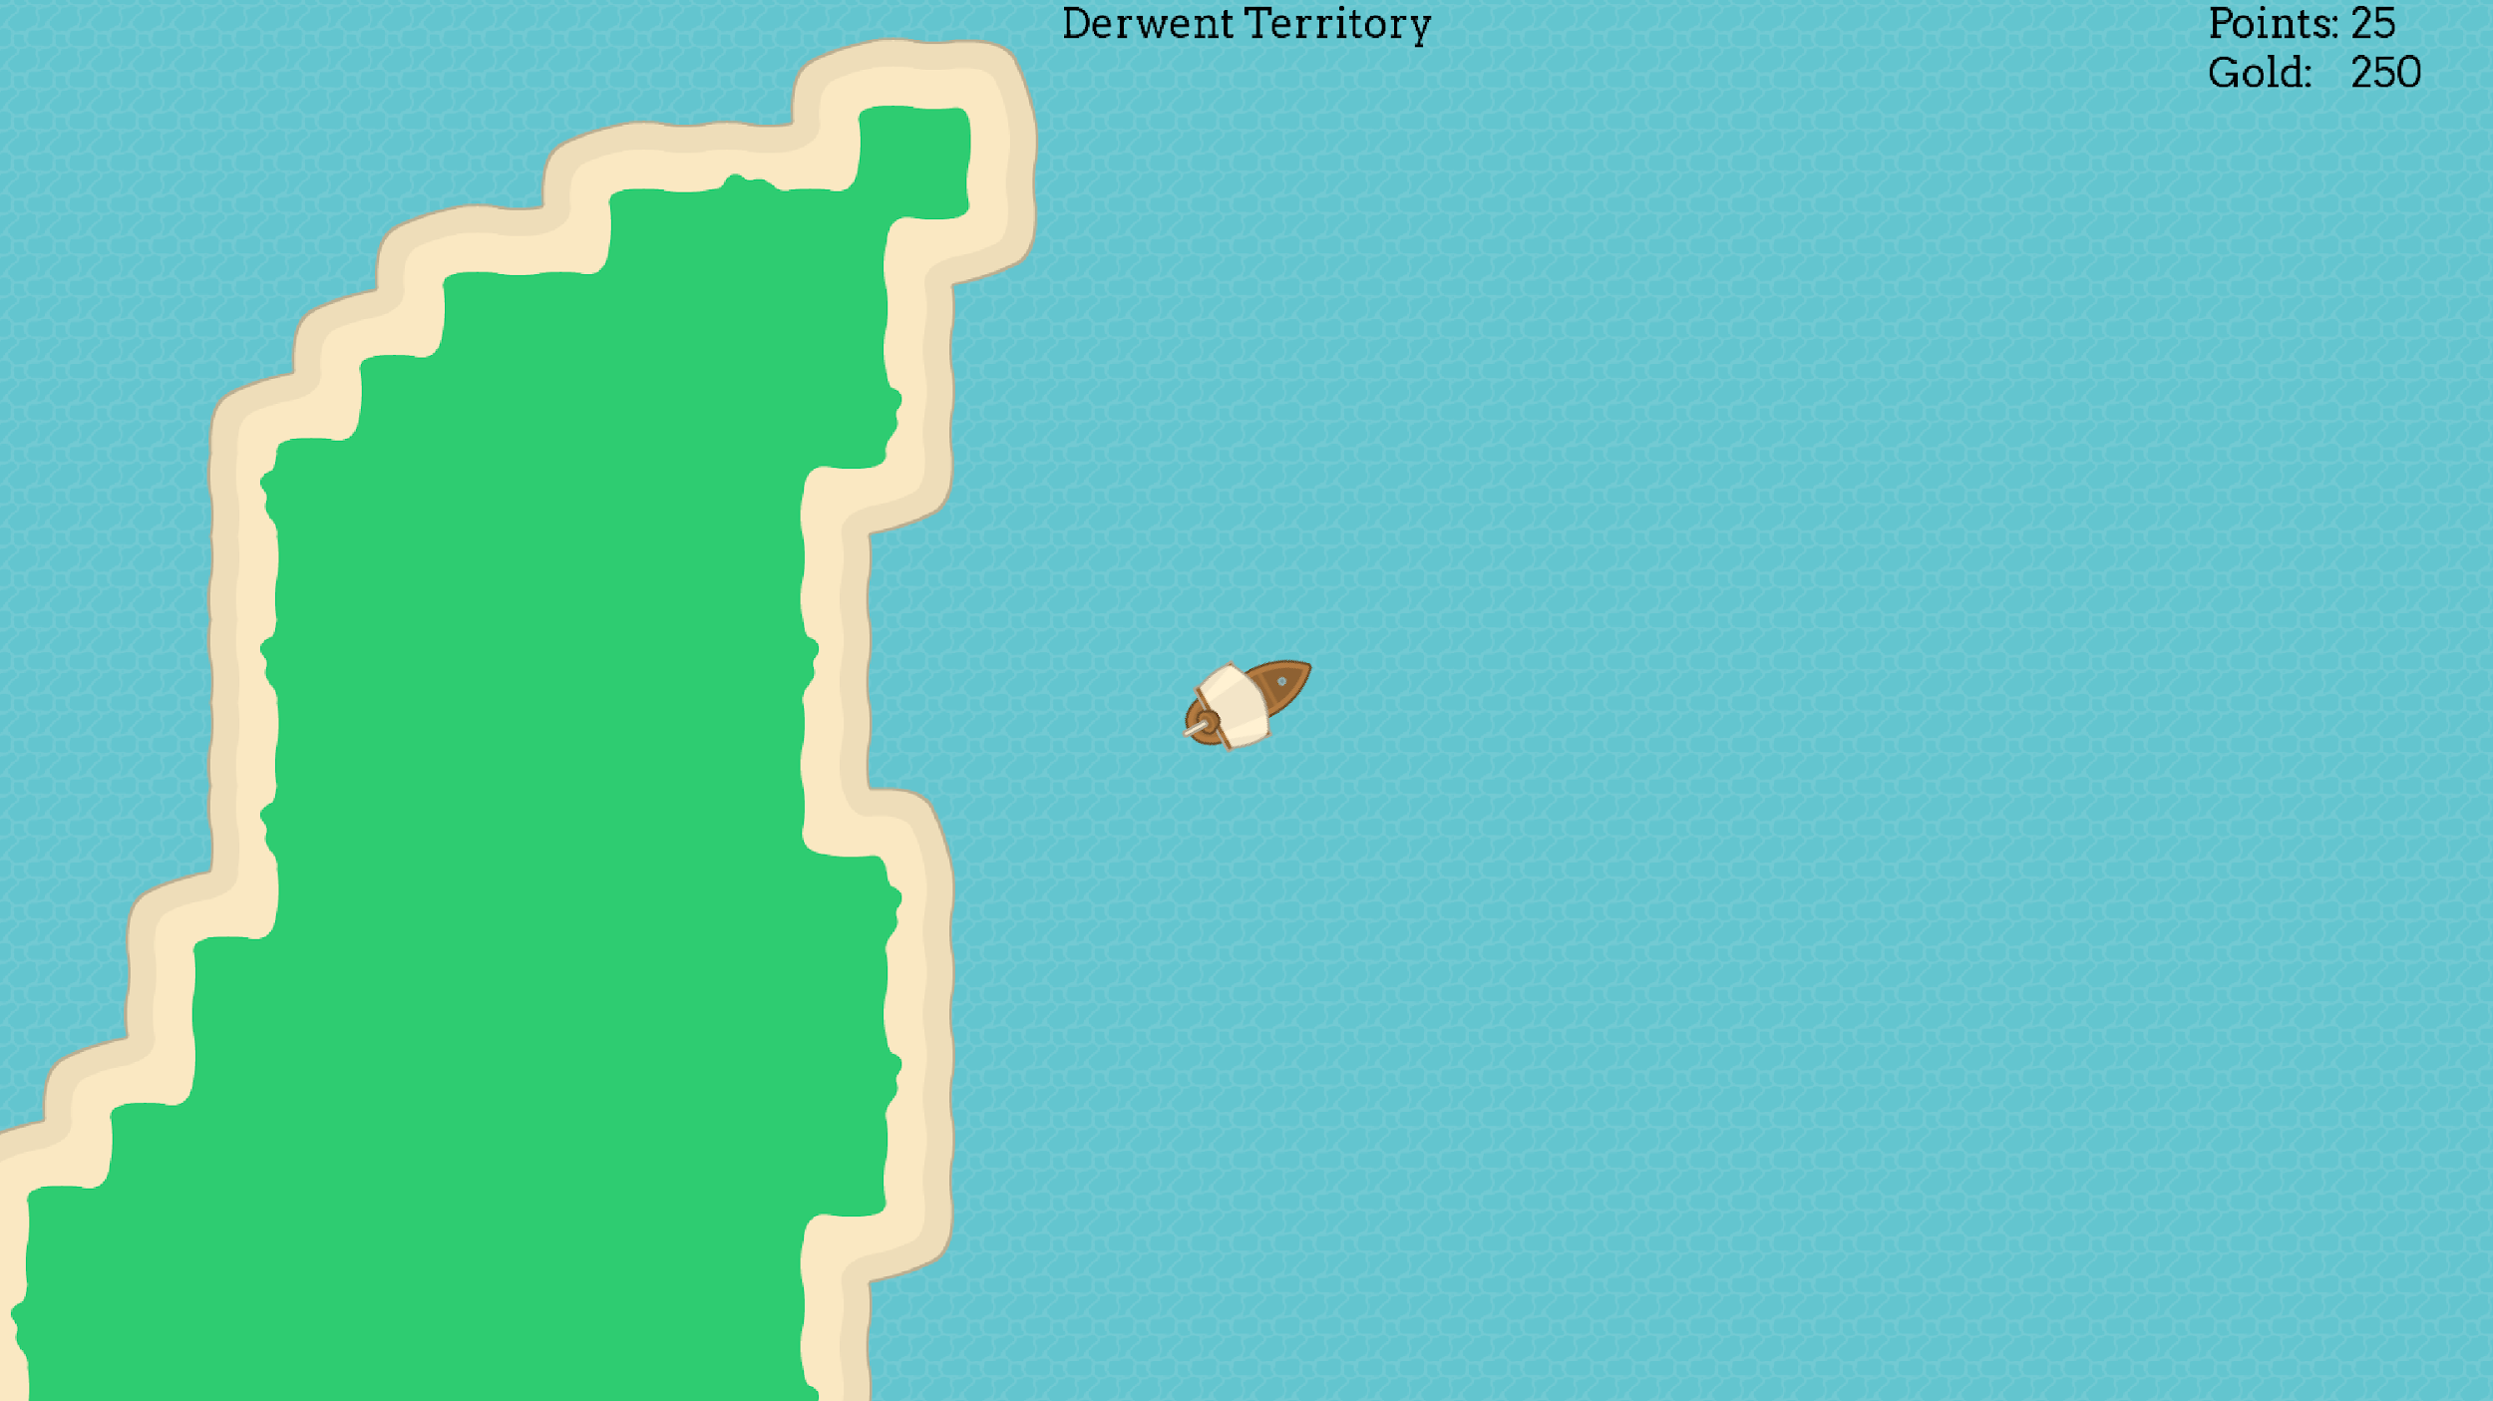

Combat

When in combat with another college you will be able to see a top down view of the enemy ship. The view will indicate different rooms within the ship in which the user can choose to target. You will also be able to see your ship in the process along with its associated health for each room. At the bottom of the screen, you will be able to see a list of the weapons which you own. These weapons can be used to fire at another enemy room. To do this, simply select the weapon you want to use and room you wish to target and then press the fire button. If the enemy is hit, it will be displayed on the screen at the enemy’s health bar will deplete at the top of the screen. If you miss with the weapon, the screen will display that you missed. If all your weapons are on cooldown, press the fire button which will end your turn and decrease your weapon cooldowns. Also at the bottom of the screen, it will display enemy stats such as evasion rate for example. Hitting a certain room will modify this percentage making it more beneficial to defeat the enemy ship. Combat ends when either the enemy or the player is defeated.

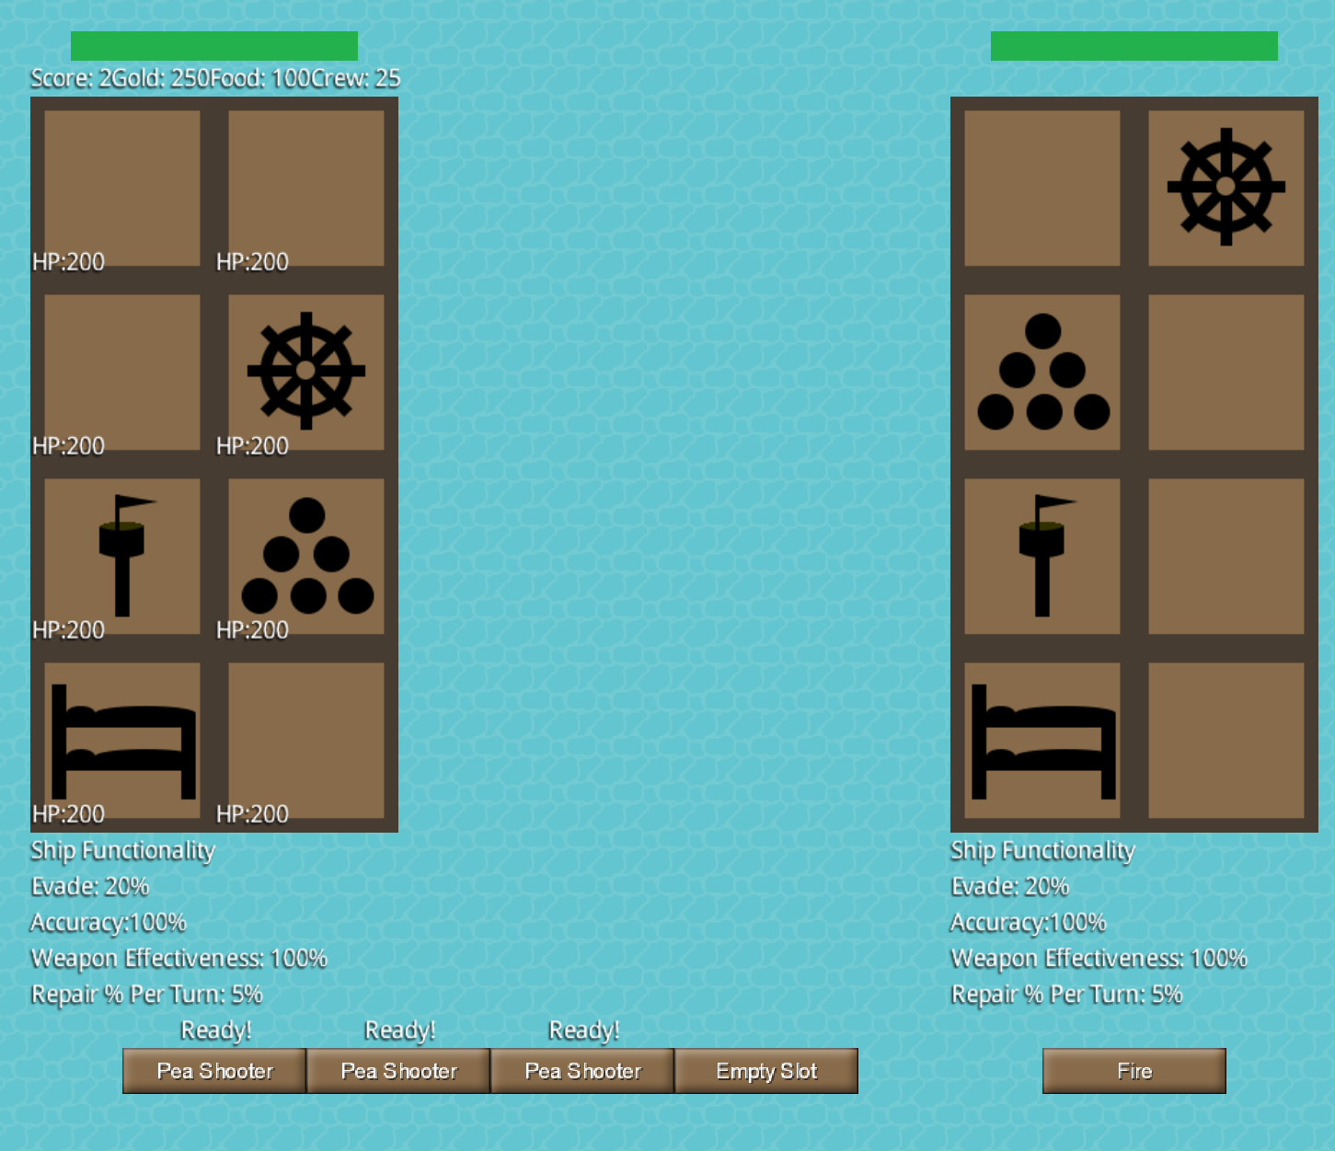

Departments

Departments have been implemented to represent shops. Each department offers a different set of weapons and room upgrades that can be purchased by the player. There is also an option to exchange gold for other resources such as food, crew and repair. The player can also choose to sell weapons and upgrades in exchange for a fraction of their original cost. Visually, the department screen is divided into sections for buying and selling weapons and upgrades as well as the option to exchange gold for various resources. The player can also view their resources and their ship’s health at the top of the screen. When the player buys an item it is removed from the shop and added to the player’s inventory, the amount of gold is also deducted from the player’s resources. The opposite occurs when selling appropriate an item. Currently the department is picked randomly.

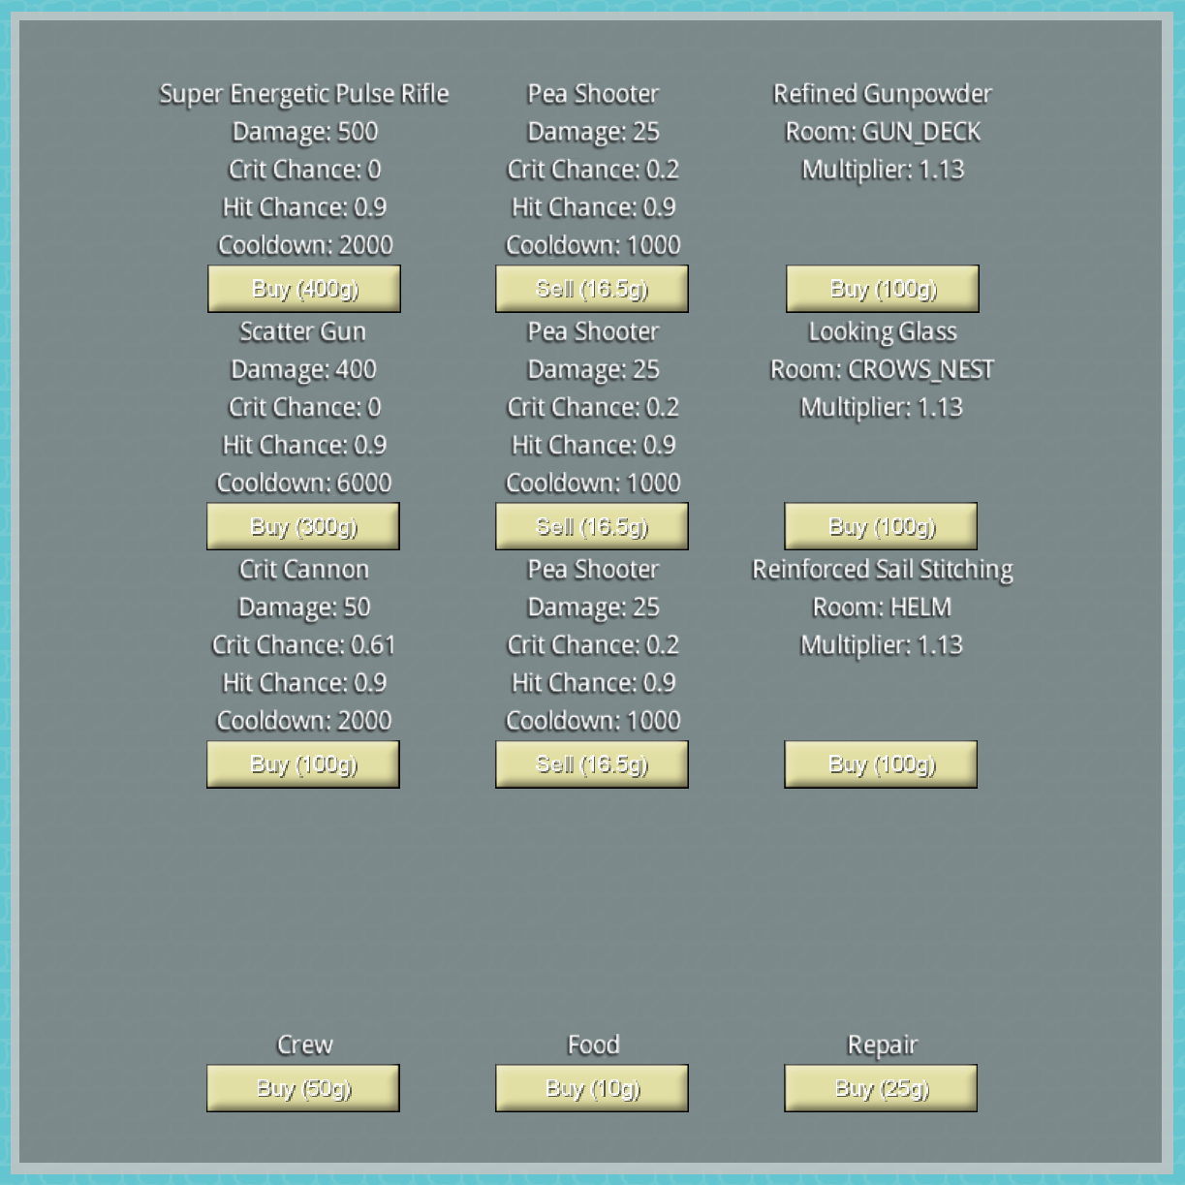

Minigame

The minigame is accessible from your college’s island. It is a variant of rock, paper, scissors called pistol, map, hook. To play, simply set your desired bet amount using the slider and choose your card. If you win you will double your bet whilst a draw returns your original bet to you. At any time you can click the button at the top to return to sailing mode.

