Web- front view of page (front-end page)

Admin – it is used to add products,edit,etc. All changes done from admin page (back-end page).

**TABLE-(Admin)**

**1.Product -** this table is to store data of products (new products) from admin(shop).

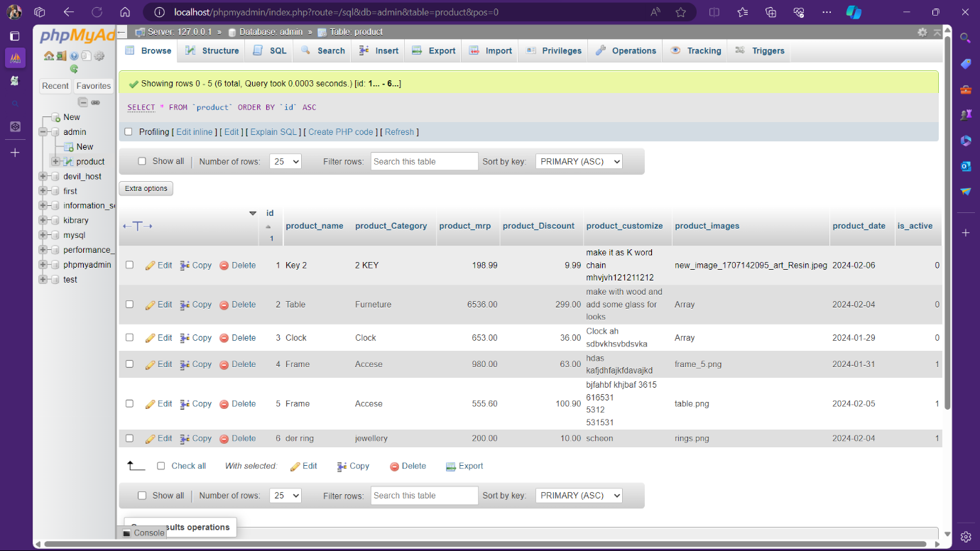

**2.Blog-** this table is used to add new blogs,edit,inactive(or)active from admin(blog).

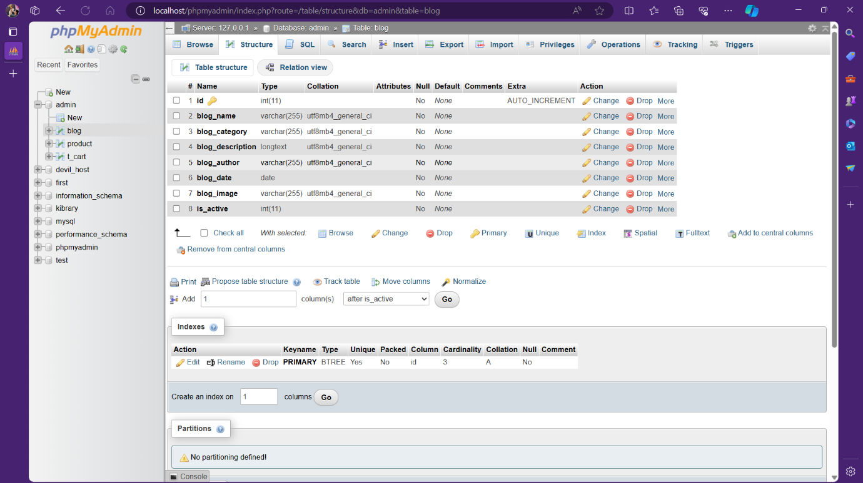

**3.Contact Us-** this table is to store data of Messages (Contact Us) from Site.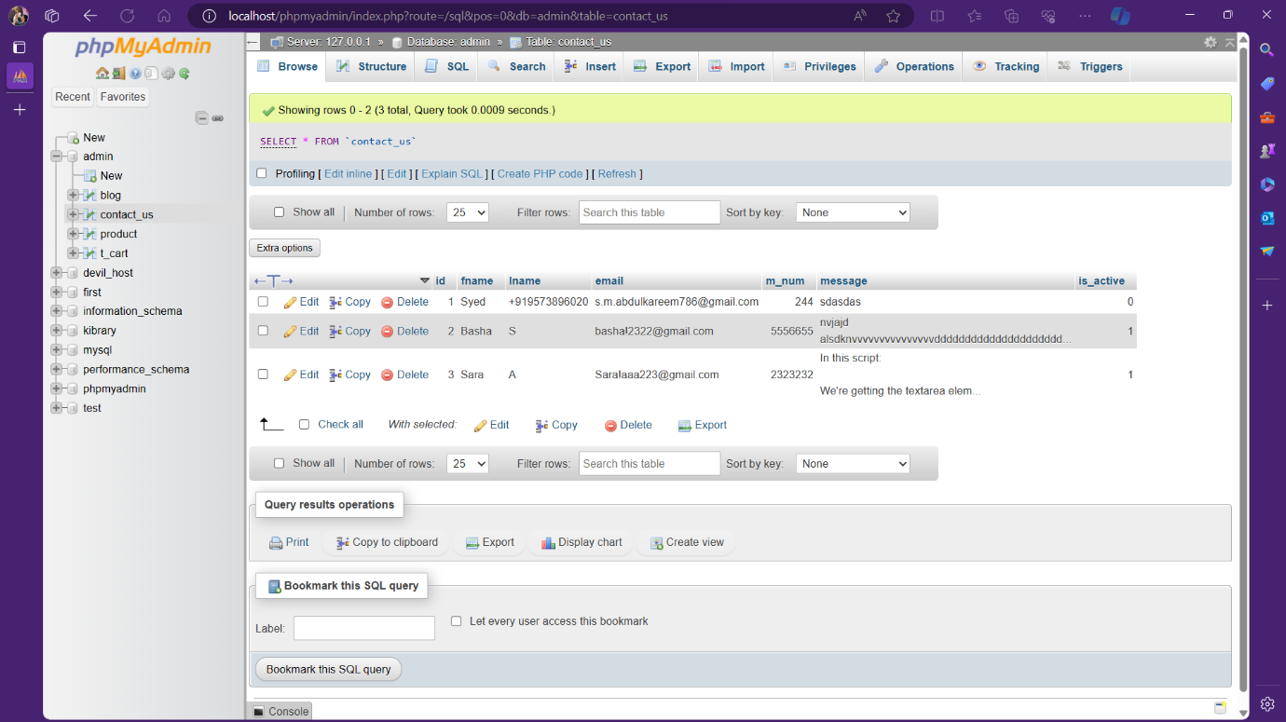

**4. t_cart-** this table is to store items in cart temporary when we click on add to cart button.

Again in cart page when we fill customize and quantity filed and clicks on proceed to checkout button. It will clear the old data from t_cart and insert new data into t_cart table.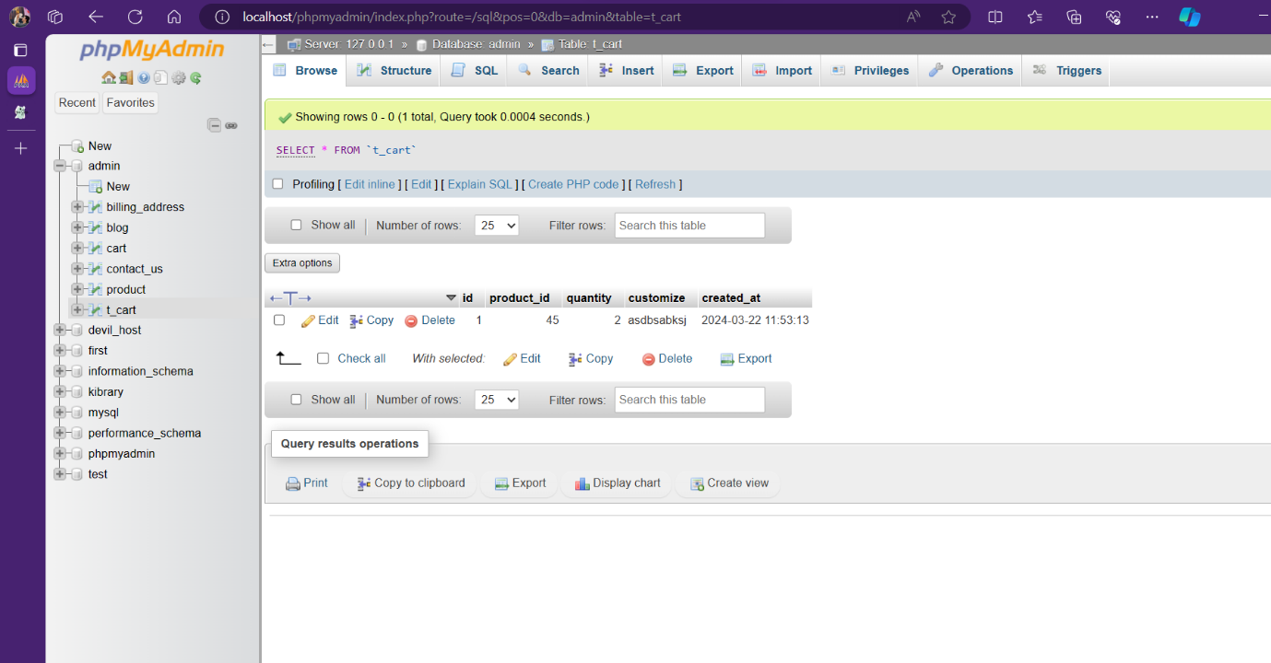

**5.BILLING_ADDRESS-** this table is to store Customers address (Or) shipping address data.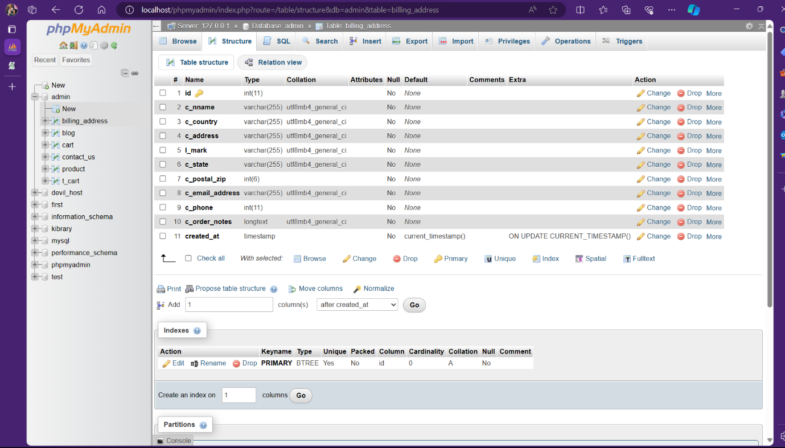

**6.Cart-** this table is to store the data of items which ordered by customer in one time.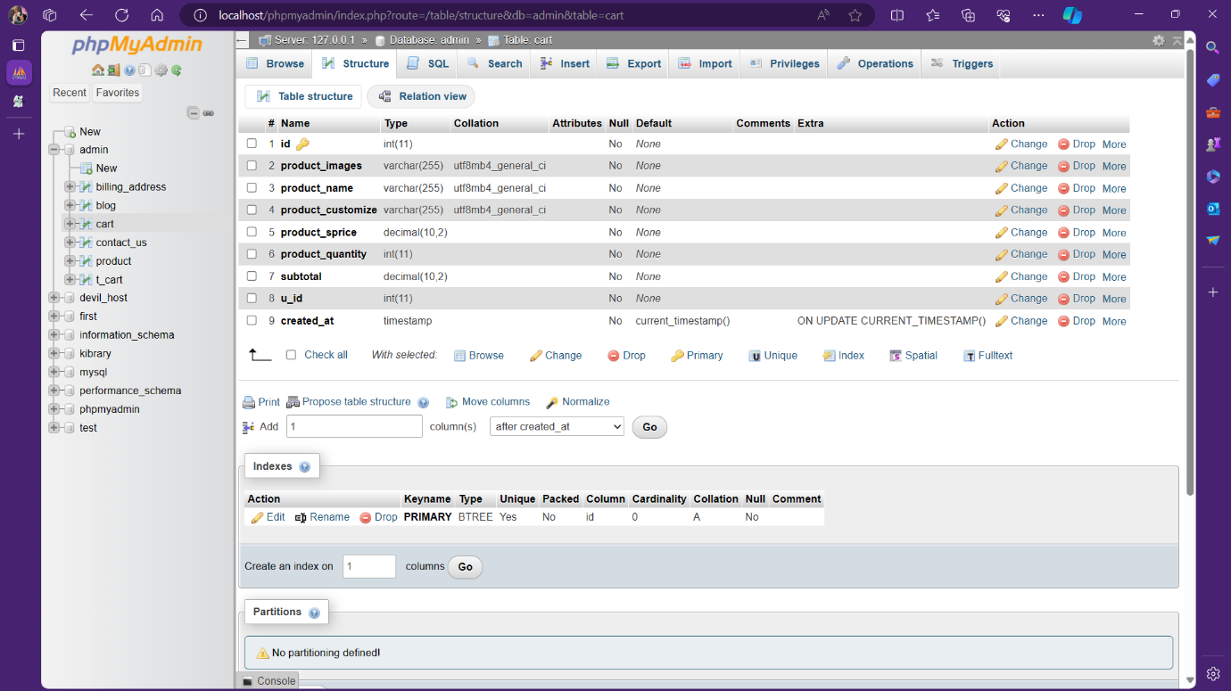

**7.**[**categories**](http://localhost/phpmyadmin/index.php?route=/sql&pos=0&db=admin&table=categories)**-** This table is to store the data of categories of products and the access is only for admin.

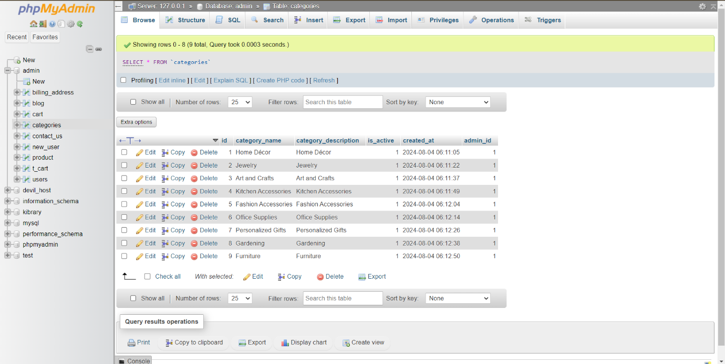

**8. new_user -** This is used to store the Customer login details.

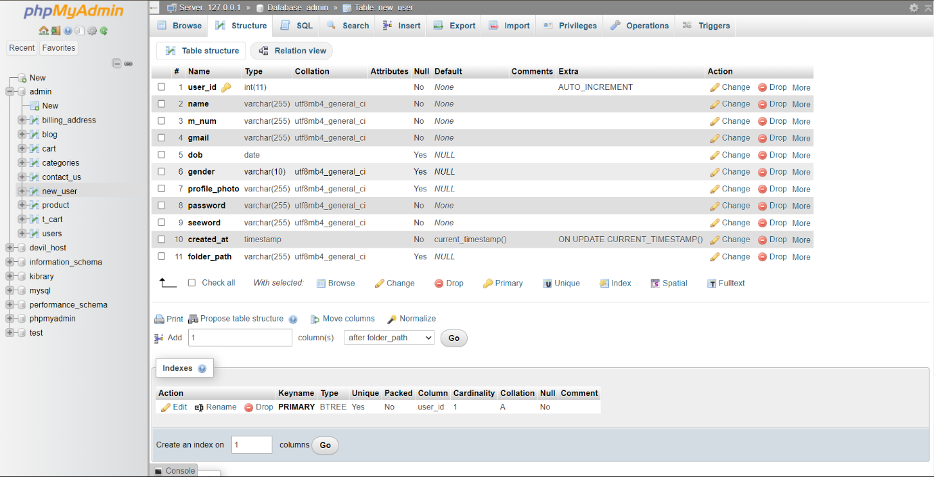

**9. users –** This is used to store the admin login details.

