Dmitriy Okoneshnikov, B22-CS-01, d.okoneshnikov@innopolis.university
x’=y, y’=sin(x), x(0)=3, y(0)=0.3, t∈[0;2*pi], n=90
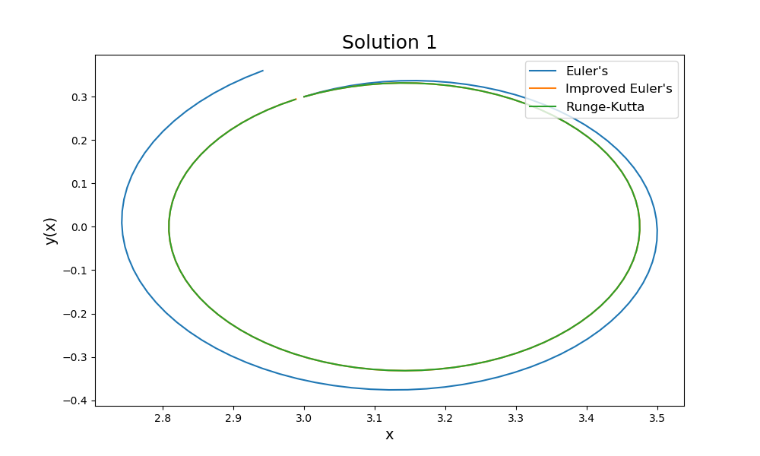
x’=y, y’=sin(x), x(0)=-1, y(0)=3, t∈[0;2*pi], n=90
