Advanced course of Measurement and Signal Processing

Assignment II Report

Name: Liu Zihua

Student ID :20M18350

All the code can be found in the attachment of this report and aslo the Github repo: *<https://github.com/Magicboomliu/Japan-Tide-analysis-forcast>*

**Task one**

**“**Perform wavelet analysis using Gabor wavelet on air temperature (気温) observation data of 1 year for every hour, and describe what is revealed by the analysis briefly.**”**

Data source :

|  |  |
| --- | --- |
| Location | Naha(那霸) |
| Year/Month/Day | 2020/01/01-2021/01/01 |
| Amount of data | 8760 hours |

1.1 Introduction

For this task , I mainly use Python to do data processing and Gabor and Morlet transform. The city I choose is Naha(那霸), which is the capital city of the Okinawa Prefecture, the southernmost prefecture of Japan. The following third libraries were used:

* *Numpy, pandas* : To read data from csv and using bilinear interpolation which using the mean value of nearest 6 values to replace the NaN value.
* *PyWavelets(pywt):* Do wavelet transform, use *pywt.cwt* function to do the CWT, and set wavelet type as'morl', scales as integers within [1, 3000]. then use the *pywt.scale2frequency* to transfer the scales into the frequencies, and use the sampling period of this data (1 hour or 3600s) to scale the frequency values to Hz.
* *Matlib.pyplot：* For visualization

I draw the related results which in section 1.2 , the y-axis is of the original data is Celesius degree and the y-axis of the Gabor transform is the frequency(Hz). The

X-axis of the all the data is the aggregated hours from 2020/01/01 1:00 ~ 2020/01/01 0:00.

1.2 Gabor (Morlet) Transform Result of NAHA 2020-2021

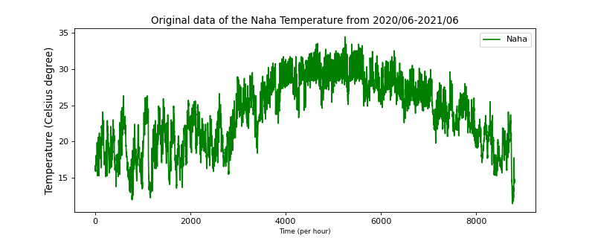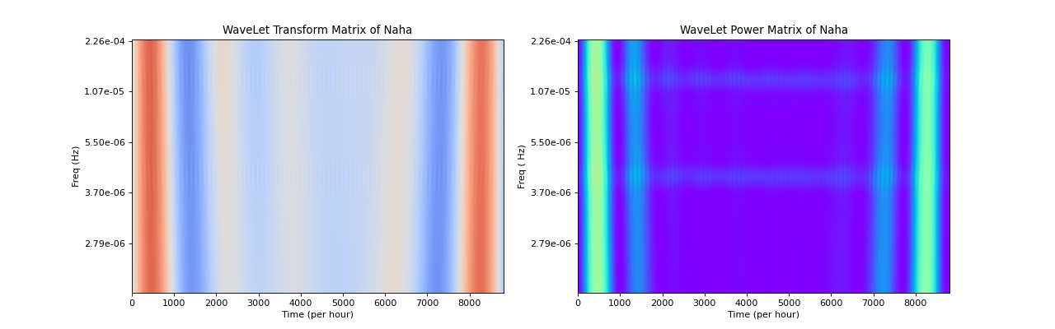(a)

(b) (c)

Fig1 (a) The orginal temperature observation data from 2020/01/01-2021/01/01, which interval is one hour. (b) The Gabor WaveLet correlation Matrix(using coolwarm cmp, the yellow means bigger correlation and blue means small correlation) (c) The WaveLet Power Matrix(The blue area means smaller, yet the green area means bigger).

1.3 Result Analysis

As we can see from the Correlation Matrix and the Power Specturm,there are two bright lines in the graph, where indict that the absolute value of correlation or the power specturem is quite high.( The 0-1000 hours and the 6800-8700 hours).

And we can also see from graph (b) and graph(c), the Gabor wavelets with the frequencty of **1.39e-5** and **4.23e-5** have a very high correlation with the temperature wave. The frequency of 1.30e-5 is corresponding to **23** hours and the frequencey of 4.23e-5 is corresponding to **68** hours. So from the result data, we can say that the temperature changes of 1 day(which is close to 23 hours) and the temperature changes of 3 days(which is close to 68 hours) are have a positive and negative correlation to the Gabor walet.

In addition, just like what I have said, ,there are two bright lines in the graph, where indict that the absolute value of correlation or the power specturem is quite high.( The 0-1000 hours and the 6800-8700 hours). This period is from Late November to the Mid-February, the winter season of Naha, shows higer similarity to Gabor wavelet at the frequency(**1.39e-5** and **4.23e-5)**. which the rest of the year do not show the relationship like this. Thi is possible that because Naha is located in Okinawa region, the winter temperature changes are affected by the ocean, and there is a strong regularity.

**Task Two**

**“**Perform fractal analysis to the wind speed(风速) observational data. Try box count method and power spectrum method. Plot log-log chart and find fractal dimension**.”**

2.1 Introduction

|  |  |
| --- | --- |
| Location | Kyoto(京都) |
| Year/Month/Day | 2020/01/01-2021/01/01 |
| Amount of data | 8760 hours |

2.2.1 The power spectrum method

For this task , I mainly use Python to do data processing. And use the Kansei city Kyoto as the data source. Because there is no directly library for fractal anaylsis, I use the following Api from *<https://github.com/inuritdino/HiguchiFractalDimension>* to get the *hdf Api* which compile from a C file to use. If you want to run my code, first compile the C file to generate the .so library using following instructions:

gcc -shared hfd.c -o libhfd.so -lm -fPIC

I draw the related results which in section 1.3. I mainly use the numpy library to do the Fourier Transform get the power specturm . Using the equation $P(f)=k/f^{β}$, here the P(f) is the power specturm. Then we use log function of P(f) and log function on the right side of the equation:

$$log(P(f))= log(k)−βlog(f)$$

The $−β$ here is the slope of the curve log(F)-log(power specturm). The use a Least squares Function to do linear regression to fit the data, as we can see in figure3.

Finally use the the space domension and the $−β$ to calculate the fractal dimension.

2.2.1.1 Visualization Result

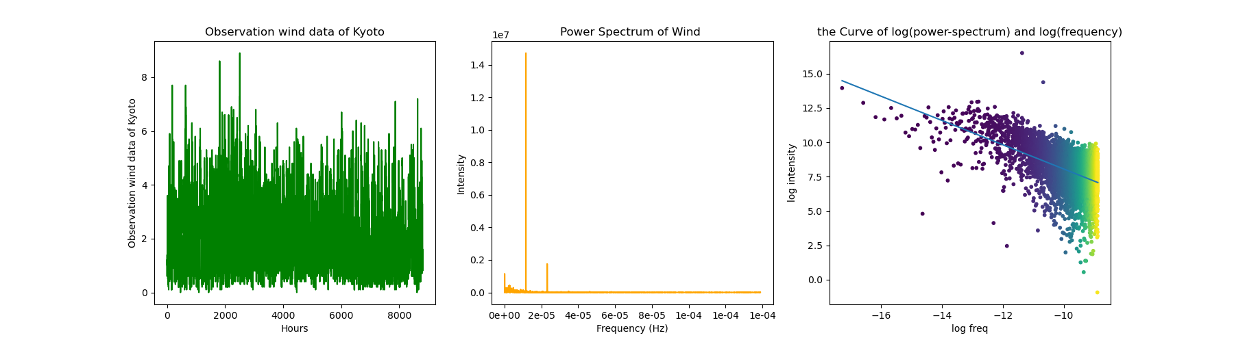 (a) (b)

（c）

According to the calculation , the fractual dimension is 1.970823920446978.

2.2.1 The Box count method

For this section, I mainly use python numpy to fo the box counting.The x-axis is the log(N) , (here N is the scale) and the y-axis is the $log(ε)$. I apply the linear regression on the log-log curve, use the the Hausdorff dimension as thd box count result.

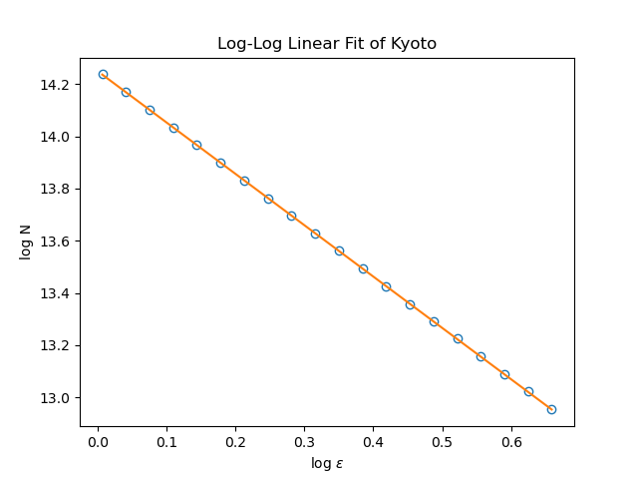

According to the calculation , the fractual dimension is 1.9701293382118037

2.3 Conclusion

|  |  |
| --- | --- |
| **Method** | **Fractual Dimension** |
| Box counting | 1.9701293382118037 |
| Power Specturm | 1.970823920446978. |