SC4001 Neural Networks and Deep Learning
Group Project — Topic J: Detecting AI-Generated Images Across Generators

Learning the Generator or the File Format
A controlled study of global–local CLIP fusion, quality-aware gating
and format-matched training for cross-generator AI-image detection
Group 158
Hou Lijie (GitHub: MagicianFrieren)
Tang Ruixuan
Patel Madhavan Pareshbhai
November 2026
Code and results: submitted ZIP (repository SC4001-AI-Image-Detection)

Abstract
Detectors of AI-generated images can perform well on their training generator yet transfer poorly to others. We study frozen-CLIP global and patch-shuffled experts, trained on Stable Diffusion 1.5, with fixed and learned fusion across six other generators. Three shared-pool data splits and two frozen test evaluations show substantial variation across generators and degradations. JPEG compression is a major weakness; the label-associated JPEG/PNG encoding difference and the response to format matching support a role for format-related cues. Format matching improves JPEG ranking but reduces clean ranking: on the Round 8 main macro, average-fusion clean AUROC falls from 0.871087 to 0.826815. Simple average and fixed-weight fusion provide strong baselines. Quality-aware gating performs inconsistently against them. Targeted changes to checkpoint selection recover part of the lost performance. Further diagnostics show source-dependent expert preferences and weak reliability signals. The tested ResNet-50 setup has lower main-macro performance than frozen CLIP. The Round 8 evaluation uses fresh images relative to the documented repository pools. Its design followed the Round 7 results, and its generator domains had already been inspected.

AI Use Statement
We used OpenAI Codex (ChatGPT) to implement, run and debug data-preparation, experiment and verification code, and to assist with supplementary development analyses, figures and report revision. Some Round 7 runs, including the test evaluation, were launched by Codex on our machine. Anthropic Claude assisted with Round 7–8 protocol planning, task specifications, split and result cross-checks, the detector overview diagram and initial drafting. Validation included synthetic tests, hash and split checks, independent reconstruction of saved predictions, and metric recomputation. Numerical claims are linked to saved experiment artifacts; the supplementary analyses are identified separately from the frozen final evaluations. The team selected the research questions and protocol decisions and is responsible for the submitted analysis, attribution and interpretation.

1 Introduction
Image generators improve and change faster than detectors can be retrained, so a useful detector must recognise images from generators it has never seen, often after the image has been compressed or resized by a social-media pipeline. Benchmarks such as GenImage [1] show that detectors trained on one generator lose much of their accuracy on others. A known risk is shortcut learning [9]: a classifier may separate real from fake using incidental properties of the dataset, such as file format or image size, instead of traces of the generation process.
We investigate three questions on a laptop-scale budget (one 6 GB GPU):
- Transfer. How well does a frozen-CLIP detector trained on one generator transfer to unseen generators, clean and under JPEG compression or down-sizing?
- Fusion. Does combining whole-image (global) and patch-level (local) evidence help, and does a learned gate that also sees image-quality cues beat simple averaging?
- Shortcut. How do label-associated image formats affect detector behavior, and what benefits and costs follow from format-matched training?
Our contributions are: (1) a fixed evaluation protocol with three shared-pool partition seeds, a development set and two frozen test evaluations, with image and generator exposure disclosed; (2) a controlled comparison of global, local, fused and gated CLIP detectors and a fine-tuned ResNet-50 under four conditions; (3) an investigation of label-associated image formats and the benefits and costs of format-matched training; and (4) targeted development modifications and analysis of saved predictions that identify where fusion gains are lost.

2 Related work
Benchmarks. GenImage [1] pairs ImageNet [8] photographs with images from eight generators (Midjourney, SD1.4, SD1.5, ADM, GLIDE, Wukong, VQDM, BigGAN). Its standard protocol trains on SD1.4 and tests on all eight generators, and it also evaluates detectors on low-resolution, JPEG-compressed and blurred images. Its baselines include ResNet-50, DeiT-S, Swin-T and artefact-based detectors such as CNNSpot and frequency methods. We use Tiny-GenImage [13], a third-party subset of GenImage.
Trained versus frozen detectors. Wang et al. [5] showed that a ResNet-50 [7] trained on one GAN with blur and JPEG augmentation generalises surprisingly well to other GANs. Ojha et al. [2] (UnivFD) argued that fully trained detectors overfit to generator-specific artefacts, and that a linear classifier on frozen CLIP [6] features generalises better across generative models. Our global branch follows UnivFD, with the smaller ViT-B/32 encoder and a logistic-regression head.
Local evidence. SFLD [3] addresses content bias using shuffled patches and averages logits from classifiers at multiple patch sizes. Our local branch adapts this idea using four fixed shuffles of 56-pixel tiles and a separate linear head.
Dataset biases. Grommelt et al. [4] showed that GenImage contains systematic JPEG-compression and image-size differences between real and generated images, that detectors learn these biases, and that controlling them changes cross-generator conclusions. We use format matching, an existing preprocessing method, to study format-related sensitivity and its interaction with global and local fusion. The study uses criteria specified before the relevant experiments and two frozen test evaluations with documented exposure.
Gating and calibration. Learned gating follows the mixture-of-experts idea [10]. Our quality-aware variant adds image statistics to the expert-score inputs, testing whether they help select an appropriate fusion weight. We compare raw scores with per-expert temperature scaling [11], and choose thresholds using Youden's J statistic [12].

3 Data and evaluation protocol

3.1 Source data and the format confound
Tiny-GenImage [13] (revision 89c4fe9, CC BY-NC-SA 4.0) contains 28,000 images: 14,000 real ImageNet photographs and 2,000 images each from ADM, BigGAN, GLIDE, Midjourney, SD1.5, VQDM and Wukong. Its SD1.4 class is empty, so we adapt GenImage's SD1.4 training protocol to SD1.5, a closely related model with the same architecture. The data contain a perfect format confound: all real images are JPEG files with varied sizes (most often 500×375), while all generated images are PNG files at generator-specific sizes (BigGAN 128², ADM/GLIDE/VQDM 256², SD1.5/Wukong 512², Midjourney 1024²). In an early pilot, a classifier given only the original image size reached 0.91 AUROC on SD1.5.

3.2 Partitions
We excluded all 1,600 images that had been inspected in our exploratory rounds (Appendix A), their near-duplicates (dHash distance ≤ 3) and 25 further duplicates. From the remainder we built the partitions in Table 1. Each of three partition seeds (20261101–03) splits the same SD1.5 + real fitting pool differently. The development set and both test sets are fixed across seeds. Within each seed, the fitting and evaluation partitions are disjoint at the original-image level, checked using file hashes, decoded-pixel hashes and dHash; the fitting pool is reused across seeds.
Table 1. Data partitions (numbers of original images).
Partition | Real | Fake | Fake generators | Used for
Expert-fit (per seed) | 750 | 750 | SD1.5 | global/local heads, ResNet-50
Gate-fit (per seed) | 250 | 250 | SD1.5 | gate training
Calibration (per seed) | 125 | 125 | SD1.5 | temperature scaling
Selection (per seed) | 125 | 125 | SD1.5 | thresholds, fixed α, epochs
Development | 300 | 600 | ADM, BigGAN (300 each) | development comparisons
Round 7 test | 500 | 3,250 | SD1.5 250; six others 500 each | final evaluation, once
Round 8 test | 500 | 3,000 | six others 500 each (new images) | final evaluation, once

3.3 Exposure, freezing and verification
Under the Round 7 protocol, GLIDE, Midjourney, VQDM and Wukong form the main macro and were excluded from the documented development decisions; ADM and BigGAN were previously inspected development sources, and SD1.5 is the fitting source. We recorded protocols and success criteria before their respective experiments, then froze code, models, thresholds and manifests with SHA-256 hashes before each test evaluation. Each test set was scored once under its frozen protocol; verifier scripts check split isolation and recompute saved metrics. An earlier team-member pilot overlapped 116 Round 7 test images. Round 8A was designed after the team had examined the Round 7 results, including the main-macro domains. The Round 8 test evaluates frozen models on new images relative to the documented repository pools, with prior knowledge of those generator domains.

3.4 Conditions and metrics
Each image is evaluated clean and under three degradations, applied after preprocessing: JPEG quality 70 and quality 50 (Pillow, 4:2:0 subsampling), and resize ½ (224 → 112 → 224 pixels, bicubic). JPEG50 is excluded from fitting and selection and is reported as an additional degradation strength. AUROC is our primary metric because it evaluates score ranking across thresholds. We also report balanced accuracy and real-image false-positive rate (FPR) at a fixed threshold chosen by Youden's J on the selection split, pooled over the clean, JPEG70 and resize views. In each final evaluation, generators share a pool of 500 real images; the development comparison uses 300 real images. Values are mean ± sample SD over the three partition seeds. The SD summarises run-to-run variation across these shared-pool splits.

4 Methods
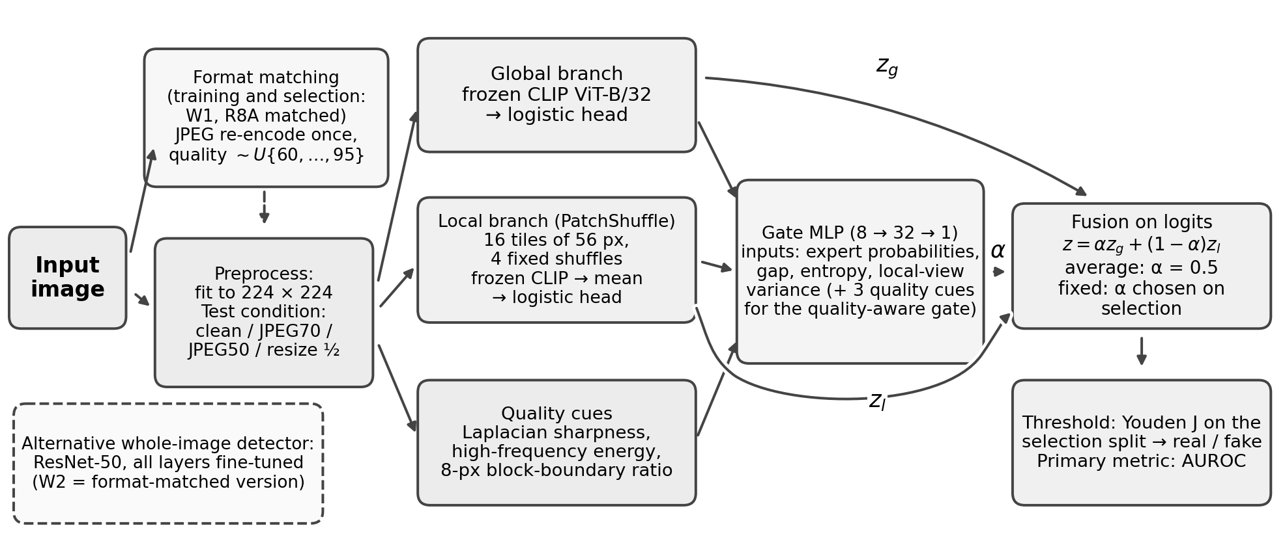
Figure 1. Detector overview. Two frozen-CLIP experts score the whole image and a patch-shuffled version. A gate (or a fixed weight α) fuses their logits. Format matching changes the training and selection inputs; evaluation inputs are held fixed.

4.1 Global branch (W0)
The image is fitted to 224×224 pixels (centre crop and bicubic resize; the original profile). The normalised image embedding of the frozen OpenAI CLIP ViT-B/32 encoder [6] (FP16) is standardised and classified by L2-regularised logistic regression (C = 1). The head is trained on clean expert-fit images only. An alternative common128 profile, which first fits the image to 128 pixels and then up-samples it, was also evaluated; it was worse for the global branch in every seed (development ADM clean 0.51 vs 0.61), so we report the original profile.

4.2 Local branch (PatchShuffle)
The 224-pixel image is cut into 16 intact tiles of 56×56 pixels, rearranged by four fixed, label-independent permutations. The four CLIP embeddings are averaged and classified by a separate logistic head. Shuffling disrupts global spatial layout while retaining content within each tile; this is intended to reduce reliance on scene arrangement. Degradations are applied before shuffling.

4.3 Fusion and gating
The two branches are fused on logits: $z = α·z_{g} + (1 − α)·z_{l}$. Average fusion uses α = 0.5. Fixed fusion chooses α from {0, 0.1, …, 1} on the selection split. The ordinary gate is a small MLP (8 → 32 → 1, sigmoid; 321 parameters) that predicts α per image from both expert probabilities, their absolute gap, their mean predictive entropy and the variance of the four local-view logits. The quality-aware gate additionally receives three image-quality cues: Laplacian sharpness, high-frequency spectral energy and an 8-pixel block-boundary ratio, which responds to JPEG blocking. For the ordinary gate these three inputs are set to zero, so both gates share an identical architecture. Output weights are initialised to zero, so each gate starts as average fusion. Gates are trained on the gate-fit split, which is disjoint from the expert-fit split, by minimising the binary cross-entropy of the fused logit (AdamW, learning rate $3×{10}^{−3}$, weight decay ${10}^{−4}$, full batch, at most 400 epochs), with early stopping on selection loss over the clean, JPEG70 and resize views. Each gate is trained from three initialisations whose metrics are averaged within a seed. Temperature scaling [11] changed rankings negligibly, so we report raw scores.

4.4 Fine-tuned ResNet-50
As a fully trainable whole-image alternative we fine-tune all layers of an ImageNet-pretrained ResNet-50 [7] (torchvision IMAGENET1K_V2) on the same expert-fit images and input geometry (AdamW, learning rate ${10}^{−4}$, weight decay ${10}^{−4}$, batch 32, 10 epochs, cosine schedule). The epoch is chosen by mean selection AUROC. One run takes about 10 minutes on our RTX 4050 laptop GPU.

4.5 Proposed modification: format-matched training
To reduce the label-associated encoding mismatch, every training and selection image, real and fake, is JPEG re-encoded once at its native resolution before preprocessing. The quality is drawn uniformly from {60, …, 95}, deterministically per (seed, image) and independently of the label. Evaluation images are unchanged, so this comparison tests the combined change to fitting and selection preprocessing. We apply this in three variants: W1, the global CLIP branch; W2, the ResNet-50; and Round 8A (R8A) matched, where both branches, the fusion and both gates (including gate-fit views) are trained on format-matched images. Its unmatched arm reproduces the Round 7 models. The two classes retain different compression histories: re-encoded real images have two compression passes, compared with one for fakes. Before training W1 and W2 we fixed three success criteria, required in every seed: (i) mean ADM AUROC over JPEG70 and JPEG50 ≥ 0.50; (ii) a drop in clean ADM AUROC of at most 0.02 relative to W0; and (iii) a drop in clean BigGAN AUROC of at most 0.02.

5 Experiments
Six exploratory rounds (Appendix A) on a 1,600-image pool found poor transfer from SD1.5 alone, strong image-size cues, and inconsistent gains from gating and augmentation. They motivated the fixed protocol of Rounds 7 and 8. Round 7 defined the data (Section 3) and re-ran all baselines for three seeds (Step C). It then ran the format-matching experiment W1/W2 under its pre-specified criteria (Step D), and evaluated all 138 frozen model instances once on the Round 7 test (Step E). Round 8 trained the format-matched local branch and fusion on development data (R8A), then evaluated 96 frozen model instances (Round 7 and R8A models) once on a test set of 3,500 images new relative to the documented repository pools. Finally, the saved Round 8 test predictions were analysed post hoc (Section 6.4). Software: Python 3.12, PyTorch 2.2, scikit-learn 1.8, with Pillow pinned to 12.2, because other Pillow versions decode some JPEGs differently and change our pixel hashes. Every step has an independent verifier script. The November improvements and diagnostics were evaluated on the previously inspected ADM/BigGAN development data. We report them as follow-up development results in Section 6.5.

6 Results

6.1 Development: diagnosing the format shortcut
Table 2 shows development AUROC on ADM and BigGAN. The global CLIP branch W0 performs moderately on clean images, but under JPEG it ranks ADM fakes below real photographs (AUROC 0.35–0.37). This pattern recurs across the three shared-pool seeds (SD ≤ 0.009). The label-associated encoding difference and the format-matching intervention support format-related cues as a contributor to this sensitivity. The local branch is less affected on ADM JPEG (0.44–0.45), but fusion remains weak in these cells. The fine-tuned ResNet-50 performs well on its source selection data yet transfers poorly to clean BigGAN (0.49).
Table 2. Development AUROC (mean of 3 seeds, original profile, raw scores). J70/J50 = JPEG quality 70/50; Rz = resize ½. SD across seeds ≤ 0.04 for ADM and ≤ 0.08 for BigGAN.
Model | ADM (development) |  |  |  | BigGAN (development)
 | Clean | J70 | J50 | Rz | Clean | J70 | J50 | Rz
W0: global CLIP | 0.606 | 0.365 | 0.354 | 0.575 | 0.750 | 0.526 | 0.539 | 0.569
Local (PatchShuffle) | 0.590 | 0.452 | 0.443 | 0.555 | 0.681 | 0.552 | 0.573 | 0.577
Average fusion | 0.612 | 0.391 | 0.374 | 0.578 | 0.747 | 0.544 | 0.561 | 0.583
Quality-aware gate | 0.601 | 0.390 | 0.383 | 0.564 | 0.725 | 0.535 | 0.551 | 0.577
ResNet-50, fine-tuned | 0.572 | 0.470 | 0.462 | 0.533 | 0.488 | 0.538 | 0.536 | 0.527
W1: global, format-matched | 0.677 | 0.576 | 0.514 | 0.704 | 0.649 | 0.637 | 0.629 | 0.634
W2: ResNet-50, format-matched | 0.527 | 0.486 | 0.485 | 0.523 | 0.337 | 0.555 | 0.559 | 0.503
R8A matched local | 0.593 | 0.504 | 0.476 | 0.546 | 0.664 | 0.662 | 0.669 | 0.536
R8A matched average fusion | 0.656 | 0.551 | 0.496 | 0.657 | 0.679 | 0.674 | 0.677 | 0.606

Format-matched training. W1 removes the ADM flip and improves ADM in every condition. It met criteria (i) and (ii) in all seeds (JPEG mean 0.53, 0.57 and 0.53; clean ADM rose by 0.05–0.08), but clean BigGAN fell by 0.08–0.12, so W1 failed criterion (iii) and therefore the pre-specified test as a whole. W1's BigGAN scores are nearly flat across conditions (0.63–0.65), a pattern consistent with some of W0's clean advantage coming from format and size cues in these 128-pixel PNGs. W2 failed all three criteria and transferred poorly to clean BigGAN under this recipe (AUROC 0.34). In R8A, format matching helped the local branch under JPEG (ADM JPEG70 0.45 → 0.50) and lifted fused BigGAN JPEG performance from about 0.55 to 0.67, but it lowered clean and resized performance.
Gates. The quality-aware gate changes its branch weights under degradation, but the changes do not yield a consistent advantage over averaging. Local gains occur: in Table 2, ADM JPEG50 AUROC rises from 0.374 for averaging to 0.383 for the quality gate. Such gains are offset by losses in other conditions. The subsequent development diagnostics examine both the source dependence of the weights and the rankings that these adjustments repair or damage.

6.2 Final test results
Table 3 reports main-macro AUROC for both test sets. The frozen global branch W0 reaches 0.85–0.87 on clean images. JPEG costs about 0.12 AUROC and resizing about 0.08. Among models trained on original images, average and fixed-weight fusion are the best or joint-best methods in every condition, ahead of W0 by about 0.005 on clean images and 0.02 under JPEG. Both gates are slightly worse. ResNet-50 is about 0.1 below frozen CLIP. Format matching trades clean AUROC for JPEG robustness. W1 loses 0.035–0.056 on clean images but gains only 0.003–0.019 under JPEG. The R8A matched average fusion is among the strongest JPEG models (0.775 and 0.777 under JPEG70 and JPEG50 on the Round 8 test), but it is 0.044 below the original average fusion on clean images. No single model is best in every condition.
Table 3. Final test results: main-macro AUROC (mean of GLIDE, Midjourney, VQDM and Wukong; 3 seeds; original profile, raw scores). Bold marks the best value in each column. All SDs ≤ 0.025. A dash means the model was not part of that test's frozen model list.
Model | Round 7 test (3,750 images) |  |  |  | Round 8 test (3,500 new images)
 | Clean | J70 | J50 | Rz | Clean | J70 | J50 | Rz
W0: global CLIP | 0.854 | 0.734 | 0.734 | 0.780 | 0.867 | 0.734 | 0.742 | 0.786
Local (PatchShuffle) | 0.813 | 0.717 | 0.712 | 0.711 | 0.819 | 0.714 | 0.716 | 0.713
Average fusion | 0.860 | 0.756 | 0.755 | 0.782 | 0.871 | 0.756 | 0.762 | 0.787
Fixed fusion | 0.861 | 0.756 | 0.755 | 0.786 | 0.873 | 0.755 | 0.763 | 0.790
Ordinary gate | 0.857 | 0.754 | 0.750 | 0.778 | 0.866 | 0.751 | 0.759 | 0.779
Quality-aware gate | 0.851 | 0.748 | 0.743 | 0.769 | 0.862 | 0.746 | 0.751 | 0.775
ResNet-50, fine-tuned | 0.748 | 0.658 | 0.640 | 0.686 | 0.761 | 0.690 | 0.673 | 0.706
W1: global, format-matched | 0.819 | 0.749 | 0.753 | 0.788 | 0.811 | 0.743 | 0.745 | 0.774
W2: ResNet-50, format-matched | 0.722 | 0.665 | 0.650 | 0.679 | — | — | — | —
R8A matched local | — | — | — | — | 0.793 | 0.745 | 0.744 | 0.714
R8A matched average fusion | — | — | — | — | 0.827 | 0.775 | 0.777 | 0.775
R8A matched quality-aware gate | — | — | — | — | 0.812 | 0.766 | 0.762 | 0.762

Fresh-image evaluation. On the published main-macro comparisons, the same frozen Round 7 CLIP models change by at most about 0.014 AUROC between the two image sets. ResNet-50 changes by up to 0.033. The JPEG sensitivity of W0 and the improvement from W1 also recur on ADM: JPEG70 AUROC is approximately 0.39 and 0.38 for W0 on the Round 7 and Round 8 tests, versus approximately 0.59 for W1 on both. These observations show similar behavior on new repository-disjoint images.

6.3 Per-generator behaviour
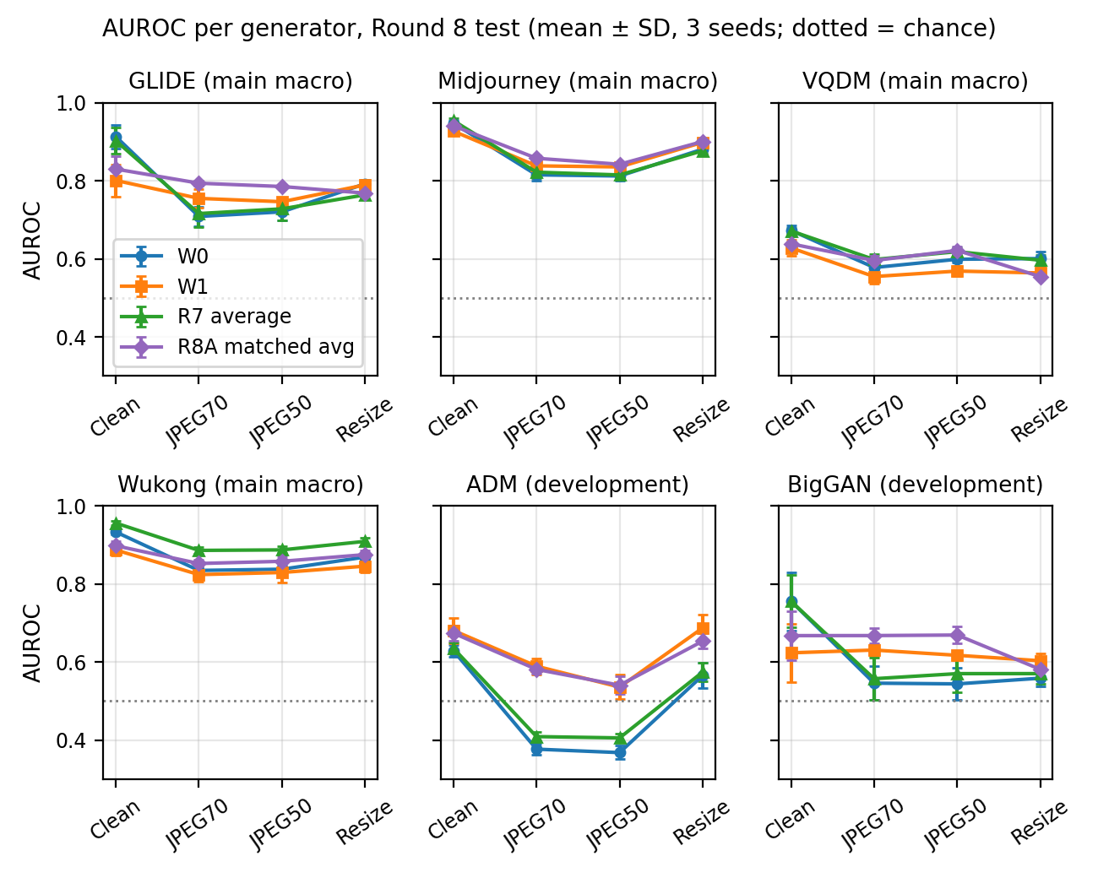
Figure 2. AUROC per generator and condition on the Round 8 test (mean ± SD over 3 seeds; dotted line = chance). ADM and BigGAN are development generators.
Figure 2 shows uneven transfer. On clean images, W0 and average fusion reach approximately 0.93–0.96 on Midjourney and Wukong and 0.90 on GLIDE, but only about 0.67 on VQDM and 0.63 on ADM. Format matching improves JPEG results for some generators, including fused GLIDE JPEG70 (approximately 0.72 to 0.79), while reducing clean GLIDE (approximately 0.90 to 0.83), Wukong and VQDM performance. ResNet-50 performs best on Wukong clean images (approximately 0.97).

6.4 Error analysis
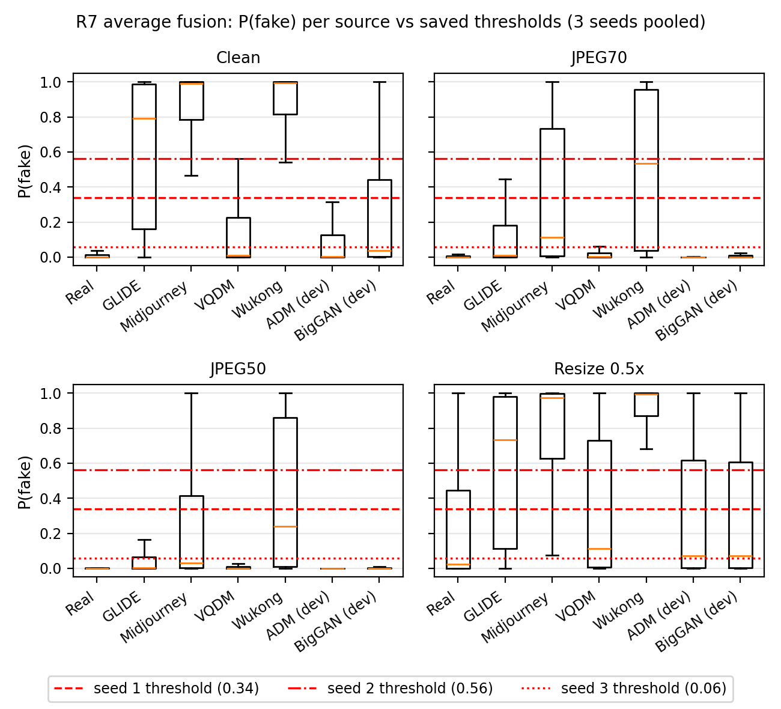
Figure 3. Average fusion (Round 7 models) on the Round 8 test: P(fake) per source under each condition, pooled over 3 seeds, with each seed's saved threshold.
Figure 3 shows how degradation shifts score distributions and error types. Under JPEG, the fake-probability of nearly all generated images collapses towards zero; at JPEG50 the fusion misses 51–92% of main-macro generator fakes and 96–98% of ADM and BigGAN fakes, while flagging only 4% of real images. Resizing has the opposite effect: 30% of real photographs are flagged as fake, against 12% on clean images. Errors are concentrated in a few generators. 688 fakes are missed in all seeds and all conditions (ADM 205, BigGAN 208, VQDM 187, GLIDE 60, Wukong 16, Midjourney 12), against a single real image. On clean images, 367 images are misclassified by all six models in all seeds, and 340 of them come from ADM, BigGAN or VQDM.
Threshold-based results describe the models at their saved operating points. Average-fusion thresholds vary across seeds (approximately 0.34, 0.56 and 0.06); each is selected using 125 real and 125 SD1.5 originals with their prescribed views. W1 uses format-matched selection inputs, so its comparison with W0 reflects changes in both scores and the selected operating point. W1's clean real-image FPR is approximately 0.26, against 0.13 for W0. At JPEG70, W1 has higher AUROC (0.743 versus 0.734) but lower balanced accuracy (0.599 versus 0.629). W0 and W1 disagree on 3–31% of images (Appendix D).

6.5 Targeted improvements and failure analysis
We investigated the weak quality-gate results through seven targeted modifications (Table 4). Changing only checkpoint selection from BCE to AUROC raised development AUROC from 0.608696 to 0.624503, versus 0.624427 for averaging. This restored performance to approximately the averaging baseline. The bounded-weight/ranking-loss candidate also remained near equal fusion.
Table 4. Targeted November modifications on ADM/BigGAN development data. AUROC is averaged over three data seeds and eight generator–condition cells unless stated otherwise. Rows report separate experiments with their own comparators.
Modification | Motivation | Comparator | Observed outcome
AUROC checkpoint selection | Align selection with ranking | Original quality gate; averaging | 0.6087 → 0.6245; averaging 0.6244. Restored baseline-level performance.
Original-view gate fitting and fixed weights | Test gate input-view mismatch | Same experts; original recipes and averaging | Gate 0.6021 vs 0.6087. Fixed fusion 0.6263 vs 0.6244, with gain in only one seed.
Bounded weights + ranking loss | Limit harmful routing | Averaging, same experts | 0.624431 vs 0.624427; weight ≈ 0.501. Little adaptive gain.
Quality-based condition routing | Use predicted degradation to choose weights | Averaging; no true condition at inference | 0.6211 vs 0.6244. Condition rules did not transfer reliably.
Additional gate generator | Broaden source coverage | Same-budget single-source rerun | 0.6202 vs 0.6244. AP/BA rose, but FPR rose from 15.40% to 18.87%.
JPEG95 stability selection | Prefer the more stable expert | Averaging for detection | Reliability AUROC 0.5083; detection 0.6111 vs 0.6244.
1:1 original/matched global training | Recover clean performance while retaining JPEG gains | Matched global expert | Overall 0.5625 vs 0.6273; clean BigGAN +0.0327, seven other cell means lower.
At JPEG70, a gate fitted with ADM as an additional source gave the global expert 72.45% mean weight on held-out BigGAN, although the local expert ranked better (0.6620 versus 0.6366). The reverse direction showed a corresponding mismatch (Figure 4). A block-boundary feature's label AUROC reversed from 0.7344 on BigGAN fitting data to 0.2974 on ADM target data. Replacing all quality inputs with training means in frozen gates partially recovered the four JPEG cell means. These observations suggest that generator-dependent expert preferences and quality signals contribute to failed transfer.
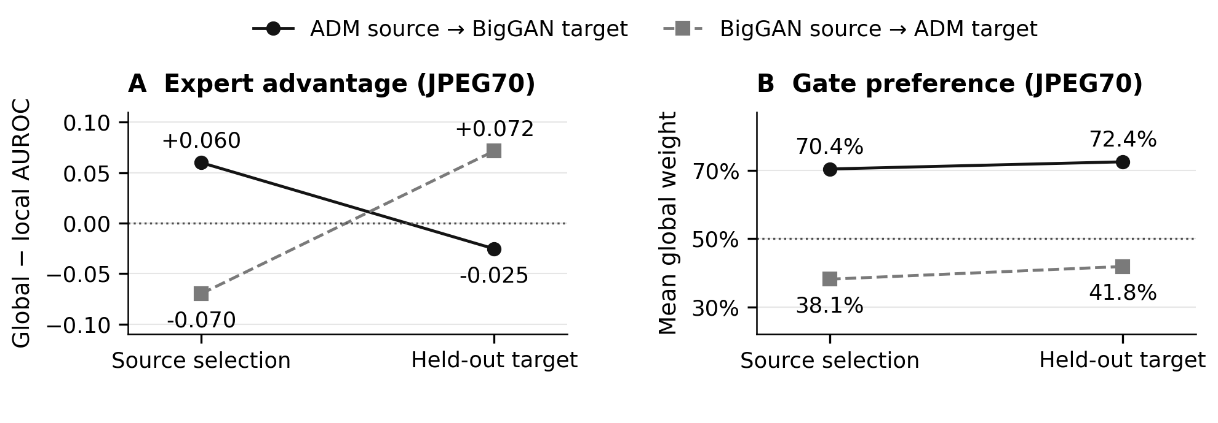
Figure 4. JPEG70 transfer mismatch in the multi-source development study. Left: global-minus-local AUROC reverses between source selection and held-out development generators. Right: mean global weight retains the source-associated preference. Source selection has 124 real/62 donor-fake images; targets have 300/300, so mean-weight changes also reflect different class composition.
Across JPEG70/50, new ranking damage exceeded repairs in all four generator–condition cells. Relative to averaging, the descriptive mean-preference and image-specific components were −0.0115 and −0.0041 AUROC; both were negative in every data-seed JPEG macro. The mean resize effect remained positive (+0.0173). Adding a generator, stability-based selection and 1:1 training fell short of the overall improvement target. Their results exposed specific limits in source coverage, reliability signals and training-view mixtures.

7 Discussion
Transfer (Q1). Frozen CLIP features carry signal that transfers to several unseen generators, especially high-resolution text-to-image models, without any fine-tuning. Transfer to VQDM, ADM and BigGAN is weak. GLIDE, ADM and VQDM all have 256-pixel outputs, yet transfer to GLIDE is stronger.
Shortcut (Q3). Label-associated file formats, the drop in ADM rankings under JPEG and the response to format matching suggest format-related shortcut learning as a contributor. The intervention changes fitting and selection inputs while keeping evaluation images fixed. On the Round 8 main macro, matched average fusion improves JPEG70/JPEG50 AUROC from 0.7556/0.7622 to 0.7749/0.7768, but clean AUROC falls from 0.8711 to 0.8268. Clean FPR rises from 12.00% to 26.73% while FNR falls from 32.72% to 24.45%. At JPEG70, FPR falls from 7.00% to 4.33%, but FNR rises from 67.32% to 72.63% and balanced accuracy falls from 62.84% to 61.52%. The clean-image cost therefore includes both lower ranking performance and a changed balance of classification errors.
Fusion and gating (Q2). Average and fixed-weight fusion are strong baselines because the branches provide partly complementary rankings. The targeted modifications in Section 6.5 recovered some lost performance; adaptive gains remained dependent on the source and condition. Source-related preferences and quality signals help explain the observed JPEG failures. Shared errors at the frozen thresholds limit the opportunities for choosing between existing binary decisions. Section 6.5 assesses logit fusion through the rankings it repairs or damages and the resulting changes in AUROC.
Limitations. Our training source is SD1.5; GenImage's reference protocol uses SD1.4. The fitting pool is small and shared across three seeds, and real-image pools are shared across generator comparisons. Seed SDs describe variation among these runs. ADM and BigGAN were repeatedly inspected during development, Round 8A followed the Round 7 results, and 116 Round 7 test images overlapped an earlier team-member pilot. November analyses are exploratory; bootstrap intervals condition on fitted models and comparisons are unadjusted. The target-mean-weight decomposition describes the observed loss through mean weight preference and image-specific adjustments. Input replacement probes the responses of frozen networks. Labels come from a third-party subset. Evaluation covers one CLIP encoder, Pillow JPEG and resizing; blur remains untested. Future work should isolate format, size and content effects and test reliability signals on independently selected generators.

8 Conclusion
Frozen-CLIP detection transfers unevenly across generators and image processing conditions. Format matching improves JPEG ranking in this setting, but reduces clean ranking and changes the balance of classification errors, failing the full pre-specified success criteria. Average and fixed-weight fusion remain strong baselines; learned quality-aware gating has no consistent additional advantage. Changing checkpoint selection recovers lost performance. Subsequent diagnostics point to generator-dependent routing and quality signals as contributors to the remaining failures. The two frozen evaluations show similar patterns on different images.

References
[1] M. Zhu et al., "GenImage: A Million-Scale Benchmark for Detecting AI-Generated Image," Advances in Neural Information Processing Systems, vol. 36, Datasets and Benchmarks Track, 2023.
[2] U. Ojha, Y. Li and Y. J. Lee, "Towards Universal Fake Image Detectors That Generalize Across Generative Models," Proc. IEEE/CVF CVPR, pp. 24480–24489, 2023.
[3] S. Gye, J. Ko, H. Shon, M. Kwon and J. Kim, "Reducing the Content Bias for AI-Generated Image Detection," Proc. IEEE/CVF WACV, pp. 399–408, 2025.
[4] P. Grommelt, L. Weiss, F.-J. Pfreundt and J. Keuper, "Fake or JPEG? Revealing Common Biases in Generated Image Detection Datasets," Computer Vision – ECCV 2024 Workshops, LNCS 15644, pp. 80–95, Springer, 2025. doi:10.1007/978-3-031-92089-9_6.
[5] S.-Y. Wang, O. Wang, R. Zhang, A. Owens and A. A. Efros, "CNN-generated images are surprisingly easy to spot… for now," in Proc. IEEE/CVF CVPR, 2020.
[6] A. Radford et al., "Learning transferable visual models from natural language supervision," in Proc. ICML, 2021.
[7] K. He, X. Zhang, S. Ren and J. Sun, "Deep residual learning for image recognition," in Proc. IEEE CVPR, 2016.
[8] J. Deng et al., "ImageNet: A large-scale hierarchical image database," in Proc. IEEE CVPR, 2009.
[9] R. Geirhos et al., "Shortcut learning in deep neural networks," Nature Machine Intelligence, vol. 2, pp. 665–673, 2020.
[10] R. A. Jacobs, M. I. Jordan, S. J. Nowlan and G. E. Hinton, "Adaptive mixtures of local experts," Neural Computation, vol. 3, no. 1, pp. 79–87, 1991.
[11] C. Guo, G. Pleiss, Y. Sun and K. Q. Weinberger, "On calibration of modern neural networks," in Proc. ICML, 2017.
[12] W. J. Youden, "Index for rating diagnostic tests," Cancer, vol. 3, no. 1, pp. 32–35, 1950.
[13] TheKernel01, "Tiny-GenImage" (dataset), Hugging Face, revision 89c4fe9efd0ebc7ce5c7641ef57d578ccd639c69, CC BY-NC-SA 4.0. https://huggingface.co/datasets/TheKernel01/Tiny-GenImage
[14] Pretrained models: OpenAI CLIP ViT-B/32 (openai/clip-vit-base-patch32, revision 3d74acf, via Hugging Face Transformers); torchvision ResNet-50 IMAGENET1K_V2 weights.

Appendix A Development history
Rounds 1–6 were exploratory and used a 1,600-image pool from four Tiny-GenImage shards (real, SD1.5, BigGAN and ADM). All of these images were excluded from Rounds 7–8.
Round | Question | Main finding
1 (pilot) | Frozen CLIP + logistic head trained on SD1.5 only | SD1.5 0.97, BigGAN 0.47, ADM 0.56 AUROC (ADM 0.34 at JPEG50). A classifier on original image size alone: 0.91 on SD1.5.
2 | Preprocessing profiles; add BigGAN to training | Mixed SD1.5 + BigGAN training lifted ADM to 0.66–0.68 (paired CI excludes 0). Harmonising to JPEG90 hurt ADM.
3 | Global vs PatchShuffle local expert; fixed fusion | Partly complementary errors; small fusion gains.
4 | Ordinary vs quality-aware gating | Neither gate consistently beat average fusion.
5 | Expert augmentation and temperature calibration | Calibration changed confidence, not ranking; joint JPEG + resize augmentation lowered ADM.
6 | Matched-dose JPEG70 vs resize augmentation | Adding resize to JPEG-only lowered ADM by 0.063 [−0.100, −0.025]; JPEG-only gain +0.016 (CI crosses 0).
7 | Fixed protocol, 3 seeds, ResNet-50, format matching (W1/W2), final test | Sections 6.1–6.2.
8 | Format-matched local branch + fusion (R8A); fresh second test | Sections 6.1–6.4.
November | Seven targeted modifications and frozen-score diagnostics | Checkpoint selection restored averaging-level performance; JPEG routing losses and positive resize results were quantified (Section 6.5).

Appendix B Reproducibility
The submission contains source_tree/ (the pinned published repository and actual November scripts/configurations), evidence/ (saved inputs, outputs and verification records), and reproduction/ (input manifests and commands). The source tree includes the Round 8 final evaluation and the teammate's analysis-c artifacts. Historical tmp/ directories are included in the package at their original relative paths. Data preparation uses pinned Tiny-GenImage revision 89c4fe9 and hash-checked shards; original images and pretrained weights are obtained separately using the supplied references. Historical environments are recorded per experiment, since Round 8A and November differ from Round 7. From the extracted submission root, run the supplied reproduce.py command to list or execute four no-training analyses: report-tables, report-figures, mechanism-predictions and mechanism-bootstrap. These were rerun from package-local inputs and matched the saved results. Full historical model fitting and feature extraction require the exact large inputs listed in review/input_artifact_manifest.json and cache_input_manifest.json. Validation for this revision covers the four analyses of saved results. Existing freeze/completion checks remain intact.
Example: python source_tree/scripts/submission_revision_20261114/reproduce.py --package . run report-tables --workspace ../rebuild-tables
See reproduction/REPRODUCING_en.txt for dependencies, all four commands, expected receipts and the separate historical-reproduction prerequisites.

Appendix C Individual contributions
Member | Contribution
Tang Ruixuan | Round 7 protocol and data splits (exclusions, three seeds, development and test sets); Step C baseline re-evaluation and fine-tuned ResNet-50; Step D format-matching study (W1/W2); Round 7 and Round 8 frozen final evaluations; code packaging.
Hou Lijie | Rounds 1–6: pilot, frozen-CLIP global branch, PatchShuffle local branch, fusion/gates, calibration and augmentation studies; Round 8A format-matched local branch/fusion; November targeted modifications, failure diagnostics and reproducible report-evidence preparation.
Patel Madhavan Pareshbhai | Post-hoc error analysis of the Round 8 test predictions: per-generator plots, W0/W1 disagreement, failure-case and score-distribution analysis (Figures 2–3, Appendix D).

Appendix D W0 vs W1 disagreement
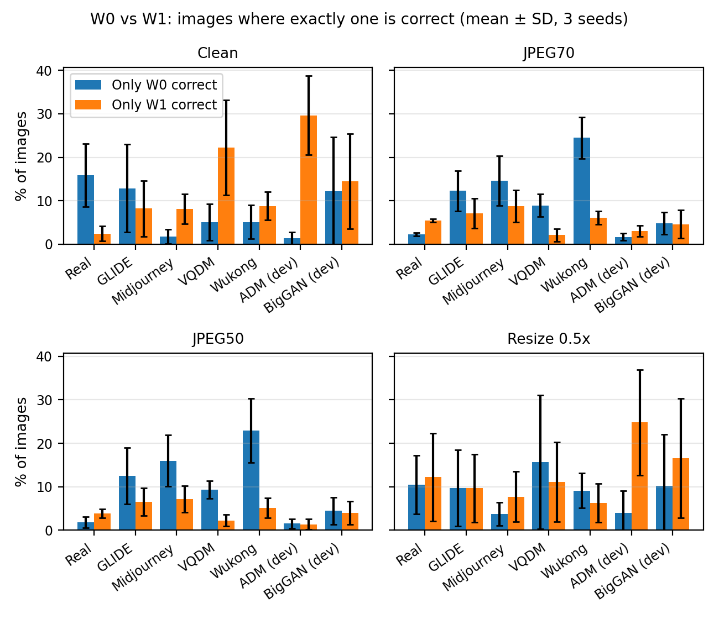
Figure D1. Share of images on which exactly one of W0 and W1 is correct, at each model's saved threshold (Round 8 test, mean ± SD over 3 seeds).

