Auf allen Maschinen:
sudo apt update
sudo apt install bridge-utils vlan

Konfiguration der Clients
nano /etc/network/interfaces

NWTK2
auto enp0s8.10
iface enp0s8.10 inet static
address 192.168.10.1
netmask 255.255.255.0
gateway 192.168.10.254
vlan-raw-device enp0s8

NWTK3
auto enp0s8.20
iface enp0s8.20 inet static
address 192.168.20.1
netmask 255.255.255.0
gateway 192.168.20.254
vlan-raw-device enp0s8

Server
VLAN 10
auto enp0s8.10
iface enp0s8.10 inet static
address 192.168.10.254
netmask 255.255.255.0
vlan-raw-device enp0s8

VLAN 20
auto enp0s8.20
iface enp0s8.20 inet static
address 192.168.20.254
netmask 255.255.255.0
vlan-raw-device enp0s8

Routing temporär aktivieren
echo 1 > /proc/sys/net/ipv4/ip_forward
cat /proc/sys/net/ipv4/ip_forward

Routing permanent aktivieren
nano /etc/sysctl.conf
net.ipv4.ip_forward=1

Routing Tabelle anzeigen
ip route show

Ping
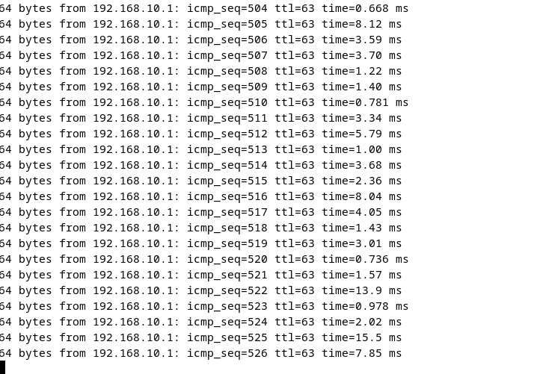

Vergleich

VLAN
(Linux)
auto enp0s8.10
iface enp0s8.10 inet static
address 192.168.10.254
netmask 255.255.255.0
vlan-raw-device enp0s8

(Cisco)
interface g0/0.10
encapsulation dot1Q 10
ip address 192.168.10.254 255.255.255.0

Routing aktivieren
(Linux)
echo 1 > /proc/sys/net/ipv4/ip_forward

(Cisco)
ip routing

Routing Tabelle
(Linux)
ip route show

(Cisco)
show ip route

Ip mit ip-Befehl konfigurieren
Ip setzten
sudo ip addr add 192.168.10.1/24 dev enp0s8.10

Interface aktivieren
sudo ip link set enp0s8.10 up

Default Gateway setzen
sudo ip route add default via 192.168.10.254

VLAN erstellen
sudo ip link add link enp0s8 name enp0s8.10 type vlan id 10

Routing Tabelle
(Linux)
192.168.10.0/24 dev enp0s8.10 proto kernel scope link src 192.168.10.254
192.168.20.0/24 dev enp0s8.20 proto kernel scope link src 192.168.20.254

Erreichbar über
Schickt zu Router mit ip

(Cisco)
C 192.168.10.0/24 is directly connected, GigabitEthernet0/0.10
C 192.168.20.0/24 is directly connected, GigabitEthernet0/0.20

Über das Subinterface

