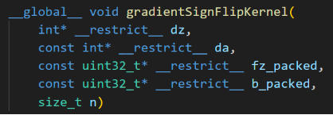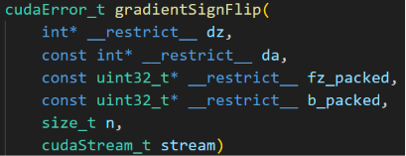
以上两个方法对应以下公式：
$$\begin{matrix}1 & \underset{→}{i^{\left(s\right)}} & n^{\left(s\right)} \\ ↓ & 1 & \\ 1 & & \end{matrix}\left(\frac{∂loss^{\left(t\right)}}{∂z_{i^{\left(s\right)}}^{\left(s\right)\left(t\right)}}\right)=\begin{matrix}1 & \underset{→}{i^{\left(s\right)}} & n^{\left(s\right)} \\ ↓ & 1 & \\ 1 & & \end{matrix}\left(\frac{∂loss^{\left(t\right)}}{∂a_{i^{\left(s\right)}}^{\left(s\right)\left(t\right)}}∙\left\{\begin{matrix}-1, & f\left(z_{i^{\left(s\right)}}^{\left(s\right)\left(t\right)}\right)-b_{i^{\left(s\right)}}^{\left(s\right)}<0, \\ 1, & f\left(z_{i^{\left(s\right)}}^{\left(s\right)\left(t\right)}\right)-b_{i^{\left(s\right)}}^{\left(s\right)}≥0,\end{matrix}\right.\right)$$
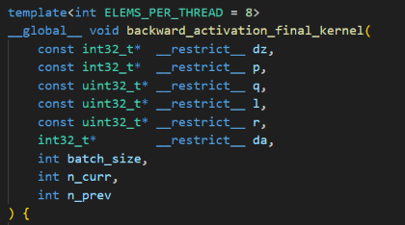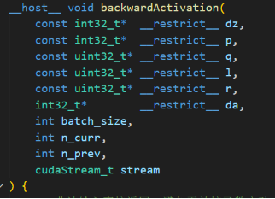
以上两个方法对应以下公式：
$$\begin{matrix}1 & \underset{→}{i^{\left(s-1\right)}} & n^{\left(s-1\right)} \\ ↓ & 1 & \\ 1 & & \end{matrix}\left(\frac{∂loss^{\left(t\right)}}{∂a_{i^{\left(s-1\right)}}^{\left(s-1\right)\left(t\right)}}\right)=\begin{matrix}1 & \underset{→}{i^{\left(s-1\right)}} & n^{\left(s-1\right)} \\ ↓ & 1 & \\ 1 & & \end{matrix}\left(\frac{∂loss^{\left(t\right)}}{∂z_{p_{i^{\left(s-1\right)}}^{\left(s-1\right)}}^{\left(s\right)\left(t\right)}}∙q_{i^{\left(s-1\right)}}^{\left(s-1\right)}+\frac{∂loss^{\left(t\right)}}{∂z_{i^{\left(s-1\right)}+1}^{\left(s\right)\left(t\right)}}∙l_{i^{\left(s-1\right)}+1}^{\left(s\right)}∙\overline{q_{i^{\left(s-1\right)}}^{\left(s-1\right)}∙δ\left(p_{i^{\left(s-1\right)}}^{\left(s-1\right)},i^{\left(s-1\right)}+1\right)}+\frac{∂loss^{\left(t\right)}}{∂z_{i^{\left(s-1\right)}-1}^{\left(s\right)\left(t\right)}}∙r_{i^{\left(s-1\right)}-1}^{\left(s\right)}∙\overline{q_{i^{\left(s-1\right)}}^{\left(s-1\right)}∙δ\left(p_{i^{\left(s-1\right)}}^{\left(s-1\right)},i^{\left(s-1\right)}-1\right)}\right)$$

