$$∀i^{\left(s\right)}∈\left[1,n^{\left(s\right)}\right]∩Z,s∈\left[1,L\right]∩Z,,t∈\left[1,m\right]∩Z,∃以下定义:$$
定义
$$f\left(x\right)=\left\{\begin{matrix}0, & x≤0, \\ 1-\left(\left\lceil x\right\rceil -x\right), & x>0,\end{matrix} \right.$$
图像如下：
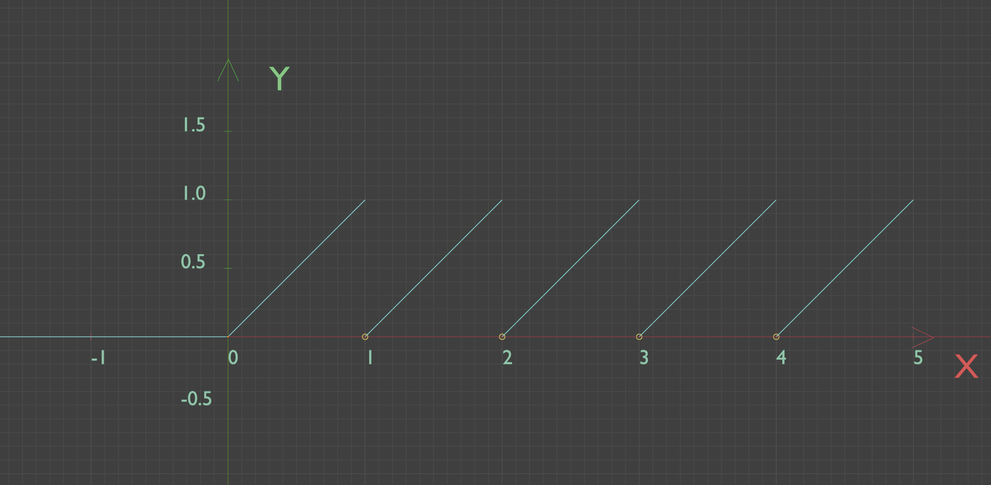
则
$$\frac{∂f\left(x\right)}{∂x}=\left\{\begin{matrix}0, & x≤0 , \\ 1, & x>0,\end{matrix} \right.$$
定义
$$σ(x,b)=\left|f\left(x\right)-b\right|$$
则
$$\frac{∂σ\left(x,b\right)}{∂x}=\frac{∂\left|f\left(x\right)-b\right|}{∂x}=\left(f\left(x\right)-b\right)∙\frac{∂f\left(x\right)}{∂x}$$
如果$s=1$，则
$$a_{i^{\left(1\right)}}^{\left(1\right)\left(t\right)}=\left|x_{i^{\left(1\right)}}^{\left(t\right)}-b_{i^{\left(1\right)}}^{\left(1\right)}\right|$$
如果$s>1$，则
$$z_{i^{\left(s\right)}}^{\left(s\right)\left(t\right)}=\sum_{i^{\left(s-1\right)}=1}^{n^{\left(s-1\right)}}{ω_{i^{\left(s-1\right)}i^{\left(s\right)}}^{\left(s-1\right)}a_{i^{\left(s-1\right)}}^{\left(s-1\right)\left(t\right)}}$$
$$a_{i^{\left(s\right)}}^{\left(s\right)\left(t\right)}=σ(z_{i^{\left(s\right)}}^{\left(s\right)\left(t\right)},b_{i^{\left(s\right)}}^{\left(s\right)})=\left|f\left(z_{i^{\left(s\right)}}^{\left(s\right)\left(t\right)}\right)-b_{i^{\left(s\right)}}^{\left(s\right)}\right|$$
定义
$$loss=\frac{1}{m}\sum_{t=1}^{m}{\left[\sqrt{\sum_{i^{\left(L\right)}=1}^{n^{\left(L\right)}}{{\left(a_{i^{\left(L\right)}}^{\left(L\right)\left(t\right)}-y_{i^{\left(L\right)}}^{\left(t\right)}\right)}^{2}}}\right]}$$
$$loss^{(t)}=\sqrt{\sum_{i^{\left(L\right)}=1}^{n^{\left(L\right)}}{{\left(a_{i^{\left(L\right)}}^{\left(L\right)\left(t\right)}-y_{i^{\left(L\right)}}^{\left(t\right)}\right)}^{2}}}$$
设定
$$ω_{i^{\left(s-1\right)}i^{\left(s\right)}}^{\left(s-1\right)}=f\left(q_{i^{\left(s-1\right)}}∙δ\left(p_{i^{\left(s-1\right)}},i^{\left(s\right)}\right)+l_{i^{\left(s\right)}}∙δ\left(i^{\left(s-1\right)},i^{\left(s\right)}-1\right)+r_{i^{\left(s\right)}}∙δ\left(i^{\left(s-1\right)},i^{\left(s\right)}+1\right)\right)$$
其中
$$δ\left(x,y\right)=\left\{\begin{matrix}1, & x=y, \\ 0, & y≤x-1或y≥x+1,\end{matrix} \right.$$

