Manual for Test GUI

1. In synchrosquezzing folder, open gui_test.py



2. Load test data

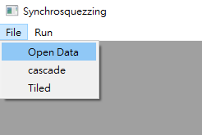

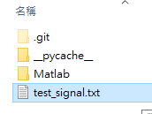

Only fit for two columns data, first column for time, second column for signal

3. Run → Original Signal: Plot the raw data

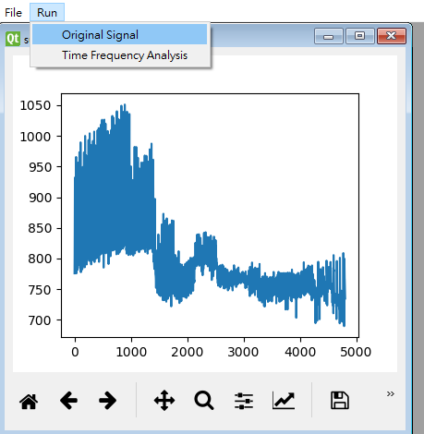

4. Run → Time Frequency Analysis



Choose Transform and adjust parameters

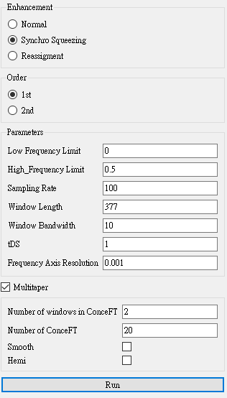

push Run to Plot

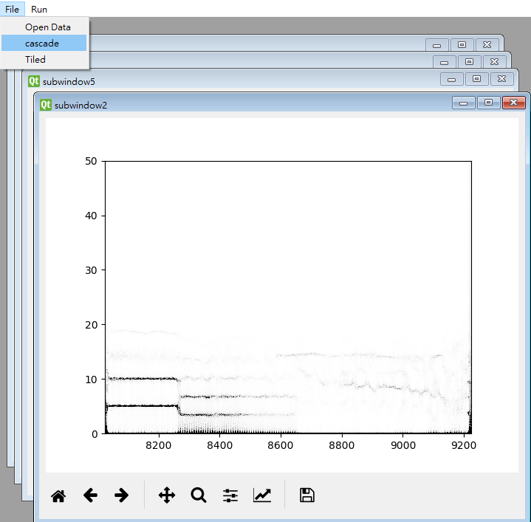5. Arrange Plots in Main Window

Cascade

Tilted

