Manual for Test GUI

1. In synchrosquezzing folder, open gui_test.py
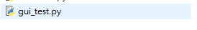

2. Load test data
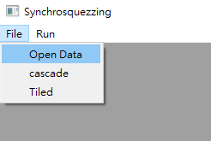

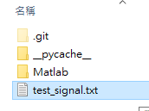

Only fit for two columns data, first column for time, second column for signal

3. Run → Original Signal: Plot the raw data

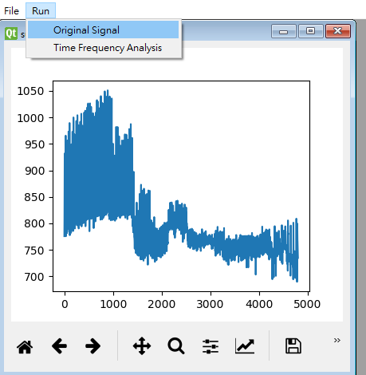

4. Run → Time Frequency Analysis
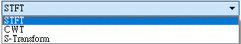
Choose Transform and
adjust parameters
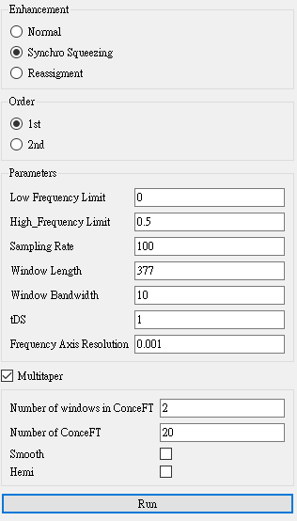

push Run to Plot

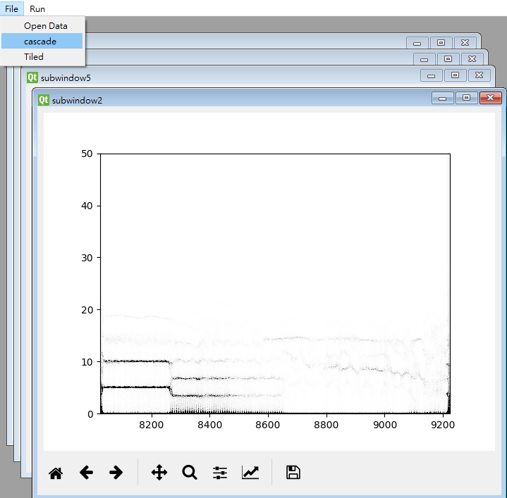
5. Arrange Plots in Main Window

Cascade

Tilted

