Joel Bravo
IST 707
May 28, 2019

Diversity in Characters in Marvel Comics

Introduction

For seventy years, Marvel Comics has been continuously growing its canon of storylines, characters, and books to meet popular demand. With the expansion of Marvel into other forms of media in recent years, such as film, television, video games, and others, the ability to reach new audiences that before may not have been interested in comic books has only increased Marvel’s popularity. Increasingly diverse audiences, however, has resulted in greater appreciation of and demand for more diverse characters. This is particularly true in the case of both female characters and those that identify as a Gender and Sexual Minority (GSM). As inclusiveness becomes of greater importance, it is a worthwhile endeavor to determine how well Marvel is doing at meeting this new challenge.

In order to determine how well Marvel is doing in creating a more diverse canon of characters, this project seeks to answer two questions:

- What characteristics are most commonly associated with characters in general and non-male characters?
- Is it possible to predict if a character is male or female based on if they are dead and their number of appearances?

The second question at a glance may not appear to be directly relevant to diversity in characters. Historically, however, characters that were female or GSM’s have been reduced to either minor roles that frequently resulted in their deaths for developing the plot arc of a male character or were outright censored due to prohibitions against non-heterosexual characters. Similarly, a better understanding of the characteristics assigned to female and GSM characters can shed light on how Marvel either has or has not improved in their representation.

Dataset Description

The dataset that is to be used in my analysis was provided by the website FiveThiryEight.com via Kaggle.com. FiveThirtyEight used this dataset in their own analysis of gender and GSM breakdowns in comic books, though their analysis was focused more on descriptive statistics, while mine will involve additional analytical techniques. The Kaggle repository consists of two separate datasets, one for Marvel Comics and one for DC Comics. However, for this project I will only be focused on Marvel. The Marvel dataset is an Excel spreadsheet consisting of some 16,377 rows and 13 columns that contains every character created by Marvel Comics up to 2014. The initial variables consist of the following:

Variable | Description | Example
page_id | Unique identifier for row | 1678
name | The name of character | Spider-Man (Peter Parker)
urlslug | The unique url within the Marvel wikia that takes you to the character | \/Spider-Man_(Peter_Parker)
ID | The identity status of a character | Secret Identity
ALIGN | If the character is Good, Bad, or Neutral | Good Character
EYE | Eye color of character | Hazel Eyes
HAIR | Hair color of character | Brown Hair
SEX | Sex of character | Male Characters
GSM | If the character is a gender or sexual minority | Bisexual Characters
ALIVE | If the character is alive or deceased | Living Characters
APPEARANCES | Number of appearances in comics up to 9/2/2014 | 4043
FIRST APPEARANCE | Month and year of first appearance | Aug-62
YEAR | The year of first appearance | 1962

As will be discussed later, not all the attributes will be particularly useful for my analysis and would later be dropped. In addition, some preprocessing of the dataset will be necessary before any analysis can take place.

Data Preprocessing - General

Before I could begin my analysis, I performed some clean up and preprocessing to make the dataset suitable for use. Based on the questions I wished to address, I already knew that the FIRST APPEARANCE and YEAR columns would not be of use. Therefore, I deleted both columns to reduce the number of variables I would be working with. Similarly, urlslug and pageid, both of which were essentially metadata from the wikia database that originally hosted the dataset, were also dropped due to having no significant use for my analysis. Because there were several empty records within the dataset, I used R to fill all empty records with “NA” for clarification.

With the unnecessary attributes dropped, I began exploring my dataset and discovered a quirk that would potentially cause problems for my analysis. The GSM attribute indicates whether a character falls within the GSM spectrum by their sexual orientation (Bisexual, Agender, etc.). Most of the cells within the GSM column have NA as a value, however. Some additional research indicates that this was an omission on the part of the database where this data was extracted and that these values should be recorded as Not GSM Characters. Given this, I replaced all instances of “NA” within the GSM column with “Not GSM” to avoid confusion. I then converted the GSM column back to a factor.

Finally, there was the matter of the APPEARANCES column. Rather than keep the number of appearances listed as-is, I opted to discretize the column values to avoid any potential issues in my analysis. I chose to discretize the values into eight bins and set the width of each bin equal to the maximum value minus the minimum value found in the column divided by eight. Once done, it was simply a matter of using the cut function on the APPEARANCES column to put into place the discretized data.

Descriptive Statistics

To better understand the dataset, I opted to make use of some descriptive statistics before pursuing any analysis. Utilizing the summary function in R can help provide some insight into the nature of the data. The output of the summary function can be seen below:

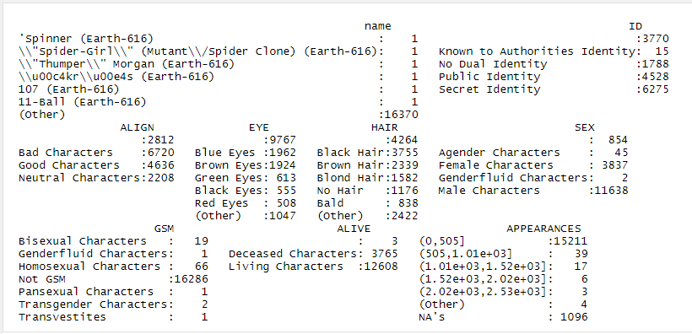

A few things stand out after summarizing the data. First, a significant majority of Marvel characters are male and are not a GSM of any sort. Indeed, it appears that other genders are severely underrepresented, as are other types of GSMs. Most characters appear less than 505 times as of 2014, which is unsurprising given the vast collection of characters that Marvel has at its disposal. There are more bad characters overall than good or neutral ones, again most likely due to Marvel requiring more villains overall than heroes. Finally, most characters maintain secret identities compared to publicly known identities, identities known to public authorities, or characters that do not have a public/secret identity.

Knowing these characteristics will be important in our analysis, as the various combinations of traits and their prevalence among non-male and GSM characters will serve as an indicator of overall diversity in Marvel’s pantheon of characters.

Analysis – Association Rules

With general preprocessing complete, I was ready to address my first question of what characteristics are most common with non-male and non-GSM characters. Utilizing the apriori function, my initial goal was to generate association rules with a confidence of 0.9 and support of 0.4. However, using these variables resulted in zero rules being generated. I chose to scale down my initial selections to a support of 0.4 while keeping confidence high at 0.9. I also kept the maximum length of the rules to 3 to avoid creating rules that were far too complex to use. In this attempt I was able to generate 32 rules from the dataset. While these rules are not specific to female or GSM characters, I nevertheless inspected several of them in order to see if any rules specific to male and/or heterosexual characters could be found that would be of use to my analysis. In particular, the following stood out:

- {SEX=Male Characters,ALIVE=Living Characters} => {GSM=Not GSM}
Support: 0.533
Confidence: 0.996
Lift: 1.001

- {SEX=Male Characters,APPEARANCES=(0,505]} => {GSM=Not GSM}
Support: 0.659
Confidence: 0.995
Lift: 1.001

- {ALIGN=Bad Characters,SEX=Male Characters} => {GSM=Not GSM}
Support: 0.325
Confidence: 0.994
Lift: 1.004

While I did not specify any GSM variables on the RHS (right hand side) of the association rules, these three rules can shed more light on the role, or lack thereof, of GSM characters within Marvel. In 53.3% of the dataset, there is a 99.6% likelihood that characters who are male and alive are not on the GSM spectrum. In an even greater percentage of the dataset, 65.9%, there is a 99.5% likelihood of male characters with less than 505 appearances not being on the GSM spectrum. Both association rules speak to a dearth of living characters that are not on the GSM spectrum, especially in light of the fact that the majority of characters have appeared 505 times or less since this dataset was created. The final association rule indicates that characters that are bad aligned, i.e., villains, and are male tend to not fall on the GSM spectrum in 32.5% of the dataset. This seems to imply that villainous characters are very much in the purview of non-GSM males.

While my initial analysis provided insight into characteristics that were common to or lacking within GSM characters, I nevertheless wanted to refine my association rules further. Specifically, I wanted to set the RHS to SEX=Female Characters in order to determine rules that specifically effects females. This proved more challenged than expected. Utilizing the same confidence and support levels as before resulted in no rules, quite possibly due to there being far fewer female characters overall. Therefore, I lowered support to 0.001, confidence to 0.8, and did not set any maximum length constraints, resulting in 20 rules being generated. As before, I combed through the rules and discovered a few rules that stand out:

{ALIGN=Bad Characters,
EYE=Green Eyes,
HAIR=Blond Hair,
APPEARANCES=(0,505]}
=> {SEX=Female Characters}
Support: 0.001
Confidence: 0.850
Lift: 3.627

{ID=Public Identity,
EYE=Green Eyes,
HAIR=Red Hair,
ALIVE=Living Characters,
APPEARANCES=(0,505]} => {SEX=Female Characters}
Support: 0.001
Confidence: 0.850
Lift: 3.627

While support for both rules are very low, due primarily to there being so few female characters in comparison to male characters, both rules seem to indicate that there is a certain diversity in traits associated with females. Aside from physical traits, 85% of the time female characters have a bad alignment and 505 appearances or less and female characters have a public identity and appear 505 times are less, respectively. In contrast to GSM characters, there is a greater likelihood of experimenting with alternative characterizations, such as having villainous female characters or female characters that do not make sure of secret identities in their activities. Indeed, neutral alignment is a common characteristic found in many other of the association rules, further reinforcing greater experimentation with roles. However, this is undercut by the fact that the number of female characters is so low. While there is more experimentation with different roles, there does not appear to be an abundance of unique female characters overall.

Finally, a noticeable trend is in the association rules is that almost all rules indicate that green eyes and red hair is an indicator of a character being female, with a few deviating a bit by containing blonde hair. It is not immediately clear why this is the case. It may be that such a combination is popular among writers. Whether this is indicative of predetermined physical standards for female characters or not would require additional analysis that is beyond the scope of this paper.

Analysis – Decision Tree Modeling

After having utilized association rule mining to determine characteristics associated with female and GSM/non-GSM characters, I wanted to turn my attention to my other question. Specifically, I wished to determine if it was possible to predict the gender of a character based on whether they were dead and their total appearances. The author Gail Simone would identify a trend, coined as Women in Refrigerators, in comics in 1999 where it appeared that female and otherwise non-male characters were disproportionately more likely to be killed off or suffer some sort of tragedy in order to advance the plot arc of a male character. Utilizing a decision tree model, I hoped to be able to engage in more tangible analysis to see if this trend could impact the way machine learning could determine someone’s gender based on whether they were alive.

Before I could start on the DT model, however, I needed to further preprocess the dataset. For my question, not all the columns would be of use, especially those that deal with physical characteristics. Therefore, I opted to remove "name","ALIGN","EYE","HAIR", "GSM", and the “ID” columns. Similarly, the few rows that had empty values were also removed. To avoid errors, I dropped any unused factor levels from when I removed unnecessary columns.

With preprocessing complete, I utilized the sample.split function to randomly divide the dataset into a training and test set. The SEX column was also removed from the testing set in order to generate my predictions. I trained the model at first utilizing the rpart algorithm and focusing on accuracy. The end results of training the model can be seen below:

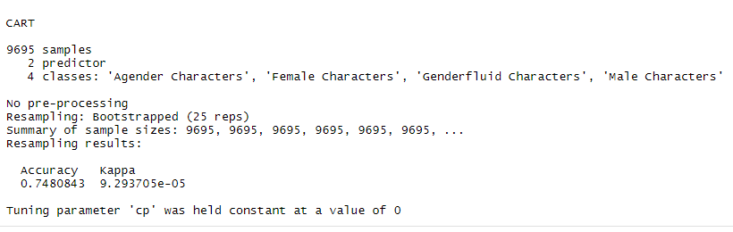

An accuracy of 74.8% was decent, but I hoped to increase this accuracy further. I made some tweaks to my initial line of code in order to optimize accuracy further as seen below:

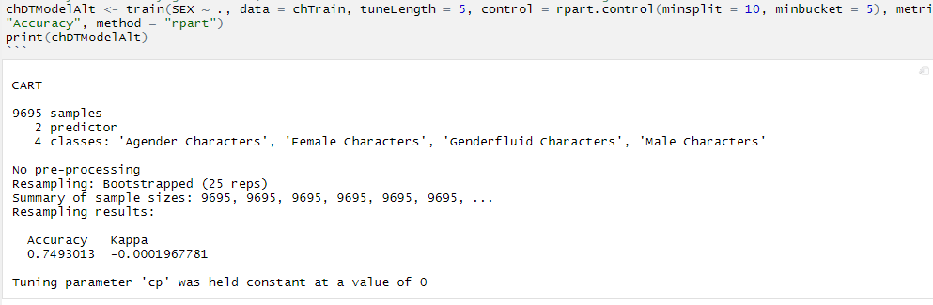

The accuracy improved just slightly at 74.9% after further tweaks. Ultimately, I settled for this level of accuracy and continued to apply my model with the testing set. The results showed that the DT model was able to determine that 74.8% of characters in the testing set were male if they were dead and based on their total number of appearances. Female characters came well behind at 24.8%, while genderfluid and agender characters received an infinitesimal .0001% and .002% respectively.

The results are interesting because it does seem to indicate that female or non-male characters don’t necessarily suffer a disproportionally higher rate of being killed off compared to male characters. It is true, however, that Marvel characters are overwhelmingly male, which can be throwing off the results.

Conclusion
Overall, there is a significant paucity in characters that are either female or a GSM compared to heterosexual men. Per my analysis via association rule mining, there does seem to be a trend towards utilizing female characters in more diverse roles, such as villains or by playing with the concept of secret/public identities. At the same time, the association rules also indicate that GSM characters are still a rarity compared to the vast number of male non-GSM characters. Despite what the Women in Refrigerators trend might potentially imply, it does not appear that women are disproportionately more likely to be killed off compared to male characters or any other gender.
While this project served to explore only two questions, there were other areas of exploration I could have attempted had time permitted. While characters are predominantly male, it would have been fascinating to determine if the growth in female and GSM characters can be traced to specific decades based on the year a character was introduced. As alluded to in this project, there definitely appears to be a certain preference towards specific physical traits based on gender, such as blonde hair and blue eyes or red hair and green eyes. Utilizing a decision tree model or another algorithm such as SVM to determine if the gender of a character can be predicated by these physical traits would be enlightening in determine physical diversity in characters. Finally, FiveThirtyEight had also provided a similar dataset for DC Comics. Applying the same analysis to the DC dataset and comparing the two publishing companies would have been an interesting look into how each company has tackling the issue of diversity and representation.
As changing social norms influence readership, publishing houses such as Marvel feel the pressure to create characters that are move diverse. Changing social mores play a large role in this, as do demographics; the fastest growing demographic among readership are women age 17-33. Despite some resistance to the trend by a few, most notably the controversial statement made by Marvel’s VP of Sales David Gabriel that diversity was responsible for Marvel’s monthly sales slump, comics with diverse characters are proving to be not only financially viable, but successful as well. The issue Thor #1, featuring a female version of the eponymous character, topped digital comic sales for two weeks straight, for example, while the Blank Panther limited run series written by Atlantic columnist Ta-Neshisi Coates proved enormously successful. There exists a lucrative market for diversity in comic books, particularly as upcoming demographics become the majority readership. Embracing these trends would go a long way to ensure a financially successful future for Marvel Comics.

