Joel Bravo
IST 718
8/10/19

Case Study

Introduction

The Syracuse Real Estate Investment Trust (SREIT) is looking to expand its portfolio of real estate in an attempt to generate greater returns on investment. Ideally, the investment opportunities should have a steady record of value growth in the past and an indication that said growth will continue in the future. Rather than letting investment opportunities be selected by chance, big data can be leveraged in order to provide more concrete analysis for investment.

Problem Specification and Background

In this case study, I plan to three questions in regard to investment opportunities:

- What three zip codes provide the best investment opportunities?
- Why are these zip codes the best for investment?
- What decision process was used to down sample from the initial data set?

The data set used for my analysis comes from Zillow’s research of the median estimated home value of a single-family residence from April 1996 to June 2019. The data set is publically available from Zillow’s website as a large CSV file. A sample of the column types is listed below:

RegionID | ID assigned to a region | 84654
RegionName | Zip code of a region | 60657
City | City the zip code belongs to | Chicago
State | State the zip code belongs to | IL
Metro | Metro area of zip code | Chicago-Naperville-Elgin
CountyName | Name of associated county | Cook County
SizeRank | Ranking of the zip code | 1

Not shown in the table due to size constraints are the various columns that represent a given month of the years represented in the data set. Each month contains the median estimated home value for that given zip code. As an example, the median home value for the 60657 zip code is $337,200 for April 1996.

To avoid any errors in my analysis, any zip codes that did not have reporting data for median home value were dropped from the data set. Overall, this did not have a significant effect in reducing the size of the original data set.

Observations

To begin my analysis, I opted to first explore the Hot Springs, Little Rock, Fayetteville, and Searcy metro areas in the state of Arkansas to see if any trends that are noticeable in these regions are also applicable to others. Creating a smaller data set containing home value data from only these four metro areas was simple enough in order to make my analysis more manageable. The new data set would be grouped by the Metro column and would drop any unneeded columns until the only data contained was the monthly median home value for each metro area. With the data formatted, I generated a time series plot that allows for a more intuitive comparison of the evolution of the four housing markets:

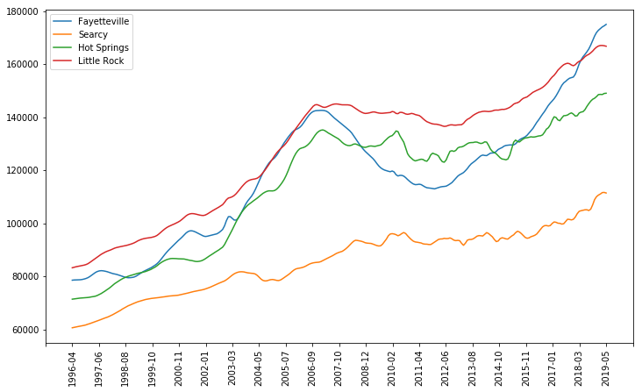
While Fayetteville, Hot Springs, and Little Rock seem to have rough parity in terms of housing value, Searcy is noticeable in that its home values have stayed relatively low and see only modest increases over the time span of the data. Fayetteville, Hot Springs, and Little Rock tend to follow the same pattern, including the rapid growth in median value and sudden decline after the housing market bubble burst, though Little Rock appears to have been affected only negligibly. All four metro areas, however, see a rapid increase in median home value past 2012-2013. Fayetteville in particular sees the biggest growth, while Searcy’s growth is far more modest and slower. As shown later, some of these trends can be seen in other areas of the country, though not necessarily to the same extent.

Analysis

For my main analysis, I chose to make use of Python’s prophet procedure, which allows for fast and relatively automated forecasting of applicable data sets. Before running the full analysis, I opted to first test forecasting on my home zip code of 93311. After subsetting my initial data set to only contain rows involving my zip code, I trained the data set using prophet and then used it to predict median home values 12 months into the future. Visualizing the forecast when coupled with preexisted data results in the following:

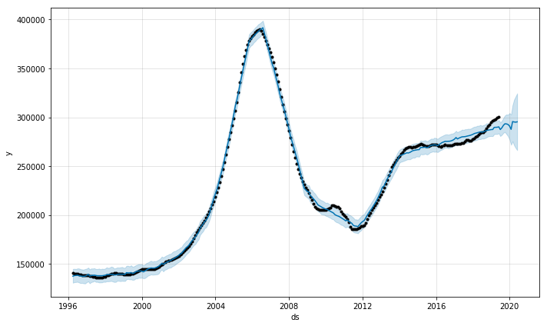
As seen with the Arkansas time series plot, the 93311 area code of Bakersfield, CA followed a similar trend of growth in the early 2000’s, a drop after the housing bubble burst/Great Recession, and gradual recovery. In Bakersfield’s case, however, the growth and decline were far more dramatic. This is consistent with California in general and Bakersfield in particular being hit exceptionally hard by the housing bubble burst. Relatively stagnant home values during 2015-2016 are against consistent with the severe drop in oil prices that had a pronounced effect on a city dominated by the oil industry. However, my forecasting shows a continuation in growth in home values that build off of what appears to be the beginning of a recovery by 2018.

Satisfied with the results, I moved to apply prophet to the data set in order to find the best zip codes for investment. The sheer size of the data set, however, made running it in prophet excessively time consuming. Given this, I opted to subset the data set to include only zip codes from California. Having been born and raised in California, my understanding of the context of home values is greater than other regions of the country, which can allow for more informed investment choices. After subsetting and further cleaning the data to make it compatible for prophet, I ran the forecasting and had the results exported as a CSV file for analysis in Excel. Unlike with my zip code example, I used a function to add in the percent change in home value for each zip code on top of Y, or the initial median home value, and yhat, or the last forecasted median home value. Filtering by the percent change in value results the following top three zip codes:

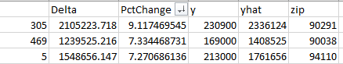

Visualizations were also created to show median home value evolution for all three zip codes:

90291
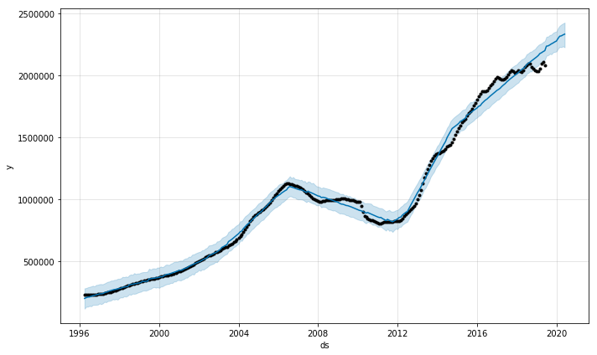

90038
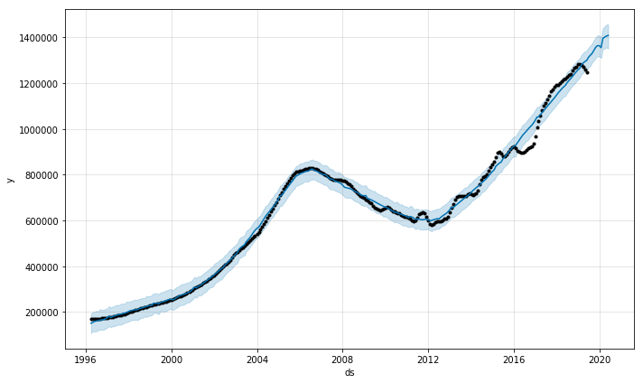

94110

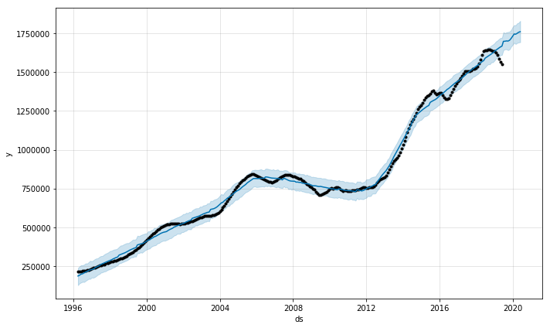

The zip codes in question map to the cities of Venice, Hollywood, and San Francisco, respectively. Unlike Bakersfield, the drop in median home values after the housing bubble burst was much less pronounced. All three zip codes would see considerable growth in median home values starting in 2012. This is reflected in the 9.12%, 7.33%, and 7.27% growth rates my forecasting model would generate. In particular, the zip code associated with Venice would see an increase in median home value from an initial $230,900 in 1996 to the forecasted value of $2,336,124. While the other two zip codes don’t quite reach the same level of growth, all nevertheless forecast median home values breaking the million dollar mark.

Conclusion

While my analysis was limited to Californian zip codes, I was able to determine that the 90291, 90038, and 94110 zip codes represent the best investment opportunities for SREIT. All three saw small to negligible drops in median value during the housing bubble burst and Great Recession, as well as rapid continued growth post 2012. Investment in these zip codes can be fruitful for SREIT should the trends continue.

