Software Requirements Specification

for

Recme
Version 1.0 approved
Prepared by Vladyslav Lapin
Kharkiv National University of Radioelectronics
01.05.2025

Revision History

Date | Description | Author | Comments
01.05.2025 | Version 1.0 | Vladyslav Lapin | First Revision

Document Approval

The following Software Requirements Specification has been accepted and approved by the following:
Signature | Printed Name | Title | Date
 | Vladyslav Lapin | Software Engineer
 | Anastasiya Chupryna | Product Owner

Table of Contents

Revision History 2
Document Approval 2
1. Introduction 5
1.1 Purpose 5
1.2 Scope 5
1.3 Definitions, Acronyms, and Abbreviations 5
1.4 References 6
1.5 Overview 6
2. General Description 7
2.1 Product Perspective 7
2.2 Product Features 7
2.3 User Characteristics 8
2.4 General Constraints 8
2.5 Assumptions and Dependencies 8
3. Specific Requirements 9
3.1 External Interface Requirements 9
3.1.1 User Interfaces 9
3.1.2 Hardware Interfaces 10
3.1.3 Software Interfaces 10
3.1.4 Communications Interfaces 10
3.2 Functional Requirements 10
3.2.1 Registration 10
3.2.2 Authorization 10
3.2.3 Getting recommendations 11
3.2.4 Evaluation of location / recommendation 11
3.2.5 Updating a profile 12
3.2.6 Changing a password 12
3.3 Use Cases 13
3.3.1 Use Case #1 13
3.4 Classes / Objects 14
3.4.1 User 14
3.4.2 Recommendation 14
3.4.3 Location 14
3.4.4 Category 14
3.4.5 Review 14
3.4.6 Filter 15
3.4.7 Preference 15
3.4.8 Context 15
3.4.9 Condition 15
3.5 Non-Functional Requirements 15
3.5.1 Performance 15
3.5.2 Reliability 15
3.5.3 Availability 16
3.5.4 Security 16
3.5.5 Maintainability 16
3.5.6 Portability 16
3.6 Inverse Requirements 16
3.7 Design Constraints 16
3.8 Logical Database Requirements 16
3.9 Other Requirements 17
4. Analysis Models 18
4.1 Deployment Diagram 18
5. Change Management Process 24

1. Introduction
1.1 Purpose
The purpose of this document is to describe an interactive communication system. The document will explain the purpose, features, limitations of the system. This document is aimed at stakeholders.
1.2 Scope
The software system, presented as a web application, will have the name Recme. Recme provides users with personalized recommendations on locations to visit, based on their individual preferences, current context, and feedback from other users. The system is designed to support people in finding places that match their mood, activity type, desired atmosphere, and situational factors such as weather and time of day. Users can apply detailed filters, such as the type of place, and indicate preferences like quietness or suitability for a group or family. The system processes these inputs together with contextual data to generate accurate and relevant location suggestions.
A key advantage of Recme is its hybrid recommendation engine, which combines content-based filtering, collaborative filtering, and contextual modeling within a deep learning framework. This allows Recme to provide smarter, more adaptive recommendations than traditional systems. The application is especially useful for individuals seeking personalized and situation-aware suggestions, whether they are exploring new areas, planning activities, or looking for places that align with specific needs or preferences.
Basic requirements for the user – stable net access, web browser and site account.
1.3 Definitions, Acronyms, and Abbreviations
Term | Definition
User | The person who created an account in the system by providing the necessary information.
Recommendation | Location that the system considered appropriate to recommend with given filters and context.
Front-end/Client | A graphical interface that a user can interact with.
Back-end/Server | The logical part of the system, which is responsible for the implementation of the system’s functionality, the calculation and management of data, as well as the responses to requests by using API.
API | An application programming interface is a collection of various tools, functions, implemented as an interface for interaction between programs.

Table 1 – Definitions
1.4 References
Privacy Politics reference
1.5 Overview
This document contains complete information about the project: its purpose, features, interface, limitations. They differ in the type of user the content is aimed at.
The “General Description” chapter is aimed at the project owner and provides an overview of the functionality of the system. It describes the requirements, which are the basis for the specification in the next chapter.
The chapter “Specific Requirements” describes details related to the functionality of the system, which is written in technical language for the developers to understand.
The chapter “Analysis Model” contains various diagrams and models that facilitate the understanding of the system by illustrating its operation and interaction with the user.

2. General Description
2.1 Product Perspective
Recme is a web-based application designed to provide users with personalized recommendations for locations to visit, based on their preferences and real-world context. It leverages machine learning to analyze user-defined filters, environmental conditions (such as weather and time), and historical behavioral patterns to offer accurate, adaptive suggestions.
The application stands out by combining traditional recommendation methods like content-based and collaborative filtering with contextual data, all within a unified deep learning model. This ensures that users receive relevant suggestions tailored to both their interests and current situations.
Below is a comparison with related platforms and why Recme is positioned to offer unique advantages:
- Google Maps: offers general location search and ratings, but lacks true personalization and context-awareness in recommendations.
- Tripadvisor: focuses on travel reviews and rankings, but doesn’t adapt dynamically to real-time context like weather or mood-based preferences.
- Yelp: provides user reviews and ratings but does not personalize suggestions beyond filters like “open now” or “nearby”.
What sets Recme apart is its hybrid recommendation engine powered by machine learning, and its context-aware logic that adapts to the user’s immediate environment and intentions.
Additionally, Recme is being developed with flexibility in mind, allowing for easy expansion and open data integration, making it more scalable and customizable than many of its competitors.
2.2 Product Features
FE-1. Users can register by providing name, email and password.
FE-2. Users can authorize by providing email and password.
FE-3. Users can choose current geolocation.
FE-4. Users can choose filters.
FE-5. Users can receive recommendations by providing filters.
FE-6. Users can evaluate location of the recommendation.
FE-7. Users can evaluate the recommendation.
FE-8. Users can update account information.
FE-9. Users can receive their history of all recommendations.
FE-10. Users can log out.
2.3 User Characteristics
There is one type of user who can interact with the system: a registered user.
Registered users can get recommendations and view their own history.
2.4 General Constraints
The client of the web application will be run on a web browser installed on the user’s device, for example, Google Chrome. System will be for different devices with different screen resolutions, the interface will most likely not be the same for every one of them, for user comfort.
The Internet connection is also a constraint for the application. The application connects to the server over the Internet and there is no way to get information without communications between client and server.
It is possible when the database will have many requests, so it may be forced to queue them and therefore increase the time needed to fetch data.
2.5 Assumptions and Dependencies
AS-1. Product will be popular among the people who like to travel.
AS-2. Product will be designed for a global audience.
DE-1. To use the web system, the user must have access to the Internet.
DE-2. To use the web system, the user must be registered.
DE-3. User cannot get recommendations if he didn’t pick current location.
DE-4. User cannot get recommendations if he didn’t pick at least 1 filter.
DE-5. Users cannot change/delete other accounts.
DE-6. Users cannot view history of other accounts.

3. Specific Requirements
3.1 External Interface Requirements
3.1.1 User Interfaces
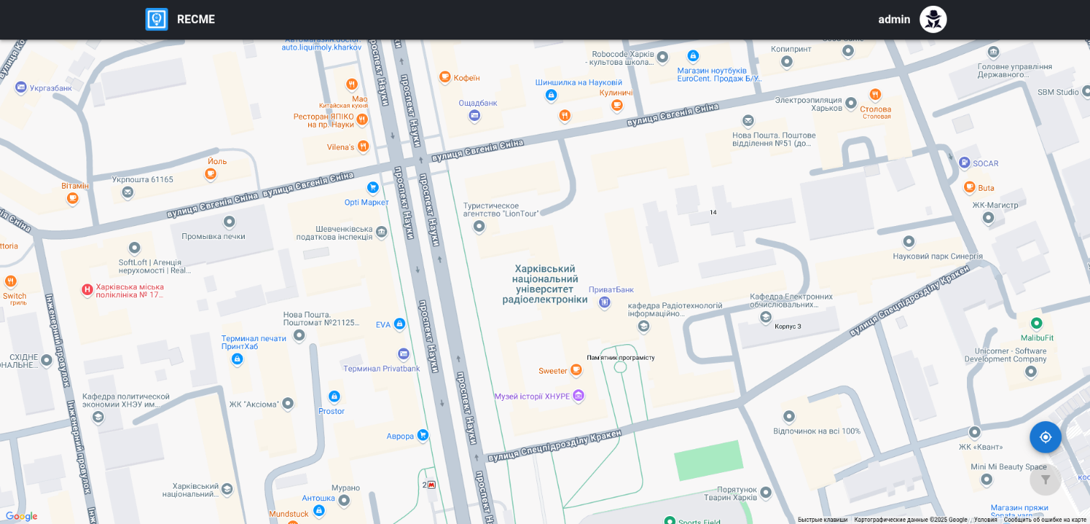
Figure 1 – Prototype of main page
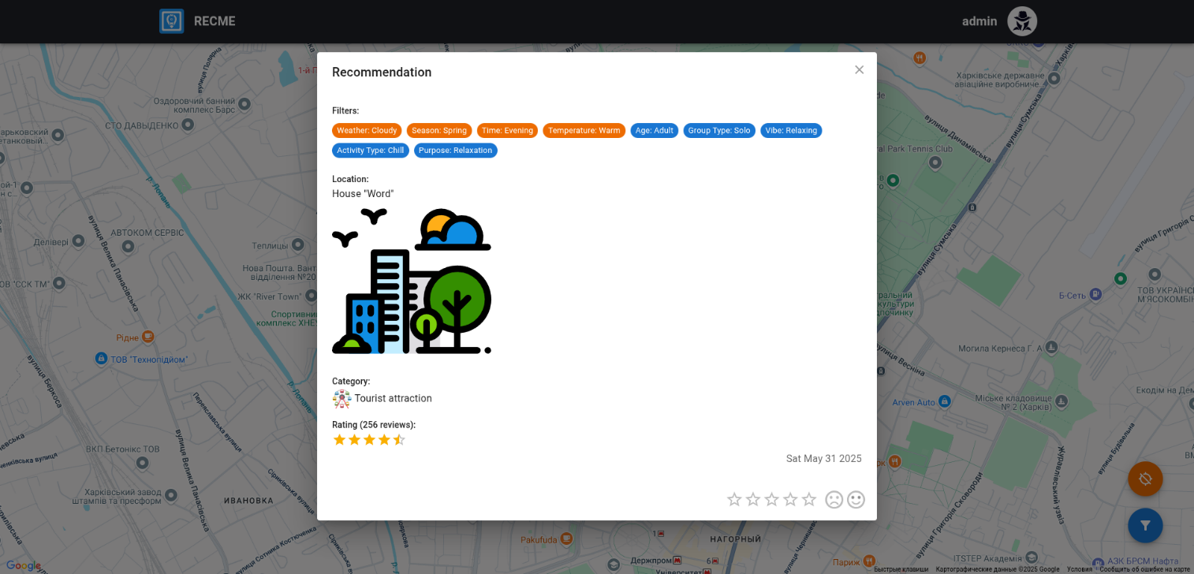
Figure 2 – Prototype of received recommendation
3.1.2 Hardware Interfaces
Users should have devices with screens like pc, laptop, or mobile device.
3.1.3 Software Interfaces
Devices should have a web-browser with support of JavaScript, cookies and have connection to the Internet.
3.1.4 Communications Interfaces
Internet connection must be established for users to have access to the web-system.
3.2 Functional Requirements
3.2.1 Registration
3.2.1.1 Introduction
Unregistered users do not have access to the system. To register into the system user will click the button “register”.
3.2.1.2 Inputs
Name, email, password, repeat password.
3.2.1.3 Processing
When the register button is pressed, the client sends the request with all the input data to the server by API. When the server receives information, it will create a user from given credentials with hashing a password and with base permissions.
3.2.1.4 Outputs
If data is correct, the system will give users access to the system. Otherwise, the system will throw an error message.
3.2.1.5 Error Handling
Application will not give user access to the system if:
- name is invalid.
- email is invalid or already registered.
- password is invalid.
3.2.2 Authorization
3.2.2.1 Introduction
Visitors do not have access to the system. To log in into the system a user must have a registered account and click the button “login”.
3.2.2.2 Inputs
Email, password.
3.2.2.3 Processing
When the login button is pressed, the client sends the request with all the input data to the server by API. When the server receives information, it will check a user with given credentials.
3.2.2.4 Outputs
If login was successful, the system authorizes the user.
3.2.2.5 Error Handling
Application will not give user access to the system if:
- email not registered.
- password is wrong.
3.2.3 Getting recommendations
3.2.3.1 Introduction
On the main page, users can pick geolocation, choose filters and get recommendations.
3.2.3.2 Inputs
Geolocation, filters.
3.2.3.3 Processing
When “apply” button of filters is pressed, the client sends the request with all the input data to the server by API. When the server receives geolocation and filters, by using deep-learning model it provides decent recommendations.
3.2.3.4 Outputs
A list of recommendations.
3.2.3.5 Error Handling
Any errors during the data change process are unacceptable and entail information about themselves.
3.2.4 Evaluation of location / recommendation
3.2.4.1 Introduction
In the modal window of recommendation, users can evaluate location / recommendation.
3.2.4.2 Inputs
Rating of location, satisfaction with recommendation.
3.2.4.3 Processing
When user has indicated a rating of location and satisfaction with recommendation, the client sends the request with all the input data to the server by API. When the server receives data, it improves the model.
3.2.4.4 Outputs
The number of stars assigned to the location rating and the selected icon indicating satisfaction with the recommendation.
3.2.4.5 Error Handling
Any errors during the data change process are unacceptable and entail information about themselves.
3.2.5 Updating a profile
3.2.5.1 Introduction
On the user page, the user can view his profile and update information about himself.
3.2.5.2 Inputs
Name or email or image.
3.2.5.3 Processing
When the apply button is pressed, the client sends the request with all the input data to the server by API. When the server receives information, it will set a new information.
3.2.5.4 Outputs
If updating was successful, the system will change old information to new information.
3.2.5.5 Error Handling
Application will not set a new information if:
- name is invalid.
- email is invalid or already registered.
- image is corrupted or has wrong extension.
3.2.6 Changing a password
3.2.6.1 Introduction
On the user page, the user can view his profile and update password.
3.2.6.2 Inputs
Old password, new password.
3.2.6.3 Processing
When the apply button is pressed, the client sends the request with all the input data to the server by API. When the server receives information, it will set a new password to the user.
3.2.6.4 Outputs
If changing was successful, the system will change the password.
3.2.6.5 Error Handling
Application will not set a new password if:
- the old password is wrong.
- the new password is invalid.
3.3 Use Cases
3.3.1 Use Case #1
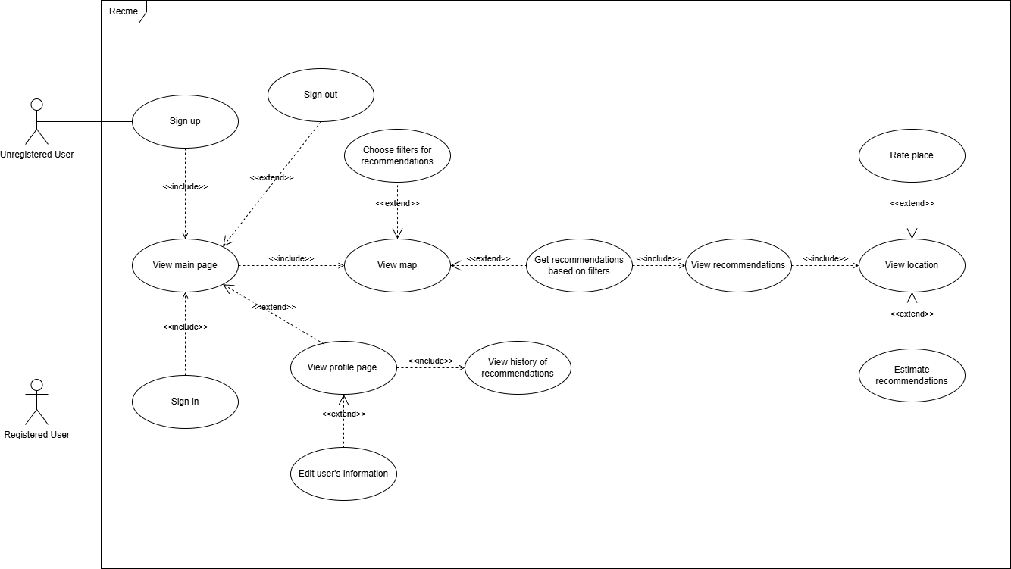
Figure 3 – User’s Use Case Diagram
3.4 Classes / Objects
3.4.1 User
#id: int
email: string
password: string
name: string
image: string
3.4.2 Recommendation
#id: int
user: int
location: int
is_liked: bool
created_at: datetime
3.4.3 Location
#id: int
name: string
category: int
latitude: float
longitude: float
image: string
3.4.4 Category
#id: int
name: string
icon: string
3.4.5 Review
#id: int
user: int
location: int
rating: int
created_at: datetime
3.4.6 Filter
#id: int
name: string
options: string
icon: string
3.4.7 Preference
#id: int
recommendation: int
filter: int
choice: string
3.4.8 Context
#id: int
name: string
options: string
handler: string
3.4.9 Condition
#id: int
recommendation: int
context: int
choice: string
3.5 Non-Functional Requirements
3.5.1 Performance
- Server response must be less than 10 seconds and should be less than 3 seconds.
- Fast exchange of data between the server and the client.
3.5.2 Reliability
- The user cannot do any actions that can damage the system.
- All errors should be caught and displayed as a notification on the site page.
3.5.3 Availability
The system must be available at any time of the day except for maintenance days.
The user cannot lose his information because all data will be stored on the server.
Accessing the web site from such browsers: Google Chrome, Firefox, Microsoft Edge.
3.5.4 Security
All user passwords are encrypted with modern algorithms.
Avoid global variables and prefer encapsulation.
3.5.5 Maintainability
The project is assembled according to the “all in one” principle, which makes it easy to fix errors on the client and server side immediately and reupload to the hosting.
3.5.6 Portability
The system has a high-level portability because it’s a web-application.
3.6 Inverse Requirements
Only registered users can have access to the system.
3.7 Design Constraints
The thoughtful, capable, easy-to-understand design. All interface parts are carefully considered to produce more quality user experience.
The product will be accessed in the English language.
Platform itself is entirely open source. So, anybody can verify that the software is secure and not collecting or leaking personal information.
3.8 Logical Database Requirements
The database will store information about users, rooms, topics, tags, messages, participants, reports, notifications, and history. PostgreSQL is used as a database. It was chosen for the following reasons: open source, supports both SQL (relational) and JSON (non-relational) querying, high levels of resilience, integrity, and correctness.
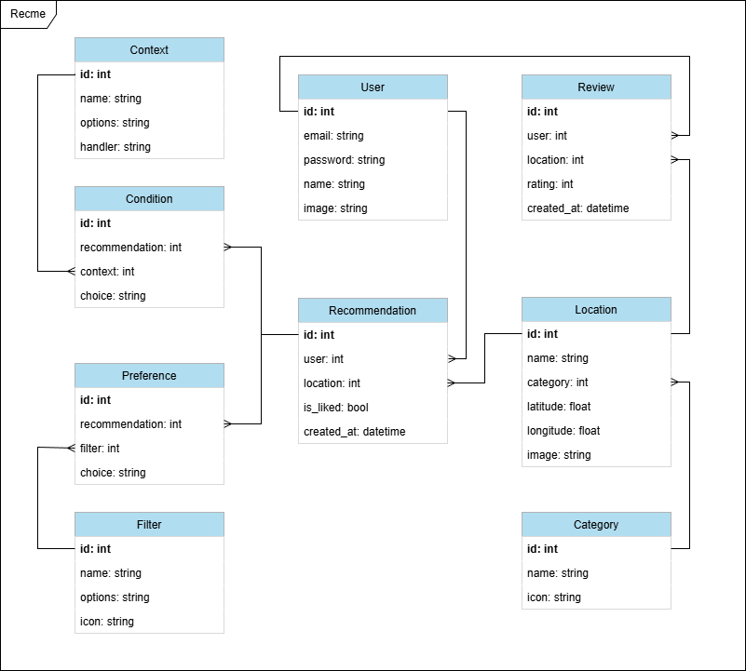
Figure 4 – ER Diagram
3.9 Other Requirements
There are no other requirements.

4. Analysis Models
4.1 Deployment Diagram
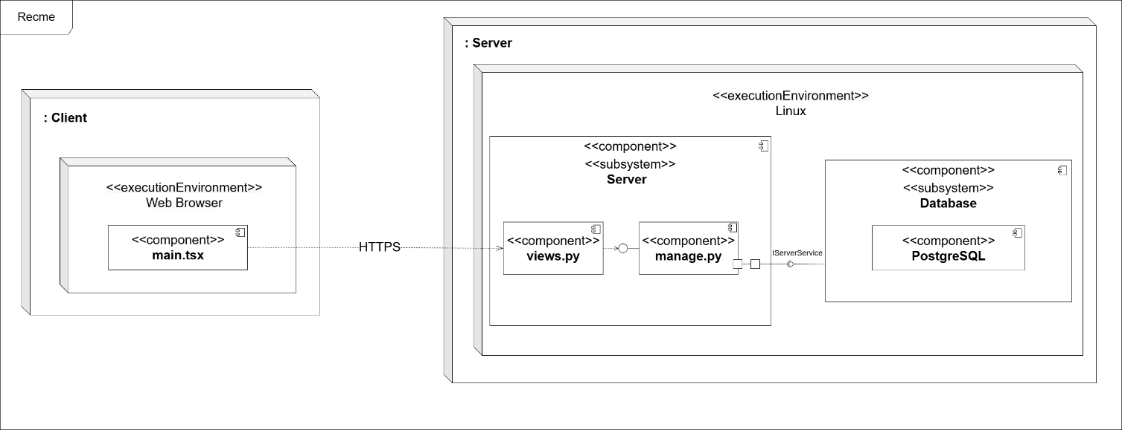
Figure 5 – Deployment Diagram

5. Change Management Process
Each change decision is negotiated between the software engineer and the product owner.

