
SDC HACKATHON 2026
Technical & Tools Declaration
Hosted by Xiamen University Malaysia (XMUM) AI Club
Submission Deadline: 25 October 2026, 7:59 AM (MYT)
Instructions: Declare every API, cloud service, AI tool, dataset, model, and sponsor resource your team used to build the project. Complete every section; where a category does not apply, tick “No” or write “None” – do not leave it blank. Submit as a single PDF document named “SDC2026_TeamName_TechDeclaration.pdf” together with your project submission. Undeclared third-party resources discovered at judging may affect your score or eligibility.

1. Team & Project Overview
Team Name | BEBZA
Project / Solution Name | Future Edge
Name (Leader) | Azimkhan Bekassyl
Email & Phone (Leader) | beka2007azimut@gmail.com · +7 701 770 7593
University Affiliation(s) | Xiamen University Malaysia (XMUM)
Live Prototype URL | https://sdc-2026-future-edge.replit.app
Code Repository URL (public / access granted to judges) | https://github.com/Magisterofdrinkingcoffee/sdc2026-future-edge (public)

2. Architecture & Technology Stack

2.1 System Architecture Overview
Describe how the components declared in this document connect end-to-end (e.g., user interface → backend → AI model/API → database → cloud hosting). Attach a system block diagram as an appendix if available.
[Maximum 200 words]
The user works in a React single-page app (built with Vite). It calls a Python FastAPI backend over HTTPS; both are served from one Replit autoscale deployment. A CV upload is read on the server with pypdf or a built-in Word reader, and personal data (name, email, phone, IC number, age, gender) is removed before any matching. Only for photos or complex layouts, and only when a key is configured, the redacted content is sent to the Google Gemini API, which returns phrases in a fixed JSON schema; every phrase is checked against the CV's own text.
Matched skills go to three models that run inside the backend: Model 1 (AI-exposure classifier trained on O*NET tasks, stored as JSON), Model 2 (damped trend forecast on monthly arXiv paper counts, refreshable live from the arXiv API) and Model 3 (exact scoring of the Catch the AI exercise). The scoring engine combines them with WEF, DOSM and MyCOL job-market figures into an Edge Score with a low–high range for two scenarios, then builds an ordered pathway from 53 checked learning resources. Catalogs are JSON files in the repository; no database, no stored user data. Diagram: Appendix A.

2.2 Languages, Frameworks & Libraries
List the main programming languages, frameworks, and third-party libraries that your team did not create. Open-source use is permitted provided it is declared and properly licensed/attributed.
Name & Version | Purpose in Project | License
Python 3.11+ | Backend, models, data tools | PSF License
JavaScript (ES2022) / Node.js 20+ | Frontend build | MIT
FastAPI 0.115.6 | REST API | MIT
Uvicorn 0.32.1 | ASGI web server | BSD-3-Clause
Pydantic 2.10.4 | Request validation | MIT
python-multipart 0.0.20 | CV file upload | Apache-2.0
pypdf 5.1.0 | Reading PDF CVs (chosen over PyMuPDF to avoid AGPL) | BSD-3-Clause
httpx 0.28.1 · pytest 8.3.4 | API tests (49 automated tests) | BSD-3-Clause · MIT
React 18 · Vite 5.4 · Tailwind CSS 3 | User interface | MIT
scikit-learn · pandas · matplotlib | Training and evaluating Model 1 only (not in the running app) | BSD-3-Clause · BSD-3-Clause · PSF-based

3. APIs & Cloud Services

3.1 External APIs
List every external API your solution calls (GenAI, maps, payments, messaging, data feeds, etc.). Do not include API keys or secrets in this document.
API & Provider | Purpose in Project | Access Tier (free / paid / sponsor-provided)
arXiv API (Cornell University) | Monthly counts of new papers for 10 AI-capability topics – the AI-trend signal (Model 2); refreshable from the app | Free
Google Gemini API (Google AI Studio) | Optional: read photo or complex-layout CVs into a fixed JSON schema. Off unless GEMINI_API_KEY is set; the app works without it | Free tier

3.2 Cloud Platforms & Deployment
List every cloud service used for hosting, storage, databases, authentication, or compute, and indicate how the prototype is deployed.
Service & Provider | Purpose in Project | Plan / Region
Replit (official SDC sponsor) | Workspace and Shell (install, build, tests, link checks), Secrets, and hosting of the live prototype via .replit → build.sh → start.sh | Autoscale deployment, 2 vCPU / 4 GiB · Asia
GitHub | Source code and version history | Free · public repository

4. AI Tools, Models & Datasets

4.1 AI Models Used in the Solution
List every AI model embedded in or called by your application, including pre-trained, fine-tuned, and self-trained models.
Model & Version | Source / Provider | Usage (pre-trained / fine-tuned / self-trained) | License / Terms
Model 1 – AI-exposure classifier (TF-IDF + multinomial logistic regression) | Team BEBZA; trained with scikit-learn on CPU | Self-trained | Apache-2.0 (our code); training labels MIT
Model 2 – damped log-linear trend forecaster | Team BEBZA (plain Python) | Self-built, fitted on arXiv counts | Apache-2.0
Model 3 – Catch the AI scoring | Team BEBZA (rule-based, known answers) | Self-built | Apache-2.0
Google Gemini (default gemini-3.8-flash, configurable) | Google | Pre-trained, called by API (optional CV reading) | Gemini API Terms of Service

4.2 Datasets
List all datasets used for training, fine-tuning, evaluation, or in the running application. State clearly if a dataset contains personal or sensitive data.
Dataset Name | Source / URL | Type (public / private / self-collected / synthetic) | License | Personal Data? (Y/N)
GPTs-are-GPTs task exposure labels (19,265 tasks) | github.com/openai/GPTs-are-GPTs | Public | MIT | N
O*NET task statements and occupations | onetcenter.org | Public | CC BY 4.0 | N
arXiv monthly paper counts, Oct 2023 – Sep 2026 | export.arxiv.org/api (collected 22 Oct 2026) | Public (self-collected counts) | arXiv API Terms of Use | N
WEF Future of Jobs Report 2025 (incl. Malaysia profile) | weforum.org | Public report | WEF terms; cited by page | N
DOSM Salaries & Wages Survey 2025; Labour Force Survey | open.dosm.gov.my | Public | Malaysia open data terms | N
TalentCorp MyCOL 2024/2025 critical occupations | talentcorp.com.my | Public report | Cited | N
Team role dataset (25 roles: titles, skills, SDG tags, descriptions) | src/database/gemini-code-…csv | Self-made, AI-assisted (Gemini) | Apache-2.0 | N
Skill, role, SDG and course catalogs; 3 sample CVs | src/backend/data/ | Self-made; sample people are synthetic | Apache-2.0 | N

4.3 AI-Assisted Development Tools
Tools used to help write code, design, content, or documentation (e.g., chat assistants, code completion tools, image generators). Declaring these tools does not reduce your score; undeclared use may.
Did your team use any generative-AI tool to help create code, design, text, or other project material?
☑︎ Yes ☐ No
If yes, list them below:
Tool & Version | Used For | Extent of Use (minor / moderate / major)
Claude (Anthropic) – Claude Code / claude.ai | Writing and refactoring code and tests, model cards, README, submission documents, and the pitch-video animation, music and sound effects (synthesized in code) | Major
Google Gemini (chat) | First draft of the 25-role dataset (titles, skills, SDG tags, descriptions) | Moderate
Kokoro TTS v1.0 (open source, Apache-2.0), voice "am_michael" | AI-generated narrator voice for the pitch video | Moderate
Replit Agent | Started an automatic "port to Replit" step on import; stopped after 12 seconds and its changes were reverted | Minor

Briefly describe how your team reviewed, tested, and took responsibility for AI-generated output:
[Maximum 100 words]
The team chose the idea, the models and every design rule, and reviewed each change before it was merged. AI-written code is covered by 49 automated tests and held-out evaluations (Model 1 cross-validation, Model 2 backtest). We replaced AI-drafted salary and risk estimates with real WEF, DOSM and MyCOL figures, and checked every course link on 24 October 2026. The running app uses no generative model to make recommendations, so it cannot invent jobs, courses or statistics.

5. Sponsor-Provided Resources
Declare any official SDC sponsor-provided GenAI API, cloud credits, tools, mentoring, or data that your team used.
Did your project use any official SDC sponsor-provided resource?
☑︎ Yes ☐ No
If yes, list them below:
Sponsor | Resource (API / credits / platform / data) | How It Was Used in the Project
Replit | Platform (workspace, Shell, Secrets, Deployments) | Development, testing and link checking in the Replit Shell; live prototype hosted as a Replit autoscale deployment (proof: Appendix B)
RunPod | US$25 GPU credit | Not used – no part of the project needs a GPU (Participant Handbook 9.4)
Aiversecity (domain sponsor) | Problem statement and rubric | Defined the six must-have features we built

Was the sponsor resource essential to the core functionality of the prototype, or could it be replaced? Explain briefly:
[Maximum 100 words]
Replit is essential to how the prototype is delivered: it is where judges reach the live app, and where we ran the build, tests and link checks with open internet access. The application code itself is portable – a standard FastAPI and React project with no Replit-specific dependencies – so it could also run on another host. We chose this on purpose, so the project survives beyond the hackathon.

6. Security, Privacy & Responsible Use

6.1 Data Handling & Privacy
What user or personal data does your application collect, store, or send to third-party services (including AI APIs)? How is it protected, and how long is it kept? State “No user data is collected” if applicable.
[Maximum 150 words]
The app collects only what the user uploads: a CV file or pasted text, skill levels, a goal role and Catch the AI answers. The CV is read in memory once and is not saved; there is no database, account or tracking of personal data. Before matching, the name line, email, phone, IC number, age, date of birth and gender are removed, so matching never sees protected characteristics. If the optional Gemini key is set, PDFs with readable text are sent to Gemini as redacted text; photos and scanned PDFs have no text layer and are sent as images. The user's progress (skills, XP, badges) is kept only in their own browser's local storage. The API key is stored in Replit Secrets, never in the repository. Our demo uses synthetic CVs only.

6.2 Known Limitations & Risks
Identify the main technical limitations of your AI components (e.g., hallucination, bias, rate limits, dependency on a single provider) and any mitigation you have implemented.
[Maximum 150 words]
Bias and scope: Model 1's labels describe US jobs in 2023; we apply them to Malaysia and use Malaysian job-market data alongside. Accuracy: Model 1 is 73.4% accurate on unseen occupations and weakest on chatbot-only tasks; Model 2 uses research papers as a proxy for AI capability and cannot foresee sudden breakthroughs; Catch the AI is one short exercise. Hallucination: mitigated by design – no generative model writes recommendations, and Gemini's CV phrases are rejected unless found in the CV text. Provider dependency: Gemini is optional with an offline fallback; if an arXiv refresh fails, the last good snapshot is kept. Users always see two scenarios, low–high ranges, a plain-English reason for every number, and a clear message that results are estimates, never hiring decisions.

7. Compliance & Readiness Checklist
Tick all boxes that apply before submitting.
☑︎ | All APIs, cloud services, AI tools, models, and datasets used in the project are declared in this document.
☑︎ | All third-party code, datasets, and models are used in accordance with their licenses, and attribution is provided where required.
☑︎ | No API keys, passwords, or other credentials are exposed in the code repository, prototype, or this document.
☑︎ | Any use of generative-AI tools for development has been disclosed and reviewed by the team.
☑︎ | Any use of official SDC sponsor resources has been declared in Section 5.
☑︎ | The prototype described here is accessible to judges through the links provided in Section 1.
☑︎ | All fields in this template have been completed within the word limits stated.

8. Declaration
By submitting this document, the team leader confirms that the information provided is complete and accurate to the best of the team’s knowledge, and that every API, cloud service, AI tool, dataset, model, and sponsor resource used in the project has been declared.
Signature: Azimkhan Bekassyl (Team Leader, BEBZA)
Date: 24 October 2026

Appendix A – System Block Diagram
How the components declared in this document connect end to end (section 2.1).
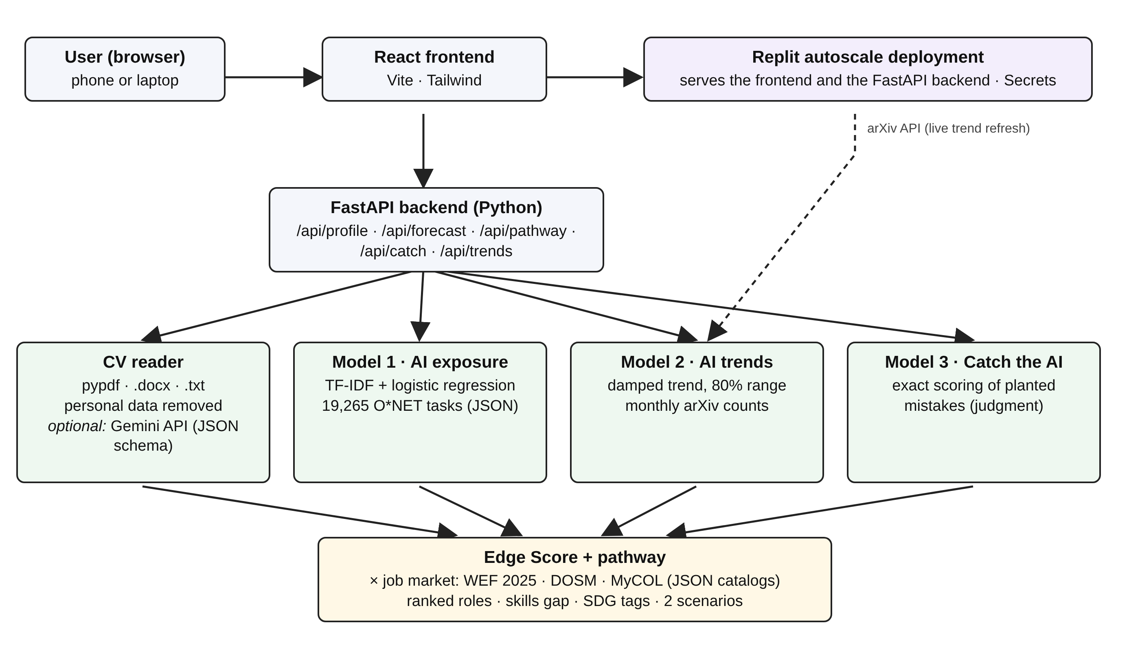

Appendix B – Replit Proof of Use
Replit account: riotbek07 (team account)
Replit project: https://replit.com/@riotbek07/sdc2026-future-edge
Live deployment: https://sdc-2026-future-edge.replit.app (autoscale, status Live)
1. Replit deployment page – status "Live" (screenshot, 24 Oct 2026)
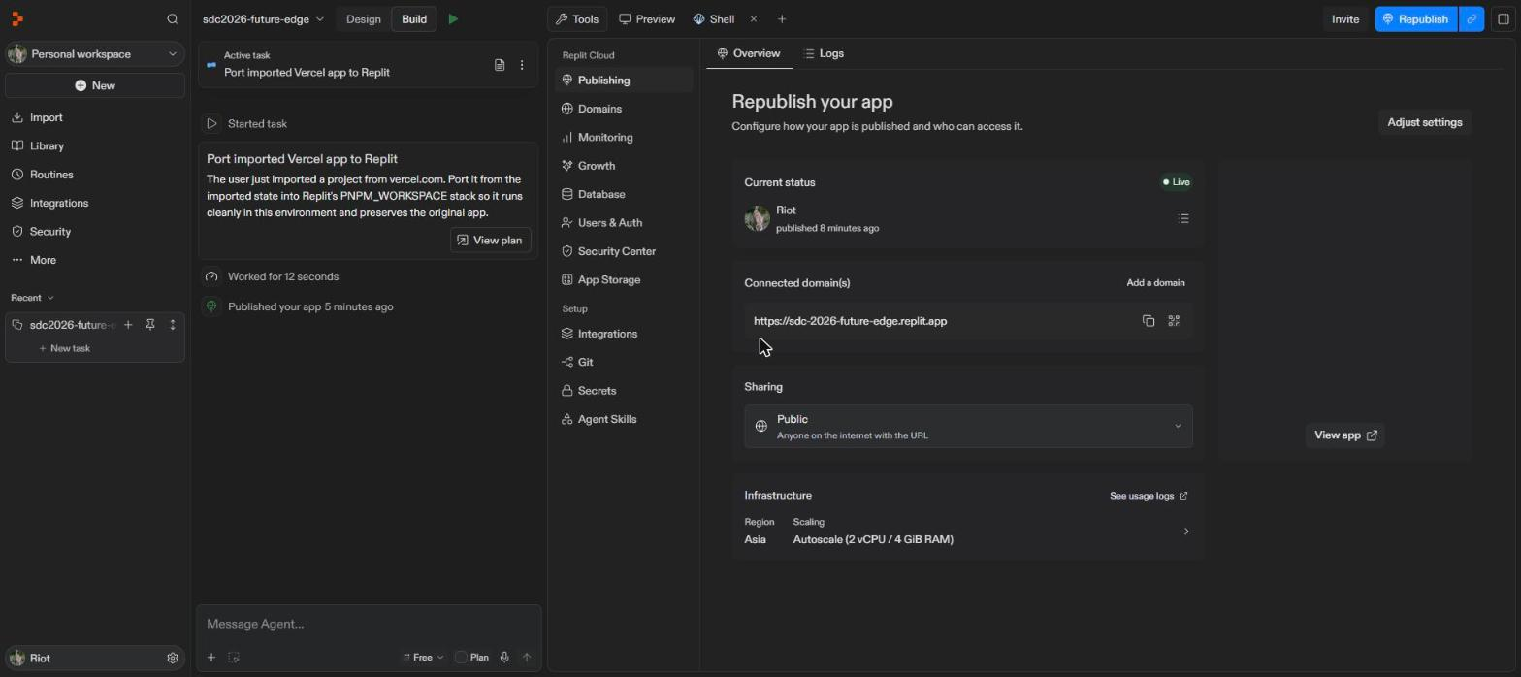
2. The live app served from the Replit deployment
