**Main Pattern List: Browse local patterns**

Screen presented on first entering the app. Lists all patterns that have been saved locally in an SQL database. Items are displayed in a RecyclerView. Clicking on an item brings up that pattern in the PatternView screen. There is a FAB for creating new patterns, which when clicked will take the user to the pattern creation screen.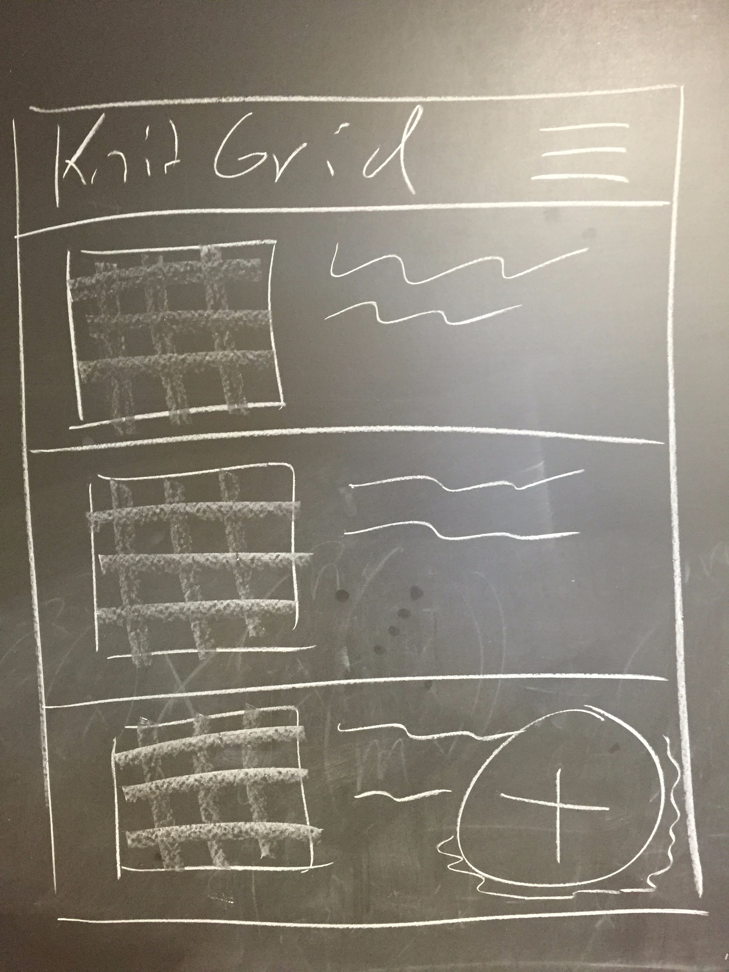

**View Pattern Screen**

Main view is a grid of stitch symbols. Clicking on a square will highlight up to that point, allowing the user to track how much of the pattern has been completed. A button bar at the top allows the user to switch between the grid view and a legend of all the stitches used in the pattern. Clicking on a stitch in the legend will bring up the details of the stitch, including some instructions. The user can pan across the grid and zoom in and out.

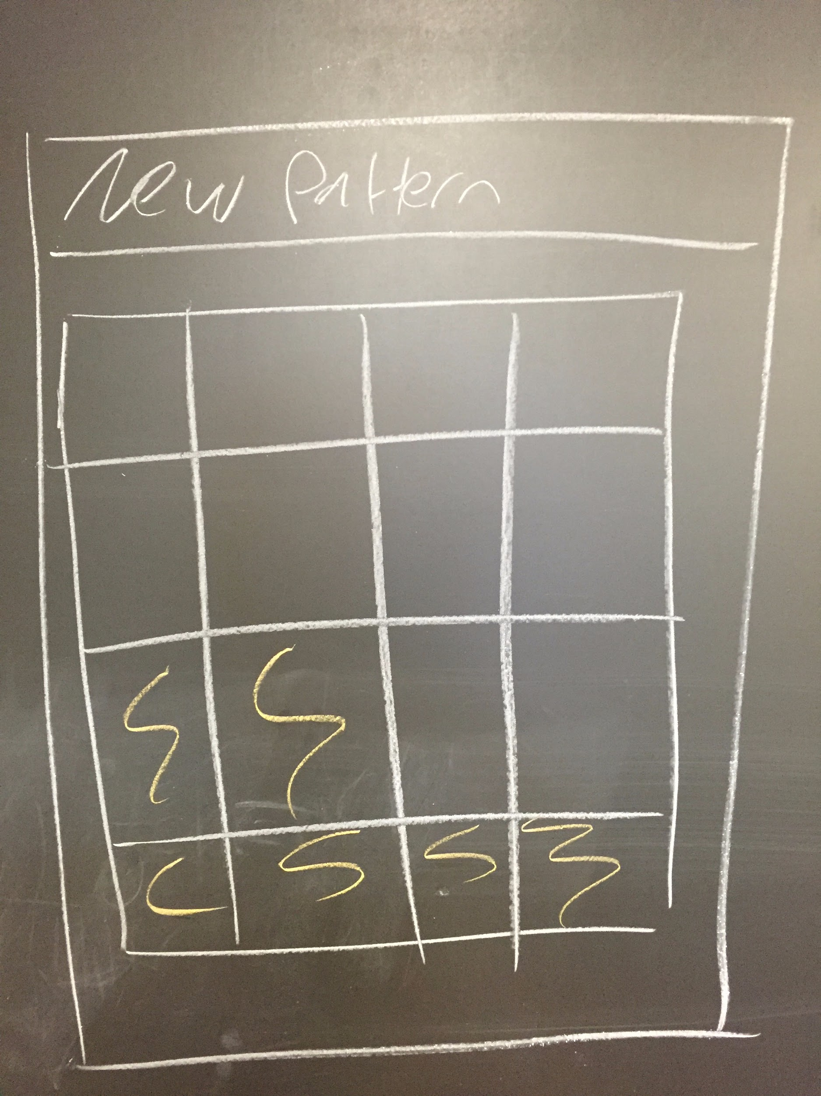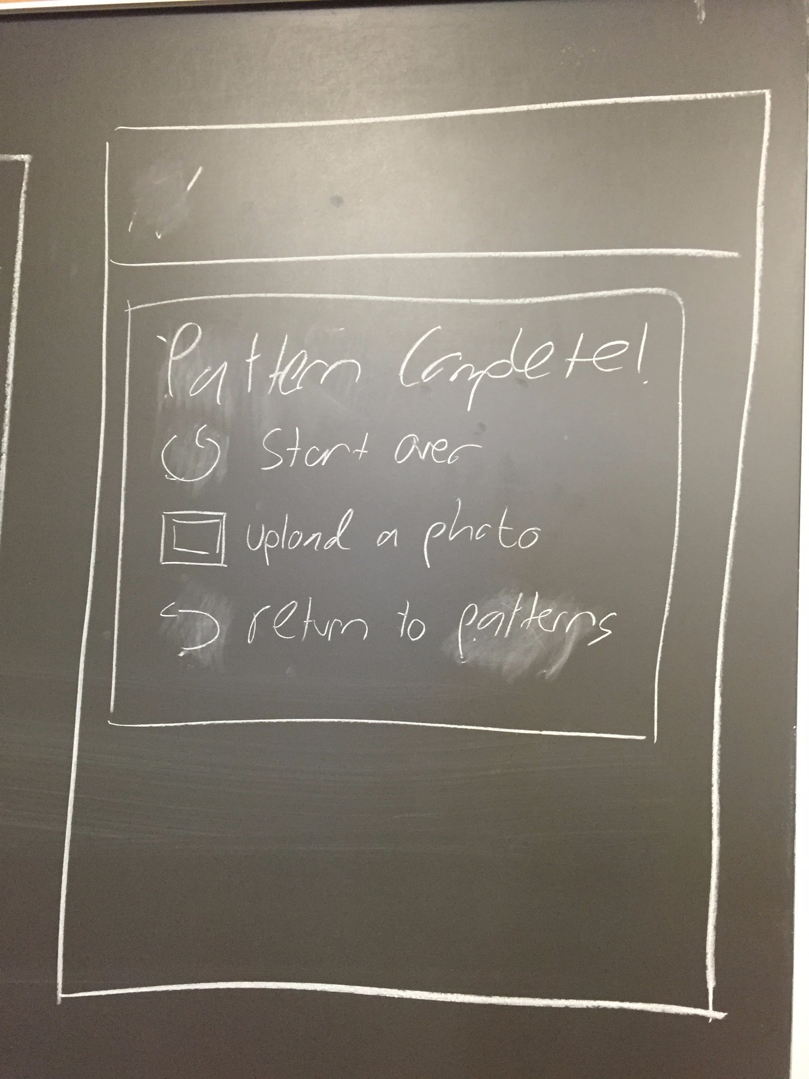

**Stitch Glossary**

A list of all the stitches currently known to the app. We will supply a set of default stitches but also allow the users to create custom ones, in case some are needed that we did not include. Clicking on a stitch in this list will take the user to the detail page for that stitch. These stitches are persisted using SugarORM.

**Create/Edit Pattern**

On enter, the user is presented with a dialog box allowing them to set the dimensions of the new pattern grid and a checkbox to select whether even rows will be shown (some knitting patterns only show odd rows). Clicking okay creates an empty grid. As the user edits the pattern, the current row being edited will be blown up large and brought to the forefront, with the current square highlighted. The user will use a button bar at the bottom to select the stitch to be added for that square. The next square will then be highlighted, right to left for odd rows, left to right for even rows. Patterns will be persisted using SugarORM and object serialization.

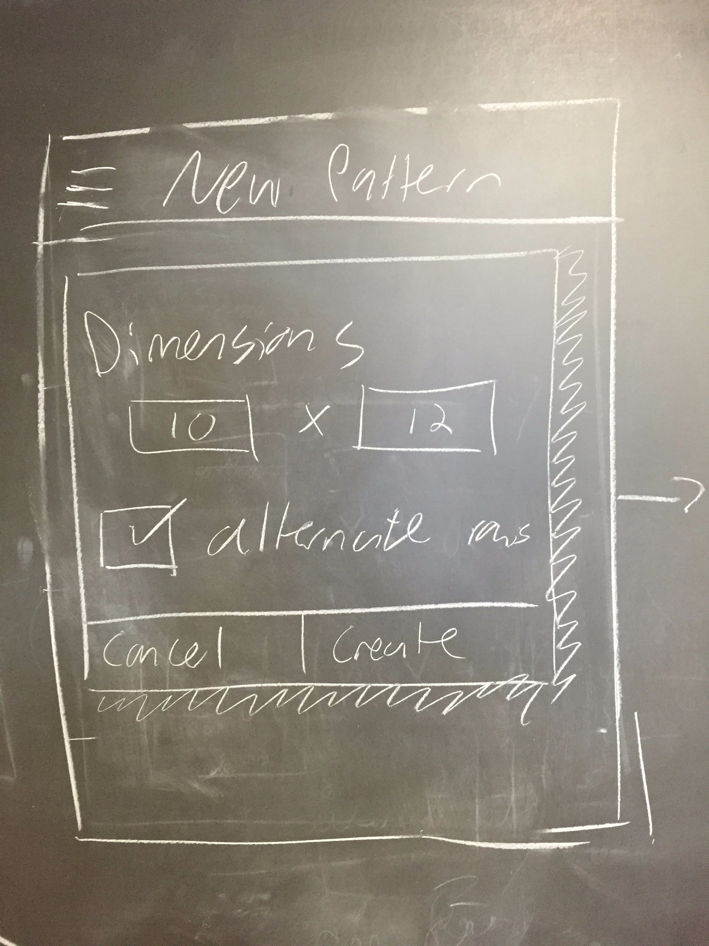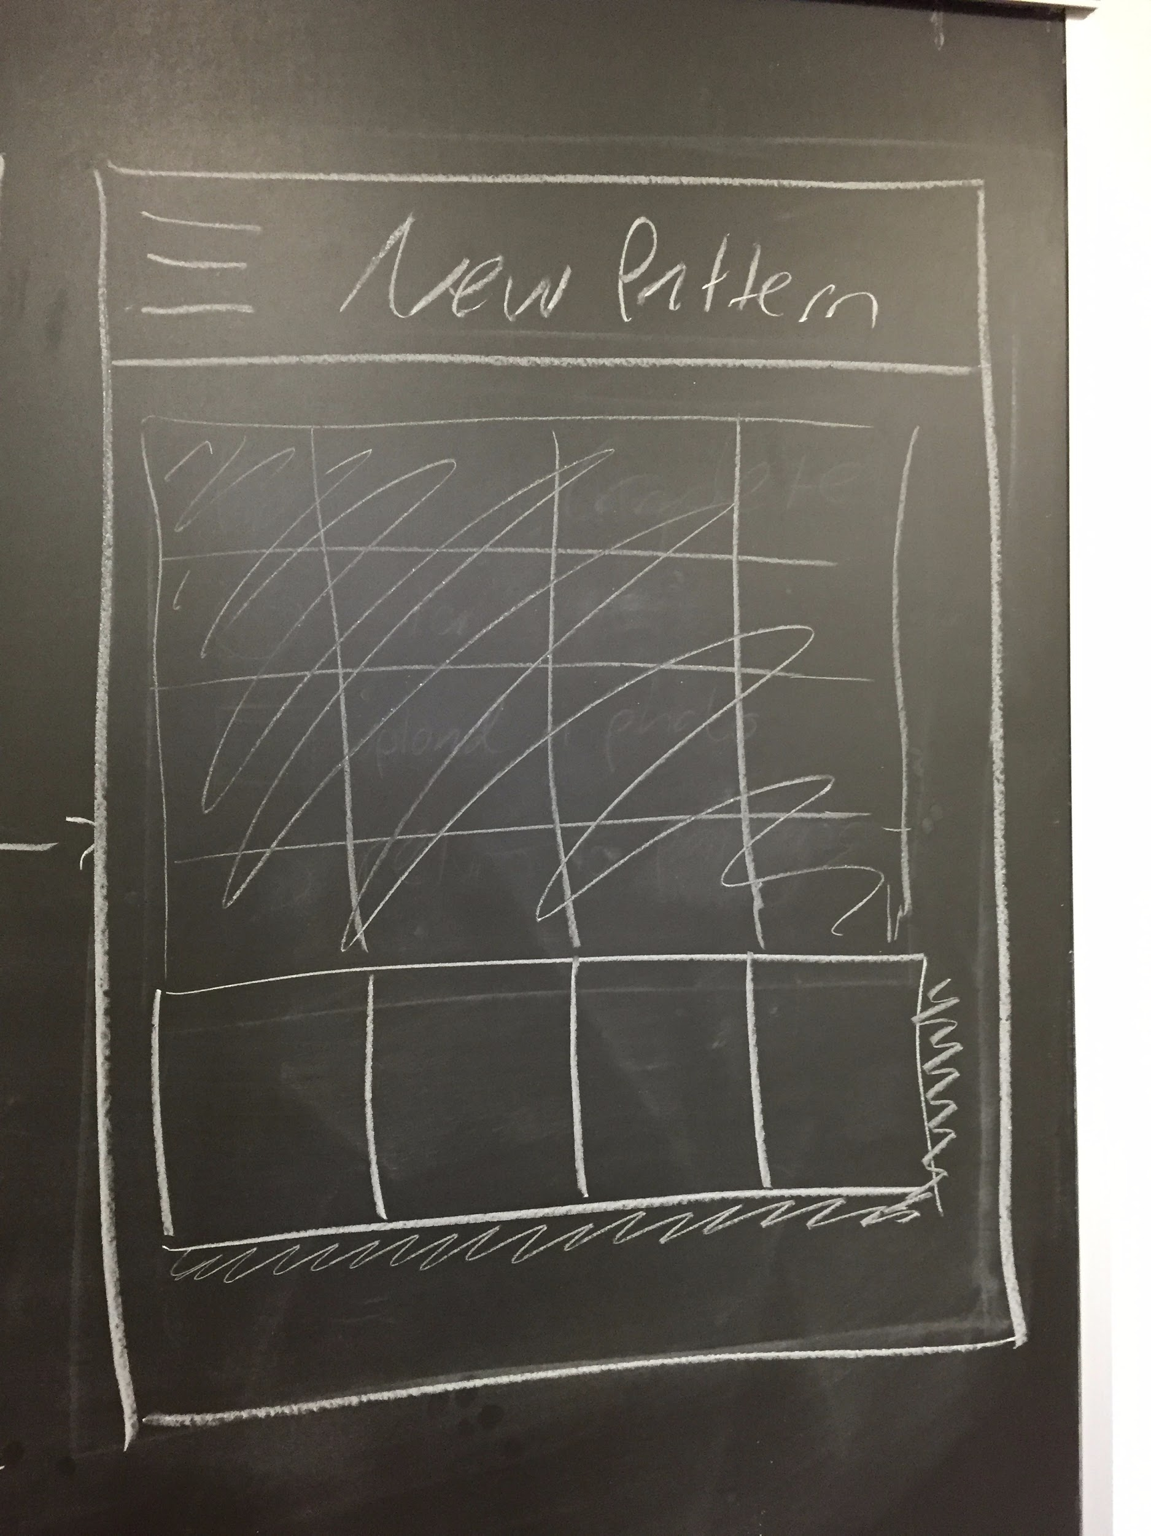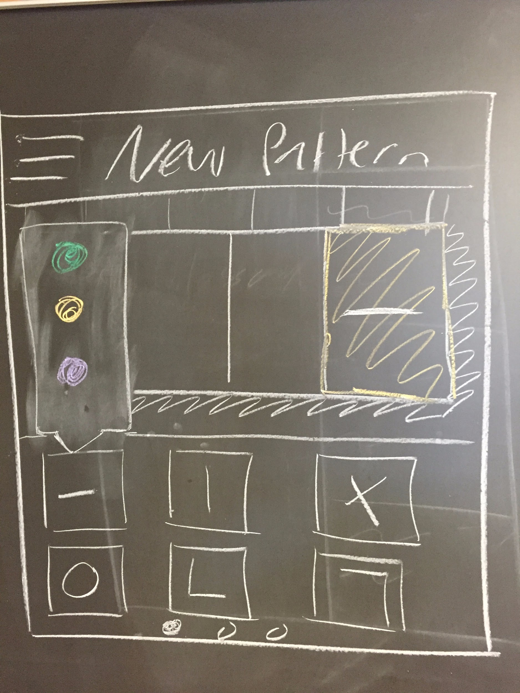

**Side bar navigation**

We will use a navigation bar that slides out from the left of the screen to allow easy movement between these various screens.

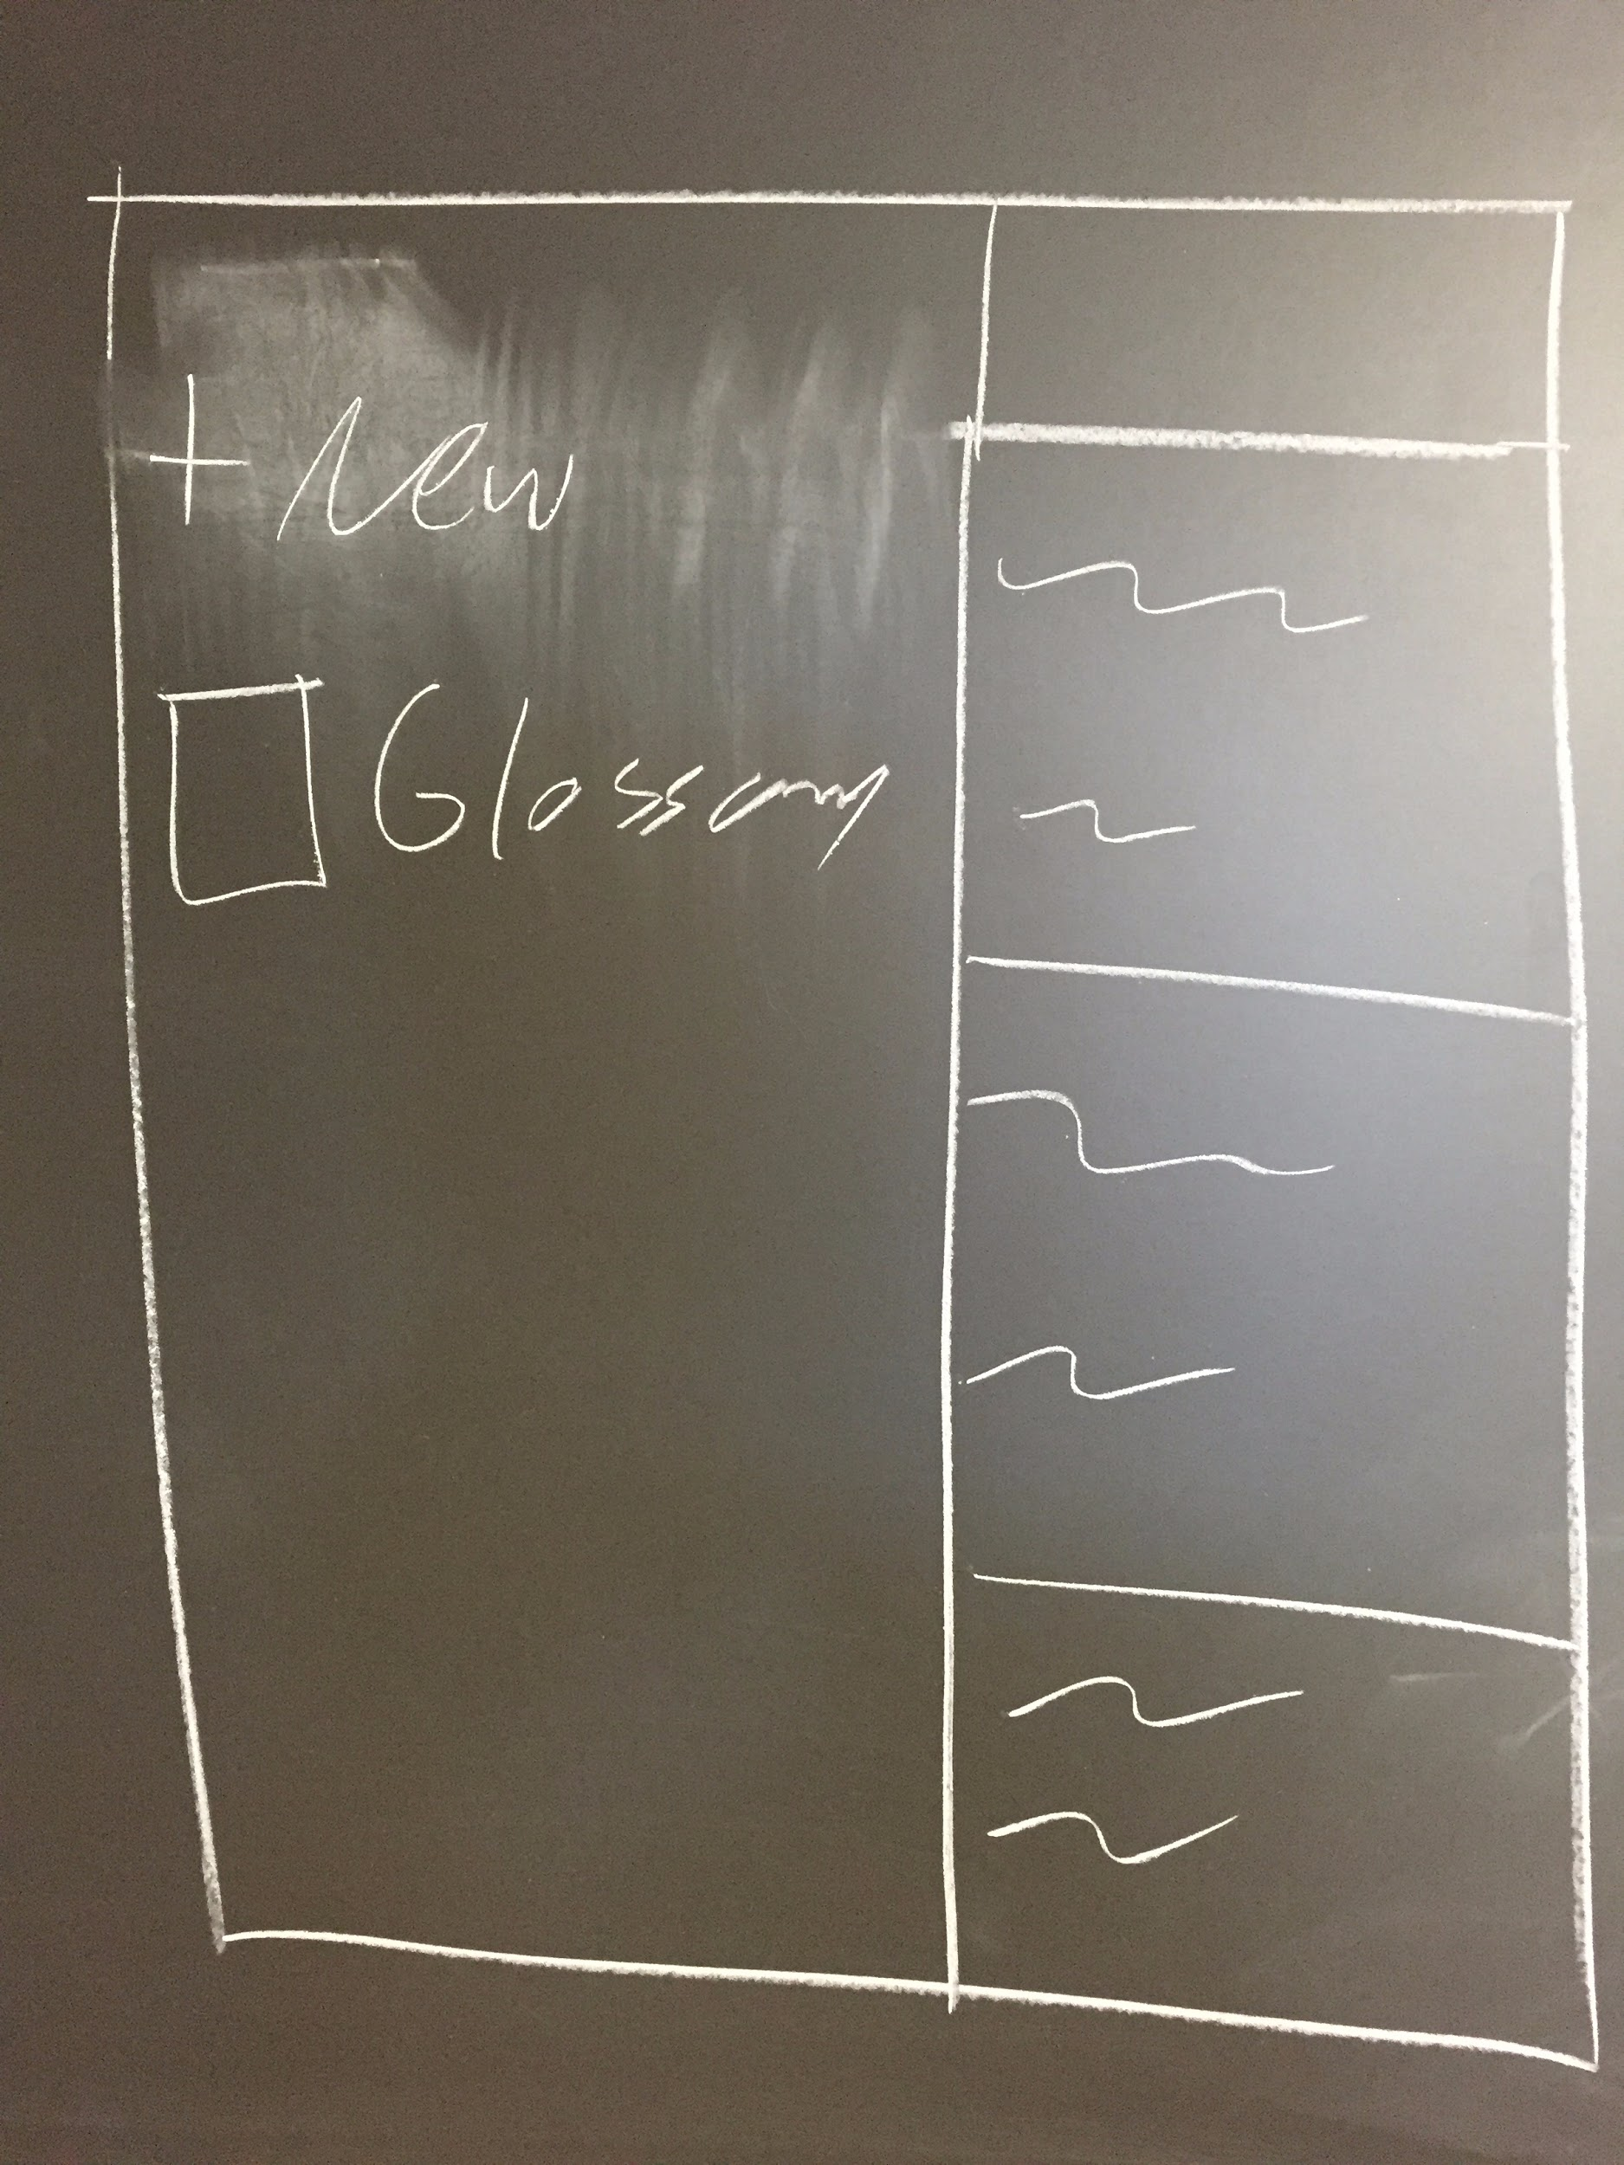

An example of a knitting pattern grid, with only odd rows shown:

