LUNAR MAGIC

GUIDE
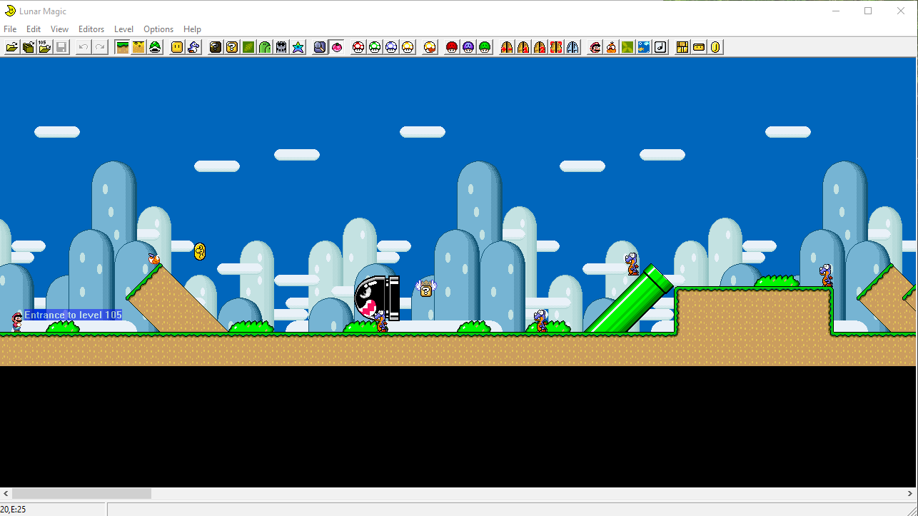

Mightyfine words for the reader

This is meant to be comprehensive guide for using lunar magic. I'll gather information from programs internal help document and internet. The guide's purpose is to be complete, easy to read document also with explanations to technical terms such as ”VRAM” for those who might not be familiar with such terms. I'll try to gather all the relevant information, links to other guides and info relevant to things in lunar magic.
The guide is written so that the table of contents can be easily used to find any function found from the program. Titles have been nested in same way as they are in the program.
The language is english so that non finnish speakers too are able to easily read the guide as well as to be practice for myself. The guide is also meant to be used as portfolio piece so that i might more easily find work one day, hopefully.
Some of the text isnt meant to be like this for the final version so if you are reading this line, you are reading the original unedited version of the guide.

Table of Contents
Mightyfine words for the reader 2
Explanations 6
Number systems 6
Terms 7
File 8
open rom 8
open level number 8
level address 8
save level to rom 8
open next/previous level in rom 8
open level from file 8
save level to file 8
graphics 9
setup tile editor 9
extract/insert GFX from rom 9
Extract / insert exGFX 9
pallettes 9
extract/import level palette to file 9
extract insert shared pallettes to rom 9
levels 9
Export/import multiple levels to file 9
analyze resources in levels 10
clear original level data area 10
export multiple levels to image files 11
export level to image file 11
emulator 12
run rom in emulator 12
setup emulator 12
12
run/stop internal emulator 12
pause, mute 12
swap f4 12
expand rom 2-8mb 12
restore 12
create full restore point 12
restore from restore point 12
create ips file from rom 13
apply ips file to rom 13
scan rom 13
recent files 13
edit 14
layer 1, 2 mode 14
edit sprites mode 14
insert manual 14
edit manual 14
bring to front, send to back, bring forward, send backward 14
object size 14
X, Y increase / decrease 14
conditional direct map16 14
remap direct map16 14
view 15
layer 1 15
layer 2 16
layer 3 16
sprites 16
sprites hex code 17
screen exits 18
subscreen boundaries 18
game view screen 19
exit enabled tiles 19
tile surface outlines 19
line guide outlines 19
tile grid 20
zoom 20
100- 800% 20
filter 20
100% increments 20
level entrances 20
block contents 21
animation 21
next animated frame 21
reset animations 21
exAnimation triggers 21
custom triggers 21
0-F 21
next,previous 21
activate trigger 21
oneshot triggers 21
00-1F 21
next,previous 21
activate 21
manual triggers 21
0-F increment / decrement 21
next / previous 21
increment / decrement manual frame 21
have star 21
timer below 100 21
have 5 yoshi coins 21
silver POW 22
POW 22
special world passed 22
invisible pow objects 22
other invisible objects 22
on/off switch on 22
conditional direct16 map on 22
512 height background 22
translucent text background 22
switchblocks 22
green,yellow,blue,red switch blocks 22
editors 22
add objects window 22
add sprites window 23
palette editor window 24
8x8 editor window 24
16x16 tile map editor window 25
background layer 2 editor window 26
overworld editor window 27
level 28
super gfx bypass 28
layer3 gfx /tilemap bypass 28
gfx index in header 29
edit level exanimated frames 30
edit global exanimated frames 30
edit animation settings 31
modify screen exits 31
modify main and midway entrances 31
modify secondary entrances 32
scan for undefined exits 33
change properties in header 33
change properties in sprite header 34
change other properties 34
change layer 3 settings 35
change music timelimit settings 35
options 36
general options 36
restorepoint options 36
change animation rate 36
use fastrom addressing for this rom 37
enable fastrom speed & apply patch 37
use sa-1 ram remap for this rom 38
use super fx ram remap for this rom 38
compression options for this rom 38
vram patch options for this rom 38
help 39
Contents 39
about lunarmagic 39

Explanations

Number systems
Hexadecimals
0-F
1,2,3,4,5,6,7,8,9,10,A,B,C,D,E,F
1,2,3,4,5,6,7,8,9,10,11,12,13,14,15,16
More about it in here: https://owlcation.com/stem/Convert-Hex-to-Decimal
Hexadecimals are numbersystem based on 16 rather than 10. On decimals numbers start repeating after 9, meaning you get numbers like 10, 11 → numbers consist of combinations of singular numbers. On hexadecimal, this happens after 16 and to represent it in more familiar 10-system, letters had to be used. 11 in hexadecimal is (when converted to 10-system) 17 and letters appear on 'normal' number 26 (1a).
Converting hexadecimals to decimals requires some math and I propably wont go into that here as this is supposed to be short summary for those unfamiliar. The link should have some explanation.

Numbers like 0x001 are also hexadecimals. 0x just means number after it should be considered to be a hexadecimal
Here is good explanation: https://stackoverflow.com/questions/9539857/0x00000000-hexadecimal
Amount of numbers in 0x0000 number can also be relevant, as it tells the size of the number in terms of memory.

Binary
1,0

1,2,3,4,5
1,10,11,100,101

Link to more reading: https://www.mathsisfun.com/binary-number-system.html
On binary, there are just 2 numbers and everything basically revolves around number 2. 1 is 1 but 2 is 10 and 3 is 11. Once you grasp the logic its more simple to understand. Basically the first (rightmost) number in binary number is always either 1 or 0 (1 or 0 in 10-system too), second-rightmost is 2 or 0, third 4 or 0 and so forth, its always increased in power of 2 as you move up the chain. Then to convert back to 10-system, you just add all the ”slots” together and 101 becomes 5 because 100 is 4 and 001 is 1.

Terms
Checksum
ROM
Emulator
Map16
GFX, exGFX

File

open rom
Choose the rom you wish to use. This is effectively your working file so make sure you have unedited backup before you start editing.
American and japanese 1.0 supermario world snes roms are supported, also mario all stars + world snes rom is supported.
If program warns about corrupt checksum, it means ROM is corrupt or it has been modified with another (non lunar magic) program. This might cause serious problems later as there could be malicious code inserted to such rom or the rom might behave in unexpected ways.

open level number
Opens one of the mario levels. There are multiple levels in ROM from 0-0x1FF(0-??), most are empty though.

level address
Opens exact ROM offset you specify. This is meant to be used to open levels that do not have pointer in the pointer table. You propably wont need to use this unless you are trying to do something clever.

save level to rom
Save your work and modify the ROM file you are using.

open next/previous level in rom
Cycles forward or backward in list of levels in the ROM.

open level from file
Opens previously created mario level file that contains all of the stuff that the level consists of. Its meant to be easy way to export singular levels. Note that file does not contain actual grapgics (GFX), use the EXTRACT GFX FILES to get those. It also doesnt contain Map16 data or shared palettes or any other level independent data. Lunar magic versions older than 1.6 work a bit differently so make sure you are using the latest version.

save level to file
Do the thing mentioned above and export the current level into its own file.

graphics

setup tile editor
You can use external editor to edit stuff. It will also save the settings you specify to your computers registry. You have to use specific programs meant to edit tiles, palettes and such. For example: tile layer pro https://www.romhacking.net/utilities/108/.

extract/insert GFX from rom
Creates GFX file from rom for tile editor program to edit. It will create graphics folder into your working directory(where the ROM file you are editing is) if it doesnt exist already.
Inserting the file will replace the GFX files within the rom with one you specify.

Extract / insert exGFX
Ex in exGFX means ”extra” as in something that does not exist in original ROM files. These are additional graphics you might want to add to your romhack. If you want to use these you have to configure SUPER GFX BYPASS setting in LEVEL menu. More about that later.(laita linkki kohtaan)

pallettes

extract/import level palette to file
Extract or replace the palette file from the ROM. Make sure the editor you are using is set to load 256 color entries. This one will use only the pallette of the level you have currently open.

extract insert shared pallettes to rom
This one will use all of the shared palettes in the rom to single file. The file will not include custom level palettes as they are stored with the level itself.
Shared pallettes are, more specifically -katso myöhemmin mitä kirjoittaa tähän lisää-

levels

Export/import multiple levels to file
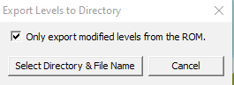
Export/import multiple levels from the rom to level file. ”Only export modified levels” option lets you choose if you want to export all of the levels (0x200), creating 512 small files.

analyze resources in levels
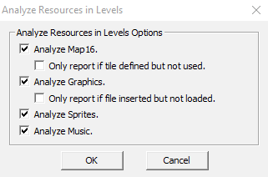
Analyzation menu

Lunar Magic 3.31
04/21/2022 09:57:46 AM

Map16 Tile Usage Report (Non-covered, Non-conditional)

Tile 0 count: 37BA
Levels: 2, 1C, BE, C0-C1, C6, CE, F7, 102, 11C, 127, 12D, 1D5
Tile 1 count: 89
Levels: 116, 118, 1BF, 1C2-1C3
Tile 2 count: 423
Levels: 1C, C0, C6, CE, F7, 11C, 12D, 1D5
Tile 3 count: 351
Levels: 116, 118, 1BF, 1C2-1C3

Excrept from the log of the unmodified rom level
So the level analyzer basically counts everything there is in the ROM. On the log you can see mentions of tiles, if you look at 16x16 tile map editor, tile 0 is water and water appears first time on levels 2 and 1C on default supermario world? Could this be a Coincidence? I think not. So the log tells you exactly how many things of each type there are in ROM and on which levels. It also counts it in hexadecimal for fun and profit.
According to the sacred texts that is lunar magic help file, it doesnt count tiles that have been covered by other tiles or otherwise have conditions that dont make the tile appear immidiately so it counts only what you can actually see. It also wont analyze bossfight levels or anything else lunarmagic cant render. In addition to tiles it will count sprites, which music tracks are used in which levels and which graphic files are used where.

clear original level data area
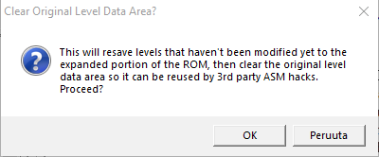
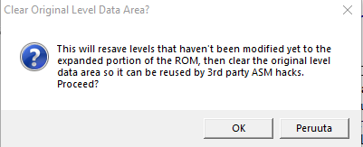
This is meant for making things nicer for 3rd party asm hacks (asm stands for assembly, more about it here https://supermarioworld.fandom.com/wiki/ASM_Hack). According to the sacred texts, there are some sections that wont still be available for use, like chocolate island 2, entrances to castles and other stuff that werent even used in original game. Those have been marked with RATS(Rom-allocaton-tag-system)
(term explained here https://www.smwcentral.net/?p=viewthread&t=102891 . It basically means marked as reserved, to prevent conflicts. Its used to prevent patches and tools from mistaking parts of the rom as free space for them to use.)

export multiple levels to image files
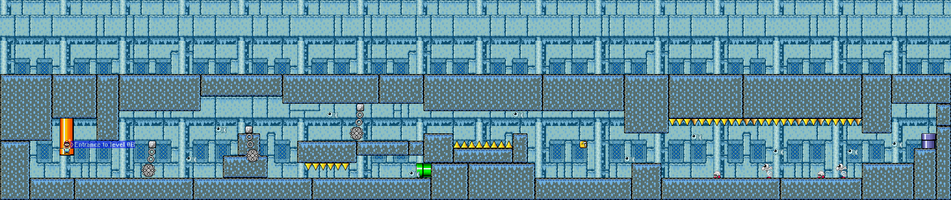
It will create image of your levels in png format. This one will create image for every single level.

export level to image file
Same as before, but only for level currently open.

emulator
Now, despite what someone might claim, EMULATORS ARE COMPLETELY LEGAL TO DOWNLOAD AND USE. Here is a link to further reading about the subject: https://www.howtogeek.com/262758/is-downloading-retro-video-game-roms-ever-legal/
(Do note that just because I link something here doesnt mean its the only or even the best source of information, use your own judgement.)
If you are looking for emulator, snes9x is the one I used for purposes of this guide. You can find one from this site: https://www.romhacking.net/

run rom in emulator
You dont have to specify which emulator to use every time, just the first time if you havent set up its path yet. Just use the path to exe file of the emulator.

setup emulator
Here you can modify the emulator path setup if you want to. Its same window that is used to setup the emulator at the first time.

run/stop internal emulator
You need lmsw.dll to use lunar magics internal emulator. It needs to be in same folder as lunar magic itself. You can download the dll here https://www.smwcentral.net/?p=section&a=details&id=20746

pause, mute
You can pause the emulator while testing your maps. This will let you scroll around the level. The tool creator was so nice that he added a mute so you dont have to listen to your banger soundtracks while editing your levels.

swap f4/ctrl+f4
Lets you choose if you want to press f4 or ctrl AND f4 to run the internal emulator.

expand rom 2-8mb
The program automatically expands the ROM as needed so you dont have to use this unless you specifically want to have extra space for something.
If you want to use SA-1(...) in your rom to have more than 4MB extra space you (have to do some stuff, i'll get to it some later time.)
Memory is precious commodity in romhacks so dont waste it. You can expand the roms capacity only so much. Maybe i'll add a section about memory saving tricks.

Restore
Restore points are basically your saves for the romhack design process. Do remember to make restore points every now and again or you might find your hard work undone when something causes rom to become unopenable. In case your rom actually becomes unopenable you can get to the restore list by taking any other supermario rom, giving it same filename as one you want to access. You can also just open some other smw rom and browse to your restore point.
Incremental restore points save space as they will track only the changes that have been done. Full restore point is always the entire thing.

create full restore point
As explained above.

restore from restore point
As explained above.

create ips file from rom
This will allow you to create patches for your ROM. Its basically portable restoration point you can give to your friends so they dont have to download your entire romhack everytime you want to add yet another bowser to your level.

apply ips file to rom
Here you can apply the patch you made to your romhack. You can also use separate patching program, like Lunar IPS you can find from here https://fusoya.eludevisibility.org/.

scan rom
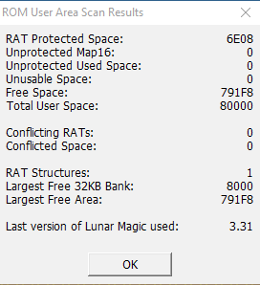
This will show you quickly some information about your rom. Before you jump to conclusions there are no rats in your computer invading your rom as their sovereign nation, plotting your demise and building their devilish machines to conquer us all. Here is quite good explanation about what RAT means: https://www.smwcentral.net/?p=viewthread&t=102891

For information about Map16, look here: https://www.smwcentral.net/?p=faq&page=1219828-map16. Its list of all the different tiles in your level.

recent files

edit

layer 1, 2 mode

edit sprites mode

insert manual

edit manual

bring to front, send to back, bring forward, send backward

object size

X, Y increase / decrease

conditional direct map16
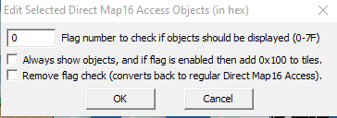

remap direct map16
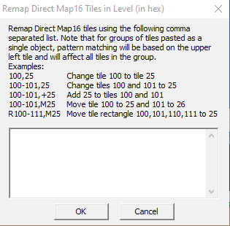

view

layer 1
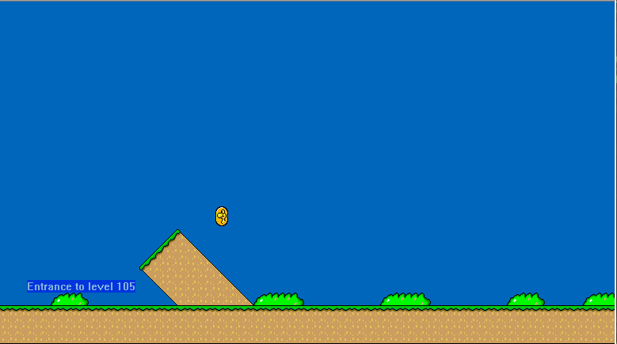

layer 2
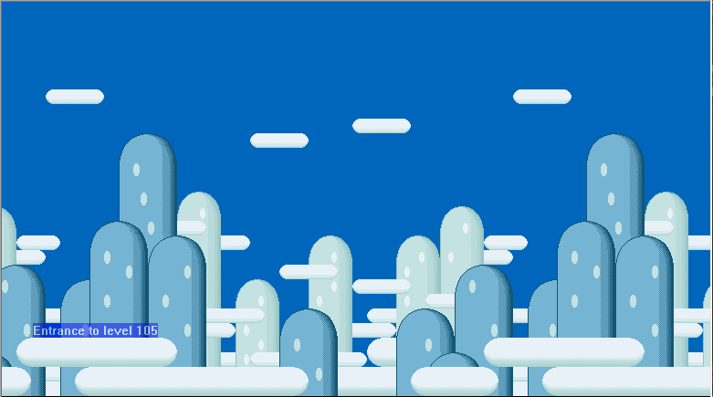

layer 3

sprites

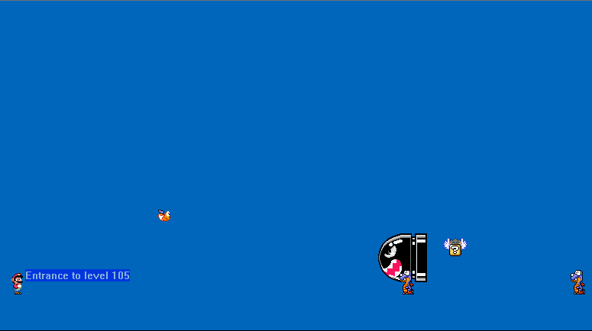
sprites hex code
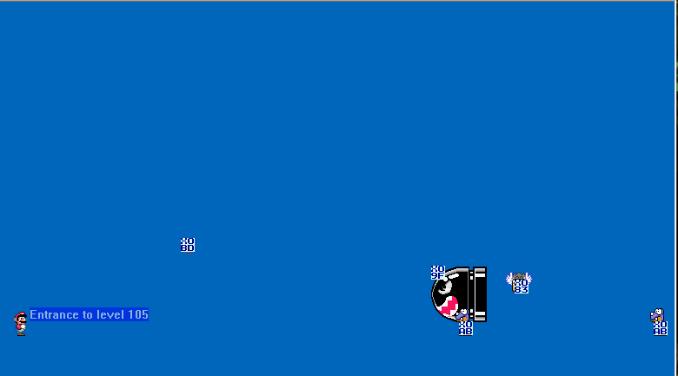

screen exits
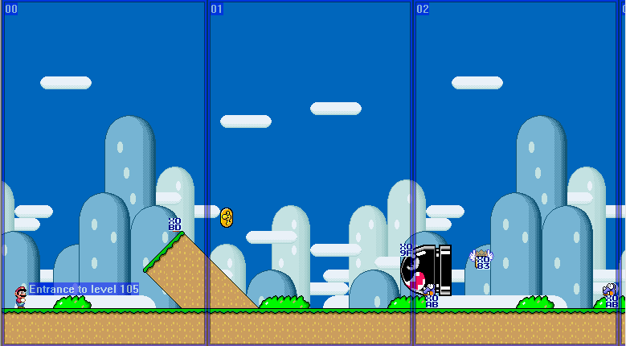

subscreen boundaries
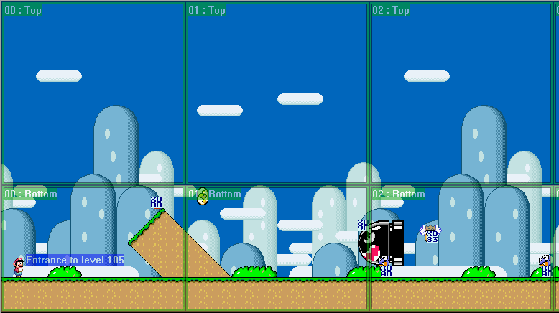

game view screen
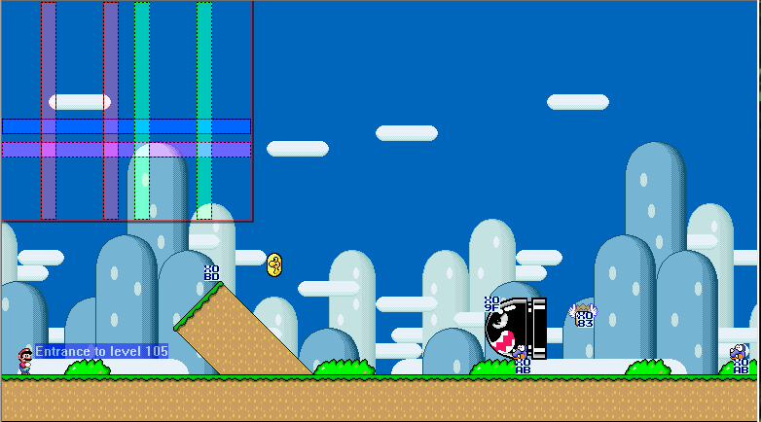

exit enabled tiles

tile surface outlines
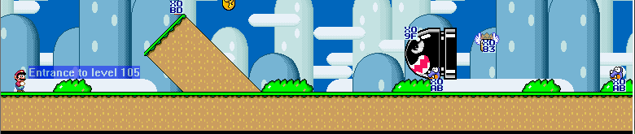

line guide outlines


tile grid
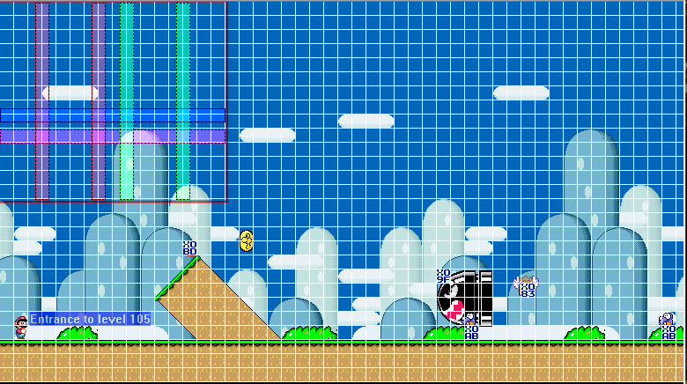

zoom

100- 800%

filter

100% increments

level entrances
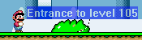

block contents

animation

next animated frame

reset animations

exAnimation triggers

custom triggers

0-F

next,previous

activate trigger

oneshot triggers

00-1F

next,previous

activate

manual triggers

0-F increment / decrement

next / previous

increment / decrement manual frame

have star

timer below 100

have 5 yoshi coins

silver POW

POW

special world passed

invisible pow objects

other invisible objects

on/off switch on

conditional direct16 map on

512 height background

translucent text background

switchblocks

green,yellow,blue,red switch blocks

editors

add objects window
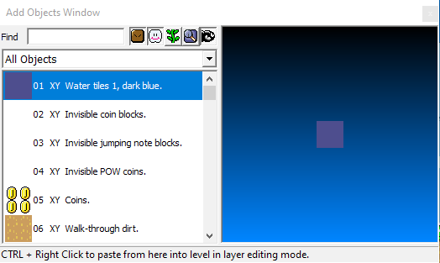

add sprites window
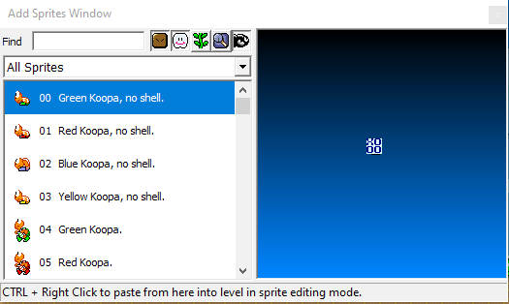

palette editor window
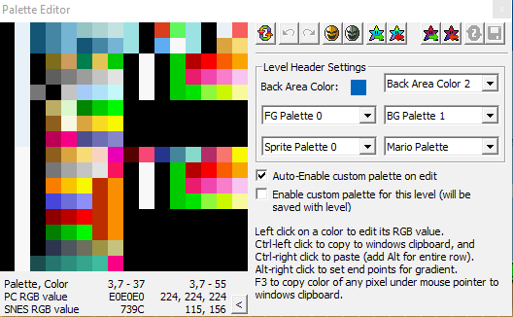

8x8 editor window
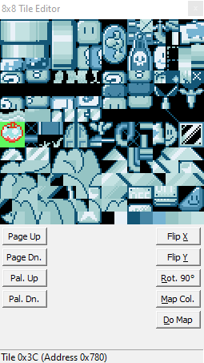

16x16 tile map editor window
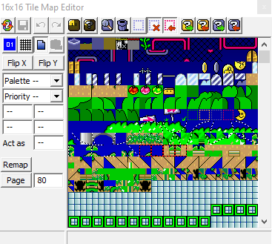

background layer 2 editor window
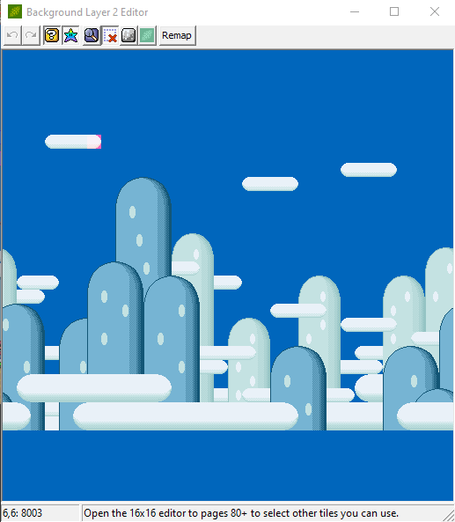

overworld editor window
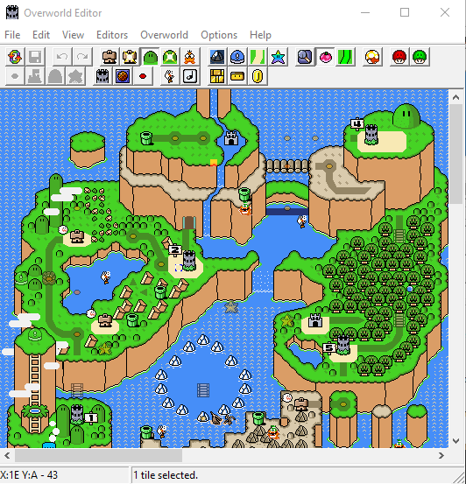

level

super gfx bypass
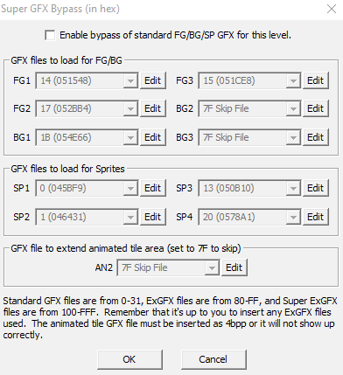

layer3 gfx /tilemap bypass
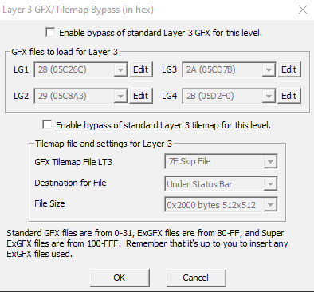

gfx index in header
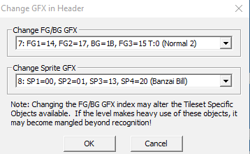

edit level exanimated frames
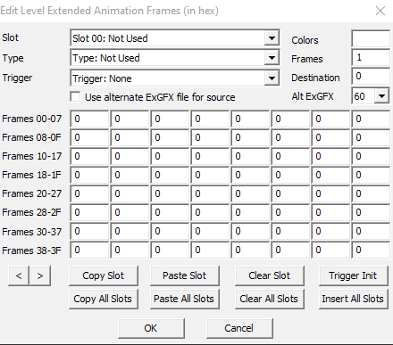

edit global exanimated frames
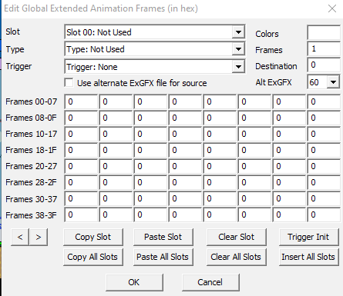

edit animation settings
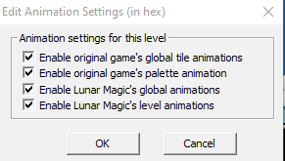

modify screen exits
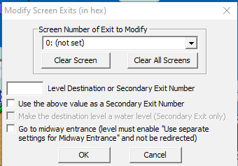

modify main and midway entrances
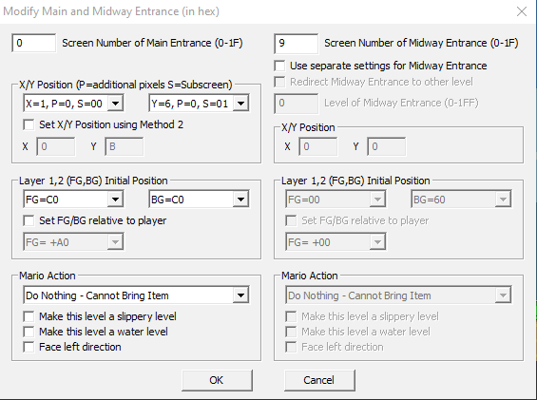

modify secondary entrances
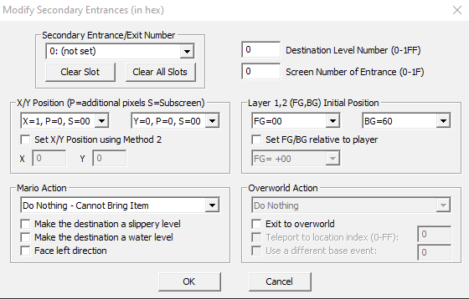

scan for undefined exits
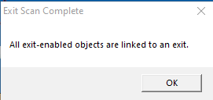

change properties in header
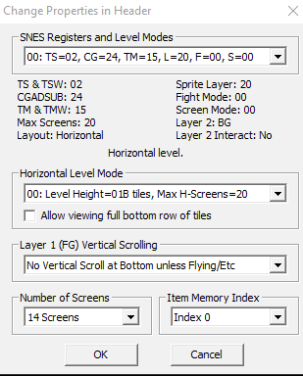

change properties in sprite header
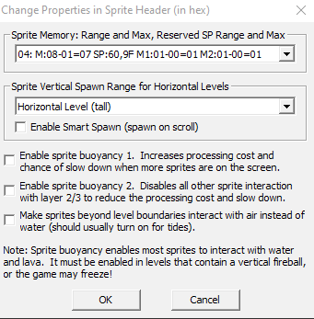

change other properties
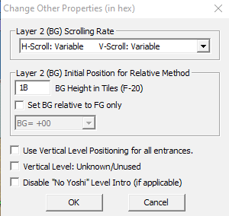

change layer 3 settings
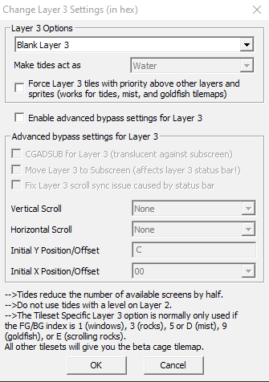

change music timelimit settings
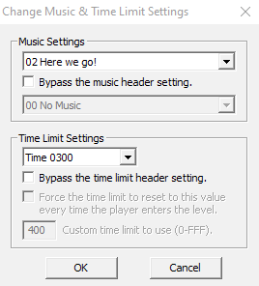

options

general options
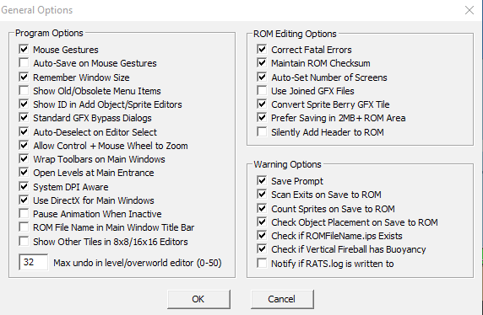

restorepoint options
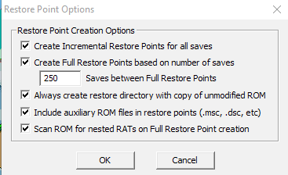

change animation rate
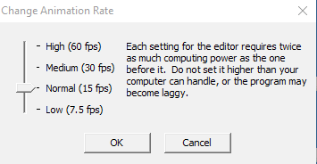

use fastrom addressing for this rom
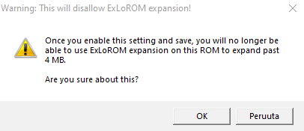

enable fastrom speed & apply patch
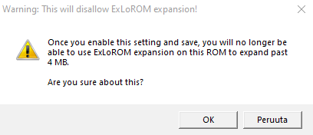

use sa-1 ram remap for this rom

use super fx ram remap for this rom

compression options for this rom
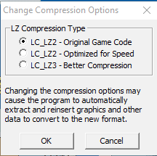

vram patch options for this rom
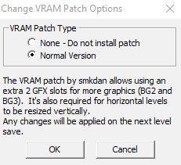

help

Contents
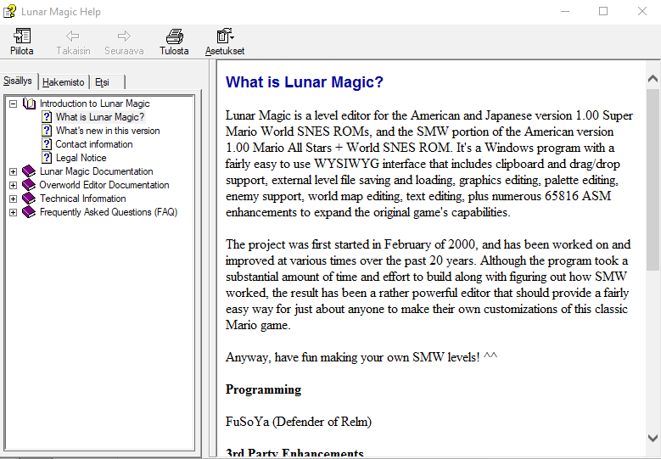

about lunarmagic
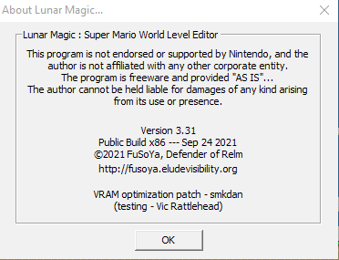

Sources:
Some parts might be directly from the source materials which would make those concerned about plagiarization very mad if not properly referenced. For the purposes of getting the guide done i'll write the guide first and worry about references later if at all. I will use direct quotations if its more useful than trying to reword something myself. I will also add my own comments, suggestions and analyzes.
Here is the list of sources where i have looked for information, maybe i'll remember to add it all. I wont add anything that doesnt relate directly to romhacks here, you have to look for those links from where they are first referenced.
(Do note that just because I link something here doesnt mean its the only or even the best source of information, use your own judgement.)

Lunar magic internal help document
https://www.romhacking.net/
https://supermarioworld.fandom.com/wiki/
https://www.smwcentral.net/

