|  |  |
| --- | --- |
| **Architetture dei Sistemi di Elaborazione**  **[AAA-GRA]** | Delivery date:  25th November 2022 |
| **Laboratory**  **6** | Expected delivery of lab_06.zip must include:   * Solutions of the exercises 1, 2 and 3 * this document compiled possibly in pdf format. |

Starting from the ASM_template project (available on Portale della Didattica), solve the following exercises:



1. Write a program using the ARM assembly that performs the following operations:
   1. Initialize registers R3 and R4 to random signed values
   2. Sum R0 to R3 (R0+R3) and store the result in R2
   3. Subtract R4 to R2 (R4-R2) and store the result in R5
   4. Force, using the debug register window, a set of specific values to be used in the program to provoke the following flag to be updated **once at a time** (whenever possible) to 1:
      * carry
      * overflow
      * negative
      * zero
   5. Report the selected values in the table below.

|  |  |  |  |  |
| --- | --- | --- | --- | --- |
|  | Please, report the hexadecimal representation of the values | | | |
| Updated flag | R0 + R3 | | R4 – R2 | |
| R0 | R3 | R4 | R2 |
| Carry = 1 | 0xB0000000 | 0x60000000 | 0x20000000 | 0x10000000 |
| Carry = 0 | 0x05000000 | 0x04000000 | 0x00000000 | 0x90000000 |
| Overflow | 0xB0000000 | 0xB0000000 | 0x90000000 | 0x60000000 |
| Negative | 0x70000000 | 0x80000000 | 0x80000000 | 0xF0000000 |
| Zero | 0x00000000 | 0x00000000 | 0x00000000 | 0x00000000 |

Please explain the cases when it is **not** possible to force a **single** FLAG condition:

It is not possible to activate only the overflow flag because having an overflow means having a carry flag activated.

In the case of subtraction, it is not possible to have only the zero flag activated because you must necessarily have the carry flag active because of the complement to 2 made to R2.

1. Write two versions of a program that performs the following operations:
   1. Initialize registers R2 and R3 to random signed values
   2. Compare the two registers:
      * If they differ, store in the register R5 the maximum among R2 and R3
      * Otherwise, perform a logical right shift of R3, sum R2 and store the result in R4

First, solve it by resorting to 1) a traditional assembly programming approach using conditional branches and then compare the execution time with a 2) conditional instructions execution approach.

Report the execution time in the two cases in the table that follows: **NOTE**, report the number of clock cycles (cc) considering a cpu clock (clk) frequency of 16 MHz, as well as the simulation time in milliseconds (ms).

Notice that the processor clock frequency is setup in the menu “*Options for Target: ‘Target 1’*”.



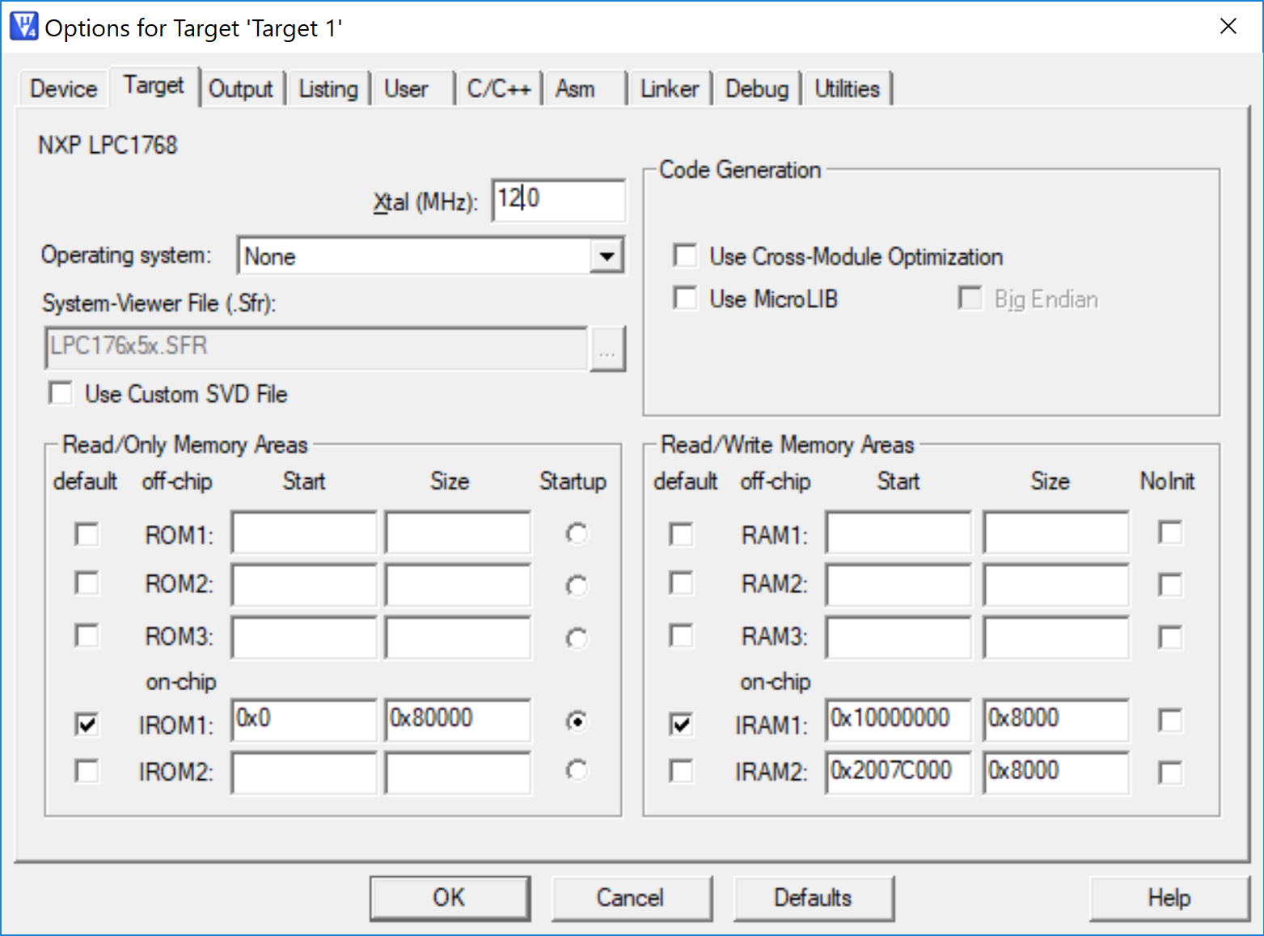

|  |  |  |  |  |
| --- | --- | --- | --- | --- |
|  | R2==R3 [cc] | R2==R3 [ms] | R2! =R3 [cc] | R2! =R3 [ms] |
| 1) Traditional | 10 | 0.00063 | 11  13 | 0.00069 (r2 > r3)  0.00081 (r2 < r3) |
| 2) Conditional Execution | 15 | 0.00092 | 15 | 0.00092 |

1. Write a program that calculates theleading zeros of a variable. The leading zeros are computed by counting the number of zeros starting from the most significant bit and stopping at the first 1 encountered: e.g., the leading zeros of 0b00000101 are 5. The variable to check is in R1. After the count, if the number of leading zeros is odd, perform the sum between R2 and R3. If the number of leading zeros is even, perform the difference between R2 and R3. In both cases the result is placed in R4.

Implement the ASM code that performs the following operations:

* 1. Determines whether the number of leading zeros of R1 is odd or even.
  2. As a result, the value of R4 is computed as follows:
     + If the leading zeros are even, R4 is the difference between R2 and R3
     + Else, R4 is the sum of R2 and R3
  3. Report code size and execution time (with 15MHz clk) in the following table.

|  |  |  |  |
| --- | --- | --- | --- |
|  | Code size [Bytes] | Execution time [ms] | |
| If R2 is even | Otherwise |
| Exercise 3) computation | 560 | 0.00473 | 0.00487 |

ANY USEFUL COMMENT YOU WOULD LIKE TO ADD ABOUT YOUR SOLUTION:

For the exercise number 3, I developed two types of algorithms:

1. Calculate the number of leading zeros by comparing the current value with the next value shifted to the left and looking at the Negative flag

2. Calculate the number of leading zeros by shifting the value to the left and looking at the Carry flag

But, for performance reasons I chose the second type because the first was slower in terms of calculation.