Firewall

Lab Report 5

Information Systems Security course (01TYM, 02KRQ)

prepared by:

Anuar Elio Magliari (s317033@studenti.polito.it)

George Florin Eftime (s303483@studenti.polito.it)

Alekos Interrante Bonadia (s319849@studenti.polito.it)
Packet filter
- Which authorisation policy is configured by default on your machine (on each of the three chains)?
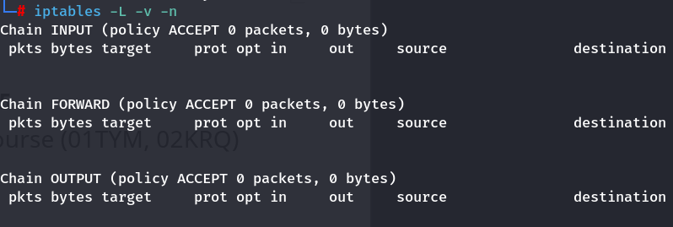

- Which chain (out from INPUT, FORWARD, and OUTPUT) do you have to modify to protect your machine from connections originating from the external users?
  - INPUT and FORWARD in order to have protection from external users
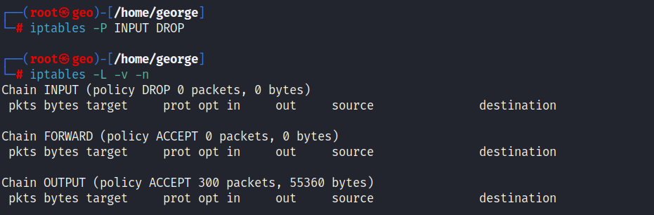
- Write down the iptables command to modify the authorisation policy of Alice’s host, so that to reject any traffic (hint: you need to modify the default policy for the INPUT chain from ACCEPT to DROP):
- Does Bob receive any responses (to the ping) from Alice’s host?
  - No, he doesn’t
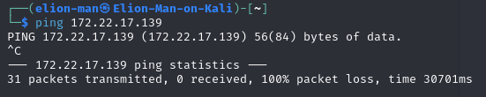

- Can Bob connect to Alice’s host via SSH and HTTP (with the browser)?
  - No, he doesn’t. In both cases, Bob doesn’t receive any response from Alice because Alice's firewall has the INPUT chain set to DROP, so it discards all requests from the external source.
- Check with nmap (running the above indicated nmap command on Bob’s host) the status of the ports 22 and 80 on Alice’s host. What is their status now?

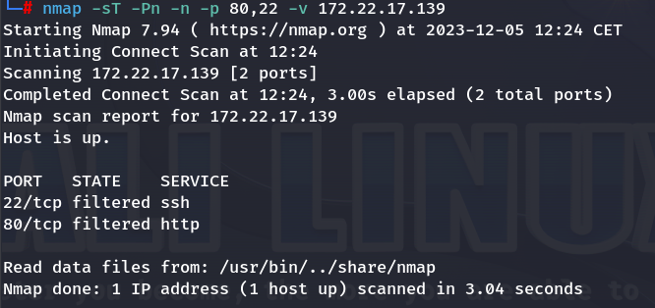
- Write down the iptables command to add a rule to the authorisation policy on Alice’s host (for the input traffic), so that to enable all ICMP traffic (for simplicity, we provide you some of the parameters of the command)
  - iptables -A INPUT -p icmp -j ACCEPT
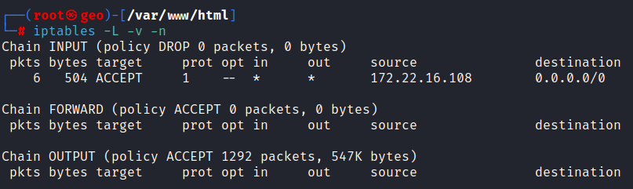
- Does Bob receive this time any response from Alice’s host in response to the ping command?
  - Yes, now he does because Alice allows all the icmp packets in input.
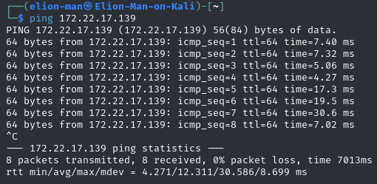

- Next, on Alice’s host, write down the iptables command to allow the TCP input traffic towards the port 80 (on Alice):
  - iptables -A INPUT -p tcp --dport 80 -j ACCEPT

- Check out the configuration of IPtables on Alice’s host. Which chain has been modified?
  - The chain modified is the INPUT chain as specified in the command
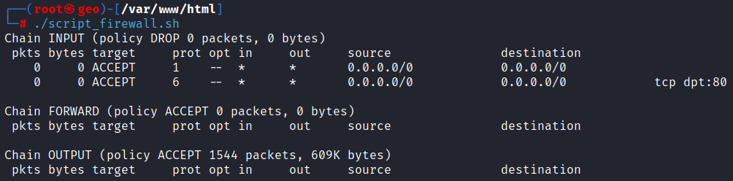
- Does Chuck receive any response (to the ping) from the Alice’s host? Why?
  - Yes, Chuck receives ping responses from Alice because she doesn’t drop the icmp requests (source is set to anyone)

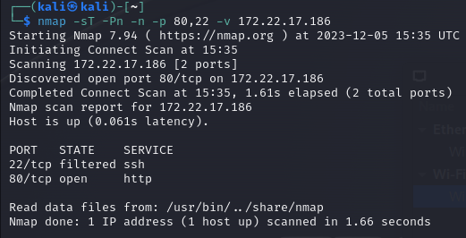

- How can nmap distinguish between filtered ports and closed ports? Verify by analysing the traffic exchanged between the two machines (e.g. with wireshark).
  - Nmap distinguishes between these two states based on whether it receives a response to its probe. In the case of a closed port, it receives a TCP RST packet in response, whereas for a filtered port, it doesn't receive any packet.
- What is the status of the port 80 (as listed by the above nmap command)?
  - The status of the port 80 is set to filtered.
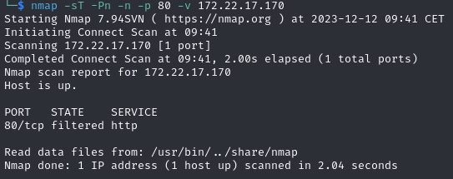
- What is now the status of the port 80 on Bob (as listed by the above nmap command on Alice’s host)?
  - The status of the port 80 is still set to filtered.
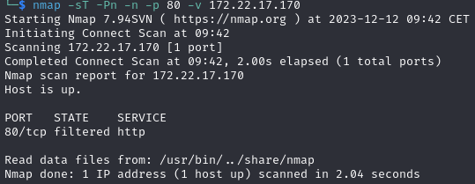
- Can Alice browse web content on Bob’s host? Verify by analysing the traffic among the two machines (with wireshark). After analyzing the traffic with Wireshark, describe what is happening with the SYN, SYN ACK, and ACK messages exchanged between Alice and Bob when Alice tries to browse web content on Bob’s host.
  - Alice is unable to browse the web content on Bob's host because she sends a SYN packet to Bob, and Bob responds with a SYN-ACK packet. However, Alice drops the response because the policies specify allowing packets from the destination port equal to 80, whereas it is not allowed to accept packets with the source port equal to 80. Consequently, Alice retransmits the SYN packet because, from her perspective, she doesn't receive the response (SYN-ACK). When the timeout expires, she retries to send the SYN packet.
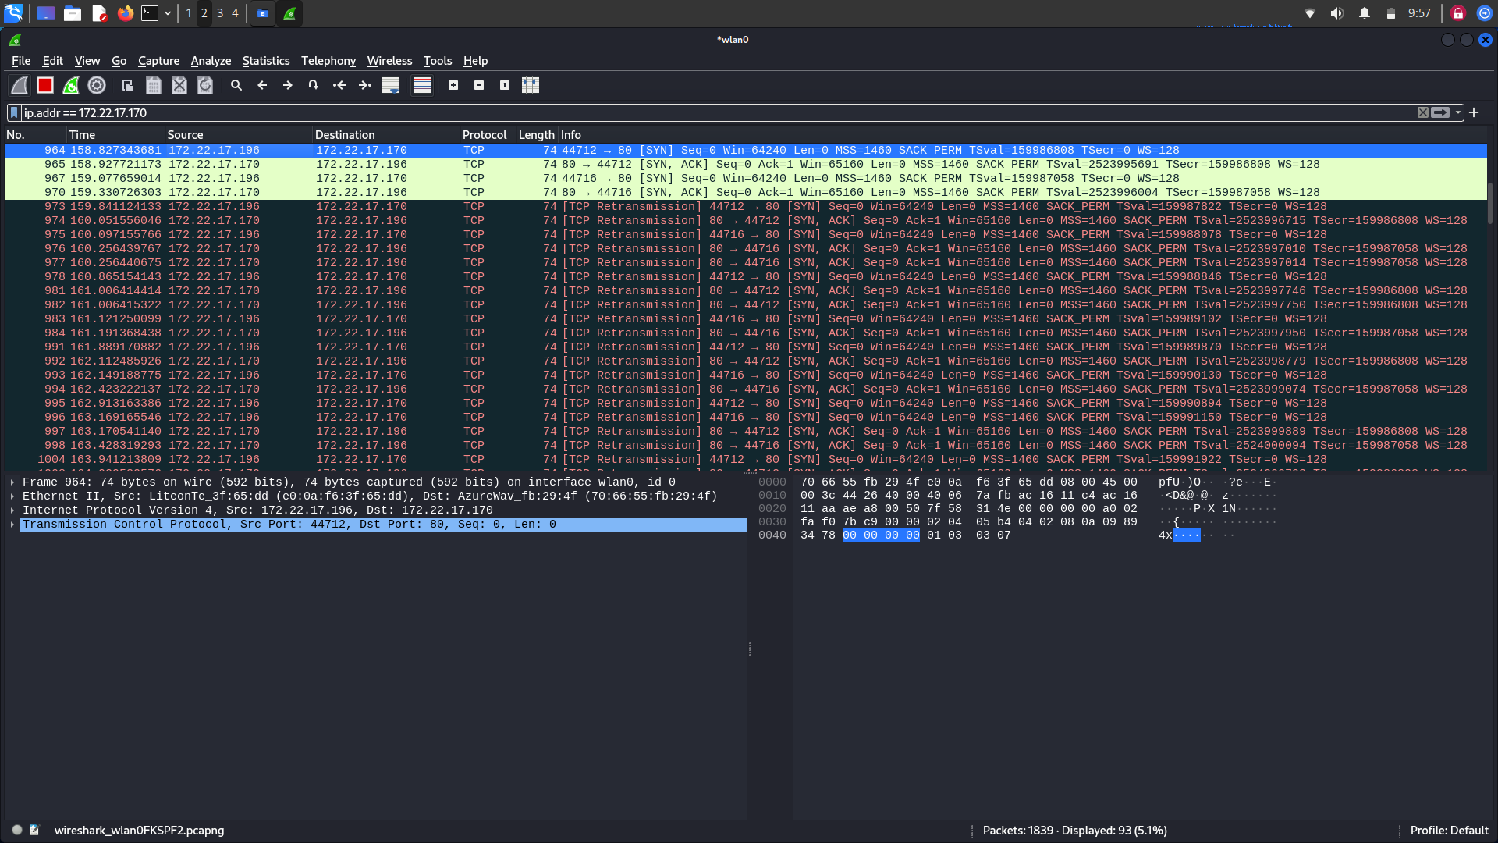
- Before passing to the execution of the next exercise, restore on Alice’s host the authorisation policy of type “ACCEPT ALL”. Hint: You need to delete all the current rules and specify afterwards the rules for the input chain.
  - sudo iptables -F INPUT
  - sudo iptables -P INPUT ACCEPT
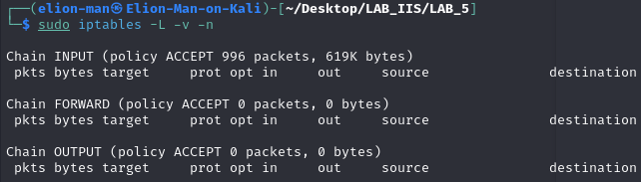

Packet filter stateless
- Can Alice browse the web server of Bob?

