Network security – basic attacks

Lab Report 1
Information Systems Security course (01TYM, 02KRQ)

prepared by:

Anuar Elio Magliari (s317033@studenti.polito.it)

George Florin Eftime (s303483@studenti.polito.it)

AleKos Interrante Bonadia (s319849@studenti.polito.it)

Section 1.1 : Network Scanning
How can this be done in practice? Which is the most common method used to determine whether a certain host is reachable?

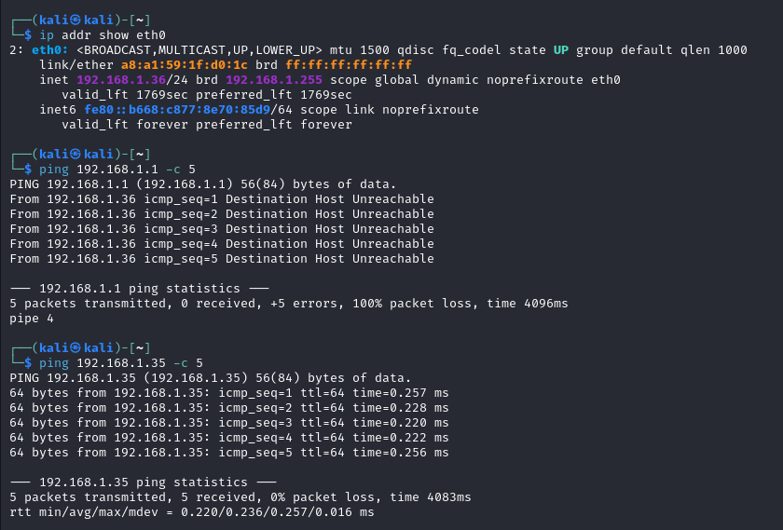
- The most common method used to verify if a certain host is reachable is using PING which use ICMP protocol. In other words, it communicates with the destination (the address ip destination must be specified) sending ICMP packets where him can reply to them.

Why (in general) it is not recommended to perform network scanning inside a monitored network?
- In general, performing network scanning inside a monitored network is not recommended because you can be revealed from the detecter.

Exercise 1

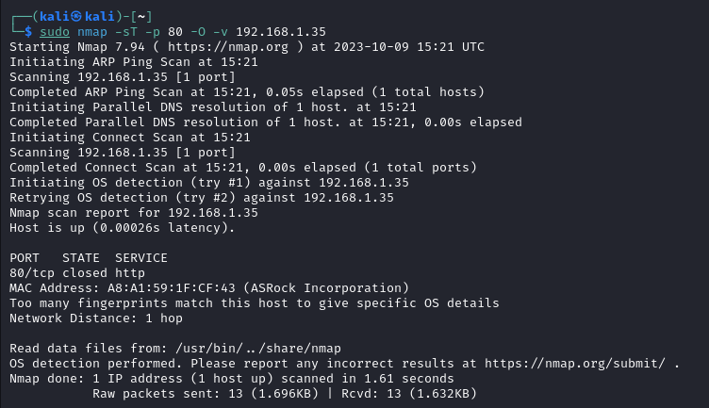

Exercise 2
Do you manage to discover which services have been activated by the victim (Alice)?
- Yes, we are able to discover which services have been activated.
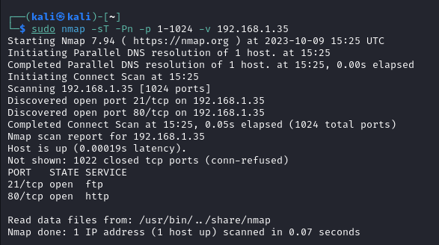

Why is it useful to avoid pinging the host (the option -Pn)?
- It is useful to avoid using ping during a port scanning of a host because this can trigger suspicious activity by the host, thus risking being blocked.
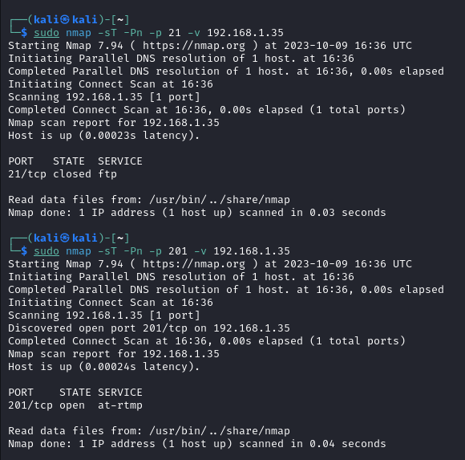

Exercise 3
Have you encountered problems? How do you think they can be solved?
- No, we haven’t! In this case we see two different available service opened each other in the relative port.

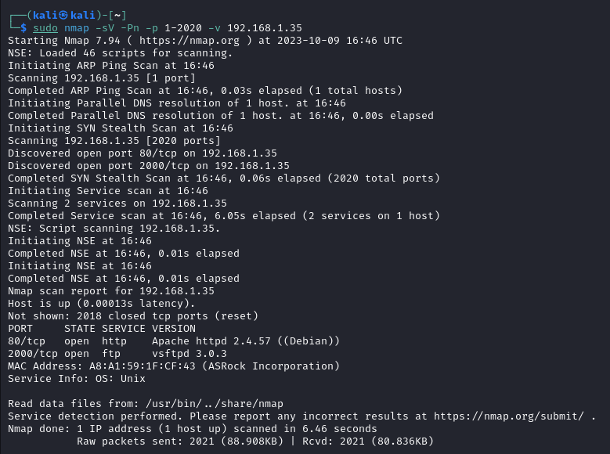
Exercise 4
Why is it recommended to use the flag -sV rather than the option -A ?

In your opinion, which techniques and security tools can be used to defend against the security attacks presented above?

Exercise 5
Before the attack
Role | IP Address | MAC Address
Alice | 192.168.1.58/24 | a8:a1:59:1f:12:cb
Bob | 192.168.1.60/24 | a8:a1:59:1f:cf:f7
Chunk | 192.168.1.59/24 | a8:a1:59:1f:12:df

After the attack
Role | IP Address | MAC Address
Alice | 192.168.1.58/24 | a8:a1:59:1f:12:cb
Bob | 192.168.1.60/24 | a8:a1:59:1f:12:df
Chunk | 192.168.1.59/24 | a8:a1:59:1f:12:df

What kind of network traffic was able to capture Chuck before the attack?
- Before the attack, Chunk was only able to capture the broadcast messages but not the direct comunication.
What type of network traffic is able to sniff Chuck after the attack?
- After the attack, due to the table modified he was able to sniff all messages between Alice and Bob.
Can you figure out from the captured network traffic how the attack works?
- Simply put, when Chuck sends the Ettercap command, it modifies the ARP table of Alice and Bob so that each of their IP addresses corresponds to Chuck's MAC address. Consequently, every message between Alice and Bob passes through Chuck, and he acts as a router forwarding the messages.
What happened to the ARP tables of Alice, Bob and Chuck? Check out.
- The ARP tables of Alice and Bob are modified with the correct IP addresses, but the MAC address corresponds to Chuck's MAC address. Meanwhile, Chuck's ARP table remains unchanged.
Take a look at the Figure ?? and try to respond to this question (where ? can be a hub, a switch, a router or even Internet): when is it possible to make a man-in-the-middle attack with ARP poisoning and which are its effects?
- The man-in-the-middle attack with ARP poisoning is only possible on a LAN due to the nature of ARP. However, its effects can compromise the security of the network. For example, an attacker within the network can carry out attacks such as DoS, MITM, sniffing, reply attacks, and others, thereby undermining repudiation, integrity, confidentiality, and availability.
Optionally, try to identify a possible countermeasure to this security attack
- One possible countermeasure can be the use of an authentication/non-repudiation method involving RSA keys between the two parties, encrypting all messages with their respective private keys. This will ensure that the message was indeed sent by the legitimate sender.
What happened?
- Bob will send the messages to the real MAC address of Alice.
What Chuck did at point 1?
- Chuck modifies the ARP poisoning delay; consequently, Chuck will re-modify the victims' ARP tables every 1000 seconds, making the attacks more effective
What is the meaning of the variable arp poison delay? Prove again the exercise by setting the variable to 1 or to the default value, 10
- For instance, if it is set to 1, the attacker will not be stealthy enough to avoid detection by potential detectors within the network.

Exercise 8
How can Chuck intercept all the web traffic of Alice?
- By using the Ettercap tool, we can poison the ARP tables of both Bob and Alice, allowing us to carry out a man-in-the-middle attack. This means that all traffic from Bob will pass through Chuck and then be forwarded to Alice.
How can you defend against these types of sniffing attacks
- To enhance the security of our messages, we can employ encryption using the RSA algorithm. In this method, Bob encrypts their messages with their private key to ensure confidentiality between Alice and Bob. When Alice receives the messages, she can decrypt them using Bob's public key.
Try to execute a login by using SSH protocol and to capture the username and password. Are you able to do so (why)?
- The attacker encounters more difficulty with SSH because it encrypts all messages from Bob to Alice and vice versa.

Exercise 9
You should see information provided by DNS.
- Trying "polito.it"
;; ->>HEADER<<- opcode: QUERY, status: NOERROR, id: 34818
;; flags: qr aa rd ra; QUERY: 1, ANSWER: 2, AUTHORITY: 0, ADDITIONAL: 0

;; QUESTION SECTION:
;polito.it. IN A

;; ANSWER SECTION:
polito.it. 86400 IN A 192.168.59.6
polito.it. 86400 IN A 192.168.40.1

Received 59 bytes from 130.192.3.21#53 in 12 ms
Trying "polito.it"
;; ->>HEADER<<- opcode: QUERY, status: NOERROR, id: 55137
;; flags: qr aa rd ra; QUERY: 1, ANSWER: 0, AUTHORITY: 1, ADDITIONAL: 0

;; QUESTION SECTION:
;polito.it. IN AAAA

;; AUTHORITY SECTION:
polito.it. 86400 IN SOA leonardo.polito.it. root.leonardo.polito.it. 2023101203 10800 1800 1209600 86400

Received 77 bytes from 130.192.3.21#53 in 0 ms
Trying "polito.it"
;; ->>HEADER<<- opcode: QUERY, status: NOERROR, id: 19893
;; flags: qr aa rd ra; QUERY: 1, ANSWER: 1, AUTHORITY: 0, ADDITIONAL: 2

;; QUESTION SECTION:
;polito.it. IN MX

;; ANSWER SECTION:
polito.it. 3600 IN MX 10 exchedge.polito.it.

;; ADDITIONAL SECTION:
exchedge.polito.it. 86400 IN A 130.192.67.194
exchedge.polito.it. 86400 IN A 130.192.67.195

Received 84 bytes from 130.192.3.21#53 in 0 ms
What does Bob see in his web browser?
- Bob sees the page associated with the IP address manipulated by Alice.
What could have happened if the attack didn’t work? Make your assumptions and confront them with what we have indicated in the initial note.
- In our case, the attack has been successfully conducted.
What does Alice see in the ettercap window?
- Alice sees all the HTTP requests made by Bob when he tries to reach www.polito.it.
How can an attacker obtain similar results (as the ones described in this section), even though the attacker is not close to the victim?
- The attack can be conducted in various ways. We can consider having access to a VPN, thereby simulating access to the LAN even if it's not physically located in the same place. Alternatively, a phishing attack can be employed, where the victim is induced to visit the desired website or to exploit potential vulnerabilities in the network that allow the attacker to gain access.

