Assumptions
This assumes:
- FFmpeg (including ffmpeg.exe and ffprobe.exe) is installed and is on the PATH
- You have installed Anaconda or Miniconda or some other Python.
- Your Python has the libraries cv2 and pydub
- You have saved the file clip-necromancy-tool.py to your computer
- You are running Windows 11 (I haven’t tried any other OS and don’t know if it works)
Getting Clip CSV

To get clip data, go to https://www.twitchanz.com/clips
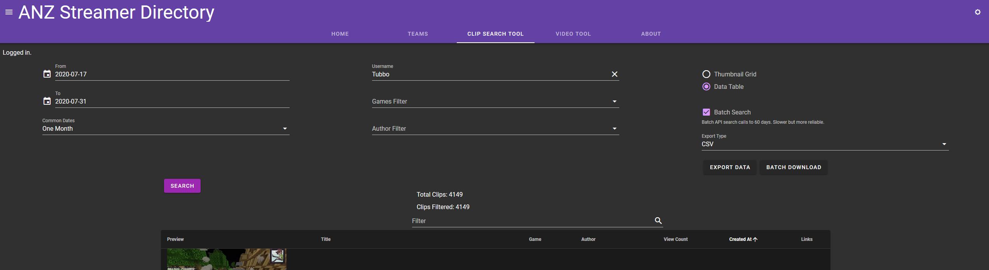
Choose the time period in question, starting a day before the stream (in case of timezone issues), and going out up to 60 days after it. Type the streamer’s username. Games Filter is not useful because streamers don’t always set their game for a stream correctly. Choose export type CSV, click “Export Data”, and save the file with a descriptive title in a place you’ll find again later.

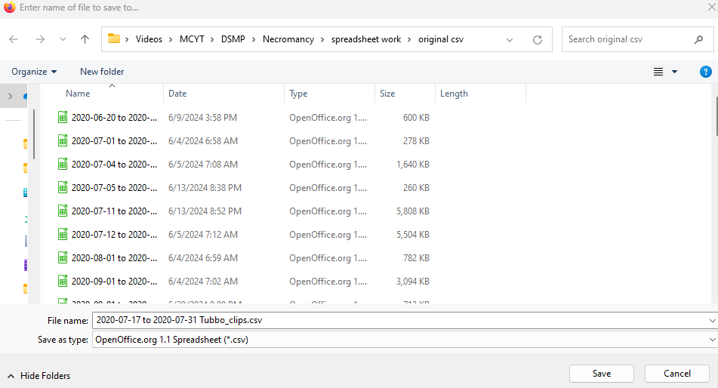

Getting Stream ID, VOD ID, maxtime

To get stream ID and maxtime from twitchtracker:
Go to https://twitchtracker.com/[streamer]/streams for the streamer.
Filter to the day of the stream, and look for the right one. Click on its date.
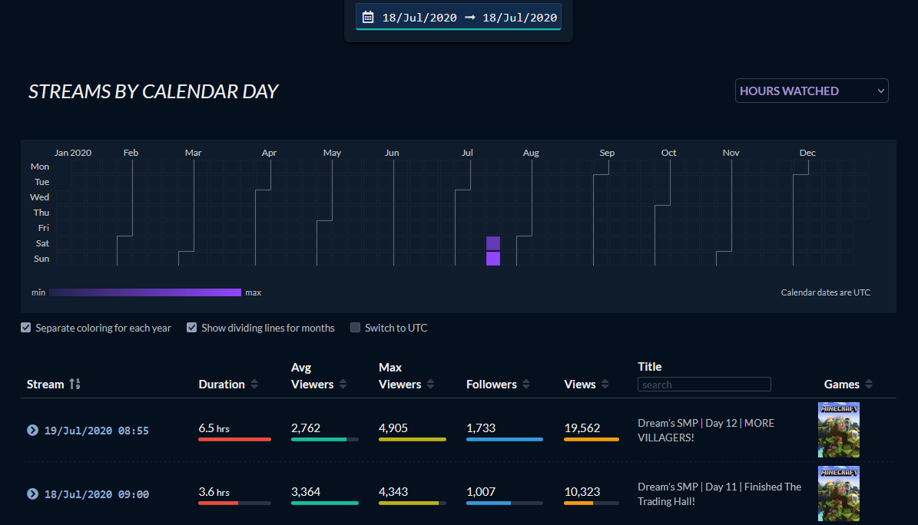

The number in the stream’s URL is the stream ID.

The maxtime is the duration of the VOD converted to seconds. To be on the safe side, add one more minute.

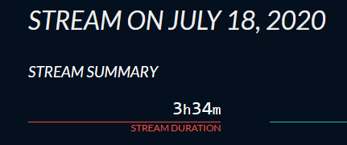

To get stream ID and VOD ID from clips:
Open the clips CSV file, with a spreadsheet program like Excel or Calc.
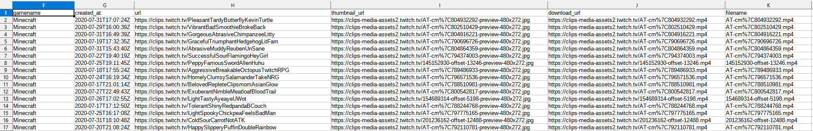

Filter the filename field to include “offset”, and sort by the field created_at.
Look for clips with a title matching the title you expect from the stream.
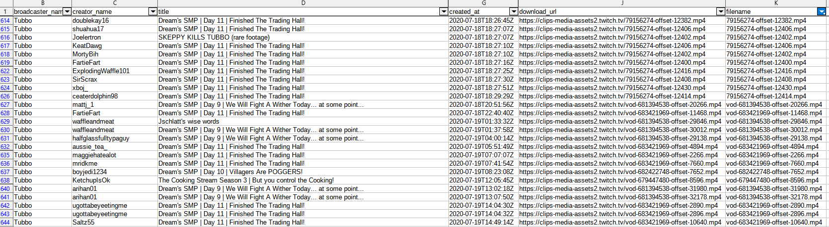
The VOD ID is the first number in the filename field of the clips from the right stream that begins with “vod-”, and the stream ID is the first number from the filename that does not.

Reconstruction Tool Setup
Open clip-necromancy-tool.py in a text editor. I use Notepad++ for convenience, but Notepad would work.

You will only be changing values in the setup section at the beginning of the document.

Set original_clips_csv_path to be the full path to the clips CSV you downloaded.
Set chosenstreamid to the stream ID and chosenvodid to the VOD ID. If you could not find the VOD ID, set it to None, like `chosenvodid = None`.
Set outputfolderpath to the folder you want the program to make to store all the files for this reconstruction.
Set streamtitle to the title of the stream, or whatever you want the video to be named.
Set starttime to be 0, and maxtime to be the maxtime you calculated.
Set checkbetween to be True (this means the program will try to find clips on Twitch’s servers that aren’t listed in the CSV. Set it to False if the clips are a weird format or you don’t want it to do that.)
Set downloadnonoffsetclips to be False and pause_at_end to be False (these are both for more complicated things I’m not covering right now.)
Leave everything else alone.
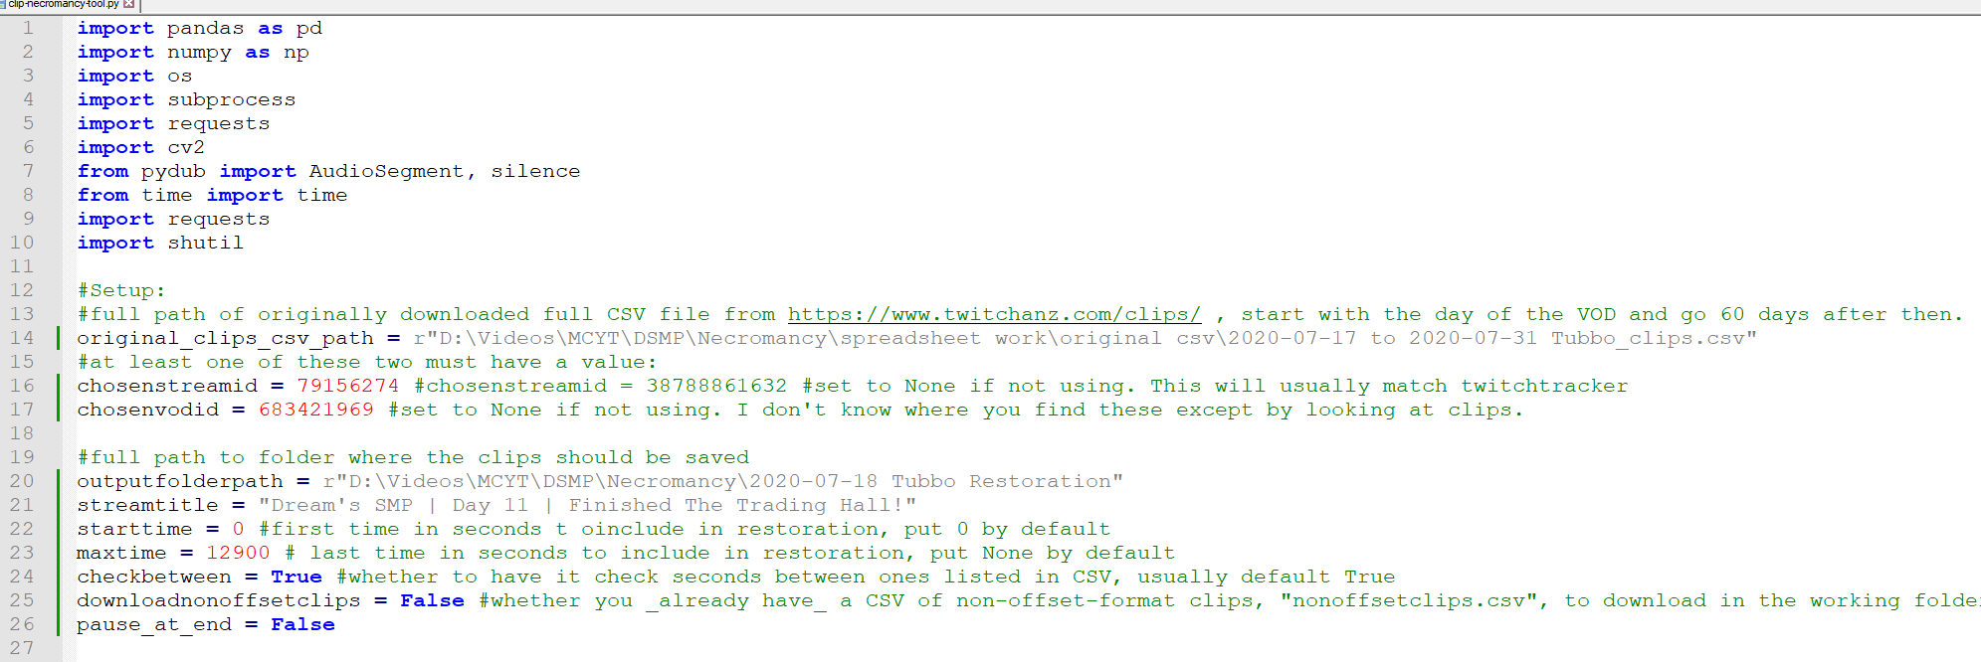

Navigate to the folder containing clip-necromancy-tool.py in the Anaconda Prompt window.
Run `python clip-necromancy-tool.py`, and wait for it to run. If it crashes, let me know and I’ll try to figure out the problem.

