# Curve Fit of baseline data

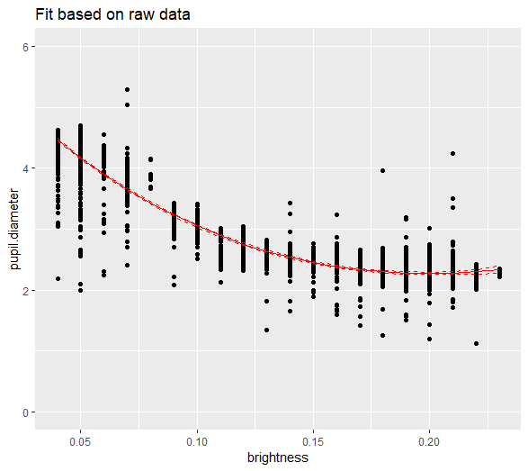

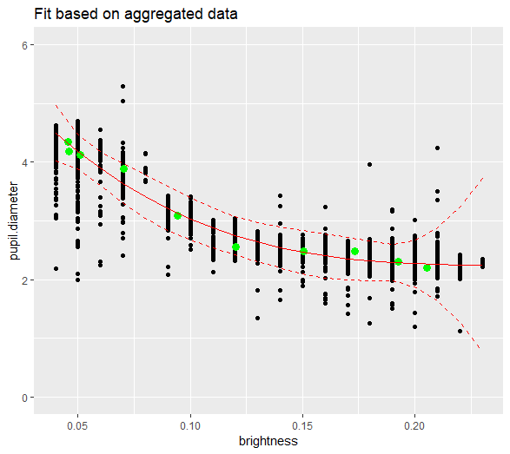

# Baseline curve applied to video data

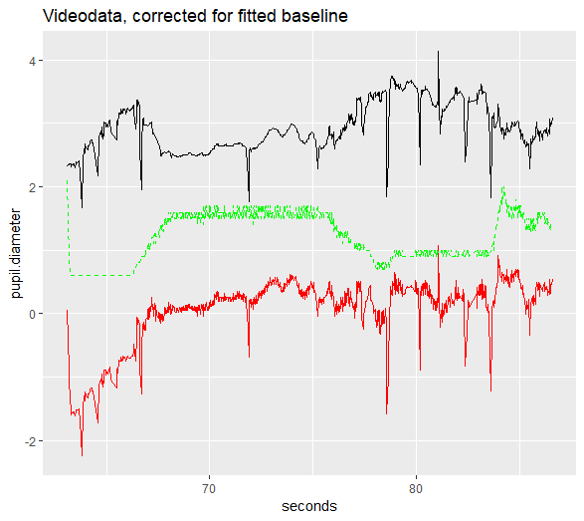

Black original pupil diameter

Red: corrected for baselevel

Green: brightness (*10) as reference