Apps

There are apps available as [Jupyter](http://jupyter.org) notebooks that accompany the GPG. We recommend using binder to access the apps.

# Jupyter Notebooks

Within the Jupyter Notebook environment, you can use shift + enter to run each cell of code, or from the menu, select cell, run all

image

# Binder

1. Launch the binder by clicking on the badge above or going to: <https://mybinder.org/v2/gh/geoscixyz/gpgLabs/main?filepath=notebooks%2Findex.ipynb> This can sometimes take a couple minutes, so be patient...
2. Select the notebook of interest from the contents
3. Run the Jupyter notebook <jupyter_notebooks>

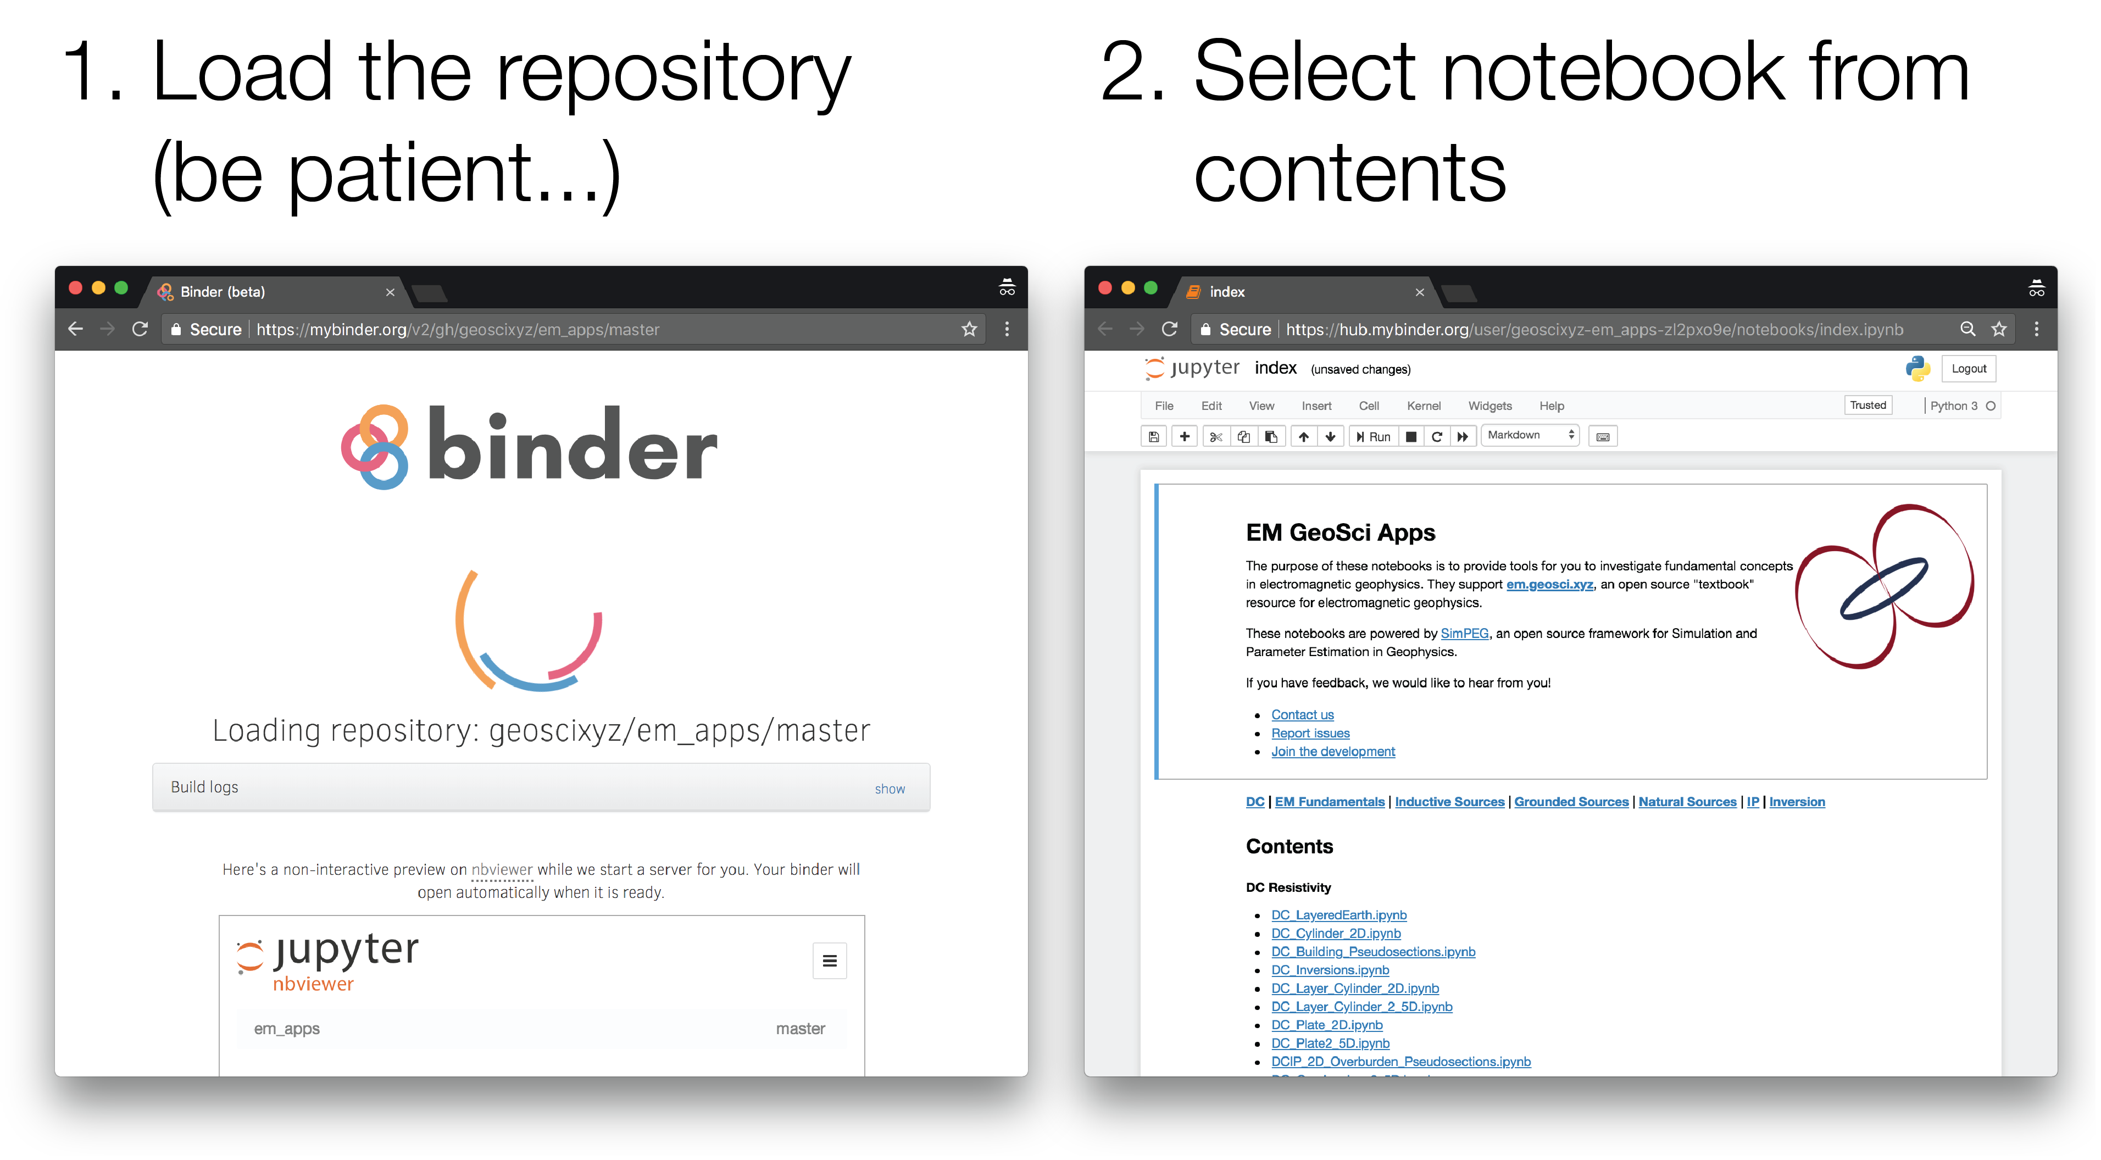

# Installing locally

If you are familiar with python and github, you can install them via <https://github.com/geoscixyz/gpgLabs>