Basic Principles

Purpose: This section provides the key components to understand the geophysical magnetic experiment. As briefly summarized in the Introduction<magnetic_physical_property> section, the magnetic survey requires a magnetic source<earth_s_field>. Rocks inside the earth become magnetized and they produce an anomalous magnetic field data<magnetics_responses>. A receiver records the sum of all magnetic fields.

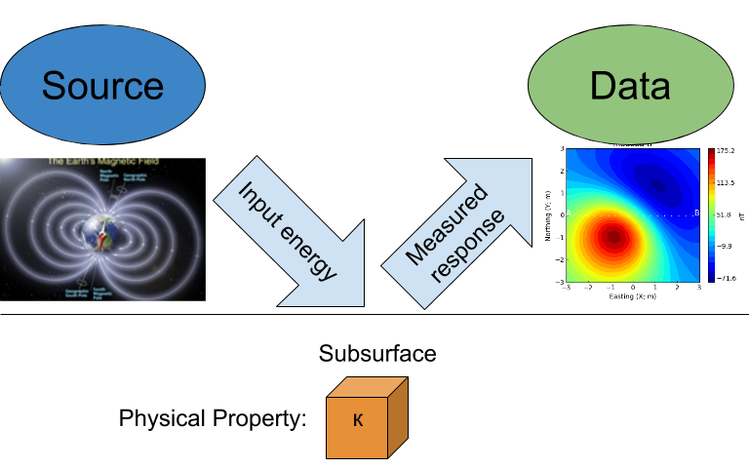

Simplified magnetic target and receiver

Important topics are:

* Source<earth_s_field>
* Magnetization<magnetics_magnetization>
* Data<magnetics_responses>
* Other important items
  + Remanence<magnetics_remanent>
  + Magnetic Charges<magnetics_charges>

# Earth's magnetic field (Source)

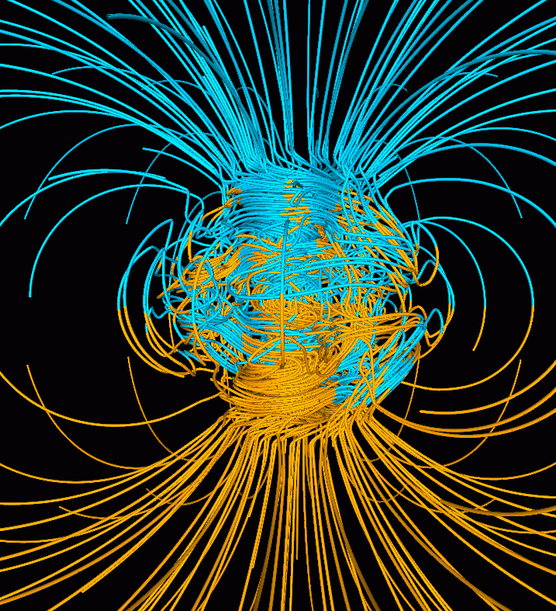

The Earth's dynamo

All magnetic fields arise from currents. This is also true for the magnetic field of the earth. The outer core of the earth is molten and in a state of convection and a geomagnetic dynamo creates magnetic fields. Close to the surface of the core the magnetic fields are very complicated but as we move outward the magnetic field resembles that of a large bar magnetic which is often referred to as a magnetic dipole.

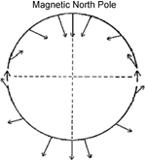

Direction of the Earth's field at the surface.

To a first approximation, Earth's magnetic field resembles a large dipolar source with a negative pole in the northern hemisphere and a positive pole in the southern hemisphere (earth_mag_vectors). The dipole is offset from the center of the earth and also tilted. The north magnetic pole at the surface of the earth is approximately at Melville Island.

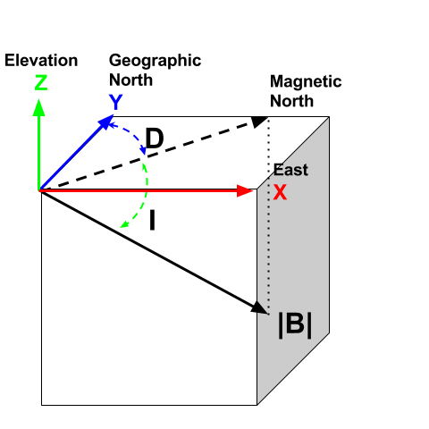

Terms for the coordinate system used in magnetics

The field at any location on (or above or within) the Earth are generally described in terms described of magnitude (), declination () and inclination () as illustrated in coord_sys.

* : The magnitude of the vector representing Earth's magnetic field.
* : Declination is the angle that *H* makes with respect to geographic north (positive angle clockwise).
* : Inclination is the angle between **B** and the horizontal. It can vary between -90° and +90° (positive angle down).

## The IGRF

Earth's field at any location is approximately that provided by a global reference model called the IGRF<magnetics_IGRF> or International Geomagnetic Reference Field. The IGRF is a mathematical model that describes the field and its secular changes, that is, how it changes with time. The IGRF is a product of the International Association of Geomagnetism and Aeronomy ([IAGA](http://www.ngdc.noaa.gov/IAGA/vmod/)), and the original version was defined in 1968. It is updated every five years, and **later** versions may re-define the field at **earlier** times. This is important to remember if you are comparing old maps to new ones.

Earth's field has a strength of approximately 70,000 nanoTeslas (nT) at the magnetic poles and approximately 25,000 nT at the magnetic equator. Field orientation and strength varies around the world, as presented in IGRF_three_figures based upon the IGRF from 2003 ([NOAA](http://www.ngdc.noaa.gov/geomag/geomag.shtml)).

2003 IGRF Magnetic Field

|  |  |
| --- | --- |
| ./images/earth-decl.gif  Earth's declination. | ./images/earth-incl.gif  Earth's inclination. |
| ./images/earth-strength.gif  Earth's field strentgh |  |

Slow changes in the exact location of the magnetic north pole occur over long periods (months-years). These changes are thought to be caused by internal changes in mantle convection. Knowing the acquisition date of a magnetic survey is important in order to understand the observed magnetic anomalies. In 2004, Earth's magnetic north pole was close to Melville Island (Nunavut) at (Latitude, Longitude)=(79N, 70W). In Vancouver (BC), the current field is orientated at D ~ 20°N, ~ 70° Inclination. Various governmental agencies are actively collecting and archiving information about the parameters of the field worldwide and can be queried with the [magnetic field calculator](http://www.ngdc.noaa.gov/geomag-web/).

Details about Earth's field can be found at government geoscience websites such as the [NOAA](http://www.ngdc.noaa.gov/geomag/geomag.shtml) geomagnetism home page, or the [Canadian National Geomagnetism Program](http://www.geomag.nrcan.gc.ca/index-eng.php) home page. An overview of Earth's magnetic field (with good images, graphs, etc.) can be found on the British Geological Survey's [geomagnetics website](http://www.geomag.bgs.ac.uk/).

## Magnetic fields from External Sources

When we record a magnetic observation we measure the field that exists at that location. Most of that field comes from inside the earth and it can be from the geomagnetic dynamo or from crustal rocks that have become magnetized. In addition there are also magnetic fields that come from outside the earth. The solar wind interacts with Earth's magnetic field and creates a magnetosphere that is "tear-dropped" shape as shown in the figure below

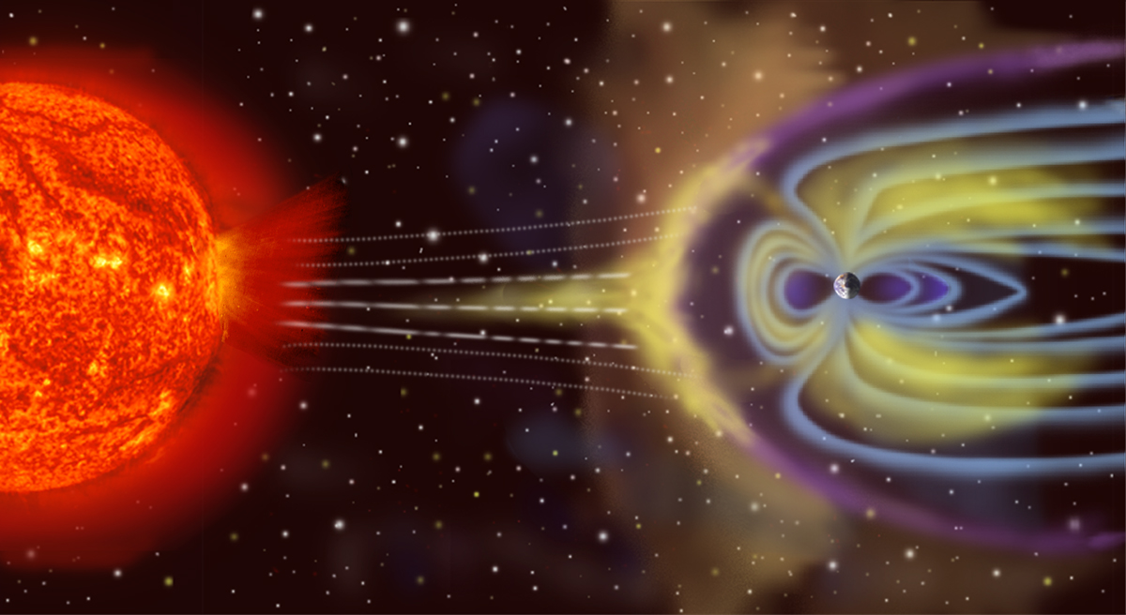

The image shows an artist' rendition of the charged particles interacting with Earth's magnetic field. The volume containing Earth's field is called the magnetosphere ([by_NASA](https://commons.wikimedia.org/w/index.php?curid=192450)).

The interaction between Earth's field and the solar wind allows charge particles to flow in the ionsphere which is a zone of ionized particles about 110 km above the earth's surface. These currents produce magnetic fields. The time-scales for these changes can be very short, in the order of micro-seconds, to large, in the order of days. Daily variations can typically be on the order of 20 - 50 nT in size. Large scale variations are caused by magnetic storms and they may be 1000's of nT in size. Magnetic storms are correlated with sunspot activity, usually on an 11-year cycle. These variations can be large enough to cause damage to satellites and power distribution systems. They are also the cause of the Aurora Borealis or Australis (northern or southern lights respectively). See the GSC's "Geomagnetic Hazards" web page for more.

# Magnetization

When the source field is applied to earth materials it causes the to become magnetized. Magnetization<physprop_magnetization> is the dipole moment per unit volume. This is a vector quantity because a dipole has a strength and a direction. For many cases of interest the relationship between magnetization and the source (earth's magnetic field) is given by

where is the magnetic susceptibility. Thus the magnetization has the same direction as the earth's field. Because Earth's field is different at different locations on the earth, then the same object gets magnetized differently depending upon where it is situated. As a consequence, magnetic data from a steel drum buried at the north pole will be very different from that from a drum buried at the equator.

The final magnetization of a rock or man-made object can be the result of a number of contributing factors. In the case of the metal drum, it can made of steel and it has complicated structure. It's walls are thin, it is hollow on the inside, and the steel has a very high magnetic susceptibility. The geometry and high susceptibility causes the induced magnetic field of the drum to be in a different direction than the inducing earth's field and the relationship MkappaH is no longer valid. Also, the drum was manufactured by molding melted steel. When that material cooled through its Curie temperature it acquired a permanent, or remanent, magnetization. It's net magnetization, when it is buried at any location on the earth will be the sum of the induced and remanent magnetizations. This is an important topic and it is further investigated here<magnetics_remanent>.

# Responses (Data)

The magnetic field that results from the magnetized earth is evaluated with the equation

where is the magnetic  
permeability<physprop_mag_permeability> of free space, is the magnetization per unit volume , and defines the distance between the object and the location of the observer. This magnetic field is referred to as the "secondary" field or sometimes the "anomalous" field . For geological or engineering problems, these anomalous fields are the *data* to be interpreted, and this is what we seek to measure.

When the magnetization is governed by the linear relationship MkappaH then the above anomalous field can be written as:

It is important to note that the left hand side of this equation is a magnetic field that is a vector. For simplicity, and for the remainder of this section, we shall drop the subscript "A" and remember that we are talking about anomalous fields. A vector in three dimensional space requires three numbers to specify it. These could be component values () or an amplitude and angles ( ). Generally a geophysical datum is a measurement of a component. For instance,

where () is a vector inner product. This means that is the projection of the vector onto a unit vector in the direction. Similar understandings exist for and . When plotting magnetic field data over an object it is therefore usual to plot maps of a particular component. A special datum that is particularly important for magnetics is the projection of the anomalous field onto a unit vector that is in the direction of the earth's field. Let this be . Then the datum is

The basic ideas behind the induced magnetization process, going from source to data, are illustrated below. The image of the data, corresponds to .

From integral_induced, we note that the induced response of the field will vary both in magnitude and orientation with respect to the inducing magnetic field . Therefore, the magnetic response of an object buried in Canada may look a lot different if buried near the equator as demonstrated in the dipole animation<magnetics_induced_demo> below. This is an important point to keep in mind when interpreting magnetic data.

: Changing magnetic response () of a buried magnetic prism as a function of inducing field orientation.

|  |
| --- |
|  |

**Student exercise** ([magnetic_app](https://mybinder.org/v2/gh/geoscixyz/gpgLabs/main?filepath=notebooks%2Fmag%2FMag_Induced2D.ipynb)):

Generate a block and bury it at a depth that is somewhat greater than its size. The block will produce a magnetic field that is like a dipole. Locate the block at:

1. the north pole
2. mid-latitude
3. the equator.

Before you simulate the data with the applet, sketch the explected magnetic field. Also, sketch the expected profile along a E-W transect, at the surface, over the middle of the buried target. Do this for all possible data types; .

In addition to components in the cartesian framework, or projections onto the direction of the inducing field, the vertical gradient of the field, can be plotted. These data are those that would be acquired with a gradiometer, and are listed as .

Note that when plotting any datum, sign conventions must be adopted. For the applet the coordinate system used is UTM: is east, is north, and is elevation which is positive up.

The sign convention will be that is positive if it points in the direction, is positive if it points in the direction and is positive if it points upward. For the anomaly is positive if it points in the same direction as the earth's field and negative if it is the opposite direction.

*Note that traditionally in magnetics the coordinate system is 'x' is northing, 'y' is easting and 'z' is positive down. To mitigate confusion we refer to these 'northing', 'easting' and 'down'*.

Unfortunately, for a field survey we measure the anomalous field plus Earth's field. (More correctly it is the anomalous field plus any other magnetic fields that are present, but we ignore that complexity for the present). Thus the observed field is

where is the combined signal from the Earth's field and from the ground . The details about how the anomalous field is extracted from the observations is explained in the Data<magnetics_data> section.

## Remanent Magnetization

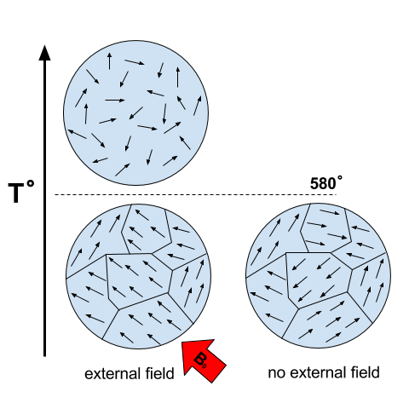

Magnetization acquired by cooling below the Curie temperature

A toy bar magnetic is a quintessential example of an object that has a remanent magnetization. If taken to outer space where there is no inducing field, it still posesses a magnetic field like that of a dipole. The acquisition of remanence occurs when a body with magnetic minerals cools through its Curie temperature. Above the Curie temperature thermal agitation prevents the elementary dipoles from aligning with the ambient magnetic field. As the material cools the magnetic particles can stay aligned and eventually lock into place in a domain structure. Each domain has all of its constituent dipoles locked into a single direction. This structure stays in place after the ambient field is removed and the object will have a net remanent magnetism. Some elements of the process are portrayed in magnetic_domains.

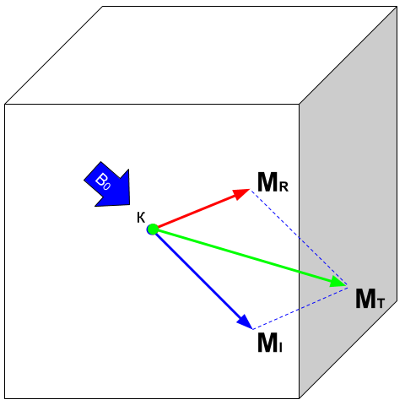

Components of magnetization

Remanent magnetization is very common in man-made objects and in rocks. UXO shows the magnetic signature of multiple UXO buried in a proving ground. Each has the signature of a dipole yet the data could not have been explained by induced magnetization of a set of compact objects. The orientation of the dipoles is too variable to be explained by that process. The proper understanding is that the magnetization of each UXO is composed of two parts: (a) An induced portion () and (b) remanent portion (). The net magnetization is:

as depicted in magnetization_components. The magnetic field due to the UXO must be evaluated with total_magnetization.

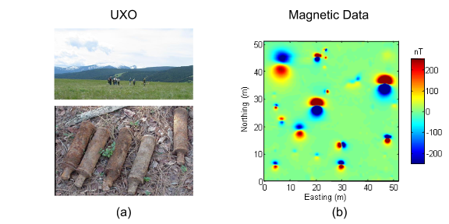

: (a) A typical UXO site. There is no surface indications of ordnance items. (b) Typical ordance items (c) Magnetic field data over a site contaminated with UXO.

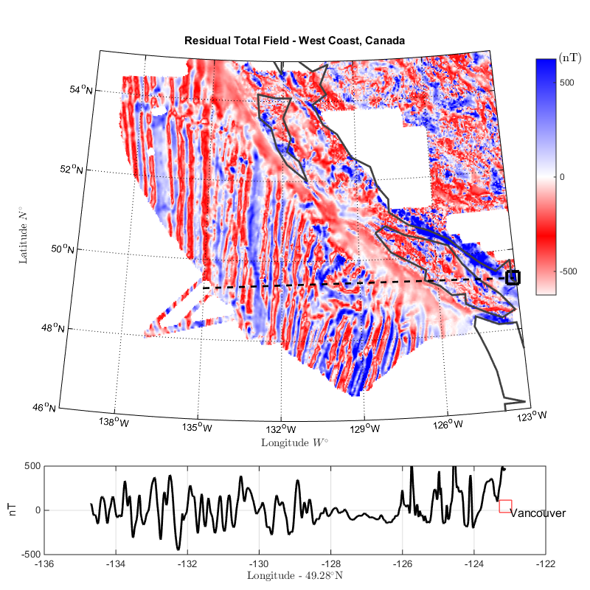

: Residual Total Field map over the West Coast of Canada. Profile data along the parallel N shows multiple reversal in crustal magnetism.

Rocks are also frequently magnetized. This is particularly true of magnetic rocks. An example that had large consequences in understanding our dynamic earth is shown in remanent_BC_coast. The is total field magnetic survey data off of the coast of British Columbia. The striped pattern of reversed polarity fields is the result of basaltic lavas erupting on the ocean bottom, cooling and aquiring a magnetization in the direction of Earth's field at that time. The fact that Earth's field periodically reverses in polarity, and that this was captured by the cooling lava, played a crucial role in the development of the theory of plate tectonics.

Similar to the previous animation, we now add a remanent component oriented east (x-axis) as presented in the dipole animation<magnetics_remanent_demo> below. Note that the remanent component is independent of the inducing direction and it substantially distorts the magnetic data compared to the purely induced response. Interpreting magnetic data affected by remanence remains a key challenge in exploration geophysics.

: Changing magnetic response () of a buried magnetic prism as a function of inducing field orientation with an added remanent component oriented along the x-axis ().

|  |
| --- |
|  |

Student exercise: Use the applet to explore the complicating effects of remanent magnetization on your prismatic body worked with previously.

# Approximating the response

Solving the integral in integral can be challenging for objects with complicated geometry as expected for geological structures. In many cases however the magnetic response of objects can be approximated by a dipole or summation of monopoles and dipoles. We elaborate upon these below.

## Fields due to a magnetic dipole

Understanding the magnetic fields of a buried dipole, and the resultant observations, is crucial because all real scenarios can be thought of as a combination (superposition) of dipoles (see Geological Features<magnetics_geological_feature> section).

If the object is "small", that is all of the object's dimensions are several times smaller than the depth to its center, then the object acts as a magnetic dipole<fields_magnetic_dipole> -- that is, a bar magnet. If the magnetization is purely induced then the direction of the dipole will be aligned with the inducing field. In fact, this is the reason why, when one gets sufficiently distant from the center of the earth, Earth's field looks like a dipole.

: Changing magnetic response () of a buried magnetic prism as a function of depth. The field is compared to a dipole with equivalent dipole moment and depth. Both responses are converging as the depth of burial increases.

|  |
| --- |
|  |

## Approximating targets using magnetic charges

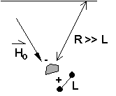

If the buried object has a complicated structure or the observer is very close to the magnetized object then it can no longer be represented as a single dipole. In magnetics_complex_structures<magnetics_complex_structures>, we will present a general method for computing the magnetic response from an arbitrary object but here we look at objects that have a uniform magnetic susceptibility. We introduce the concept of magnetic charge and show how this can be used to compute the response for some simple objects like a pipe or sheet.

First we begin with the concept of magnetic charges or poles. They can't be generated in practice. If you cut a small magnet in half, you will have two smaller dipole magnets. Let be a magnetic charge. It has units of Webers. The charge creates a magnetic field, that is given by

If is positive the field lines of extend radially outward in all directions as indicated by the drawing. If is negative the field lines have the same shape but they point toward the source.

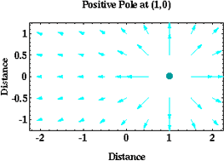

Magnetic field lines generated by a positive magnetic pole.

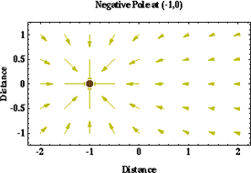

Magnetic field lines generated by a negative magnetic pole.

If a positive and negative charge are put in proximity they form a dipole and the field lines look like the diagram below.

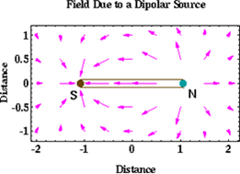

Magnetic field lines generated by a postive and negative pole which form a dipole.

If the distance between the two charges is then the dipole has a magnetic moment (units: ). As seen in the above figure the magnetic field inside of the body points from the positive pole to the negative pole. The dipole moment on the other hand extends from the negative(south) pole to the positive(north) pole. Formulae for the magnetic field in cylindrical or cartesian coordinates can be found in standard texts.

As an aside we notice that magnetic charges behave exactly as point electric charges. An important distinction is that electric particles can exist by themselves whereas magnetic charges always occur in pairs. The reason for this is that all magnetic fields fundamentally arise from currents.

Consider a magnetic field impinging upon a body of arbitrary shape and uniform susceptibility. In the interior of the body, the magnetic elements align themselves with the inducing field. The sketch below illustrates the process. Each cell becomes a dipole which can be represented by a plus and minus magnetic charge. At the interior boundaries, the effects of positive and negative charges cancel and the net result is that the magnetic field away from the body is effectively due to the negative magnetic charges on the top surface and the positive charges on the bottom. This greatly simplifies both computations and understanding.

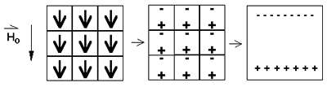

The resultant anomalous magnetic field can be thought of as being due to a distribution of magnetic poles on the surface of the body. Conceptually, a picture of the large scale effect can be drawn as shown here:

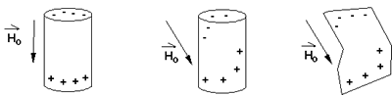

## Working with magnetic charges

The magnetization in a body of constant magnetic susceptibility is . As illustrated in the above diagram, the magnetic field outside the body can be represented as fields due to charges on the surface of the body. The surface charge density is given by

So the strength of the magnetic charges on the surface depends upon how the direction of the magnetic field is aligned with the boundary of the object. In the image above, there are charges on the top and bottom of the prism but there are no charges on the sides where the magnetic field is parallel to the boundary.

There are some circumstances in which the concept of magnetic charge greatly simplifies the problem. Consider a pipe, or vertical prism, and an incident magnetic field that is pointing down. The magnetization points vertically downward and is zero except at the two ends. At the top the charge density is and at the bottom it is . Suppose the pipe has a radius and thus an area . If the radius of the pipe is small compared to the distance from the observer then the effect is the same as if all of the charge was sitting at the top of the pipe at its center. The total charge on the face is the area (units ) times the charge density .

and the magnetic fields are like those given in equation B_from_Q and shown in Positive_magnetic_pole.

The same phenomenon is happening at the bottom of the pipe but there the charge is . At the surface the magnetic field is the sum of fields due to the two charges, but if the pipe is very long, then the contribution from the bottom of the pipe becomes negligible. The resultant observed field is effectively that due to a monopole, or point charge, of strength . This handy simplification often arises in practise.

The equation B_from_Q provides the anomalous magnetic field due to a charge of strength . This is a vector. When we measure the magnetic anomaly we measure one or more individual components of this field. The total field anomaly is the projection of the anomalous field onto the direction of the earth's field so the magnetic field anomaly over the pipe is

where is the depth of burial. Equivalently, if we substitute for the magnetic charge and write the expression using the earth's magnetic field then

## Geologic Features and representation for modeling

Some simplified geologic features that can be detected (and sometimes characterized) using magnetic data are shown below. They represent models of the true Earth, which provide useful first order understanding about structures and rock type distributions, in spite of being simplifications of the real earth.

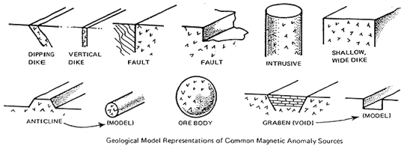

For each model, the concept of surface magnetic charges then permits evaluation of the fields; here are examples.

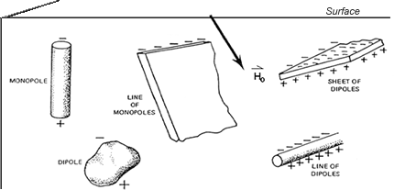

As seen in the figures, for these types of features the responses can represented as monopoles, dipoles, lines of dipoles, sheets of charges etc. This can help us understand what the magnetic response of such objects are. For instance a buried cylinder or rebar can be thought of as a line of dipoles. Sometimes field data are interpreted using these simple approximations. There are numerous parametric inversion algorithms that have been generated to accomplish this.

Some images on this page adapted from "Applications manual for portable magnetometers" by S. Breiner, 1999, Geometrics 2190 Fortune Drive San Jose, California 95131 U.S.A.