Node design (visual encoding by role)
Node type | Shape | Color | Size encodes
User / endpoint host | Circle | Blue | Number of active flows
Router / switch / gateway | Diamond or hexagon | Gray | Traffic volume passing through
Server (internal asset) | Square | Teal | Criticality (DB, auth server = bigger)
External / internet node | Cloud shape | Coral | —
Compromised / high-risk node | Same shape + red glow ring or pulsing border | Red overlay | Infiltration probability score
Keep shape as the primary role encoding (works even in grayscale/print) and color as a secondary cue — that also leaves color free to double-encode risk (a node's fill can shift from gray→amber→red as its predicted compromise probability rises over time, which is a nice way to show your world model's forward simulation directly on the graph).

Edge design (communication channels)
Encode protocol/channel type with color + dash pattern together (never color alone, per your dashboard's explainability requirement):
- HTTP/HTTPS — solid teal line
- SSH/RDP (admin/lateral-movement-relevant) — solid amber, slightly thicker (these are the interesting ones for kill-chain tracking)
- DNS — dotted gray
- Internal TCP (generic) — solid gray, thin
- UDP — dashed green
- Flagged/suspicious flow (scan pattern, anomalous SYN behavior, matches attack-stage signature) — dashed red, thicker, optionally animated (marching dashes) so it visually stands out as "live threat"
Additional edge encodings:
- Thickness = bytes transferred or packet count (log-scaled)
- Opacity = recency (fresher flows fully opaque, older ones fade)
- Arrowhead direction = flow direction; use a double-line or two arrowheads for bidirectional

Hover tooltips
On an edge — this is where most of your flow/packet features surface:
- Src IP:port → Dst IP:port, protocol
- TCP flags present (SYN/ACK/FIN/RST/PSH/URG)
- Bytes & packets transferred, flow duration
- IAT stats (mean/variance/max)
- Retransmission count, TTL variance (if packet-level available)
- Model's infiltration-contribution score for this edge (attention weight or SHAP value) — this is your explainability requirement satisfied directly in the graph
- Mapped MITRE ATT&CK stage if flagged (e.g., "Reconnaissance — port scan signature")
On a node:
- Hostname/IP, role (user/router/server), OS/service if known
- Current predicted state (benign / at-risk / compromised) with probability
- Active flow count, in/out traffic volume
- Top contributing neighbor edges to its risk score
Let me sketch the legend and a small example graph so you can see how this reads visually.
V
visualize
V
visualize show_widget
A few implementation notes for building this for real:
- Library: for the actual dashboard, use Cytoscape.js or vis-network rather than raw SVG — you need force-directed layout, click/hover events, and real-time updates as new flow windows arrive. Cytoscape has native support for edge dash-patterns, arrow styles, and data-driven styling (mapData() for thickness/opacity), which maps directly onto the encoding above.
- Risk pulsing: animate a node's border color/opacity based on its live infiltration-probability score — this turns the static "attack progression timeline" requirement into something visible directly on the topology, not just a separate chart.
- Time scrubbing: since your dashboard needs an "attack progression / timeline" section anyway, add a time slider above the graph that replays the K-step forward simulation — nodes/edges light up in sequence as predicted stages (recon → lateral movement → C2) unfold. This single graph view can satisfy 3 of your 4 "core requirement" dashboard sections (network overview, attack progression, flagged traffic) if done well.
- Performance: for CIC-IDS-2018 scale (millions of flows), don't render every flow as an edge — aggregate by (src, dst, protocol) pair per time window and only surface individual flows in the hover tooltip or a side panel on click.
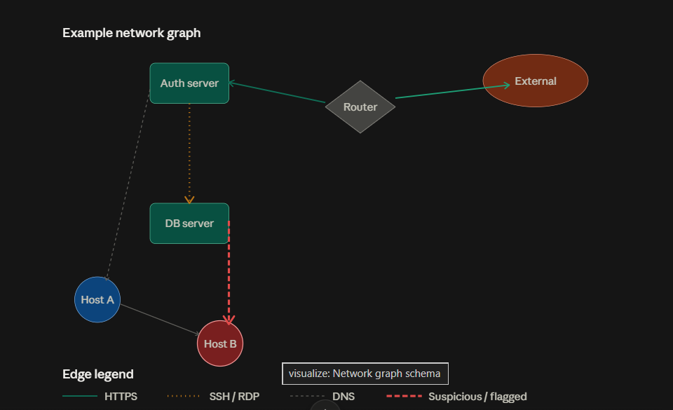
Flagged flow
That's the pattern: a flagged flow gets a distinct edge treatment (thicker, dashed red) plus a badge marker at its midpoint so it's spottable even when zoomed out or when many edges overlap, and clicking/hovering it opens a detail panel with the model's reasoning.
A few things worth deciding explicitly:
- Severity tiers, not just binary flagged/clean. Use the infiltration-probability score to pick the shade: amber for "elevated" (0.4–0.7), red for "high confidence" (0.7+). A single hard cutoff throws away information your world model is specifically designed to produce.
- Badge vs. full edge styling — for a busy graph with hundreds of edges, don't turn every flagged edge fully red/thick; that gets noisy fast. Consider: normal edges stay muted gray/thin, and only flagged edges get color + the badge. This makes threats pop instead of fighting for attention with benign traffic.
- Persistence across time steps — if you're doing the K-step rollout, a flow that stays flagged across multiple predicted windows should visually accumulate (e.g., pulsing animation, or a small counter badge "flagged 3 consecutive windows") since sustained progression is more actionable than a single-window blip.
- Click vs. hover — hover for the quick glance (probability + stage), click/pin for the full explainability panel (SHAP/attention breakdown), since your grader will want to see you didn't bury the explainability requirement one layer too deep.
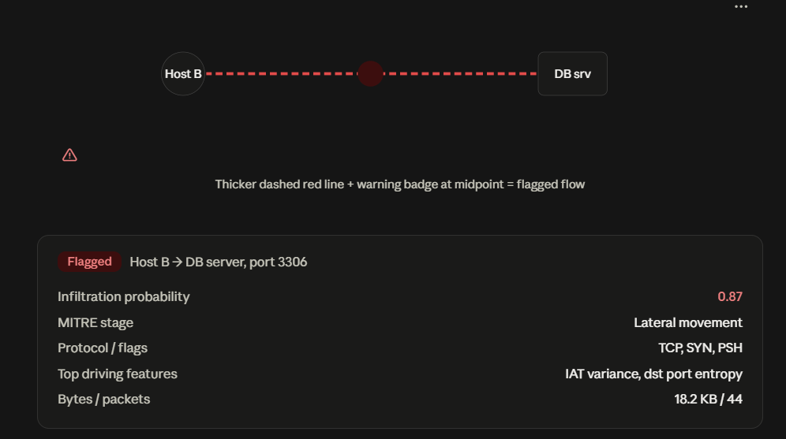
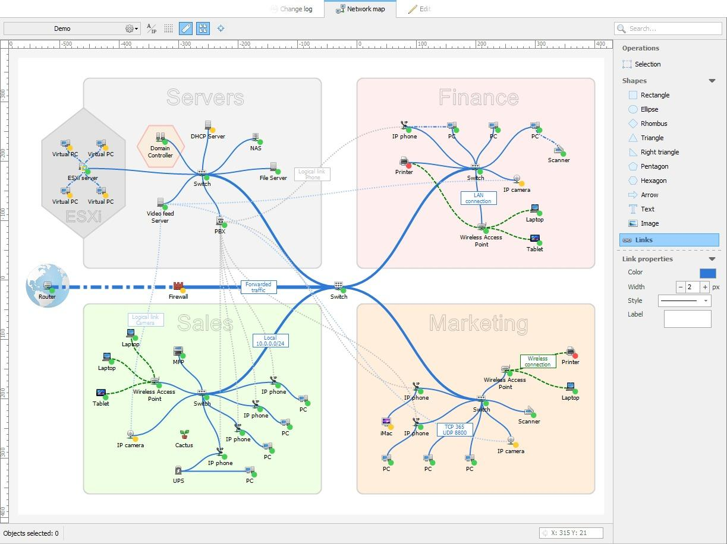
Yes — that reference image is a classic subnet-grouped topology map (looks like it's from a tool like Netbrain, LanTopoLog, or ManageEngine). You can absolutely replicate this style and it actually works better for your world-model dashboard than a flat force-directed graph, because subnet grouping gives defenders immediate context ("the attack is inside Finance, hasn't reached Servers yet").
Here's how the pieces map onto your project:
Subnet grouping → colored translucent background regions (like their gray "Servers", pink "Finance", green "Sales" zones), each containing a switch/AP hub with devices fanning off it. This is a compound/parent node pattern, not just visual grouping — cluster nodes by VLAN or subnet CIDR so the layout engine keeps them together automatically.
Device icons → swap your plain circles/squares for small icon glyphs (PC, IP phone, camera, AP, switch, firewall) like they've done — much faster to scan than shape+color alone at this density.
Link styling (this is the part most relevant to your dataset):
- Solid blue = wired/switch uplink
- Dashed green = wireless
- Dotted gray = logical link (e.g., "Logical link Phone" in their image — a VLAN trunk or virtual association, not a physical wire)
- Thickness = trunk/uplink importance (their inter-switch backbone links are visibly thicker)
Let me mock up your version — subnets as zones, with your flagged-flow overlay layered on top of this style so it's clear the two systems compose.
