- WAP on method overriding on Inheritance to display the name of the city.
Steps:
- Create a new project, select console application from the template and name the project as “InheritanceOverride.cs”.

- Create a class as “CityBaseClass” and “CityDerivedClass” .
- Allow the derived class to override a method of the base class using virtual methods or Abstract methods.
- Create the instance of the “CityDerivedClass” class in the main class, access the methods and print the values

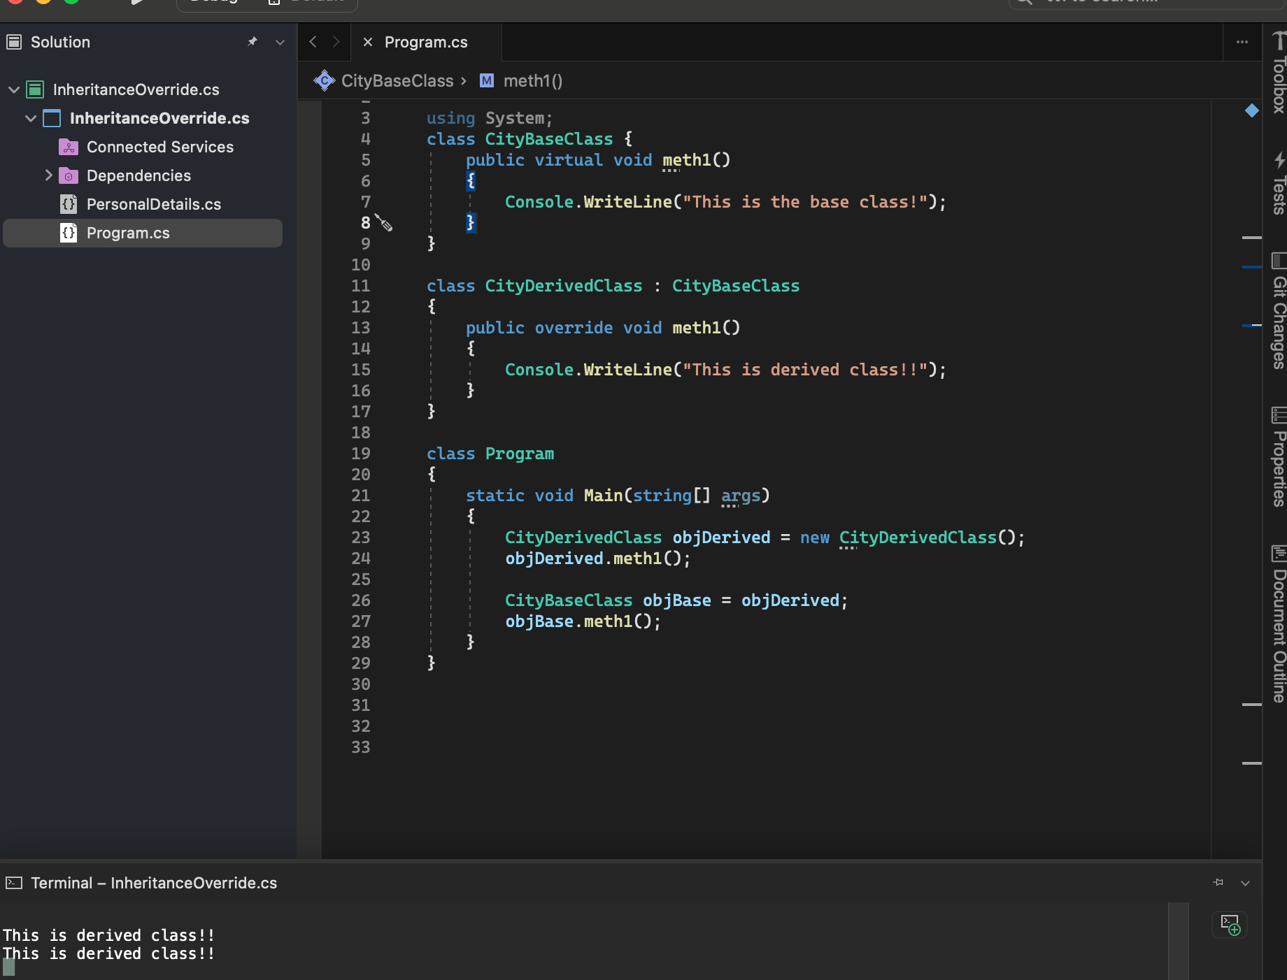
- Wap on Generic collection. Create a list of PersonalDetails and print all the items in the list, filtering the list using the condition(Age>35), Sort the List(T) on FirstName, Add new List(T) to the existing List(T), Remove male employees from the List(T)
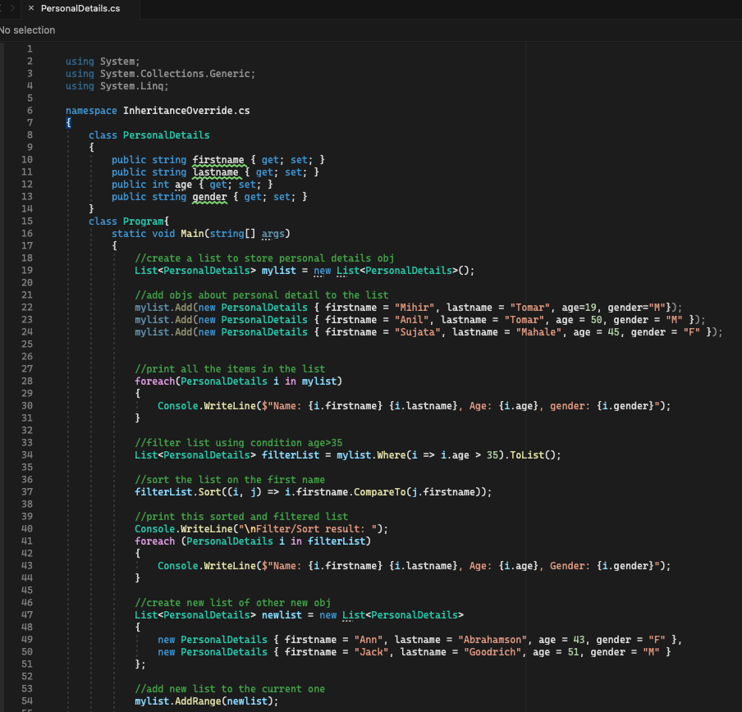
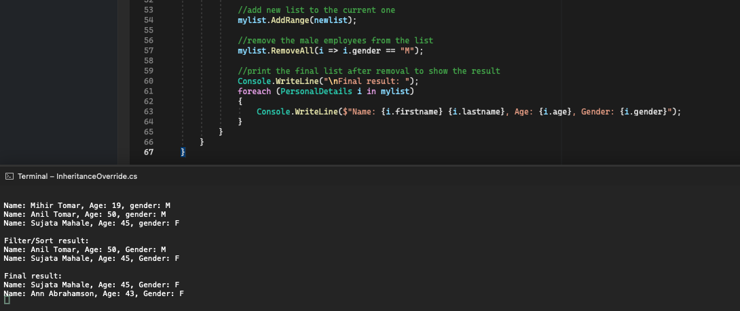

- Wap to display the Employee details using collections.
This is a console application to print the employee details using collections.
Steps:
- Create a new console application project named CollectionDemoConApp.
- Above the main class, write the below class.
public class Employee
{
public Employee(int id, string name)
{
EmpId = id;
EmpName = name;
}

private int _EmpId;

public int EmpId
{
get { return _EmpId; }
set { _EmpId = value; }
}

private string _EmpName;

public string EmpName
{
get { return _EmpName; }
set { _EmpName = value; }
}
}

In the main class , write the code to

Add 5 Employee records using a dictionary and Print all of them
//Here the Dictionary is defined by int as key and Employee class as the
value.
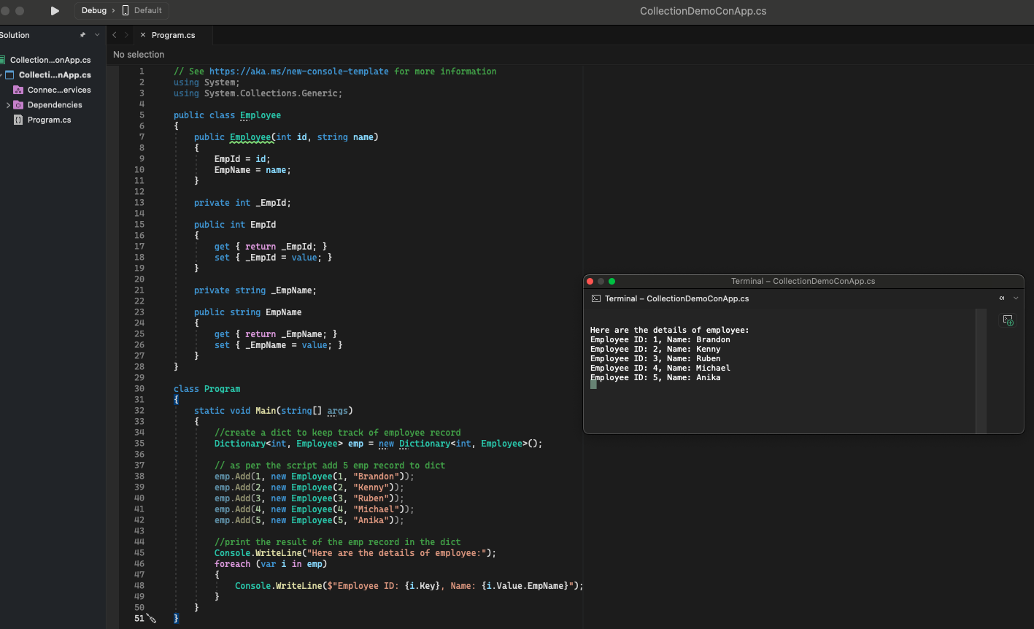
- Review all examples in the folder and practice each example by creating and writing the project individually.

