

A

PROJECT REPORT

ON

**SMART DUSTBIN USING CLOUD COMPUTING & IOT**

**“SmartBin”**

SUBMITTED BY

**RITESH SRIVASTAV (29) - 12020002017032**

**UMESH RAJ (25) - 12020002017027**

**MOHIT KUMAR (33) - 12020002017036**

**ASHUTOSH RAI (31) - 12020002017034**

**Under the Guidance of:**

**Prof. Abhijit Bose**

**Prof. Lopa Mandal**

**Prof. Kajari Sur**

For Partial Fulfilment of the Requirements for Bachelor’s of Technology in

CSE (IOTCSBT) .



**_____________________________________________**

**CERTIFICATE OF APPROVAL**

This is to certify that the project work entitled **SMART DUSTBIN USING CLOUD COMPUTING & IOT** has been successfully carried out BY **RITESH SRIVASTAV**, **UMESH RAJ**, **MOHIT KUMAR** and **ASHUTOSH RAI** for the subject **CLOUD COMPUTING & IOT Lab** during the academic year 2022-23, Semester-VI for partial fulfilment of Bachelor’s of Technology in CSE (IOTCSBT). The work carried out during the semester is satisfactory.

Signature: Signature: Name: Name:

(Research Co-guide) (Research Guide)

Signature: Signature: Signature:

Name: Name: Name:

(Research In-charge) (HOD, CSE IOTCSBT) (Principal)

________________________________________________________________

**ACKNOWLEDGEMENT**

We would like to extend our sincere regards & express our gratitude to our teachers who encouraged us for making this project & report which helped us in preparing this detailed research work and we came to know about so many new things, we are really thankful to them because without their guidance, it would not have been possible.

**Table Of Contents**

|  |  |  |
| --- | --- | --- |
| S. No. | Contents | Page No. |
| 1 | ABSTRACT | 5 |
| 2 | INTRODUCTION | 6 |
| 3 | PROBLEMS | 8 |
| 4 | LITERATURE SURVEY | 9 |
| 5 | FLOWCHART & WORKFLOW | 10 |
| 6 | HARDWARE & SOFTWARE | 12 |
| 7 | CODE ON THE ARDUINO | 14 |
| 8 | SNAPSHOT OF THE BLYNK APP | 16 |
| 9 | USABILITY ANALYSIS | 17 |
| 10 | CONCLUSION | 18 |
| 11 | REFERENCES & BIBLIOGRAPHY | 18 |

**ABSTRACT**

We are living in an age where tasks and systems are fusing together with the power of IOT to have a more efficient system of working and to execute jobs quickly! With all the power at our finger tips this is what we have come up with.

The Internet of Things (IoT) shall be able to incorporate transparently and seamlessly a large number of different systems, while providing data for millions of people to use and capitalize. Building a general architecture for the IoT is hence a very complex task, mainly because of the extremely large variety of devices, link layer technologies, and services that may be involved in such a system.

One of the main concerns with our environment has been solid waste management which impacts the health and environment of our society. The detection, monitoring and management of wastes is one of the primary problems of the present era. The traditional way of manually monitoring the wastes in waste bins is a cumbersome process and utilizes more human effort, time and cost which can easily be avoided with our present technologies.

**INTRODUCTION**

IoT stands for Internet of Things & is described as the use of embedded devices to link physical stuff electronic sensor and the software that is enables these devices to send and receive data from one another. By connecting physical devices to the internet, the IOT accomplishes sensing, data collection, storage, and processing.

In this paper, we will design a system to collect waste from time to time, and if that is not possible, we will attach one mechanism to it for urgent purposes. The dustbin has enough space for another two days due to the mechanism. Waste management is primarily handled by municipal committees in Indian cities. When the rubbish containers full up, we employ ultrasonic sensors to detect the inflow. When the garbage bins fill up, sensors that use ultrasonic waves are accustomed towards indicate the level of garbage in the bins. The sensor would be installed on top of the bin, allowing the municipal committee to be notified when the rubbish level had reached its highest level. Dustbin shall be then collected as quickly and efficiently as possible after that.

We live in a time when with the potential of IoT, jobs and systems are merging well together create an extra effective working systems and the to complete things faster! These are what’s we've keep coming up with everything of the strength that is right at our fingers. The IoT means Internet of things will have the ability to integrate a vast number of diverse systems in a transparent and seamless manner, while also giving information that will be used by millions of individuals profit from. Constructing a generic The Internet of Things (IoT) architectural design is thus a tough task endeavour, owing to enormous number a collection of gadgets, connection layer technology, and service could become a part of this kind of network.

0ne of our key environmental problems has always been the handling of household waste, which seems to have a negative influence on our society's well- being ecology. One of most pressing issues of our time is the identification, monitoring, and management of trash. The conventional method of visually checking waste in the dustbin is a time-consuming processes that requires too much human work, the passage of time, money, all of this may be prevented by using today's technology. That's also everyone’s situation answer, a trash management company system that are fully automating. That’s also everyone’s situation Internet of Things an innovative trash tracking system solution to keep cities clean and healthy. The key to a "Smart City" is the most pressing necessity of the hour for a developing country. Hazardous pollution and its ensuing repercussions on humanity's health, increasing global warming, and ozone layer depletion are some of the ecological issues that pose a threat to this. Municipal Solid Leftovers (MSL) are likely to be the source of most environmental pollution. For just a quick and painless clearance of all the created Municipality waste solid bins, proper maintenance is required. Trash can be any unwanted stuff scraps out of the public zone, society, college, home, cities and so on. It is an academic article associated with the concept of a "smart world" is according to the IOT means “Internet of Things”. Such, in order to live a wonderful life, tidiness is essential, and tidiness begins with the waste can. This venture will aid in the elimination of the trash disposal problem. The Internet of Things is a new correspondence worldview that envisions a not-too-distant future in which everyday objects will be outfitted with microcontrollers, advanced communication handsets, and reasonable convention stacks that will enable them to communicate with one another and with clients, transforming them into a basic piece of the Internet. This project will provide an IoT Garbage Monitoring Framework to help keep metropolitan areas clean.

**PROBLEMS**

A large number there’ve been a lot of apartments and flats built erected even in fast-paced urbanisation areas in recent years. This is owing to strong housing demand, which has skyrocketed as both a consequence people migrating from rural to city in search of works. The government has also built new complexes of apartments to serve expanding the urban population region. The people that live in the apartments are dealing with a number of challenges. Solid waste disposal is one of them. Unlike in individual homes, all occupants of the apartments share a shared trash can, which soon fills up. Garbage overflow is a sanitary hazard that could lead to illnesses such as dengue fever and cholera fever. Furthermore, this is a waste of time and energy to do so drive surrounding a building or a location only discover now that is some rubbish can is full & others are not really the case. On rare occasions, there may be issues with the truck's capacity due to a large amount of rubbish. The idea came to while we're together noticed that perhaps the cube van is used through run all throughout region twice a day collecting solid waste. Although this approaches were comprehensive, it had been ineffective. Let's pretend that street A is a major thoroughfare, and we're on it notice the fact that rubbish bin fill ups quickly, whilst street B's bins aren’t even when half-full after two days. It is a prime illustration based on real-life events, which led to the moment of “Swatch Bharat Abhiyan ”.

**LITERATURE SURVEY**

* “Smart City Dustbins: A Comprehensive Review of Technology and Innovation in Waste Management” by Ruchita Gupta and Kritika Vyas – This review article provides an overview of the technologies and innovations used in smart city dustbins, including sensors such as ultrasonic sensors, infrared sensors, and fill-level sensors, and the use of cloud computing for data storage and analysis.
* “Smart Dustbins in Smart Cities: Challenges and Opportunities” by Sanjay Kumar, Arvind Kumar Sharma, and M. P. Gupta – This review article explores the challenges and opportunities of implementing smart city dustbins in urban areas, including the use of sensors such as weight sensors, proximity sensors, and temperature sensors, and the use of cloud computing for real-time data monitoring.
* “Smart Waste Management: A Review of Smart City Dustbins and Their Role in Sustainable Development” by Md. Rakibul Islam, Laila Arjumand Banu, and Sheikh Muhammad Allayear – This review article discusses the role of smart city dustbins in achieving sustainable development goals, including the use of sensors such as fill-level sensors, temperature sensors, and gas sensors, and the use of cloud computing for data management and analysis.
* “Smart Dustbins for Clean and Green Cities: A Review of Recent Developments and Future Directions” by Abhijeet Kumar Singh, Amarjeet Kaur, and Akashdeep Singh – This review article examines recent developments in smart dustbin technology and discusses potential future directions, including the use of sensors such as ultrasonic sensors, fill-level sensors, and gas sensors, and the use of cloud computing for real-time data monitoring and analytics.

**FLOWCHART & WORKFLOW**

This IoT project idea uses an ultrasonic sensor to detect the level of garbage in each garbage bin and send those data to the main IoT program. A webpage shows the level of garbage on each garbage bin and highlights the amount of garbage on each bin. A buzzer puts on when garbage is over the limit.

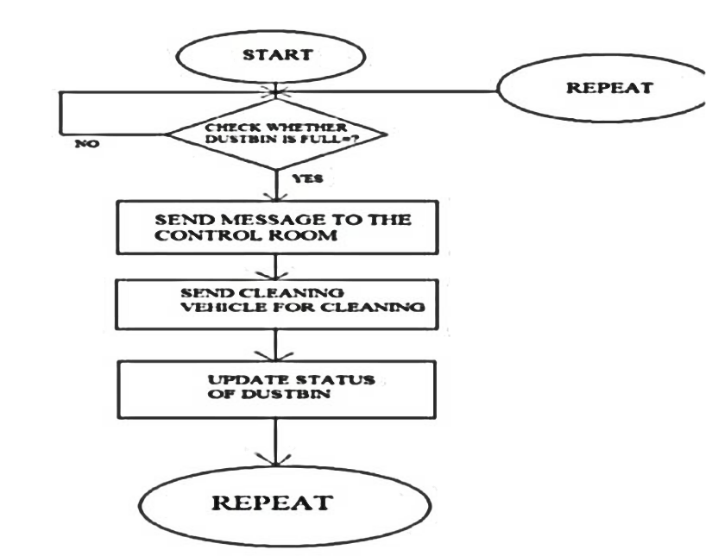

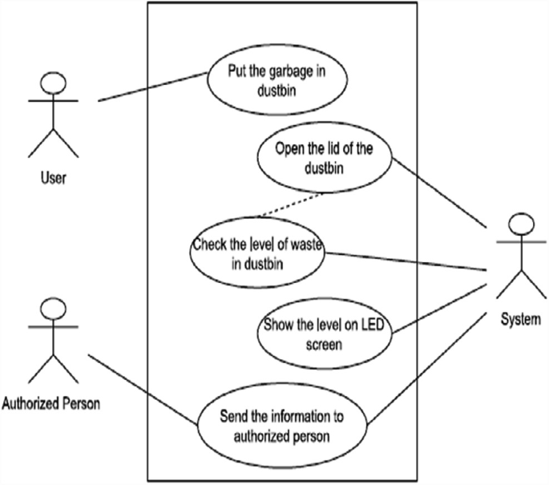

**HARDWARE:**

* 2 x AA Batteries ( Gearbest) these batteries will power the Arduino board
* Plastic Container (Gearbest) I found an old plastic container in which all the components could fit. The box is important as you can easily access the components and it's waterproof.
* Battery Holder Case (Gearbest)
* Ultrasonic Sensor (Gearbest) An ultrasonic sensor measures distance. It will be attached to the lid indicating the quantity of trash. Our system's key component.
* Jumper Wires (Gearbest)
* Arduino MKR1000 (Amazon) The center piece is one of Arduino's latest micro-controller, which simplifies the task of connecting to the Internet using prebuilt libraries that can be downloaded.
* White Spray Paint Turn your regular box into a more professional product

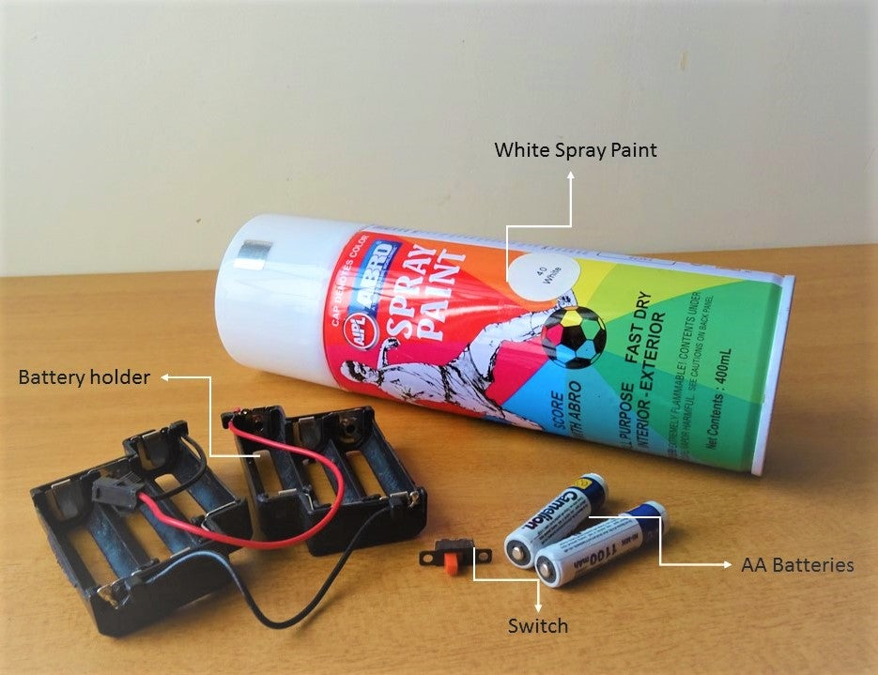

**TOOLS:**

* Electric Drill (Gearbest)
* Hot Glue Gun (Gearbest)

**SOFTWARE:**

* Arduino IDE
* Blynk An android app that allows communication with WiFi compatible micro-controllers.

Quick word about Gearbest, you can find all products especially for hobbyists.Cheap and good quality highly recommended, do check them out!

**CODE FOR THE ARDUINO:**

#define BLYNK_TEMPLATE_ID “TMPL3j02LCgaw”

#define BLYNK_TEMPLATE_NAME “Smart”

#define BLYNK_AUTH_TOKEN “nLlqFGkHvuRRSf8AlOS2g372DzLABNKX”

#define BLYNK_PRINT Serial

#include <WiFi.h>

#include <WiFiClient.h>

#include <BlynkSimpleEsp32.h>

Char auth[] = BLYNK_AUTH_TOKEN;

Char ssid[] = “Home_2G”;

Char pass[] = “iem@aiml”;

BlynkTimer timer;

#define echoPin 32

#define trigPin 33

#include<ESP32Servo.h>

Servo servo;

Long duration;

Int distance;

Int binLevel=0;

Void SMESensor()

{

Int ir=digitalRead(34);

If(ir==HIGH)

{

Servo.write(180);

For(int i=0; i<50; i++)

{

Blynk.virtualWrite(V2, 90);

Ultrasonic();

Delay(25);

}

Servo.write(0);

Blynk.virtualWrite(V2, 0);

}

If(ir==LOW)

{

Ultrasonic();

Delay(20);

}

}

Void ultrasonic()

{

digitalWrite(trigPin, LOW);

delayMicroseconds(2);

digitalWrite(trigPin, HIGH);

delayMicroseconds(10);

digitalWrite(trigPin, LOW);

duration = pulseIn(echoPin, HIGH);

distance = duration * 0.034 / 2; //formula to calculate the distance for ultrasonic sensor

binLevel=map(distance, 21, 0, 0,100); // ADJUST BIN HEIGHT HERE

Blynk.virtualWrite(V0, distance);

Blynk.virtualWrite(V1, binLevel);

}

Void setup()

{

Serial.begin(9600);

Servo.attach(13);

pinMode(34, INPUT);

pinMode(trigPin, OUTPUT);

pinMode(echoPin, INPUT);

Blynk.begin(auth, ssid, pass, “blynk.cloud”, 80);

Delay(200);

Timer.setInterval(1000L, SMESensor);

}

Void loop()

{

Blynk.run();

Timer.run();

}

**SNAPSHOT OF THE BLYNK APP:**

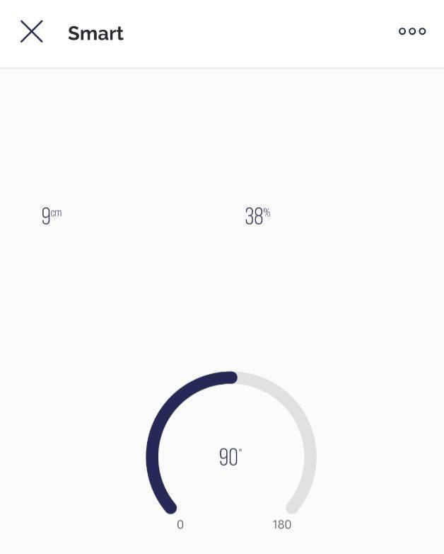

**USABILITY ANALYSIS:**

Usability factors;

* 1. User interface:

The mobile app’s user interface should be intuitive and easy to navigate. Users should be able to access the main features of the app with minimal effort, such as checking the dustbin’s status, controlling the dustbin’s functions, and setting up notifications. The app should also provide clear and concise information about the dustbin’s status, such as whether it needs to be emptied.

* 1. Functionality:

The app should have all the necessary functions for controlling and monitoring the smart dustbin. Users should be able to open and close the lid of the dustbin, set up alerts for when the dustbin is full, and monitor the dustbin’s status in real-time. The app should also have a user manual that explains how to use all the features of the dustbin.

* 1. Connectivity:

The app should connect to the smart dustbin easily and reliably. It should have a strong Wi-Fi signal and be able to transmit data quickly and efficiently. Users should also be able to access the dustbin’s data from anywhere with an internet connection.

* 1. Accessibility:

The app should be accessible to all users, including those with disabilities. It should have features such as text-to-speech and high-contrast modes that make it easy for users with visual or hearing impairments to use the app.

* 1. Security:

The app should have robust security measures in place to protect users’ data and privacy. It should use encryption to secure data transmissions and have measures in place to prevent unauthorized access to the app.

Overall, a smart dustbin enabled with cloud and controlled by a mobile app should be easy to use, functional, and secure. By considering these usability factors, you can ensure that your product is accessible and user-friendly for a wide range of users.

**CONCLUSION:**

In conclusion, the smart dustbin enabled with cloud and app control is a significant technological innovation that promises to revolutionize waste management. With the ability to automatically sort and compact waste, as well as providing real-time information on waste levels and collection schedules, this system offers a more efficient and effective solution to the challenges of waste management. The app control feature provides convenience and ease of use to the users, enabling them to monitor the status of the dustbin and schedule waste collections from the comfort of their mobile devices. This technology has the potential to reduce waste overflow and improve sanitation in cities and towns, ultimately leading to a cleaner and healthier environment. The adoption of this smart dustbin technology is a step towards a more sustainable future, and it is encouraging to see such innovative solutions being developed to tackle the pressing issue of waste management.

***REFERENCES & BIBLIOGRAPHY:***

* Ghose, M. K., Dikshit, A. K., & Sharma, S. K. (2006). A GIS based transportation model for solid waste disposal—A case study on Asansol municipality. Journal of Waste Management, 26(11), 1287–1293.
* Medvedev, A., Fedchenkov, P., Zaslavsky, A. (2012). Waste management as an IoT enabled service in smart cities. Springer.
* Prabu, P. (2016). IoT based waste management for smart city. IJRCCE, 4(2).
* Navghane, S. S., Killedar, M. S., Dr. & Rohokale, V. M. (2016). IoT based smart garbage and waste collection bin. IJARECE, 5(5).