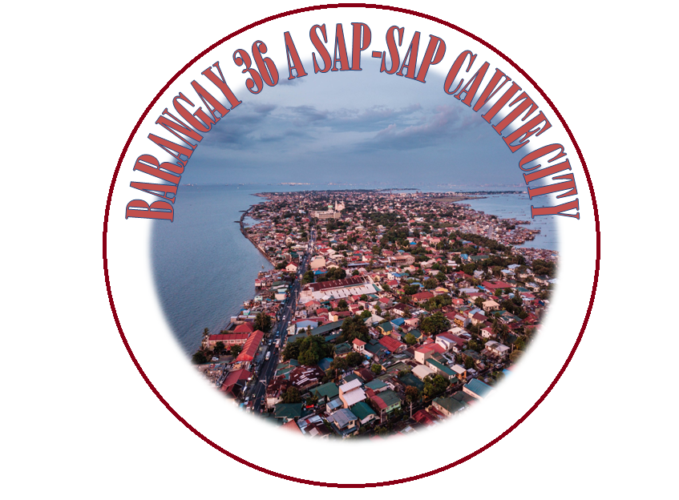

**EFREN ENRIQUEZ**

BARANGAY CAPTAIN



**ROBERTO SALVADOR**

(Committee on Sports)

**TERESA DE GUZMAN**

(Committee on Finance)

**LOIDA ARCIAGA**

(Committee on Disaster )

**GLAIZA MERCADO**

(Committee on Health/education)

**ARNOLD GAJUM**

(Committee on Peace and Order)

**THELMA MAPALO**

(Committee on Cleanliness and Beautification)

**RIZALYN MORO**

(Committee on Public Work)

**JONALYN MAPALO**

(Barangay Secretary)

**JHOANNA RODRIGUEZ**

(Barangay Treasurer)

**LIWAYWAY SANTIAGO**

(B.R.K)

***Barangay Councilors:***

**JONIEL N.MEJORADA** SK CHAIRMAN

**EFREN ENRIQUEZ**

**Barangay Captain**

**This is to certify that SHEENA MAE M. DIAZ is a resident of** **1253 YAGIT St.Caridad,Cavite** **City,Barangay 36 - A SAPSAP is a FIRE VICTIM last January 23,2016**

**This certification is being issued upon request of the interested party for any purpose it may serve him/her best.**

**Issued this_25_ day of _July___, 2018.**