Misc Lab1
3220102732 周伟战
Task1
1.1复现6种乱码情况
- 用 GBK 解码 UTF-8 编码的文本
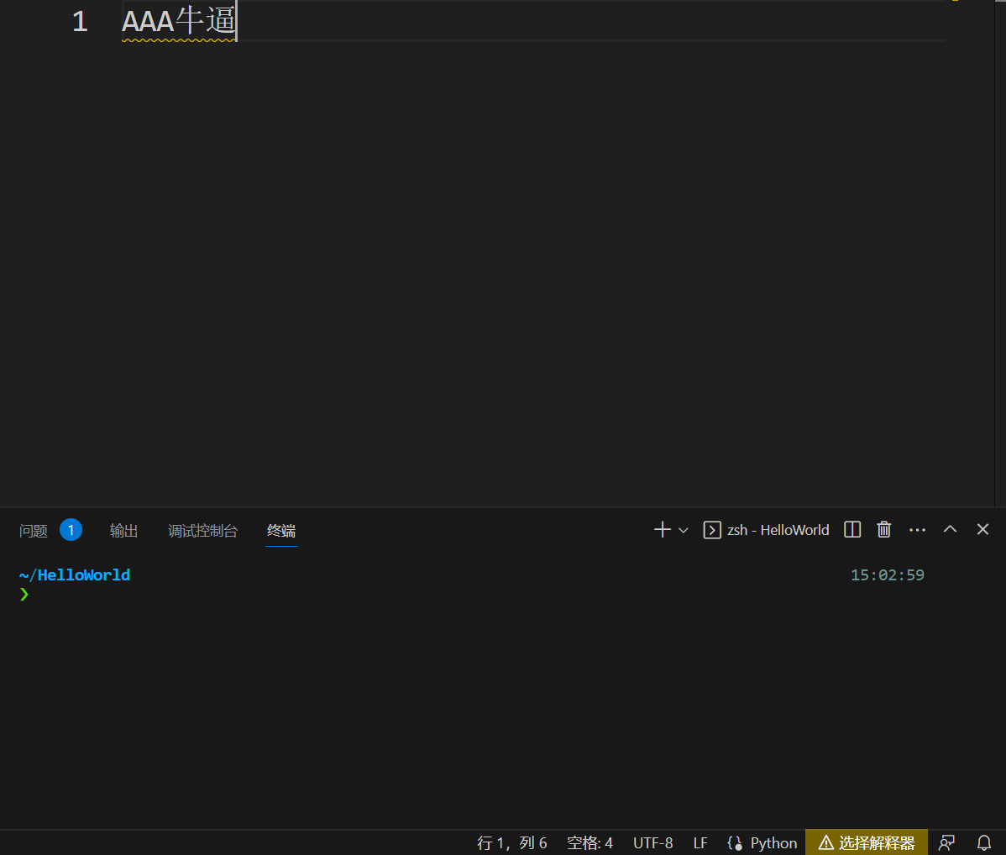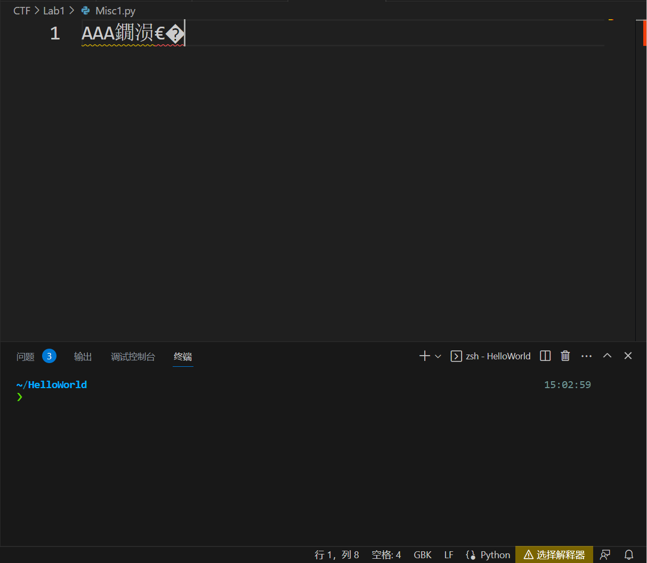
- 用 UTF-8 解码 GBK 编码的文本
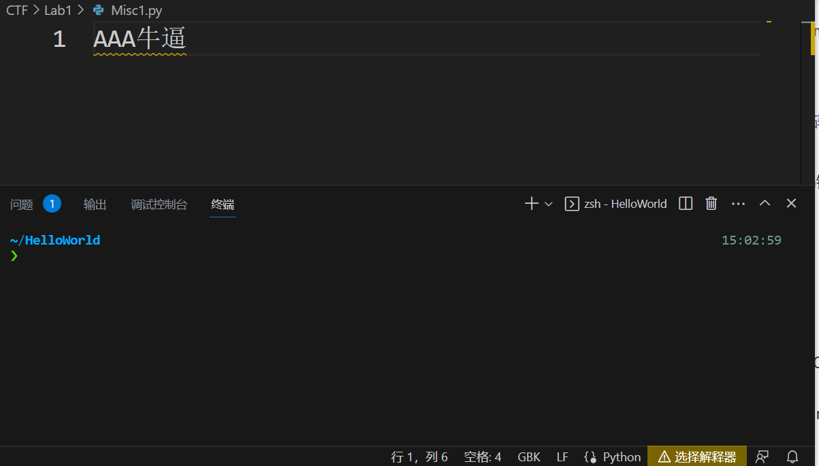
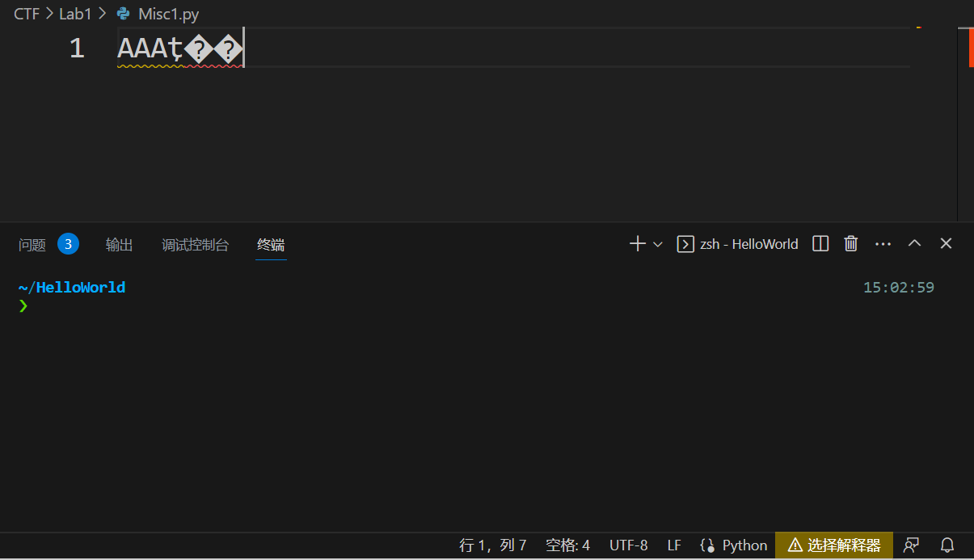

- 用 latin-1 解码 UTF-8 编码的文本
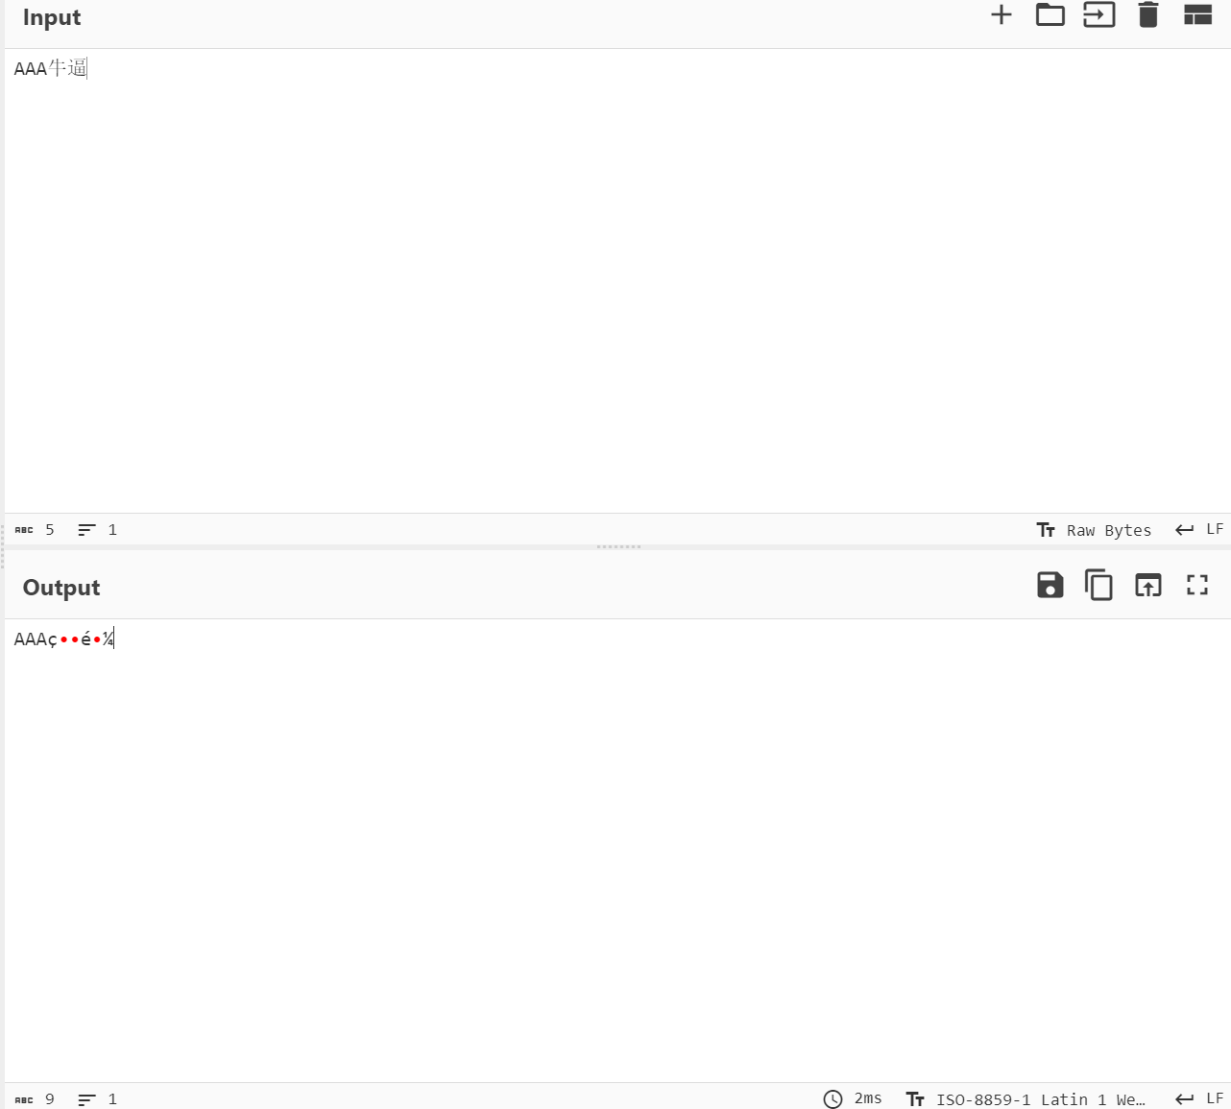
- 用 latin-1 解码 GBK 编码的文本
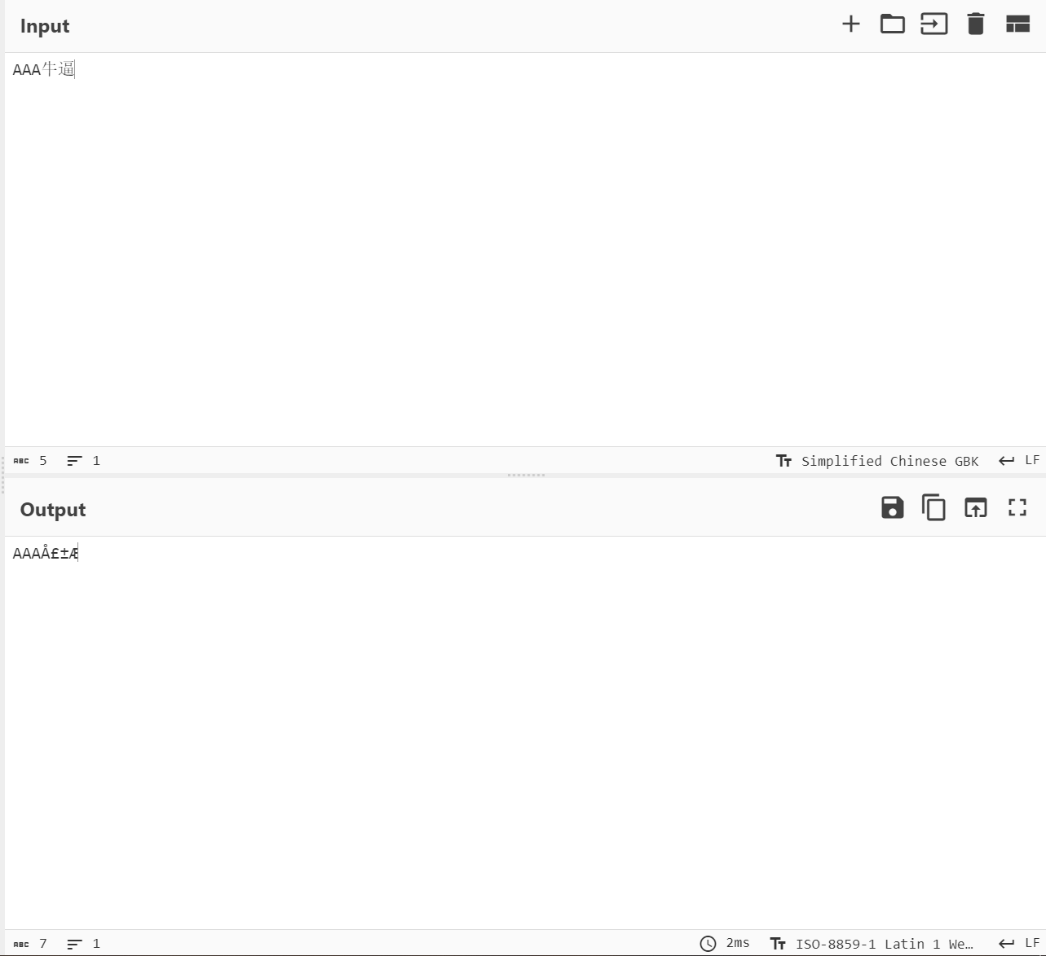

- 先用 GBK 解码 UTF-8 编码的文本，再用 UTF-8 解码前面的结果
UTF-8的原码
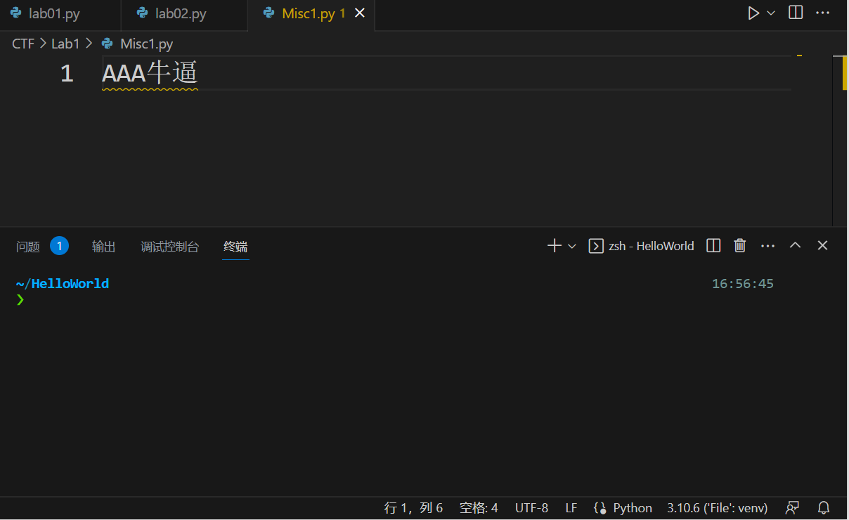
通过GBK重新打开后解码
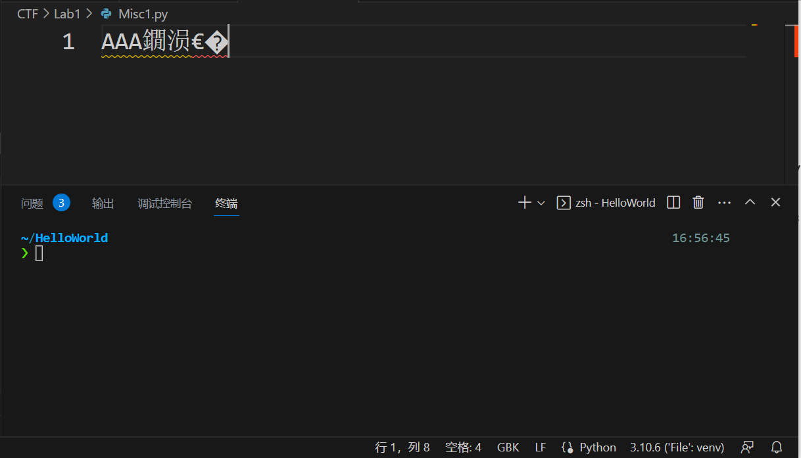
然后再保存后重新利用UTF-8打开
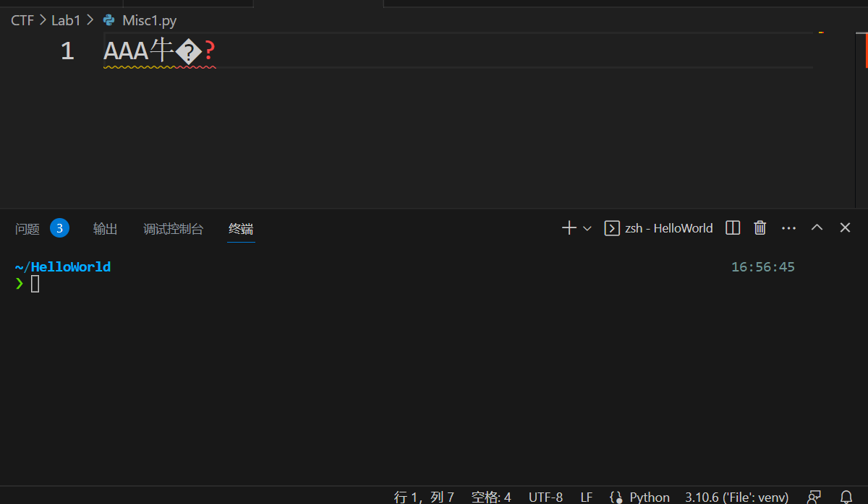
- 先用 UTF-8 解码 GBK 编码的文本，再用 GBK 解码前面的结果
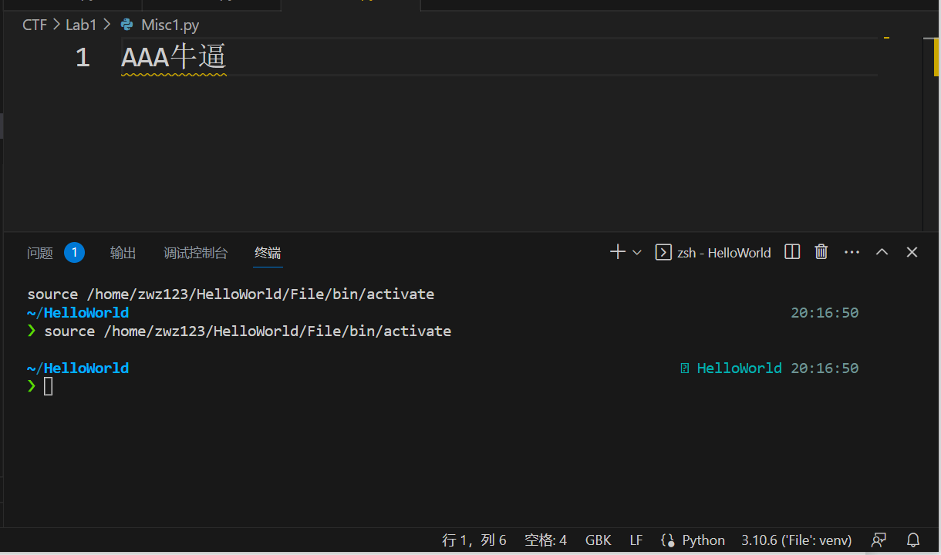

再重新用UTF-8编码打开该GBK文件
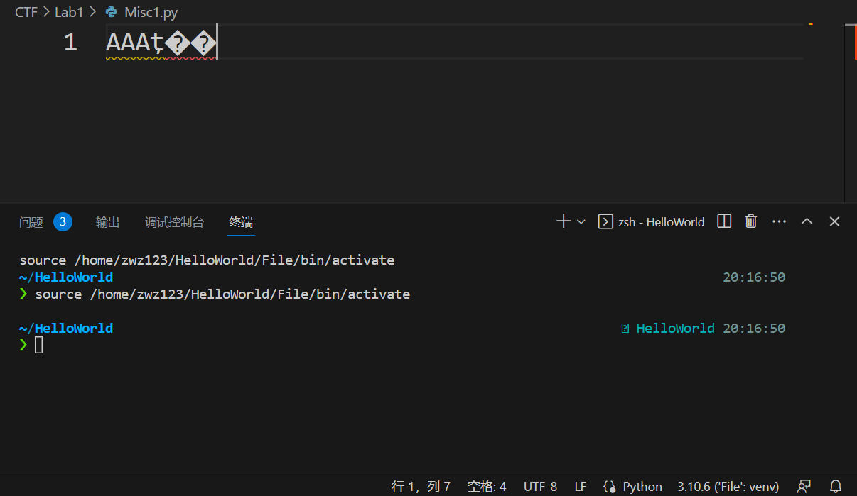
再进行重新编码保存，并用GBK重新打开得到AAA牛锟斤拷
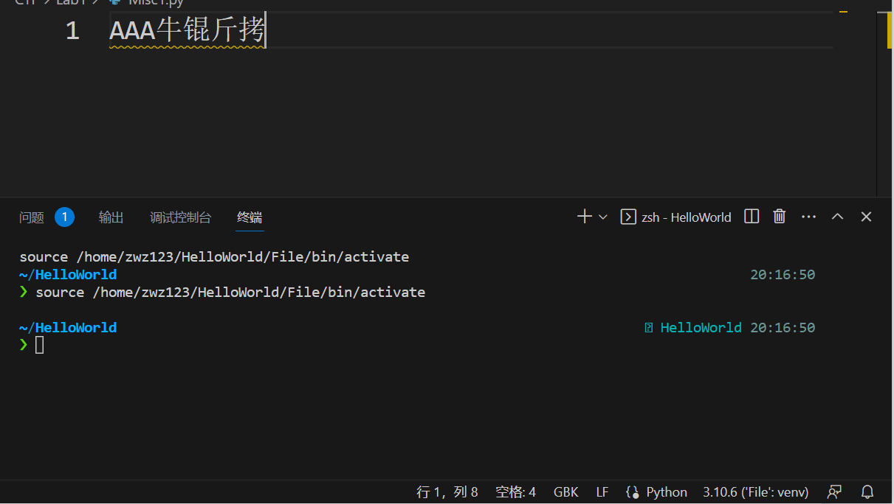
1.2.1
Q:在自行研究了 GB 系列编码后，请阐述 GB 系列是如何实现三个版本兼容的？
A：GB系列实现的是GB18030兼容的三个版本
1：GBK
2：GB2312
3：ASCII
（1）首先是GB2312是可以叫做区位码，由两个字节组成，第一个字节是区，第二个字节是位。（分别是高低位，“高位字节”使用了0xA1–0xF7（把01–87区的区号加上0xA0），高位字节有部分是空区，“低位字节”使用了0xA1–0xFE（把01–94加上0xA0））他们分别选取了94个bit，那么GB2312就可以包含94*94=8836个字符。GB2312为了兼容ASCII码，把小于等于127的字符，表示为ASCII，单个字节，依旧以0开头，与原本的意义相同。但其他的字符都是两个字节，而且都以1开头，为了与ASCII码区分开来。
如：我叫ABC 这句话用GB2312码来表示：
11001110 11010010（我） 10111101 11010000（叫） 01000001 （A）01000002 （B）01000003 （C）
这样就达到了兼容ASCII码的效果；
- GBK兼容了GB2312和ASCII码：GBK编码是微软在GB2312的编码规则基础上，利用GB2312未编完的空间，共收录21886个汉字和图形符号，其中汉字（包括部首和构件）21003个，图形符号883个。这样下来，GBK编码向下完全兼容GB2312编码，也等同于兼容ASCII码。
- GB18030兼容GBK编码：采用变长多字节编码，每个字可以由1个、2个或4个字节组成。具有这样的特点，使得其可以包含161w的字符。1个字节的是保留了ASCII码的编码规则，而2个字节的是对于GBK编码的保留与拓展，而4字节的是用于包含所有Unicode编码下的UTF四字节区段。从而做到了GB18030兼容3个版本。

1.2.2
Q：针对六种乱码情况，哪些是你觉得可以恢复的，哪些是不可以恢复的？
A：我觉得以上只有两种可恢复，3，4两种。以4举例，因为对于Latin-1是对于ASCII码的扩展，可以表示任何单字节的字符，任何字节流都可以用其解码。（ASCII最高位为0，而Latin-1最高位为1，这样将GBK编码下的字符转换成Latin-1，可以看成将多个两字节的字符，分别拆开都拆成了2个单字节的Latin-1字符。）这样的好处是所有单字节都可以涵盖掉。然后，只要是该Latin-1字符串都是由GBK而来，那么，重新回到GBK就可以实现恢复的效果。对于UTF-8编码也是如此。所以我认为3，4可恢复，而1，2，5，6不可恢复。原因是会出现编码损失，无法像Latin-1转化成单字符可以完全覆盖，当GBK和UTF-8很多的编码区域是没有交集的，就导致有些乱码无法重新恢复回去。
1.2.3
“锟斤拷”，这三个词是由于 UTF-8编码是来源于Unicode字符集的转化问题。就比如Unicode在和GBK编码转化的过程中，GBK编码的字符肯定是有一部分 Unicode无法表示，Unicode官方用了一个占位符来表示这些文字，这就是：U+FFFD REPLACEMENT CHARACTER。U+FFFD的UTF-8编码是0xEFBFBD，如果重复多次形成：EFBFBDEFBFBDEFBFBD 。那么将转化后的Unicode重新变成了GBK编码的时候。GBK中的除了ASCII码，其他都是两个字节的编码，EFBF,BDEF,BFBD.就分别对应了“锟”“斤”“拷”三个字符。1.1.6中的“6)先用 UTF-8 解码 GBK 编码的文本，再用 GBK 解码前面的结果”AAA牛逼---->AAA牛锟斤拷，就是由于这个原因。“逼”这个字，从GBK变为UTF-8的编码是Unicode无法表示的。
Task2
Challenge1
Vigenere解码
以下是解题代码：
Step1:先求解密钥长度
代码在Misc.zip中的Vigenere-decrypto(1).py中
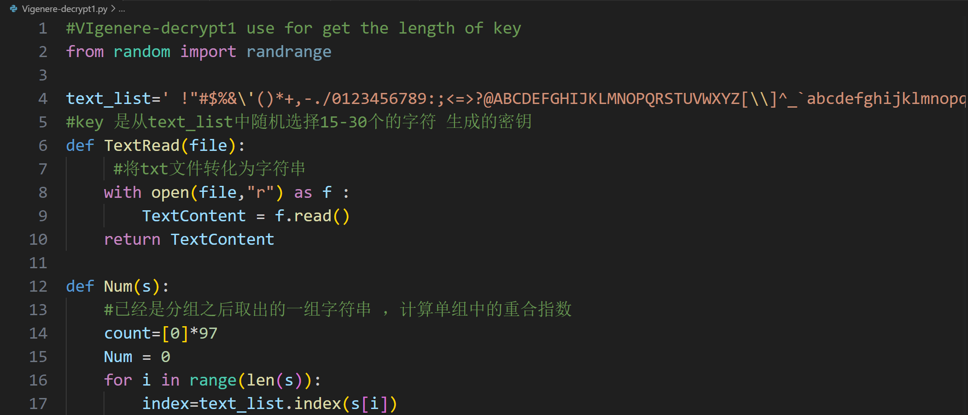
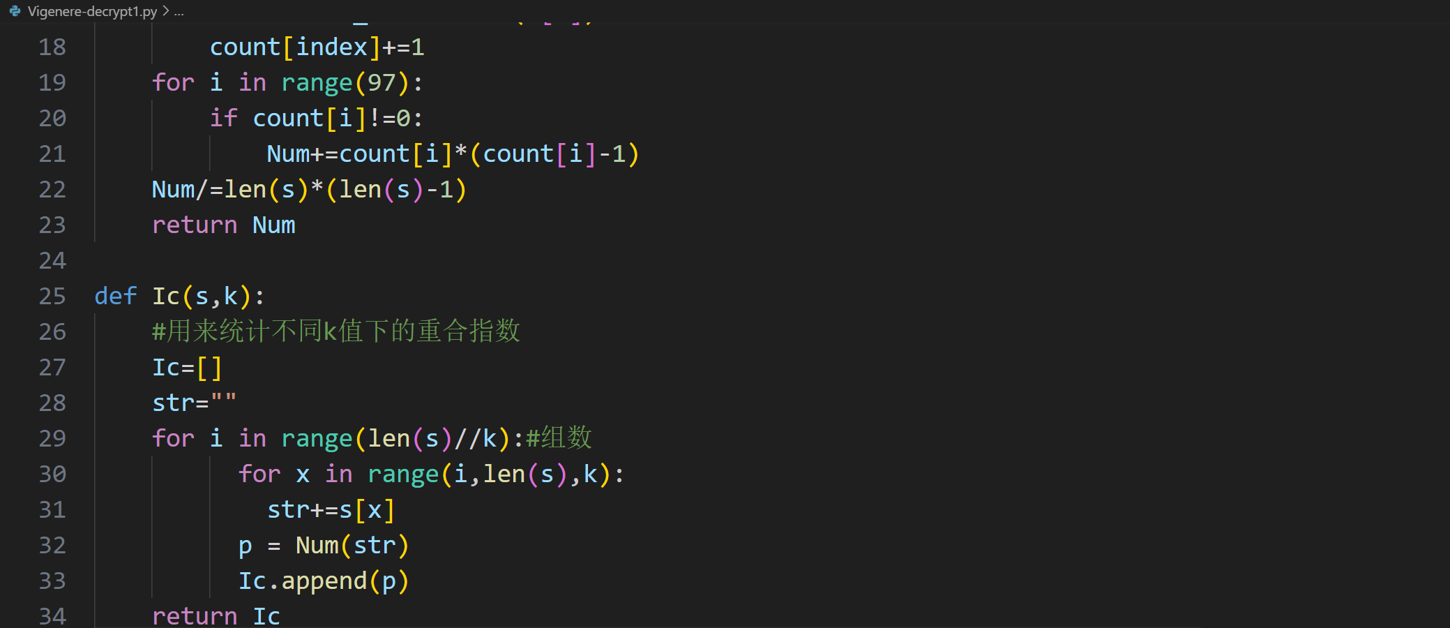
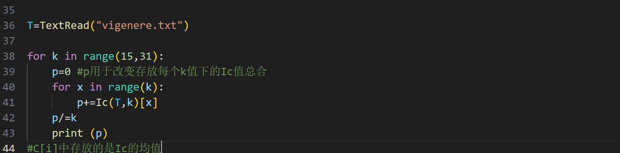
0.03459784961078679
0.036255956720073736
0.03344268791214023
0.03609708271185117
0.03520982960248611
0.034196049891084775
0.03383462158072611
0.034262435691612865
0.03830053002394148
0.036043758485237894
0.03647059166610666
0.0347398741452819
0.03250182725535983
0.0338630034887915
0.03771683757058582
0.034791778064769595
这些是输出后的结果，发现k=29的时候，算出的Ic最接近0.038。由此可以推断出key的长度为29.
Step2:利用key=29来解密Vigenere乘法加密
这是第一组的字母出现
u>; +00 +;0qn^5 EEiT6Td!!ds!;h!EETT1T }!O16 } QSETEd s1 ^0T}T+^ 11 O;&0&;!1d+ Td ;E;^ m;s^E T+1+ndh15&0T^0;}^ T^T^OO0;} !& ;;;TT0m^
Vigenere-decript3.py用于获得该分组后的字符出现频率
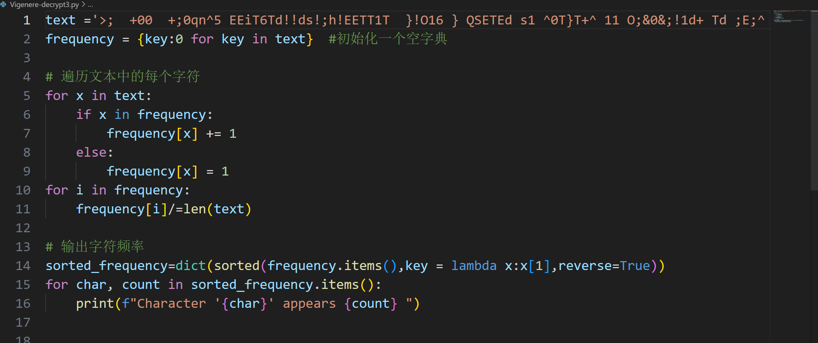

用以上的代码统计频率从大到小排序
Character ' ' appears 0.15555555555555556
Character 'T' appears 0.1111111111111111
Character ';' appears 0.0962962962962963
Character '^' appears 0.07407407407407407
Character '0' appears 0.06666666666666667
Character 'E' appears 0.05925925925925926
Character '1' appears 0.05925925925925926
Character '!' appears 0.05185185185185185
Character '+' appears 0.044444444444444446
Character 'd' appears 0.044444444444444446
Character '}' appears 0.037037037037037035
Character 'O' appears 0.02962962962962963
Character '&' appears 0.02962962962962963
Character 's' appears 0.022222222222222223
Character 'n' appears 0.014814814814814815
Character '5' appears 0.014814814814814815
Character '6' appears 0.014814814814814815
Character 'h' appears 0.014814814814814815
Character 'm' appears 0.014814814814814815
Character 'u' appears 0.007407407407407408
Character '>' appears 0.007407407407407408
Character 'q' appears 0.007407407407407408
Character 'i' appears 0.007407407407407408
Character 'Q' appears 0.007407407407407408
Character 'S' appears 0.007407407407407408
推断出来第一个字符是key[0]= 这个一开始还没破译出来，需要等最后爆破
对于i=1即第二组字符串推断可知：频率分布
Character ' ' appears 0.23648648648648649
Character '}' appears 0.11486486486486487
Character 'G' appears 0.08108108108108109
Character 'E' appears 0.05405405405405406
Character '9' appears 0.05405405405405406
Character 'T' appears 0.0472972972972973
Character ',' appears 0.0472972972972973
Character 'o' appears 0.04054054054054054
Character 'a' appears 0.04054054054054054
Character ':' appears 0.033783783783783786
Character 'q' appears 0.033783783783783786
Character '+' appears 0.033783783783783786
Character 'r' appears 0.02702702702702703
Character 'F' appears 0.02702702702702703
Character '~' appears 0.02702702702702703
Character '*' appears 0.02027027027027027
Character '8' appears 0.02027027027027027
Character 'p' appears 0.013513513513513514
Character 'L' appears 0.006756756756756757
Character 'i' appears 0.006756756756756757
Character '.' appears 0.006756756756756757
Character 'V' appears 0.006756756756756757
Character 'H' appears 0.006756756756756757
Character 'w' appears 0.006756756756756757
Character 'N' appears 0.006756756756756757
可以推测”}”所对应的大概率是字母”e” 此时的密钥key[1]=’.’
Vigenere-decrypt4.py中来利用字母出现的频率逆推key
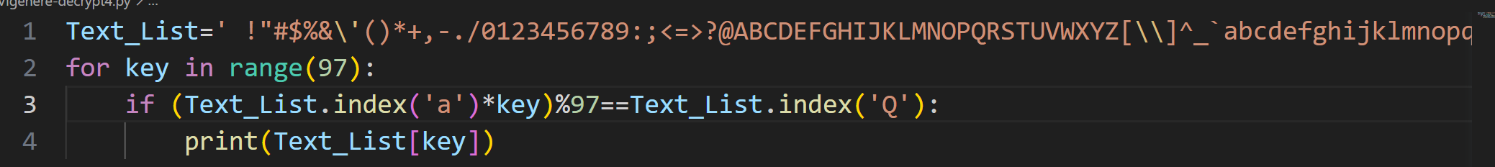
有代码推得 key[1]=’.’
同理，看第三组
Character ' ' appears 0.1925925925925926
Character 'y' appears 0.08888888888888889
Character '_' appears 0.08888888888888889
Character 'p' appears 0.07407407407407407
Character 'Z' appears 0.05925925925925926
Character '3' appears 0.05185185185185185
Character 'V' appears 0.05185185185185185
Character 'c' appears 0.05185185185185185
Character 'I' appears 0.044444444444444446
Character 'h' appears 0.044444444444444446
Character '%' appears 0.037037037037037035
Character '@' appears 0.037037037037037035
Character '7' appears 0.02962962962962963
Character '*' appears 0.022222222222222223
Character 'M' appears 0.014814814814814815
Character '}' appears 0.014814814814814815
Character '.' appears 0.014814814814814815
Character '2' appears 0.014814814814814815
Character '|' appears 0.007407407407407408
Character 'K' appears 0.007407407407407408
Character 'f' appears 0.007407407407407408
Character '{' appears 0.007407407407407408
Character 'u' appears 0.007407407407407408
Character 'O' appears 0.007407407407407408
Character ')' appears 0.007407407407407408
Character ';' appears 0.007407407407407408
Character 'Q' appears 0.007407407407407408
Key[2]=6

同理得到后面的X . 6 z c K 1 r P 1 I A y ~ X X X h o 2 a X X & D G X \’ X
(具体推理过程在u.docx文件中)

uy thz mid-nin^;a/3j8 oent'i^> the =erm "ic^J5D 8Q" enP{|;d thz AmericaQ i?3S}Q^e, *G< ice NQs still /&t( 6W^inn.vX to ab(ect the (</- {( ord.vV+y ci5]zens in ;-/ Q:]?ed K2V0es. -+e ice tV[R/ S|W{ wiPY 0he gefwth of +4

<4E Lce 6'\ used ]n hotel?w T@u7:(s, SvW hosp{=als, anu 4@ 4{c6 foAqV+d-loL`ing citw R/@>7:+ in /|;sh mzQt, fresz p
.($ Gnd *G<0er.Ab=er the d4=
5 sQx (1sjFq1865k2 as ice i%X ?\W" to i7nrigeeQte frei0E
>2|lN it 'z^o ca|W into h:*q/9 z% use( m5en bz(ore 1884w #@>x ?he .Q7 sold ]n New Y:]ZQ f8]aadeu?8Ea, ad% Baltim:]aQ 2:% oneQ28Erd ob that so (
3 lf+ton ':i ChiIQgo, wen(
h ~Vc%liey xTr thz]r own u?x0 M(yl had <76ome 4fssible BxC?,47 G ne6 8TusehL1d conveQ4al>H$ ?he .Q7dox, y precurs:] h; <+6 mo9{|! refe]gerator/ -?= 6W6n i#\7!ted.83aking aQ a+;^w]6nt .Q7dox wyl not as x%X( Vl we LnXst noN supposeb Al j8W earu: !inetzWnth cen(*b@u <+6 kn[qz;dge L( the phwL<7. {( heaPZ hhich ras esseQ;<?5 <f a sbn7!ce ob refrigeV[

2I$ {as AGWEmenty:y. The +/xp2I\W(se #*<Eon t2Qt the b^L
8=7"<x wS~ Tne t2Qt preveQ;a3 j8W ice /|Tm me3=ing was /p > }:+e m.~<1ken, (or it wYL T9H c6lti#D Tf thz ice tha( D//~{:ued PY7 cool{4g.
NeveV;-/5H\lN eaAL^ effoe=s to ec:@5p8*7 %ce .vw}uded rrapping ;-/ ^wW in *LV!kets# which k^
-(7 %ce Hi{O doidZ its joBU *2j o(til v71r thz end of (Ea 3^:W?eenPY 6entueu did in[x&T2_\ Gchiq\7 the 1Wlicate B[i?3=7 <f i#~}}atiod and cir+*i?-^{4 nee9{W for y4 effici^@
8=7"<x.
HSVQ:AAAO]_like_T4xp=Bug:B_M3'YaS!}
B~= as ear G ?. FD=3, Sv Engen{fus Mary [&3 ~V:uer, 98Tmas tfore, hau 4/<I f( thq |Eght 5:ack. He /Ll<s Q farL Vdout 5renty mi xq 2?<l%de PY7 city ff WashiQV
h3b (<r wWnws the @illage :g F< |Z6tow# =1s thz market +x&T<_E Ahen Y7 used Qn icebo- 5+ (yl own f7^ign 5f transp:]
9^\ [uttqi 0o mae`et, he G/.l= <+Gt c'~<Tmers rould pa?L P1 <+6 ra2nW}y me3=ing stuGg
3 <+6 tu*~ Tf hiM competi(/bX j{ Pay S [+emiu| price f:] #84 "StteAZ ^till (resh anu -?/s ]( neS2$ one-4fund bri+sqI!0:W advSv<1ge ob his iceB/[Q %{fxe en?z1ined# was tha( p?/t7:+ wo'LW no lL4ger hav^
h j|Qgel P* Oarke5 at nigh( <l |%6r t[ 9;ep t2Wir prodr9a > {1v
PeAYV&s thz most ob[45P. =QB arPn\0ic ceWation r^gi/>j\ row 2{{&le l{@e is by Q<\/ |](g tW{ ;nvirL4ment - (Ea 42<Wxialy V!d teI+nologie? %L@^zQ[le P* 1 cul5ore. StoQxs * {%N trq{ dark, Tlay, anu q?3s Qxe gqv7+ally Qvailabl^ x?-H|]Gls. u: addi5]on, dep^@R
3S f( thq zTcali5u, other ]aX2?|T6s mS: de acIWssible: L-/5>\2 hor#~$ gold# copper, [&3 4y1ger. 98; difbWrent us^L T2 =+%ch y*wEetieM put the?x p@j7:%als '|; of {4terest (/ ?3j8:<pol[Dy^ts w2f may as5w +2_ W.ampu{$ why 4Wople ch:/q/ j{ Sse bLVm and 4ot copp^] H9H: [oth n<;ms aeW availaBbaI Dz=rougW <sere y:e no coQ9iP.^]W ans6{|^ yet# the way 4& *(yTr a y*wEety f]ews its x&L8_{4uent n\ some5]mes appY]al- y4 its Q8Tice y4d use oG %\-^\=%c mS27+ialsT The use /p >H|=Gin L{<1ls, bfr examp xs 42^ [e rq~7+ved bfr cerem:@<?5 {"9ecty {n speI]al impoV;%l>HE cr tW{ delieb in the ?*D//IV=Sral ?{hers L( a ston^ 5\ j|W6 maE w1use y sculptoV
h h7 +ens.2y5e to =hat mat^]<?5m@Brat .~ &artiIolarly m^[&
3Sxoa to ':0hropL1ogist i?
#< |WGlizS2yTn thy= althou0E T9H cGter.'z^ ava{1able to [ X2=yW?y mS: 0o so|W extent b<p8j fx inHL};nce N+at it cY@ 32 V:?ist.QV}ly, 5+e materc[iX h^ (o mq':^ detz:mine whY;
. Wf(e. iY^ do t2W artist? <l EV7Gnesq \Tciet rake saQ(
3j{ Pattqi:^; an1 the artcL
X ^: >oma# \Tciet melt saQ( T2 xfxm gu'\^? MoeWover, e[x& *(74 the ~VOe ma5Wrial is *q/= y4 the ~VOe wa
by memb^]q 2~ %%ffeA{:0 soc{Wties, tzx +2_Z <r sP:z; of 5+e work [[b
<4 W(orm[G\}y frLc cultur^
h =}1?ure( + sociz=y may scQDt( w+<ose 2{ reprzlent obj^9
X | Phen[a7!a thy= are im#/bT@I< ?o iP~ &opuly=ion. An x[?4^:Q?ion *x the y:t of th^ }
=szW Agey <;lls ~l somethc@ @h{o? thq Z;dievy1 preoccr %T8 : {ith 28;olog{Tal doctV4&/s N4 add.2yTn to :evealin0
#< [:%marE wTncerdl of a s:9</-U$ ?he b*:0ent L( that s:9</-Ucl art aVm alsL reflect ;-/ =}1?ure$~ ^ocia3 stratifc9%T8 :5
开始爆破
- 第一位uy-->By 利用Vigenere-decrypt4.py中的函数 推得key[0]=’S’
- 第27位为’enPer’---->”enter” key[26]=’X’
- 第29位为’ente|’---->”enter” key[28]=’a’
- 第23位为’oentury’--->’century’ key[22]=’4’
- 第15，16，17位利用mid-nineteenth来破解
得到key[14]=’\\’,key[15]=’P’.key[16]=’-’
最后收尾完成所有密码的破译
得到key=’ S.6zck1r,P1IAy~\\p-h02aR4&DGX\’a’(注意转义符)

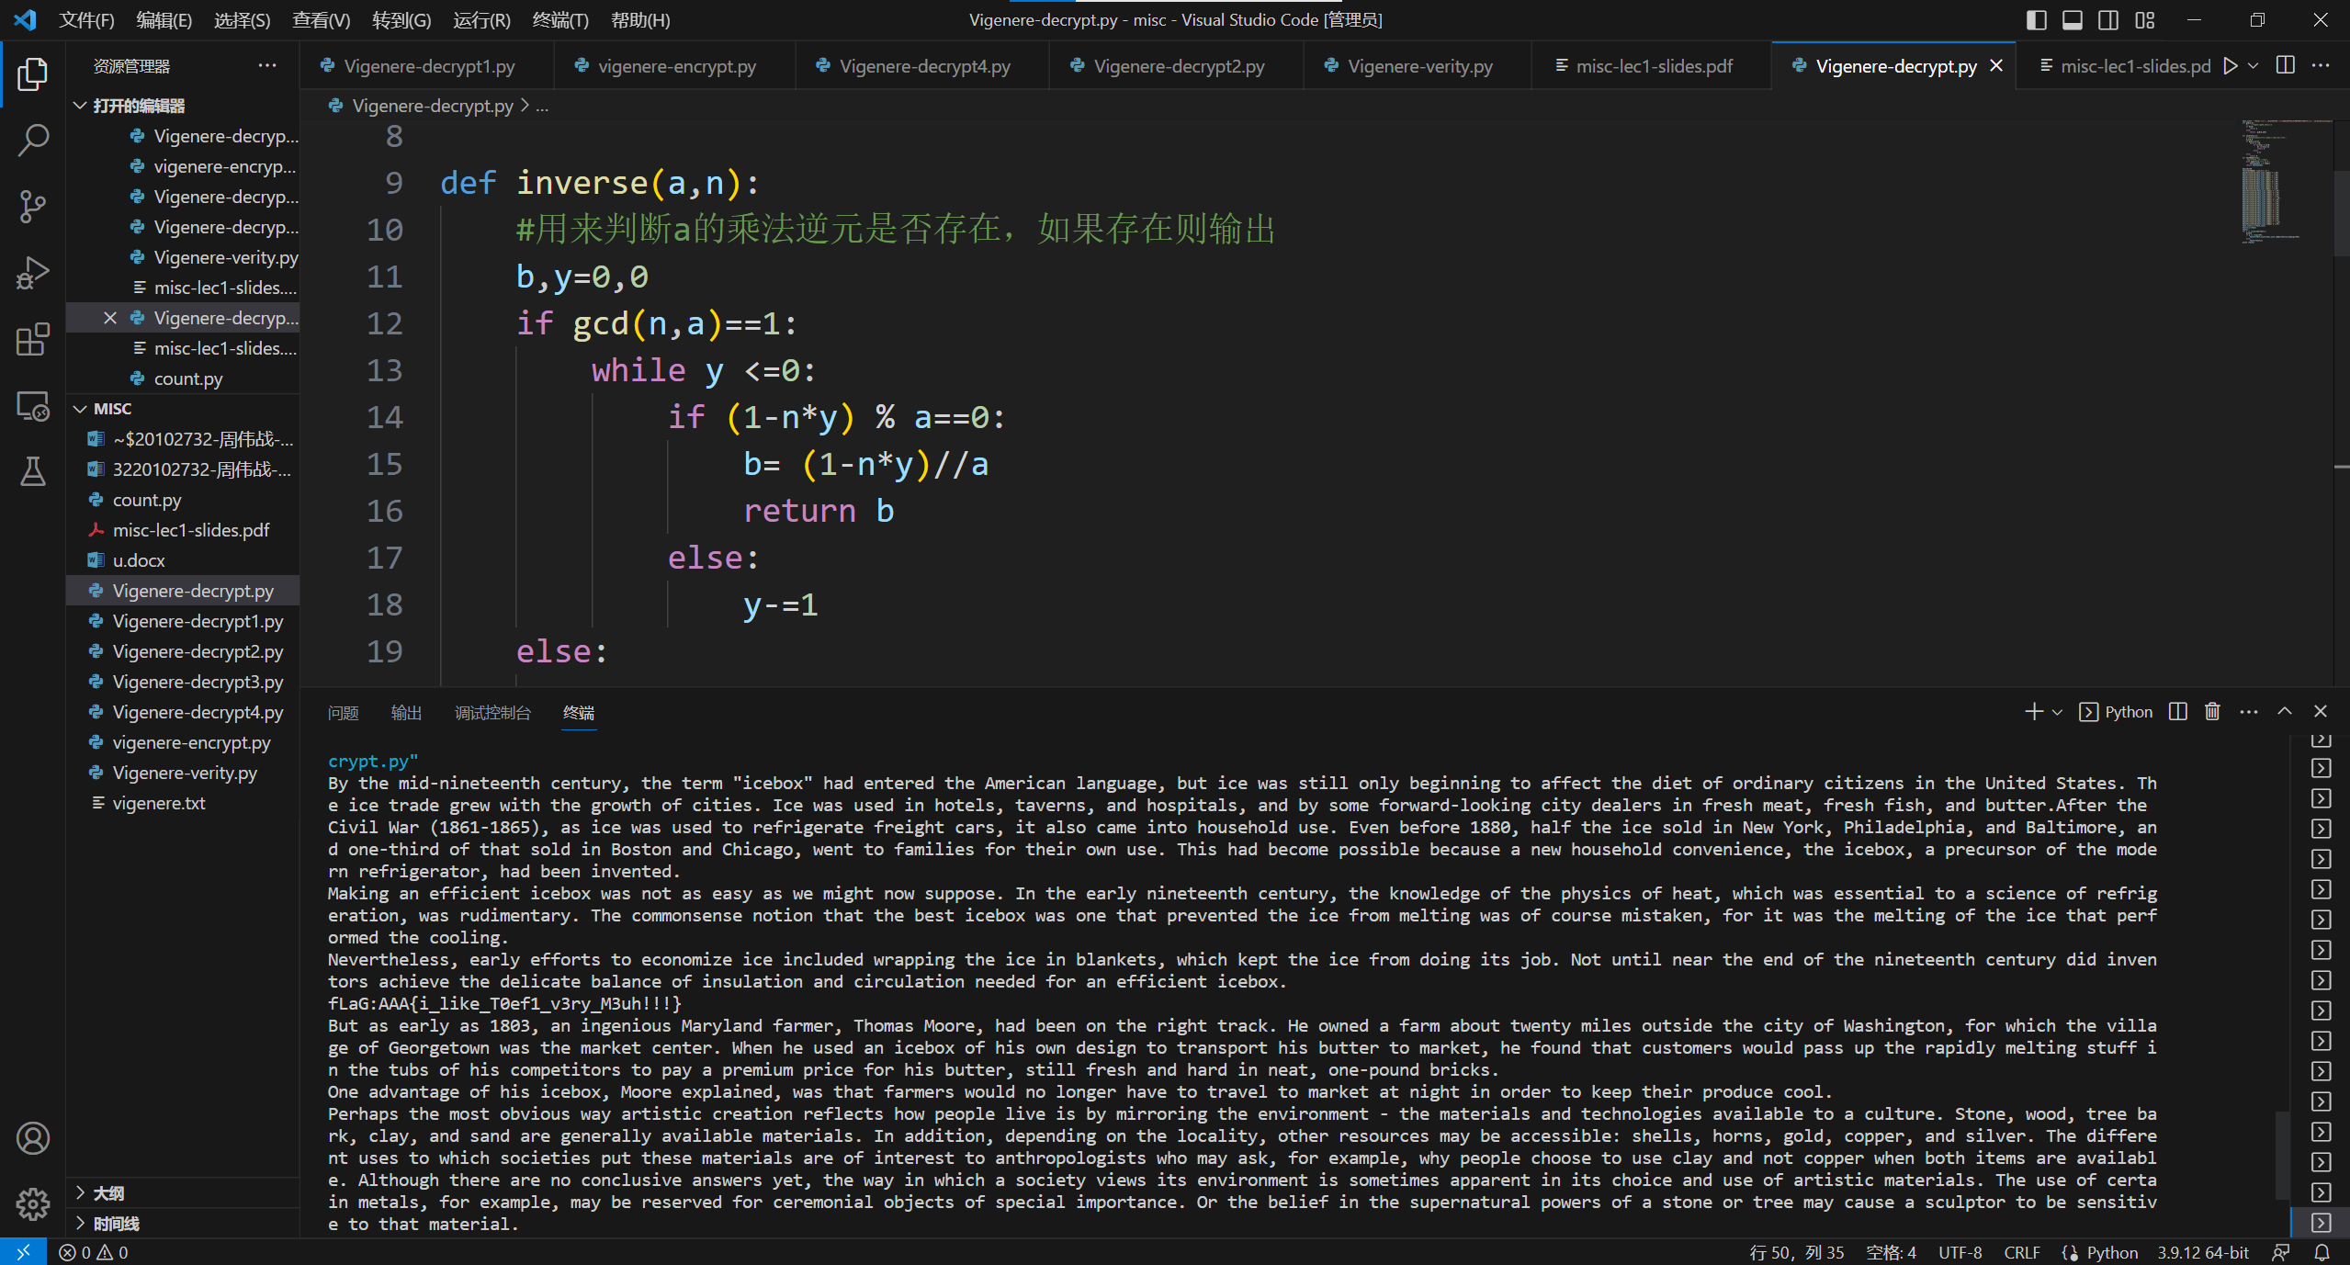
具体的解题过程在u.docx中（分别是每一组的字母出现以及频率）
解题代码在（emm分成了6个小程序，没合并）
Vigenere-decrypt.py （用于恢复原文）
Vigenere-decrypt1.py(用于爆破重合指数，获得key的长度为29)
Vigenere-decrypt2.py（用于取得各组字符串的内容）
Vigenere-decrypt3.py(用于获得每个分组字符串部分的字母出现频率)
Vigenere-decrypt4.py（用于反推密钥）
Vigenere-verity.py(用于验证该密钥的正确性，通过验证前几位频率较高的字母出现，有无符号出现等来确认正确性)
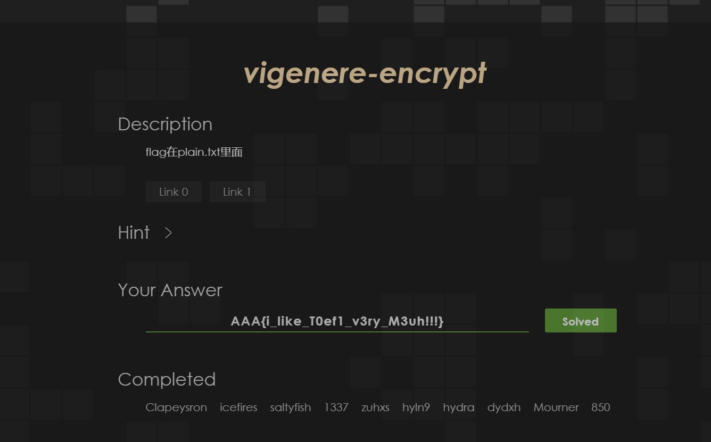
Flag是AAA{i_like_T0ef1_v3ry_M3uh!!!}
（下一页附上原文）
By the mid-nineteenth century, the term "icebox" had entered the American language, but ice was still only beginning to affect the diet of ordinary citizens in the United States. The ice trade grew with the growth of cities. Ice was used in hotels, taverns, and hospitals, and by some forward-looking city dealers in fresh meat, fresh fish, and butter.After the
Civil War (1861-1865), as ice was used to refrigerate freight cars, it also came into household use. Even before 1880, half the ice sold in New York, Philadelphia, and Baltimore, and one-third of that sold in Boston and Chicago, went to families for their own use. This had become possible because a new household convenience, the icebox, a precursor of the modern refrigerator, had been invented.
Making an efficient icebox was not as easy as we might now suppose. In the early nineteenth century, the knowledge of the physics of heat, which was essential to a science of refrigeration, was rudimentary. The commonsense notion that the best icebox was one that prevented the ice from melting was of course mistaken, for it was the melting of the ice that performed the cooling.
Nevertheless, early efforts to economize ice included wrapping the ice in blankets, which kept the ice from doing its job. Not until near the end of the nineteenth century did inventors achieve the delicate balance of insulation and circulation needed for an efficient icebox.
fLaG:AAA{i_like_T0ef1_v3ry_M3uh!!!}
But as early as 1803, an ingenious Maryland farmer, Thomas Moore, had been on the right track. He owned a farm about twenty miles outside the city of Washington, for which the village of Georgetown was the market center. When he used an icebox of his own design to transport his butter to market, he found that customers would pass up the rapidly melting stuff in the tubs of his competitors to pay a premium price for his butter, still fresh and hard in neat, one-pound bricks.
One advantage of his icebox, Moore explained, was that farmers would no longer have to travel to market at night in order to keep their produce cool.
Perhaps the most obvious way artistic creation reflects how people live is by mirroring the environment - the materials and technologies available to a culture. Stone, wood, tree bark, clay, and sand are generally available materials. In addition, depending on the locality, other resources may be accessible: shells, horns, gold, copper, and silver. The different uses to which societies put these materials are of interest to anthropologists who may ask, for example, why people choose to use clay and not copper when both items are available. Although there are no conclusive answers yet, the way in which a society views its environment is sometimes apparent in its choice and use of artistic materials. The use of certain metals, for example, may be reserved for ceremonial objects of special importance. Or the belief in the supernatural powers of a stone or tree may cause a sculptor to be sensitive to that material.
What is particularly meaningful to anthropologist is the realization that although the materials available to a society may to some extent limit or influence what it can do artistically, the materials by no means determine what is done. Why do the artists in Japanese society rake sand into patterns; and the artists in Roman society melt sand to form glass? Moreover, even when the same material is used in the same way by members of different societies, the form or style of the work varies enormously from culture to culture. A society may
simply choose to represent objects or phenomena that are important to its population. An examination of the art of the Middle Ages tells us something about the medieval preoccupation with theological doctrine. In addition to revealing the primary concerns of a society, the content of that society's art may also reflect the culture's social stratification.

