Simulation of chromatographic processes

Anna-Karin Nordin

Department of Chemical Engineering, Lund Institute of Technology

##### Abstract

The aim of this Master thesis was to implement tools for parameter study and estimation, together with a graphical user interface (GUI). To do this the existing software, its models and numerical methods, have been studied along with methods for parameter estimation and regression. The implemented tools have been supplemented by a graphical user interface that facilitates use of the tools by guiding the user and illustrating the results. The tools compare the residuals between model response and experimental data. With the tool for parameter study it is possible to study the influence of the variation of a parameter on the sum of squares of the residuals. The tool for parameter estimation estimates model parameters by nonlinear regression based on least squares. Parameter studies and estimations have been performed on experimental data with the results showing a satisfactory function of the tools. Parameters in both dispersion and general rate models have been successfully estimated.

###### Introduction

The Department of Chemical Engineering is a member of the centre *CBioSep*, which conducts research in the field of bioseparation. In the scope of this research, software for simulation and optimisation of chromatographic processes has been developed in MATLAB. The current version is called BioSim 1.5 (Lintorp 2002, Berg 2002). Tools for parameter study and estimation using BioSim 1.5 for simulation have been implemented.

###### Chromatography

Chromatography is a separation technique commonly used in the biotechnology industry. The sample that is to be separated is transported in a *mobile phase*. The mobile phase is forced through an immiscible *stationary phase*, which is fixed in place in a column. The components of the sample distribute themselves between the mobile and stationary phase to a varying degree depending on their physical and chemical properties. Components that are strongly retained by the stationary phase travel slowly through the column, and vice versa. As a consequence of these differences in mobility, sample components are separated (Skoog et al. 1971).

###### Mathematical Models

In this thesis, mathematical models are used to describe the chromatographic process. The models are based on differential mass balances for the mobile and stationary phases. This yields a set of partial differential equations to be solved. The complexity of the solution depends on which transport phenomena that are taken in consideration.

The *kintetic-dispersive model* describes convection, dispersion and adsorption by the following partial differential equation (Carlsson 1994):

 (eq. 1)

The *general rate model* includes convection, dispersion, mass transfer between bulk liquid and particle pore liquid, diffusion in the particle pores, and adsorption. The process is described by (Carlsson 1994):

 (eq. 2a)

 (eq. 2b)

Numerical Solution

To solve the partial differential equations in space and time, a numerical method called the *Method Of Lines (MOL)* is used. The space dimension is thereby discretised into a number of grid points. The finite difference method is used for the discretisation. An approximate solution to the partial differential equation is made in each grid point, thus transforming it to a set of ordinary differential equations in time (Nilsson 2002). These equations can be solved by an ODE-solver in MATLAB.

Parameter Estimation

In parameter estimation (also called model calibration) the parameters in a model structure are “tuned” to experimental data to make the model accord with the experiment. The difference between model response and experimental data is minimised by regression. In this thesis, the method of least squares has been used for regression. The Levenberg-Marquardt method is used as standard method.

**Parameter Estimation Tool**

A tool for parameter estimation has been implemented. An overview of the program structure is presented in figure 1. Model data are read by estMain in the form of a MATLAB structure called BioSim. estMain also reads experimental data and calls the file nonlinreg, which performs the actual regression. BioSimulator runs a simulation by calling Engine, and also carries out pre- and post-processing. Engine starts a simulation in BioSim 1.5, the simulation program implemented by Lintorp (2002) and Berg (2002).

Engine

BioSimulator

nonlinreg

estMain

BioSim

ExpData

BioSim

***Figure 1.*** *Overview of the program structure for the parameter estimation tool.*

###### Parameter Study Tool

A tool for parameter study has been implemented. With this tool, it is possible to study how the variation of one of many parameters affects the sum of squares of the residuals between model data and experimental data. The program structure is similar to the structure of the parameter estimation tool, as can be seen in figure 2. Model data and experimental data are read by parStudyMain. The chosen parameters are varied and simulation is carried out for each parameter value by calling BioSimulator.

BioSimulator

parStudyMain

BioSim

Engine

BioSim

ExpData

***Figure 2.*** *Overview of the program structure for the parameter study tool*.

###### BioSepEstimator

The tools for parameter study and estimation have been supplemented by a common graphical user interface (GUI). The interface facilitates use of the tools by guiding the user and illustrating the results. The complete program is called BioSepEstimator, and is shown in figure 3.

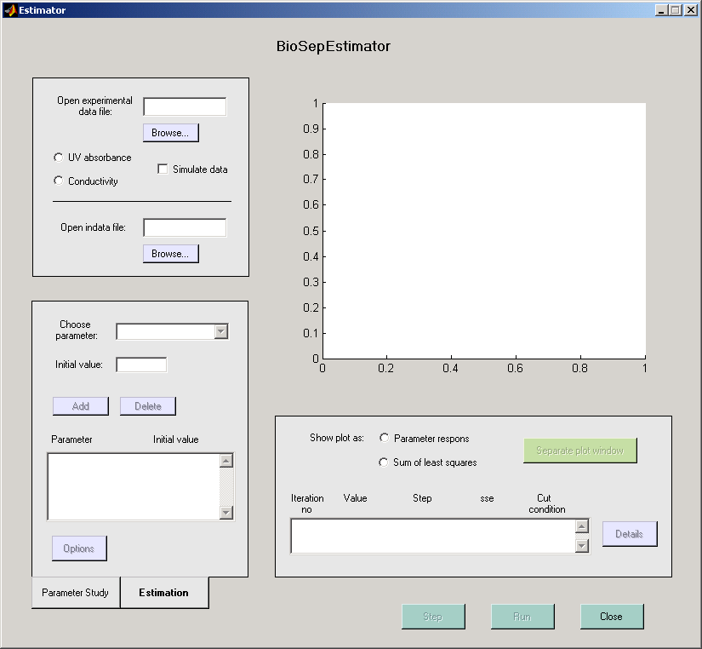

***Figure 3.*** *BioSepEstimator. The tab for parameter estimation is active.*

**Estimation of Dispersion from Experiments on Bovine Serum Albumin**

An experiment was carried out with bovine serum albumin (BSA) on the chromatography system ÄKTA-purifier. The BSA molecules are not adsorbed, but diffuse into the particles to a limited degree. Despite this diffusion, an inactive dispersion model, i.e. the model structure in equation 1 without the adsorption term, was used for the estimation. The interstitial velocity (vint) has to be modified to account for the extra volume in the particles:

 (eq. 3)

The bracketed expression is called the apparent porosity (void) for the particle bed. This expression was varied along with the dispersion coefficient (Dax) in a parameter study. The apparent porosity for the particle bed varied between 0.4 and 0.5, and Dax between 1⋅10-6 and 2⋅10-6 m2/s. Figure 4 shows the model response for the different parameter values along with the experimental data. The values εc + (1-εc)⋅εapp = 0.45 and Dax = 2⋅10-6 m2/s resulted in the model response closest to the experimental data, and were therefore used as initial values in the estimation.



***Figure 4.***  *Result from parameter study. The model responses for the different parameter values are indicated by dashed lines. The experimental data are represented by crosses.*

The parameters were estimated with the initial values obtained from the parameter study. The following results were obtained:

Dax = 1.77⋅10-6 m2/s

εc + (1-εc)⋅εapp = 0.424

Sum of least squares = 0.010396

A linear regression analysis of the estimation shows that the parameter variance is low. The 95% confidence interval and joint confidence region are shown in figure 5.



***Figure 5.***  *The 95% confidence interval (dashed box) and joint confidence region (ellipsoid) for the estimation of dispersion coefficient and apparent bed porosity.*

Estimation of Diffusion from Experiments on Immunoglobulin G

The experiment was carried out with Immunoglobulin G (IgG) on a packed column. The IgG molecules diffuse into the particle pores but are not adsorbed. An inactive general rate model, i.e. the model structure in equation 2a and 2b without the adsorption term, was used to simulate the process.

The values used for the dispersion coefficient (Dax) and the porosity (void) for the particle bed (εc) were obtained by an experiment with Latex particles on the same column. The parameters were estimated from an inactive dispersion model. For more details, see Nordin (2003). The film mass transfer coefficient (kf) was set to   
5⋅10-6 m/s.

A parameter study for the effective diffusion coefficient (De) and apparent particle porosity (εp) was carried out where De varied between 1⋅10-11 and 2⋅10-11 m2/s, and εp between 0.45 and 0.55. The sums of squares of the residuals for the different parameter values are shown in figure 6. The values De = 1.67⋅10-11 m2/s and εp = 0.506 resulted in the model response closest to the experimental data, and were therefore used as initial values in the estimation.



***Figure 6.***  *Result from parameter study. The sums of squares of the residuals as a function of the parameter values.*

An estimation was performed with the initial values obtained from the parameter study, resulting in the following values:

De = 1.72⋅10-11 m2/s

εp = 0.505

Sum of least squares = 0.000825

###### Conclusions

Tools for parameter study and estimation have been implemented in MATLAB. The program enables the user to compare model response with experimental data. The tools have been supplemented by a graphical user interface that facilitates usage of the program by guiding the user and presenting the results by numbers and graphs. The resulting program is called BioSepEstimator.

With BioSepEstimator it is possible to carry out estimations in a step-wise manner. This function can be alternated with full run estimation, enabling the user to continue to step if the result from the full run does not have the required accuracy. This makes the tool very flexible and even suggests a specific methodology to the user:

1. The influence of the variation of a parameter is studied with the parameter study tool. This results in an approximate parameter value.
2. Step-wise estimation is started at the approximate parameter value. This enables the user to see how the estimator behaves before starting a full run estimation.
3. Full run estimation is started. The estimator stops when a certain accuracy is achieved.
4. Step-wise estimation is continued if more accuracy is required.

Experiments have been performed to evaluate BioSepEstimator. The results show that the program is able to estimate parameters in both dispersion and general rate models.

The experiment on BSA shows the possibility for BioSepEstimator to use experimental data directly imported from ÄKTA.

###### Further Work

Today, BioSepEstimator is functional for single experiments. To increase usability, it would be interesting to implement a method for multi-response. This method would enable the estimator to read data from several experiments and perform a parameter estimation for the different experiments simultaneously.

###### Table of Symbols

 concentration in mobile phase 

concentration in particle pores 

dispersion coefficient 

effective diffusion coefficient 

porosity (void) of particle bed 

apparent particle porosity 

film mass transfer coefficient 

length coordinate of column 

adsorbed amount 

length coordinate of particle radius 

particle radius 

time 

interstitial velocity for mobile phase 

References

Berg C. (2002), *Simulation of Chromatographic Processes – Methodology for construction and implementation of graphical user interface*, Lund: Chemical Engineering 1, Lund Institute of Technology.

Carlsson F. (1994), *Mathematical modelling and simulation of fixed-bed chromatographic processes*, Lund: Chemical Engineering 1, Lund Institute of Technology.

Lintorp F. (2002), *Simulering av kromatografi-processer – metodik för implementering och kompilering av MATLAB-applikationer*, Lund: Chemical Engineering 1, Lund Institute of Technology.

Nilsson B. (2002), *Process Simulation Using MATLAB*, Lund: Chemical Engineering 1, Lund Institute of Technology.

Nordin A-K. (2003), *Simulering av kromatografiprocesser – parameterskattare med grafiskt användargränssnitt*, Lund: Chemical Engineering, Lund Institute of Technology.

Skoog D. A., Holler F. J. & Nieman T. A. (1971), *Principles of Instrumental Analysis, Fifth Edition*, Philadelphia: Saunders College Publishing.