Exam questions 2011:
Task 1)
Task 2.1) How are DoTask data organized on disk? Please draw a figure to illustrate
the data organization.
DoTask is a table which uses hash file organization, which means it uses a hash function to provide a unique address in memory for each record to be stored. However using static hashing will not always be able to provide a unique address for each record and therefore some records may have to be stored in the same address. The solution for this problem is to allocate overflow buckets and create a linked list of records at this address.
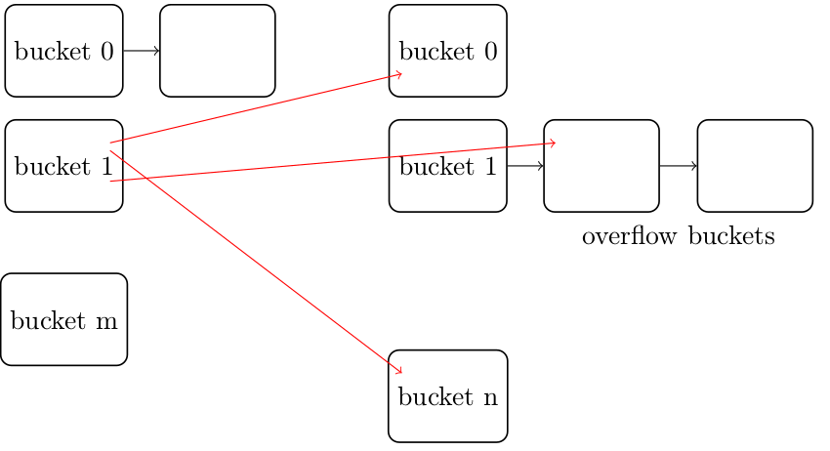

Task 2.2) Sketch an algorithm to make a natural join of the People and DoTask
tables.
1. Fetch buckets from each table that has the same “Pid” hash value.
2. Compare the records from each bucket
3. Write one of the values which are equal to a output buffer page.
4. When the buffer page is full, write it to disk
5. Repeat the process until all buckets have been read.

Task 2.3) What is the performance overhead of your algorithm for the above question?
The performance overhead is measured in the number of disk seeks and disk block transfers.
To make things easy I assume that one disk block is the same size as a bucket of data. I also assume that the “People” file uses 500 and the “DoTask” file uses 100.000 buckets to store its data but the buckets are only half full. So the total number of disk blocks to store the files are: (500/2) * (100.000/2) = 12.500.000 full disk blocks.

The files are only read in once and written out once which results in 500+100.000 disk block transfers for the files and 12.500.000 disk block transfers for the result.
In total this results in: 12.500.000 + 500 + 100.000 = 12.600.500 disk block transfers.

Assuming 20 buffer pages are allocated to store each input file and the output file there is around: 12.600.500 / 20 = 630.025 disk seeks in total.

Task 2.4) Sketch an algorithm to make a natural join of the Tasks and DoTask
tables.
1. Read the records from the Task table into the buffer pages.
2. Use the indexes in the Task table to fetch the matching records from the DoTask table
3. Write the matching records to the output buffer pages
4. When an output page is full, write it to disk and continue the process until all records have been read.

Task 2.5) What is the performance overhead of your algorithm for the above question?

Task 3.1) What is functional dependency P → Q of a relation instance r?
A → B: NO
B → C: YES
A → C: YES
AC → B: NO
AB → C: YES

Task 3.2) What is a schema decomposition? What is the purpose of making a schema decomposition?
The main goal of decomposition is to reduce redundancy in a table. This is done by dividing/decomposing a relation into several relations.
The set of schemas: R1, R2, R3….R(n) is a decomposition of relation R, if R = (R1 union R2 union R3 union ….. R(n)).

Task 3.3) What is a lossless schema decomposition?
A decomposition of a relation “R” is called a lossless decomposition if the natural join operation of the R’s set of sub relations produces the exact same relation before the decomposition. Such as: R1 – join – R2 – join – R3 …… = R

Task 3.4) What is a schema decomposition that preserves functional dependencies?
Dependency preserving means that the sub relations still hold the functional dependencies of the original relation. Such that the dependency F = F1-union-F2-union-….Fn.

Task 4.1) What is an ACID transaction?
A transaction is any operation that is treated as a single unit of work, which either completes successfully or does not complete at all, and leaves the system in a consistent state. The classic example is transferring money between bank accounts. ACID is the properties that define a transaction:
Atomic: All changes to data must be performed successfully or not at all
Consistent: Data must be in a consistent state before and after the transaction
Isolated: No other process can change the data while the transaction is running
Durable: the changes made by a transaction must persist

Task 4.2) Describe the two-phase locking protocol (2PL), strict two-phase locking protocol (S2PL), and rigorous two-phase locking protocol (R2PL).

Two-phase locking protocol: Two-phase locking protocol: in this type of protocol any transaction can not read or write data until it has acquired an appropriate lock on the data item. There are two types of locks:
- Shared lock: This is a “read-only” lock that can be shared between processes because it can’t update the data item
- Exclusive lock: the lock can only be obtained by one process at a time because this lock allows both read and write operations on the data item.

The two-phase locking protocol has two phases:
- Growing phase: The execution of the transaction starts and the process obtains the locks it needs. In this phase it is not allowed to release locks. After the locks are obtained the process can do its work on the data.
- Shrinking phase: The process is allowed to release the locks it holds as the process ends, but is not allowed to obtain new ones.

Strict two-phase locking protocol is similar to the two-phase locking protocol but the difference is that it does not release the EXCLUSIVE locks until the whole transaction is finished/commits. It can still however release the “shared” locks.

Rigorous two-phase locking protocol is also similar to the two-phase locking protocol but is even stricter. In this protocol ALL locks, both exclusive and shared locks, can not be released until the process is finished/committed.

Task 4.3) Discuss the advantages and shortcomings of these protocols.
Advantages:
- All three of these protocols guarantees serializability, which means that processes can operate on a shared piece of data as if they were executed in a sequential order.
- Strict and rigorous two-phase protocols both guarantees strict scheduling, which means that there are no dirty reads or writes caused by two processes operating on the same piece of data. Strict scheduling means that one process can only perform reads or writes on data ONLY after the first process commits the work it is doing on the same data.
- Rigorous two-phase has no deadlocks and starvation (time consumption) is avoided.

Disadvantages:
- The protocols are more time consuming since they need to use time to acquire locks.
- Some processes may end up waiting for a data item that is held on to by another process resulting in even more waiting.

