Exam questions from 2015

Question 2.1) Sketch how Orders data are organized with a figure and some brief description.
- A hash organized file consists of an index file and a table file.
- A hash organized file consists of buckets where the bucket stores one or more disk blocks that contains records.
- The address/bucket for which a record should be stored is decided by a hash function.
- All records that are stored in the same bucket has the same hash value on their search key.
- When a bucket is full and no more records can fit inside it, a overflow bucket is created and the record is stored inside.
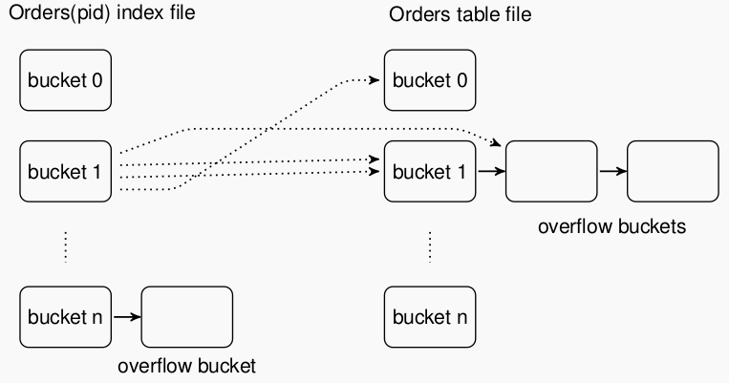

Question 2.2) We are going to make a natural join of the tables Customers and Orders Customers 1 Orders , with the hash join algorithm. Describe how the algorithm works.
- Hash join consists of two phases: build phase and the probe phase:
  - Build phase:
    - for each row in the table, calculate the hash value for each column.
    - Store the row in a hash table and use the calculated hash value as key for this row
  - Probe phase:
    - For each row in the second table, calculate the hash value for each column
    - Check if the calculated hash value matches a hash value key in the hash table.
    - If there is a match, check the actual columns and output the hash as a match

Question 2.3) What is the primary performance overhead of database systems in general?
- Assuming that the main memory is large enough to store each part of the outer loops from each table, then the blocks from each table is read into memory only once.
- If table 1 is in the outer loop it has to be searches through twice to compare all the records from this table. So there are 2*(the number of blocks in table 1) number of seeks.
- If all the blocks are read in once to main memory for comparison then there are (number of blocks in table 1 + number of blocks in table 2) block reads.
- The overhead of writing the result depends of the sizes of the tables being joined. Dependent of the use case, the result is not necessarily written back to disk either.

- Check the previous exam for calculations!!!!!!!!

Question 3.1) What is functional dependency X → Y of a relation instance r?
- A functional dependency means that if you have a value of X which you can find an unique value for Y, then Y is functionally dependent on X. If X however allows you to find multiple different values for Y then there is no functional dependency.

Check if the following functional dependencies are satisfied.
a) cid → cname: YES
b) cname → city: NO
c) {cname, city} → cname: YES
d) {cname, city} → cid: YES

Question 3.2) What is third normal form (3NF)?
- Third normal form is a table which is also in second normal form and does not have any transitive dependencies. Transitive dependency means that an attribute in a table is dependent on an attribute that is not a primary key or part of a primary key).
- For any dependency (X → Y), X must be a super key
- Y acts as a non-prime attribute. Meaning, every element of Q forms a part of a candidate key
- In a relation that is in 1NF or 2NF, when none of the non-primary key attributes transitively depend on their primary keys, then we can say that the relation is in the third normal form of 3NF.

Question 3.3) Given the relation schema R(A, B, C), F = {A → C, B → C} . Explain why R is not in 3NF.
- AB is the only candidate key in this relation and neither of those are a superkey. Also C is not part of the candidate key.

Question 3.4) Can you decompose schema R into 3NF with the 3NF synthesis algorithm?

Question 3.5) Why do we need 3NF?
- We need 3NF to reduce redundancies in a table and a majority of tables in 3NF are free from deletion, update and insertion anomalies. In addition a table in 3NF would always ensure losslessness and preserve functional dependencies.

Question 3.6) What problem may 3NF have?
- There may still be redundancies in the table

Question 4.1) What is an ACID transaction?
- A transaction is a series of operations which are treated as a single unit of work, which either completes successfully or does not happen at all. ACID is the properties that define a transaction:
- Atomic: all changes to a database must happen successfully or not at all
- Consistent: data must be in a consistent state before and after the transaction
- Integrity: no other process can access/change the data while the transaction is running
- Durable: the changes made by a transaction must persist.

Question 4.2) What is a log for transaction processing?
- A log is a series of log records which logs all transactions and database modifications made by transactions. They are used to perform transaction rollback and database recovery.
How is a log organized?
- A log is typically organized in two parts:
  - A stable part such as a file on a disk
  - A buffer in main memory which in turn will be flushed to a disk
What are the operations on a log?
- Unforced append: appends a log to the end of the buffer
- Buffer flush: flushes the buffer in main memory to disk
- Forced append: consists of an unforced append directly by a flush to disk
- Read/scan
What are the performance costs of these operations?
- An unforced append is a memory operation and the overhead can be ignored.
- A flush needs one seek and a number of disk block transfers depending on the size.
- A read/scan needs one seek and a number of disk block transfers depending on the size.

Question 4.3) What kinds of log records do you need to rollback individual transactions when the database system is up and running? What information should the record contain?
- To be able to undo a transaction/perform a rollback you need the identification of the transaction and the old value before the update (before image)
- To know when a rollback is completed you also need the “start transaction id”.

Question 4.4) What if you also want the database to recover from a system crash?
- We need the “commit/abort transaction ID” to know which transactions were active when the system crashed.
- We need the “checkpoint transaction id’s” to know when the recovery process can finish.

