Exam questions 2017
Question 2.1) What is the primary performance overhead of database systems in general?
- The performance overhead for database systems based on hard disks is decided by the number of seeks and block transfers.

Question 2.2) Describe how table Watchers is organized with hash on “sid”.
- The “Watchers” table is a hash organized table. A table with this kind of organization consists of buckets containing one or more data blocks which in turn store records.
- To decide where to store a record with the “sid” key the value is put through a hash function. The result of this hash function decides the address/bucket number of where the record should be stored. In other words all records stored in the same bucket has the same hash value.
- If a bucket is full and can not store another record then a overflow bucket is created and linked together with the other bucket(s).

Question 2.3) Describe how table Watchers is organized as a B + -tree with “sid” as the search key.
- In A B+-tree organization the records are stored in a balanced tree structure. It uses a key-index idea where the primary keys are used to sort the records. For each primary key a index value is calculated and mapped to the record. The address of the record is the same as the index of the record.
- All records are stored in the leaf nodes which is pointed to by the upper nodes.
- Each node in the tree is the size of a block
- All records are stored in the leaf nodes of the tree, and each The leaf nodes of the tree are linked together

Question 2.4) Discuss which file organization you would choose for table Watchers. Focus on the performance of the operation to find the watchers of a given “sid”. Take into account the fact that the numbers of watchers of shows can vary from very few to millions.
- For a hash file organized file the overhead is to walk through all the buckets and overflow buckets which has a the “sid” hash value. If I assume that one bucket is the size of one block the length of the overflow bucket chain is N, then to find a record it would take on average N/2 number of seeks and block reads.
- For a B+-tree organized file the overhead is to first, navigate from the root of the tree to the leaf node containing the first record with a “sid” value. Then walk through the blocks containing records with the “sid” value
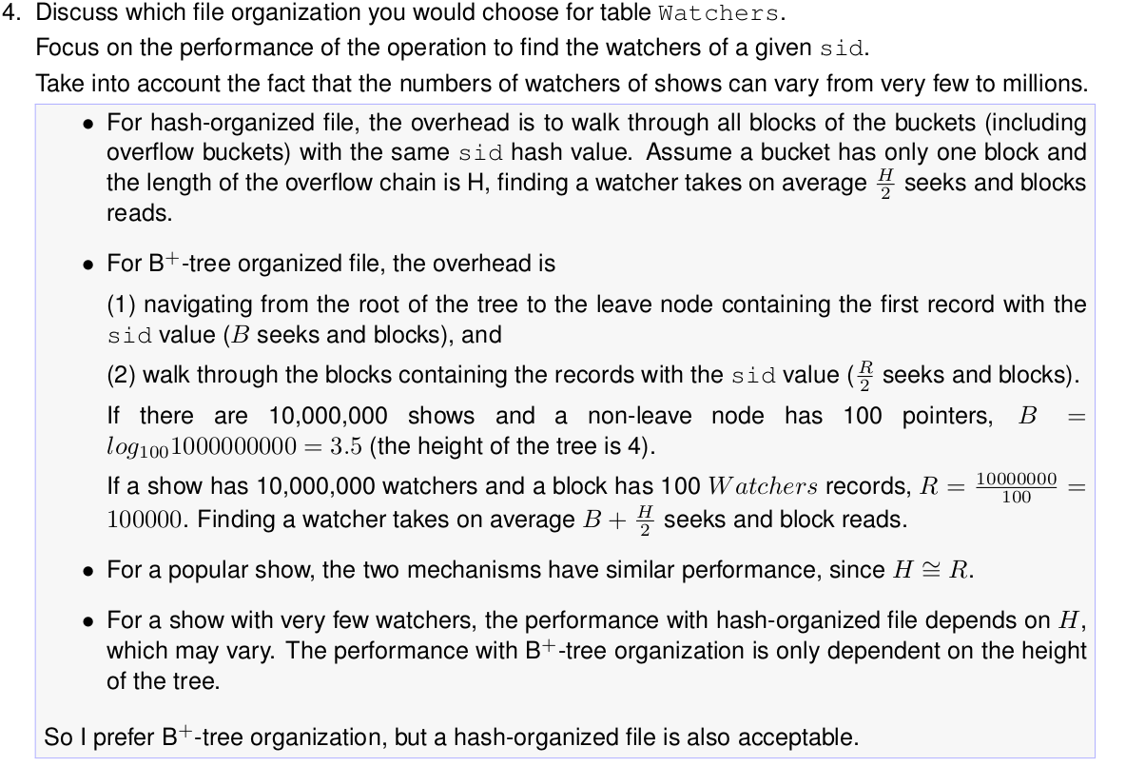

Question 3.1) What is a relation schema in Boyce-Codd Normal Form (BCNF)?
- For a relation to be in Boyce-Codd normal form it must fulfill these requirements:
  - Every attribute must be a single valued attribute (First normal form)
  - It must have no partial dependencies (Second normal form)
  - Have no transitive dependencies (third normal form)
  - For every functional dependency (X→Y), X must be a super key or a candidate key

Question 3.2) Given the relation schema R(A, B, C), F = {A → B, B → C}.
Is the schema in BCNF?
- The relation R is not in BCNF because in the dependency B→C, B is not a super key
- In the relation R, A is the only candidate key

Question 3.3) Given the relation schema R’(A, B, C), F’ = {A → B, B → A, B → C} .
Is the schema in BCNF?
- Yes, because in all the functional dependencies , the attribute on the left is a super key-index

Question 3.4) What is a lossless decomposition of a relation schema?
- A decomposition of the relation schema R is called a lossless decomposition if the natural join operation of the relation R’s subset relations produces the exact same relation as before the decomposition.

Question 3.5) Use one of the schemas R or R’ above to discuss why a lossless BCNF decomposition is useful.
- A lossless BCNF decomposition is useful for several reasons:
  - It helps in reducing data redundancy and avoiding inconsistencies in the data
  - Breaking down a relation into smaller pieces reduces the risk of data anomalies and increases data integrity
  - A BCNF decomposition ensures that each decomposed relation satisfies the BCNF conditions
  - Breaking a relation into smaller pieces can improve query performance since the size of the relation is smaller

Question 4.1) What is an ACID transaction?
- A transaction is a series of operations performed on a database which can be considered as a single operation, meaning either the operation will happen successfully or not at all.
- ACID is the properties that defines such a transaction:
  - Atomic: all operations and changes on the database are atomic and must be performed successfully or not at all
  - Consistency: the data are left in a consistent state before and after the transaction
  - Isolated: while the database is being modified, no other process can interrupt or change the same data.
  - Durable: the changes made by a transaction must be persistent.

Question 4.2) Describe a concurrency control mechanism based on timestamp ordering.
- Timestamp ordering protocol:
  - The timestamp ordering protocol is used to order the transactions based on their timestamp.
  - The order of transaction is the ascending order of the transaction creation.
  - The priority of older transactions is higher which is why they are executed first.
  - To determine the timestamp of a transaction the protocol uses the system time or a logical counter.
  - Lets assume there are two transactions, T1 and T2. T1 enters the system at time 007 and T2 enters at 009. T1 therefore has a higher priority and is executed first.

Question 4.3) Discuss what this concurrency control mechanism achieves.
- This mechanism guarantees serializability, meaning executions are equivalent to sequential executions in transaction initiation order.

