Exam questions 2018 kont

Question 2.1) The table’s organization is a hash file organization with hash on Uid. In addition there is a hash index on Mid.
Sketch how the table Recipients are organized and give a brief description.
- A hash organized file consists of an index file and a table file.
- A hash organized file consists of buckets where the bucket stores one or more disk blocks that contains records.
- The address/bucket for which a record should be stored is decided by a hash function. In this case the address is calculated based on the “Uid” search key.
- All records that are stored in the same bucket has the same hash value on their search key.
- When a bucket is full and no more records can fit inside it, a overflow bucket is created and the record is stored inside.
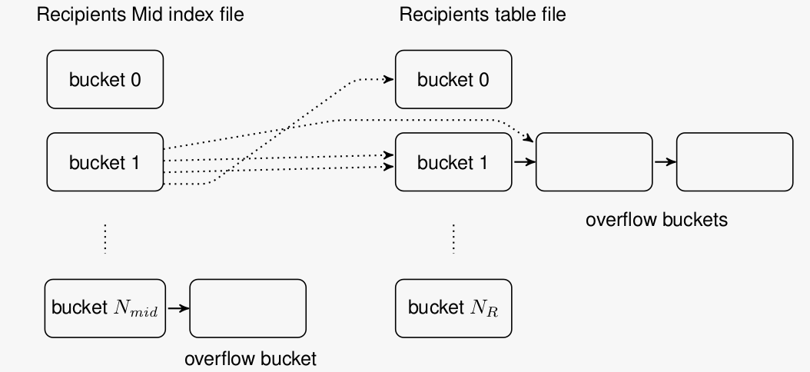

Question 2.2) What is the primary performance overhead of database systems in general?
- The primary performance overhead of database systems in general are I/O (Input, output operations), due to the need of reading and writing of data from a disk storage, so the performance is often calculated by the number of disk seeks and block transfers.
- Other factors that contribute to the performance are how the CPU is utilized, memory usage, network latency and acquiring of locks.

Question 2.3) Given the “Uid” value of a user, how to find the Mid’s of the messages sent to the user? What is the performance overhead of the search?
- First calculate the hash value of “Uid” to find the buckets where the Mid’s of the user are stored. Then walk through the buckets and overflow bucket and fetch the Mid’s.
- The overhead is to walk through the number of blocks in the buckets. If we let B=number of blocks and N=number of overflow buckets, then the overhead measurement will be: N+1 number of seeks and (N+1)*B number of disk reads.

Question 2.4) Given the Mid value of a message, how to find the Uid’s of recipients of the message? What is the performance overhead of the search?
- First calculate the hash value for Mid and find the bucket of the index file.
- Then go through all the blocks, buckets and overflow buckets to get the index entries.
- For each index entry, read the block in the Uid’s table and get the record.
- The performance overhead is calculated as such:
  - B=number of blocks in a bucket. N = number of overflow blocks. R=number of recipients of a message.
  - (N+1+R) is the number of seeks to find each bucket and each Recipient
  - (N+1) * B+R is the number of disk reads to read each block and get the index entries for each Recipient.

Question 3.1) What is functional dependency X → Y of a relation instance r ?
- A functional dependency means that if you have an attribute X in a relation(table) where the attribute X allows you to find the value of another attribute (B), then B is functionally dependent on X. So if X=1 always correspond to B=3, then there is a functional dependency. If X=1 corresponds to B being equal to many different values, then there is no dependency. A dependency is show as such: B → X (B is dependent on X)
- For the example instance of table Users in Question 1, check if the following functional dependencies are satisfied.
  - Name → Country: NO
  - Country → Name: NO
  - {Name, Country}→U id: YES
  - Uid → {Name, Country}: YES

Question 3.2) What is a super key of a relation schema?
- A DBMS key is an attribute or a set of attributes which allows you to uniquely identify a record OR a row of data in a relation. A super key is all the keys that are possible in a relation. It is an attribute (or a set of multiple attributes) that can be used to identify all rows of data in a table.
Can you define a superkey using functional dependencies?
- K→R

Question 3.3) Given a relation schema (R = ABCD) with functional dependencies {AB → CD, D → B}.
Is AB a super key of R? Why and why not?
- YES. If you have the key AB, then you are able to identify CD and B uniquely, and A speaks for itself. Therefore AB = ABCD.
Is AC a super key of R? Why and why not?
- NO. Because neither A, C or AC can uniquely identify ABCD.
Is AD a super key of R? Why and why not?
- YES. Because with AD you can identify B, and then with AB you can identify CD. Therefore AC = ABCD

Question 3.4) What is a candidate key of a relation schema?
- A candidate key is the minimal set of super keys that can be used to uniquely identify all rows of data in a relation. Meaning if you need a combination of attributes to identify a row, then the minimal number of these attributes is the candidate key. If you CAN use 3 attributes to identify a row, but actually only need 2 of these, then the two of them are the candidate key.

Can you find all candidate keys of the above schema R ?
- AB and AD can be used to uniquely identify all rows in the relation. Neither A, B, C or D are superkeys.

Question 3.5) Why is the concept of functional dependency useful in the design of a database schema? Explain with the schema R .
- Functional dependencies helps with finding redundancies.
- In the relation schema R, D→B is a functional dependency BUT D is not a superkey. This means that the value B must repeat for every occurrence of D, which may lead to these anomalies:
  - Insertion: for every insertion of D then the same value for B must be inserted.
  - Update: if D is updated then B must also be updated, and if this is not done correctly there occurs inconsistencies.
  - Deletion: when the value D is deleted, a corresponding B value might disappear.

Question 4.1) What is an ACID transaction?
- A transaction is any operation that is treated as a single unit of work, which either completes successfully or does not complete at all, and leaves the system in a consistent state. The classic example is transferring money between bank accounts. ACID is the properties that define a transaction:
  - Atomic: All changes to data must be performed successfully or not at all
  - Consistent: Data must be in a consistent state before and after the transaction
  - Isolated: No other process can change the data while the transaction is running
  - Durable: the changes made by a transaction must persist

Question 4.2) What is a log for transaction processing?
- A log is a sequence of log records. A log record is a recording of a database transaction (recording of values that were modified during a transaction for example)
- A log is used for transaction rollback and database recovery.

How is a log organized?
- A log file typically has two parts: a file on disk storing all records. And a buffer in main memory buffering log records which will eventually be flushed to the disk file.

What are the operations on a log?
- Append: a log record is appended to the end of the tail in the buffer
- Buffer flush: flush the buffer part in main memory to disk. The buffer is appended to the end of the log file.
- Forced append: is a regular append but immediately followed by a buffer flush.

What are the performance costs of these operations?
- A regular append is a memory operation and can be ignored.
- A buffer flush needs 1 seek and one or more disk block transfers based on the buffer size.
- A log read needs 1 seek and maybe a number of disk block transfers.

Question 4.3) What is write-ahead logging (WAL)?
- Write-ahead logging is a method that preserves the atomicity and durability of data writes.
- It is a technique where you are logging the data in a secure storage BEFORE making any permanent changes in the database. This way you ensure the durability of a write in case of a server crash.

Question 4.4) Describe an implementation of write-ahead logging.
- Each log record has a unique Log Sequence Number and each database page keeps the log sequence number of the last update.
- Before writing a database page to disk, the log buffer needs to be checked if it contains the log record with the log sequence number.
- If the log sequence number is in the buffer, the buffer needs to be flushed before the database page is written to disk.

Question 4.5) Describe briefly how to commit a transaction with a single disk write.
Explain why it works.
- An “update log record” contains the old and new values of an update. To commit it, use a forced append.
- If there is a commit log record on disk, that means that the transaction has committed.
- Since the new value is now on the log disk, if the system crashes before the update is written to the table file on disk, we can redo the transaction to restore the new value.

