# **Basic Programming Tasks**

Name:

Give an example of each of the following concepts in the C# Language, Write the code, screenshot it and add it to this document:

1. How to print a message: 
2. How to take int or double input from the user:
3. How to take a string input from the user:
4. How to declare and initialize a Boolean variable: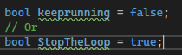
5. How to declare and use arrays: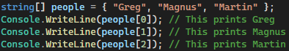 Or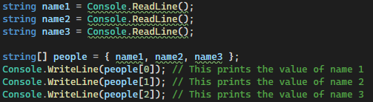
6. How to use the if conditional statement: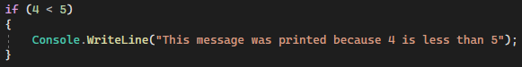
7. How to use the if else conditional statement: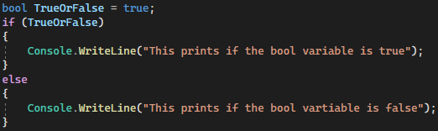
8. How to use the switch statement: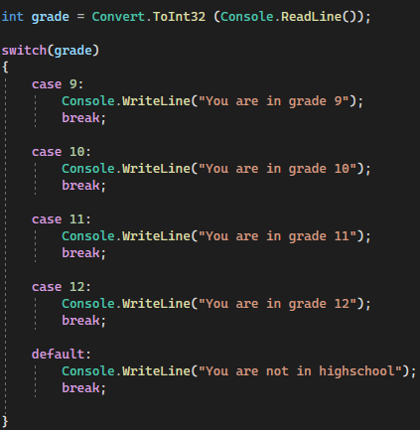
9. How to use the ‘goto’ label to create a loop: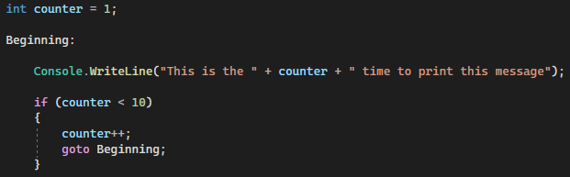
10. How to use ‘for’ loops: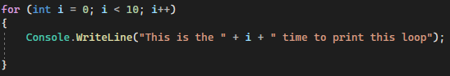
11. How to use ‘while’ loops: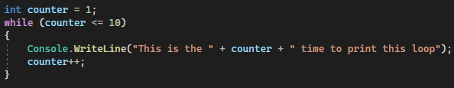Or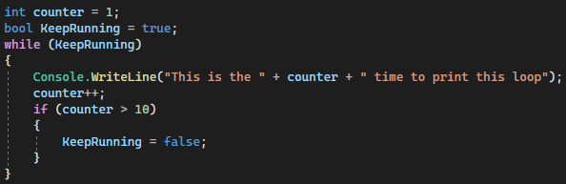
12. How to use ‘do while’ loops: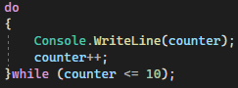
13. How to use foreach with an array: