**Report**

In the project, I utilized DQN algorithm, which we can see on Cell 10.

**Hyperparameters:**

Batch Size = 64

UPDATE = 4,

GAMMA = 0.99

TAU = 1e-3

LR = 5e-4

Buffer size = 100000

I also built a neural simple layered network that uses the value function. We have 37 units on input layer, 64 units in each hidden layers, and 4 units on output layer.

**REWARDS**

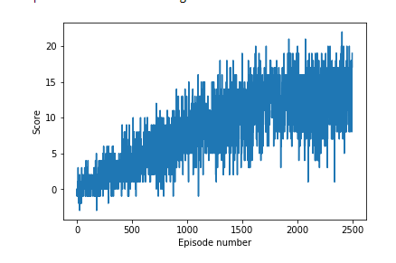

As we can see, the reward is increasing and the reward reached a score of 13.50 at 2500 episodes when the game is over. In the future, I would like to create a little bit and much complicated DQN compared to this model and also, I wanted to test the model and play it on Unity environment so I can literally see if the banana I picked is a yellow or blue color.