Nginx Load Balancing Experiment (Least‑Connections vs Random)

Hypothesis Formulation
Modern reverse proxies provide multiple load balancing strategies, each with different behaviour under variable backend workloads. This experiment compares Nginx’s Least‑Connections (LC) strategy against the Random strategy. Random assigns each incoming request uniformly to any backend, without considering its current load. LC, in contrast, dynamically routes requests to the backend with the fewest active connections.
The hypothesis guiding this work is:
Least‑Connections will increase throughput, reduce tail latency, and significantly improve fairness under heterogeneous workloads compared to Random load balancing.

Experiment Design
A synthetic workload generator issued concurrent HTTP requests to an Nginx reverse proxy. Three CPU‑bound job types were defined using PBKDF2 hashing iterations: A (heavy), B (medium), and C (light). Two workload scenarios were evaluated: (1) homogeneous heavy traffic (A‑only), and (2) mixed traffic (A/B/C). Each scenario was tested under steady streaming mode and under burst-oriented batch mode. Metrics collected included RPS, median latency, p95 latency, and job‑level fairness relative to expected theoretical scaling.
The experiment was executed in a containerized environment using Docker Compose. The setup consisted of a single Nginx reverse proxy and five identical backend worker containers running a CPU-bound Flask service exposed on /calculate. Nginx was configured with two upstream endpoints, one using Random and one using Least-Connections, each mapped to a separate port to enable side-by-side comparison. A separate sender container acted as the workload generator and issued HTTP requests to either endpoint, producing both steady-stream and burst-style load. For mixed-traffic scenarios, the job sequence cycled deterministically ensuring a repeatable pattern of heavy, medium, and light requests without depending on randomness. All services ran on the same Docker network, isolating the load-balancing strategy as the only changing variable in the experiments.

Results

Steady Throughput (LC vs Random)
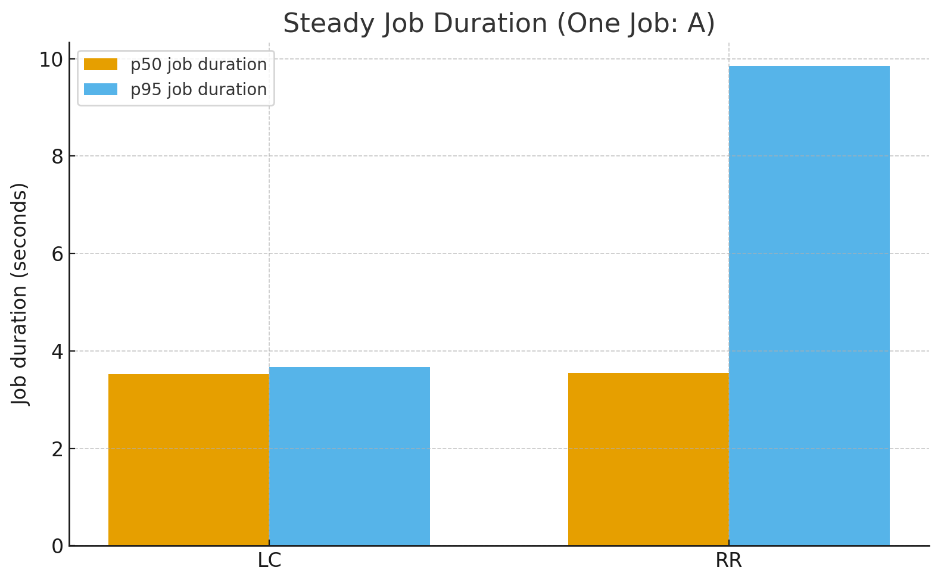

Observed vs Expected Median Latencies
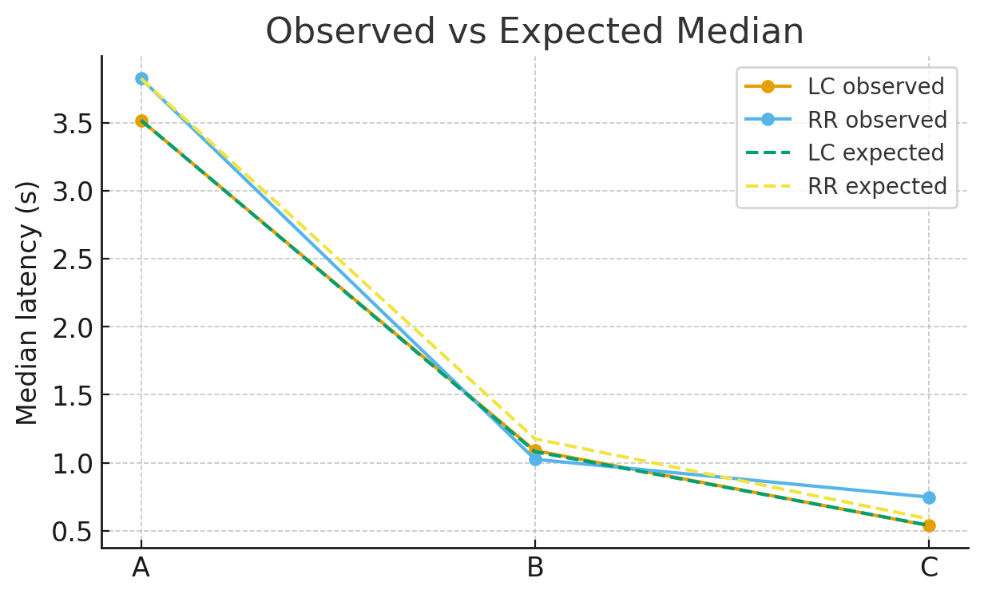

Observed vs Expected p95 Latencies
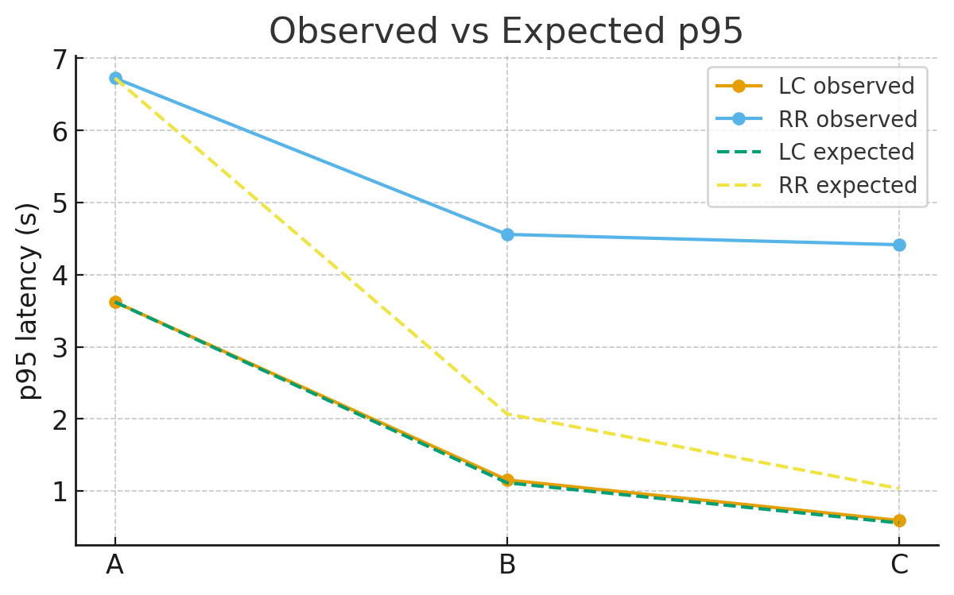

Interpretation and Demonstrator Study
Across all tests, Least‑Connections consistently outperformed Random. The throughput difference in the mixed A/B/C scenario was especially striking: LC achieved roughly 60% higher RPS than Random. This demonstrates that Random frequently assigns heavy requests to already saturated backends, while LC more effectively distributes load based on real‑time utilisation.
Tail latency differences were even more pronounced. Under Random, p95 latencies were inflated by factors of 4–10× relative to LC, particularly for small jobs (B and C), which frequently became queued behind long‑running A jobs on unlucky backends. LC, by contrast, maintained stable and predictable p95 values aligned with expected iteration ratios.
Fairness analysis reinforces these findings. When plotting observed median and p95 latencies against theoretical expected scaling (based on iteration counts), LC followed the expected curve closely. Random diverged sharply: small jobs that should finish in under a second often exceeded four seconds in p95 due to imbalance. This confirms that LC not only improves raw performance but also preserves proportional fairness.
Overall, the demonstrator study validates that Nginx’s Least‑Connections strategy provides meaningful added value in environments with heterogeneous request durations. For interactive systems, multi‑service architectures, or any workload with variable computational cost, LC offers substantially better responsiveness and predictability than Random load balancing.

