TDT4195 – Assignment 1

# Task 1

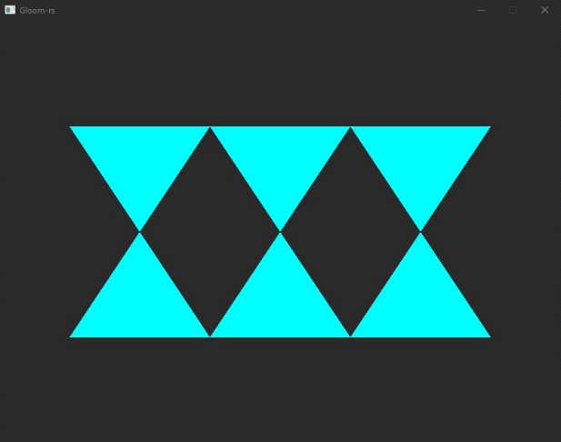

# Task 2

## 2.a

### 2.a.1

When we set all *z* values to 0.0, we get this shape:



If we set the first *z* value to -1.2 instead of 0.0, we get the shape below. Why, because the first *z* value is 1.2, which is outside the clip box, so not everything is rendered. This phenomenon is called **clipping**.



When we set the first *z* value to -1.2 and the last to 1.2, we get this shape. Notice that both the first and the last *z* indexes are > 1.0, so they are not rendered. Therefore, the triangles edges seem “cut off”.

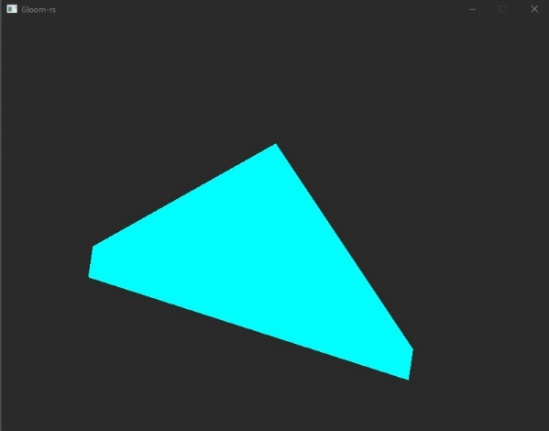

### 2.a.2

Clipping occurs when we try to render somethiWeng outside the clip box (clipping volume).

### 2.a.3

OpenGL uses clipping to save performance. It does not need to render things that are not visible.

## 2.b

### 2.b.1

The affected triangle disappears.

### 2.b.2

The triangle disappears because of **culling**. The ordering of the coordinates matter! We need to draw the triangle in a counterclockwise matter. If we draw the triangle in a clockwise matter, we are looking at the triangle from its back, so it is not rendered.

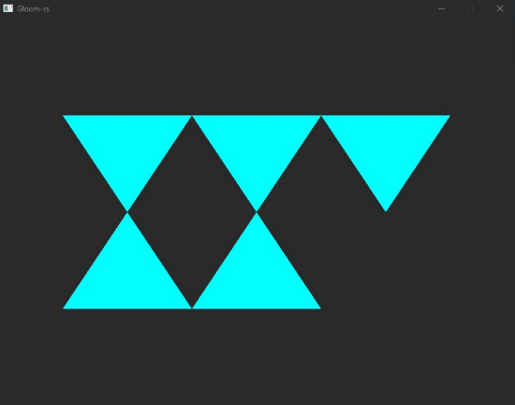 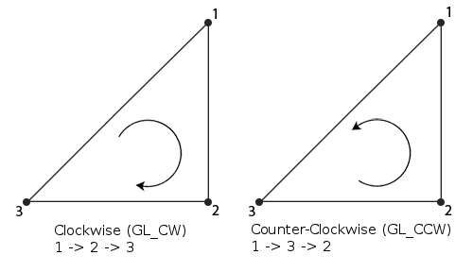

### 2.b.3

As mentioned, the rule is counterclockwise. This can be changed in OpenGL.

## 2.c

### 2.c.1

The depth buffer should be cleared for each frame to remove the depth values from the previous frame. When we redraw a frame, we want to use depth values (*z* indexes) from this render, not the previous. If we forget to clear it, some pixels may not be rendered because they are “behind” some pixels from the previous frame.

### 2.c.2

As the OpenGL paper said: “The Fragment Shader is executed once for every single fragment.”. Typically used for complex scenes.

### 2.c.3

* Vertex shaders - responsible for transforming (translating, scaling, rotation etc.) each vertex. It is run once for each drawn vertex.
* Fragment shaders - responsible for the colour of each fragment. A fragment is a pixel that OpenGL attempts to draw. It has a depth; therefore, it can be behind another fragment which leads to it not being drawn.

### 2.c.4

Memory usage saving. Triangles often share the same vertices, so we can reference them instead of storing them redundantly.

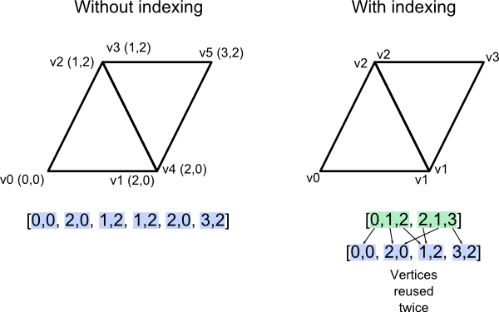

### 2.c.5

The pointer parameter defines the number of bytes until the first value in the buffer. If we only use a single entry-type (e.g. floats) we can pass in the null pointer. However, if we have multiple entry-types (e.g. floats and integers), we need to specify which index they start from.

## 2.d

### 2.d.1

Since my image was symmetrical, I had to adjust it:

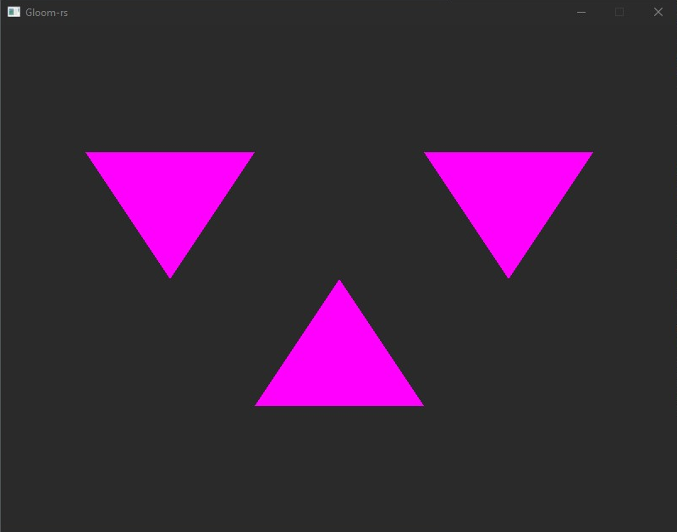

Now we reverse the *x* and *y* coordinates in the vertex shader:

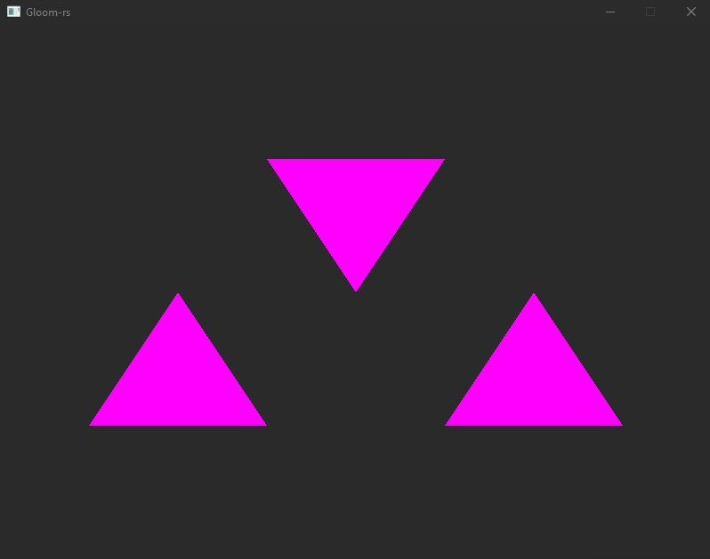

### 2.d.2

Swapped red and green values:  
color = vec4(1.0f, 0.0f, 1.0f, 1.0f); instead of color = vec4(0.0f, 1.0f, 1.0f, 1.0f);

