AI / Non-AI Collaboration Log – Task-Based Template
Complete one log for each major milestone of your project (min. 4 logs total).
Maximum 2 logs per week. Each log should take ~10–15 minutes.
Choose and fill either Path A (AI) or Path B (Non-AI) for each milestone and omit the other, depending on what you used.

Milestone Categories (choose one for each log)
- Planning & Research – defining goals, gathering requirements, outlining scope.
- Design & Architecture – creating structure, workflows, and initial prototypes.
- Core Development – building main features, core functionality, and foundational systems.
- Integration – connecting components, services, or data sources.
- Quality Assurance – testing, debugging, and refining functionality.
- Optimization – improving performance, usability, and efficiency.
- Finalization & Delivery – polishing, documentation, deployment, and handoff.

Log Entry # 4
Milestone Category: Quality Assurance
Date / Week: ___________________
Commit ID / Screenshot link: ___________________

Path A – If you used AI
- Task Description
(1–2 sentences about what you worked on)
Example: “Integrated the weather API and displayed results in a card layout.”
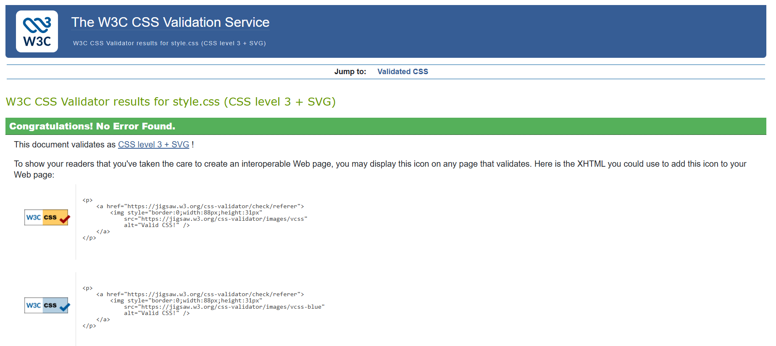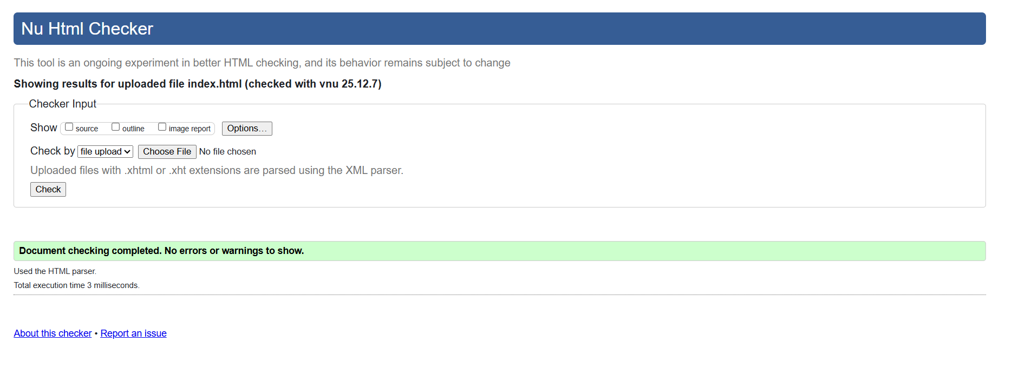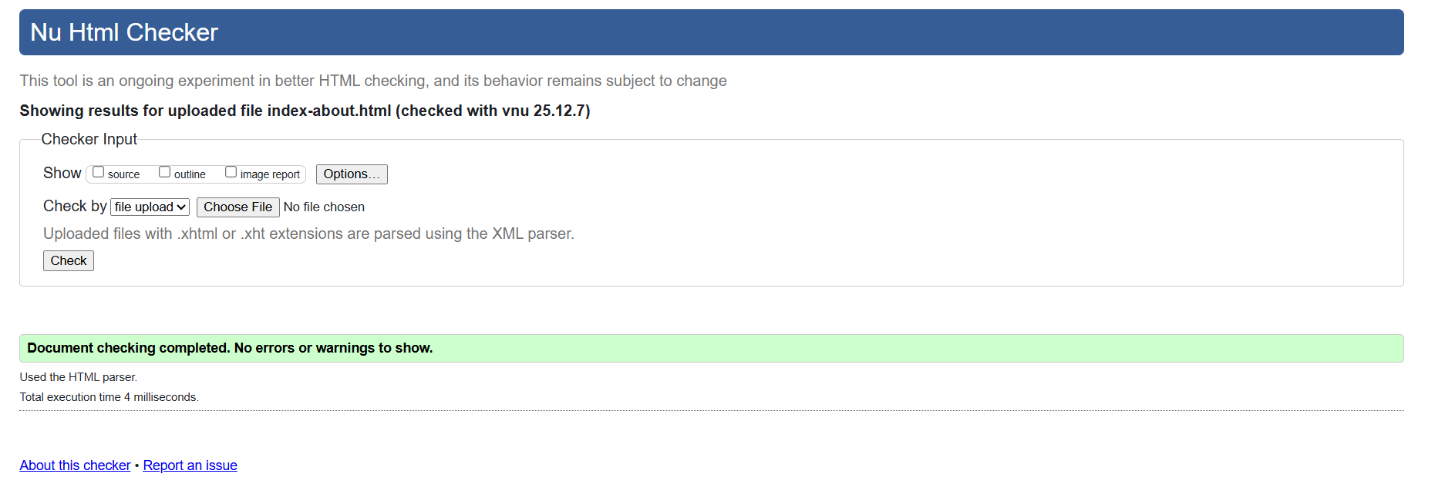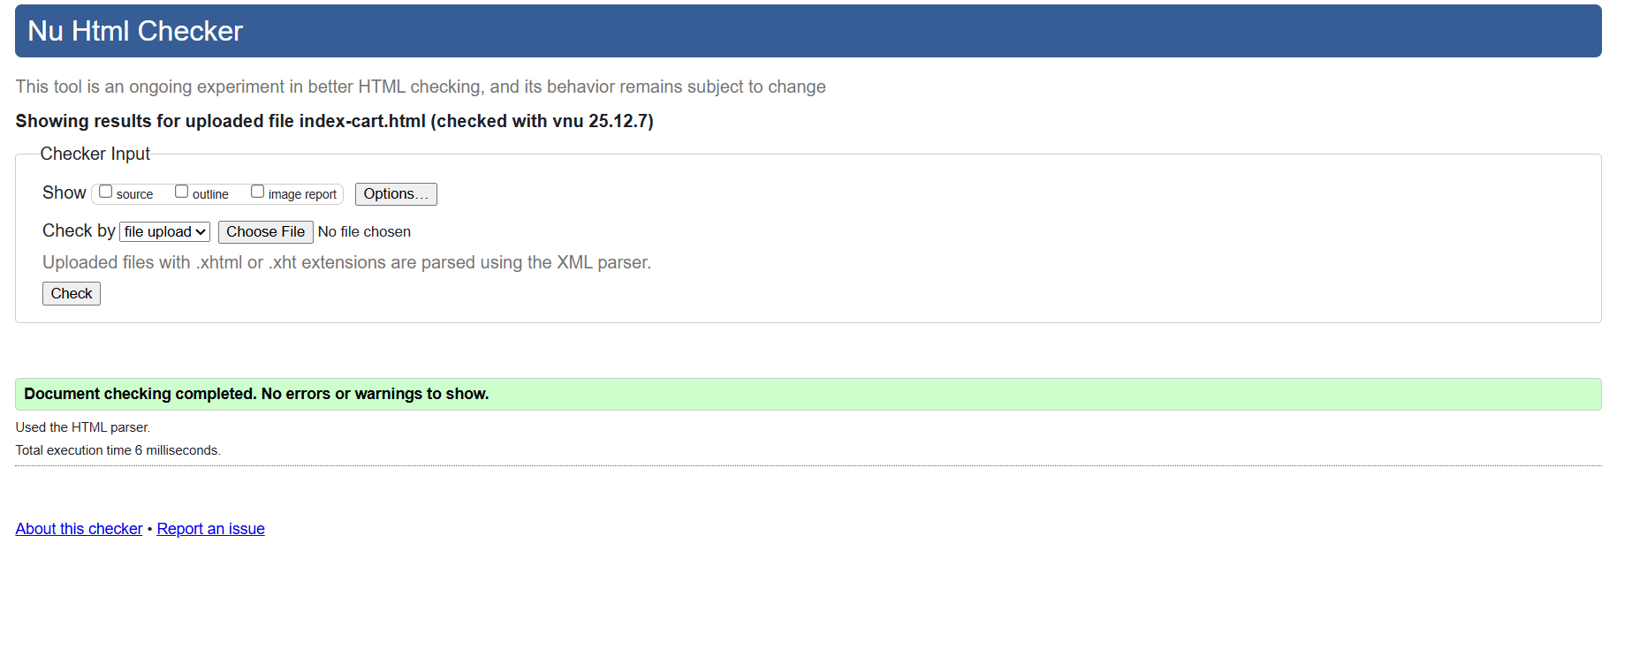

- AI Input
(Paste 1 AI prompt + 1 snippet of AI output, Share your AI conversations with the share button, share the entire history of the AI chat not the response only.)
https://chatgpt.com/share/69359870-e01c-8011-b0e7-43ee51172edc

Error: Bad value pictures/oak chair.avif for attribute src on element img: Illegal character in path segment: space is not allowed. From line 40, column 13; to line 41, column 55 <img src="pictures/oak chair.avif" alt="Oak chair"↩ onclick="openPopup(this.src, 'Oak chair')">↩
ChatGPT said:
You’re getting this error because file paths in HTML cannot contain spaces unless they are URL-encoded or renamed.
Here are 3 ways to fix it:

✅ Option 1: Rename the file (best method)
Rename your image file to remove the space:
- oak_chair.avif
- oak-chair.avif
- oakchair.avif
Then update your HTML:
<img src="pictures/oak_chair.avif" alt="Oak chair"
onclick="openPopup(this.src, 'Oak chair')">

✅ Option 2: Keep the space but encode it (not recommended)
If you must keep the space, you can use %20:
<img src="pictures/oak%20chair.avif" alt="Oak chair"
onclick="openPopup(this.src, 'Oak chair')">

✅ Option 3: Wrap the file path in single quotes (still requires encoding)
Even with quotes, spaces are not allowed unless encoded:
<img src='pictures/oak%20chair.avif' alt="Oak chair"
onclick="openPopup(this.src, 'Oak chair')">

⭐ Best practice
Rename the file so it has no spaces, then update the path. This avoids future bugs and works everywhere.
If you want, you can show me your folder structure and I’ll help you make sure all your paths are correct!

- My Edit / Change
(1–2 sentences: What you modified, why, or what you learned)
Example: “AI didn’t handle API errors. I added try/catch to manage missing data.”
I learnt how to fix validation errors, mainly I now can remind myself to never put spaces in a file name and to not leave the image link or the placeholder name blank

- Reflection Prompt (choose one / add your own)
  - What mistake did AI make, and how did you spot it?
  - What did AI do better/faster than you?
  - What unique decision did you add that AI couldn’t?
  - How would you explain this feature to a non-coder in 2 sentences?
Ai is a quicker way to find solutions for errors rather than just searching up the error online, what’s more is that they can tell you why it is wrong and you can ask further questions

Path B – If you did not use AI
- Task Description
(1–2 sentences about what you worked on)
Example: “Created responsive navbar with media queries.”

- Support Source Used
(Document what helped you: docs, tutorials, peers, debugging)
Example: “I used MDN docs on flexbox and StackOverflow for media query syntax.”

- My Edit / Change
(1–2 sentences: What you modified, why, or what you learned)
Example: “The tutorial used px units, I switched to rem units for accessibility.”

- Reflection Prompt (choose one / add your own)
  - What mistake or confusion did you find in the resource, and how did you resolve it?
  - What did the resource help you do more quickly?
  - What unique decision or creativity did you add that wasn’t in the resource?
  - How would you explain this feature to a non-coder in 2 sentences?

