**Tumor fraction inference from CNV**

**General purpose**

This script is used to calculate tumor fraction from copy number variation profile of bulk tumor tissue sequencing data.

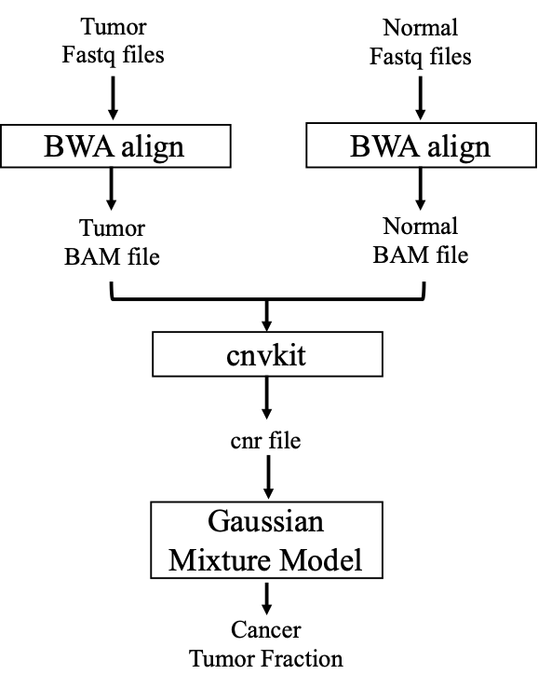

**Required input**

1. Sample name (for output)
2. CNVkit output ( *\*.cnr*  ) file.

The CNVkit package, including its documentation, could be found at: <https://cnvkit.readthedocs.io/en/stable/>

**Execution**

In shell: use Rscript 2.Bulk.Panel.Sequencing.Tumor.fraction.from.CNV.R $sample_name $sample_cnr, where

**Algorithm**



Genomic regions of different copy number state are commonly observed in tumor. Capture-based sequencing of such regions is subjected to technical and biological variation, and thus give rise to a noisy readout. We assume that the log2-depth-ratio between tumor and normal samples on a set of genomic regions at similar copy number state in tumor would follow Gaussian distribution. We then have:

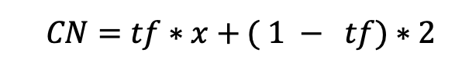

Where CN = the observed copy number (raw), tf = give tumor fraction of the sample, and x = the actual copy number state. Because copy number state of any given genomic region should be an integer, we have x as an integer. Noticing tf is constant across a number of paired CN:x combinations, we could infer tf from linear regression.

The script firstly takes in a cnr file which tells log2-depth-ratio of given tumor sample and the normal sample on a captured region. Then, model-based clustering based on parameterized finite Gaussian (Mclust) is applied to the log2-depth-ratios. This give rise to a number of mean-of-log2-depth-ratio (mu) for each cluster of genomic regions, which should be at similar copy number state. The script iterate through a series of combination of x in order to have a best linear fit.

**Outputs**

1. A scatter plot of observed (y axis) and inferred (x axis) copy number states, such as:

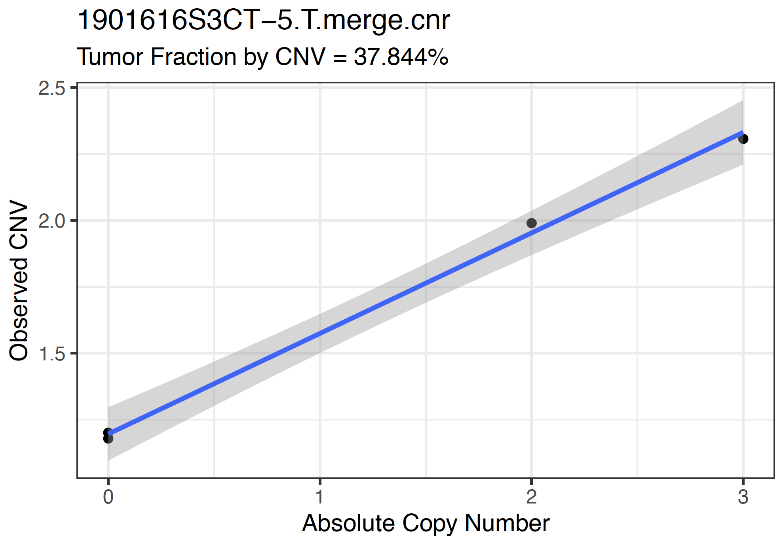

1. A json file output recording the linear regression output, in which:
2. coefficients = the linear regression coefficient, which could be inferred as tumor fraction.
3. r2 = the goodness-of-fit of linear regression
4. sample = the input sample name
5. cn_stat_mod = the inferred copy number state for each cluster. Sometimes there could be multiple clusters with similar inferred CN, which is possible.
6. k = tested knn-clustering number
7. Intercept = linear regression intercept
8. Intercept_info = 1-intercept/2 . This should be the ‘tumor fraction at CN=0’ and it should be close to `coefficients`. If abs(Intercept_info-coefficients) > 0.05 then it flags for unsatisfactory fit and the result could not be used. It might be necessary to re-run the script, since knn clustering is innately random. Usually abs(Intercept_info-coefficients) <= 0.05 is considered a good fit.

|  |
| --- |
| [  {  "sample": "1901616S3CT-5.T.merge.cnr",  "coefficients": 0.3784,  "r2": 0.9965,  "cn_stat_mod": "0,0,2,3",  "k": 5,  "Intercept": 1.1962,  "Intercept_info": 0.4019  }  ] |

1. A txt file output which is a tab-delimited version of the json file.

**Environment**

|  |
| --- |
| > sessionInfo()  R version 3.6.2 (2019-12-12)  Platform: x86_64-pc-linux-gnu (64-bit)  Running under: CentOS Linux 7 (Core)  Matrix products: default  BLAS: /gpfs/bin/R-3.6.2/lib/libRblas.so  LAPACK: /gpfs/bin/R-3.6.2/lib/libRlapack.so  locale:  [1] LC_CTYPE=en_US.UTF-8 LC_NUMERIC=C  [3] LC_TIME=en_US.UTF-8 LC_COLLATE=en_US.UTF-8  [5] LC_MONETARY=en_US.UTF-8 LC_MESSAGES=en_US.UTF-8  [7] LC_PAPER=en_US.UTF-8 LC_NAME=C  [9] LC_ADDRESS=C LC_TELEPHONE=C  [11] LC_MEASUREMENT=en_US.UTF-8 LC_IDENTIFICATION=C  attached base packages:  [1] parallel stats4 stats graphics grDevices utils datasets  [8] methods base  other attached packages:  [1] mclust_5.4.6 mixtools_1.2.0 cowplot_1.1.0  [4] ggthemes_4.2.0 RColorBrewer_1.1-2 ggforce_0.3.2  [7] bezier_1.1.2 GenomicRanges_1.38.0 GenomeInfoDb_1.22.1  [10] IRanges_2.20.2 S4Vectors_0.24.4 BiocGenerics_0.32.0  [13] readr_1.4.0 tidyr_1.1.2 reshape2_1.4.4  [16] dplyr_1.0.2 ggplot2_3.3.5  loaded via a namespace (and not attached):  [1] Rcpp_1.0.5 pillar_1.4.6 compiler_3.6.2  [4] plyr_1.8.6 XVector_0.26.0 bitops_1.0-6  [7] tools_3.6.2 zlibbioc_1.32.0 lattice_0.20-41  [10] lifecycle_0.2.0 tibble_3.0.4 gtable_0.3.0  [13] pkgconfig_2.0.3 rlang_0.4.11 Matrix_1.2-18  [16] GenomeInfoDbData_1.2.2 withr_2.3.0 stringr_1.4.0  [19] generics_0.0.2 vctrs_0.3.4 hms_0.5.3  [22] segmented_1.2-0 grid_3.6.2 tidyselect_1.1.0  [25] glue_1.4.2 R6_2.4.1 survival_3.2-7  [28] polyclip_1.10-0 kernlab_0.9-29 farver_2.0.3  [31] tweenr_1.0.1 purrr_0.3.4 magrittr_1.5  [34] splines_3.6.2 MASS_7.3-53 scales_1.1.1  [37] ellipsis_0.3.1 colorspace_1.4-1 stringi_1.5.3  [40] RCurl_1.98-1.2 munsell_0.5.0 crayon_1.3.4 |