Assessment Report
Abiodun Magret Oyedele
Java QAP3

Screenshots of each problem

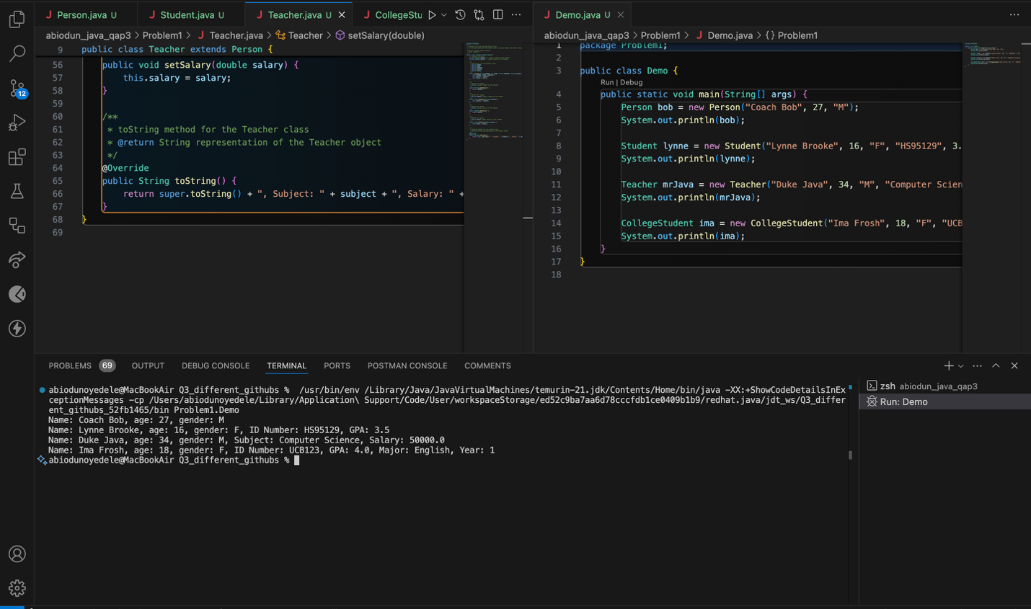
PROBLEM1

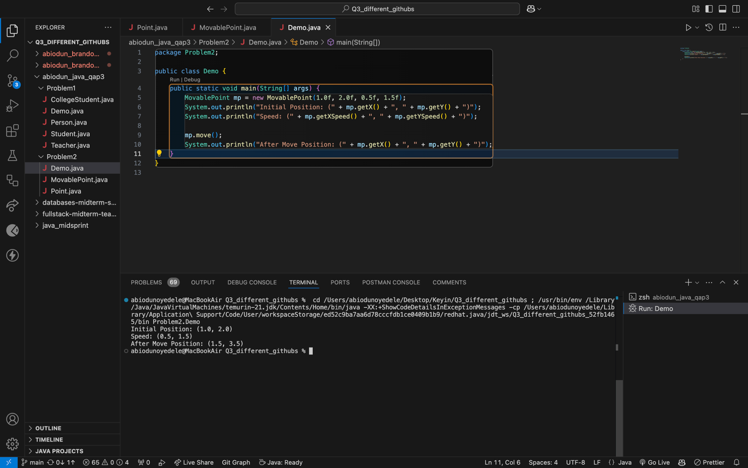
PROBLEM 2

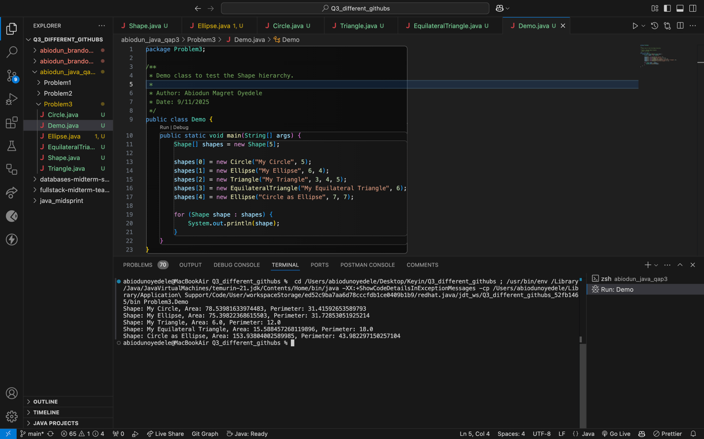
PROBLEM3

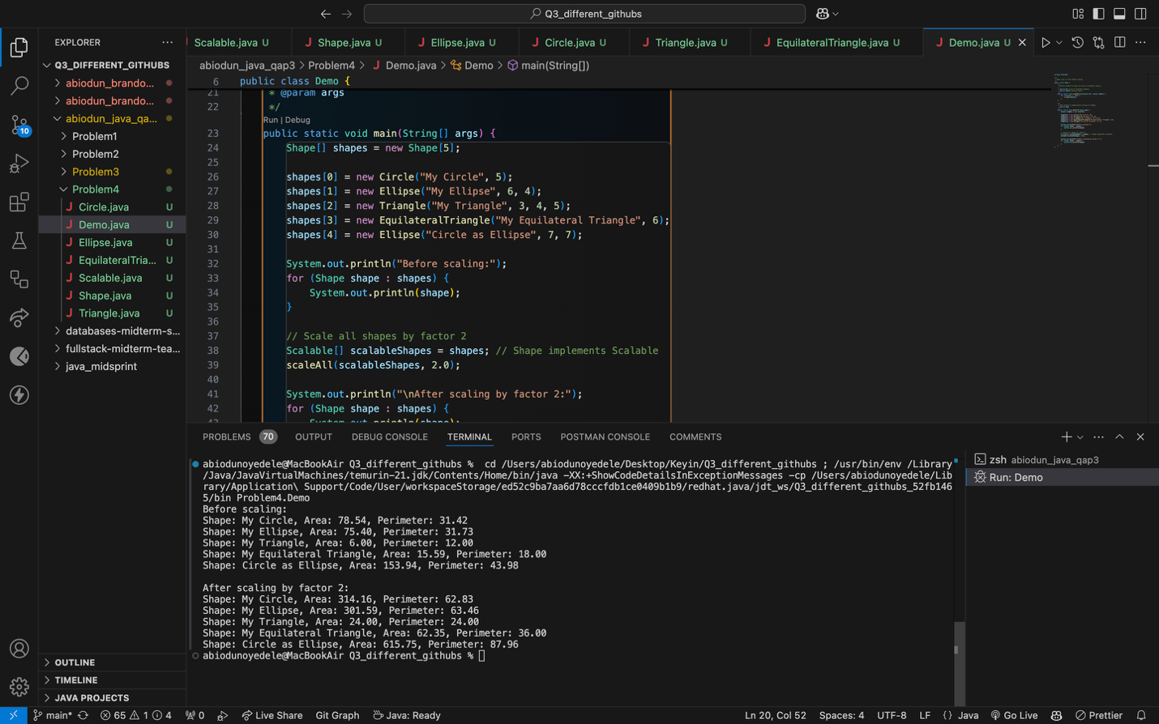
PROBLEM 4

Responses to Instructions Questions
- Estimated Hours Taken: 10 hours
- Online Resources Used: Lectures from class
- Help from Classmates: No, I did not get help from any classmates.
- Help from Instructor: No, I did not ask for help from an instructor.
- Difficulty Rating & Confidence:
- Problem1: Difficulty: 3/10; Confidence in solving similar problems: 7/10
- Problem2: Difficulty: 3/10; Confidence in solving similar problems: 7/10
- Problem3: Difficulty: 6/10; Confidence in solving similar problems: 5/10
- Problem4: Difficulty: 7/10; Confidence in solving similar problems: 5/10

