**The Spinsolve-Expert Batch Menu**

Contents

Overview 2

Batch file commands 3

New batch 4

Load batch 4

Save batch as 4

View batch folder 5

Batch functions 5

Add Waits between batch protocols 5

Remove Waits from batch list 5

Change comments in batch list 6

Change parameters in batch list 6

Batch Commands 6

ReturnSample 6

SelectSample 6

StartAtTime 7

WaitTime 7

|  |  |
| --- | --- |
| Overview This menu controls the setup of the batch folders as well as providing some built-in functionality which can be added to batch files.  The batch folder stores the templates for all experiments in the batch list. Each experiment consists of a folder with the same name as the protocol, followed by the comment in parentheses. e.g.  Proton (Ibuprofen)  Inside this folder is the acquisition parameter file needed to run this experiment. Note that collected data is not stored here, but rather in the history folder hierarchy. For example for the following batch list: |  |

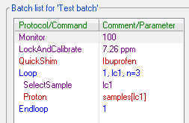

The batch folder has the following contents

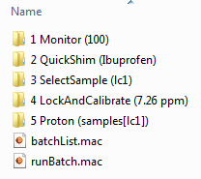

The numbers provide a way to make each entry unique – this allows protocol and comment names to be the same. The batchList macro contains the list of all experiments and any loops which should appear

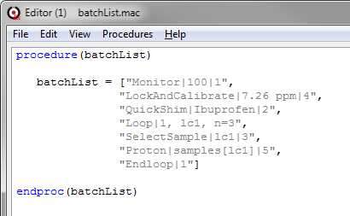

Note that in this file comments and file numbers are separated from the protocol name by a vertical bar ‘|’. The numbers are not displayed in the batch list.

Finally, runBatch.mac is the Prospa program which allows the batch list to be executed. This file is generated automatically when you start the batch process.

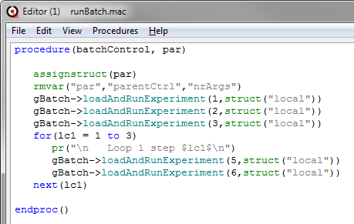

In this case the numbers refer to the experiment position in the batch list. Note that a normal Prospa for-next command is used to implement the batch loops and that lc1 is just the loop variable.

Here are the various options available in this menu:

# Batch file commands

The following commands act on the files in the batch folder. All batch folders are stored in the following location:

<prospa_preferences>\SpinsolveParameters\Batch

Clear Batch

This will delete the contents of the current batch folder and the batch list. All items in the folder will be moved to the trash. A confirmation is required.

## New batch

This allows a new batch folder to be defined. This should be an empty folder where you have write permission. The folder name will appear in the batch list title

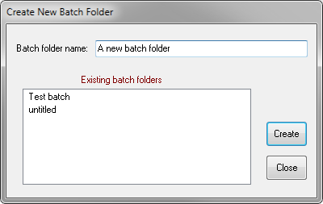

Note that batch files are stored in the user preferences folder:

<preferences>\ SpinsolveParameters\batch

## Load batch

This will allow the selection of an existing batch folder and will load the contents of the batch list for that folder:

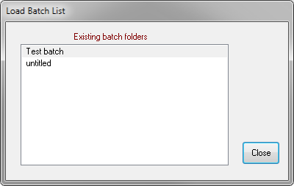

## Save batch as

If you want to make a copy of the current batch folder you can use this option. Note there is no Save option as the current batch is saved after every modification:

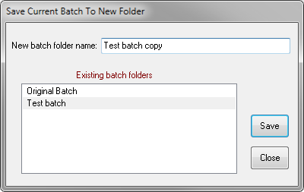

Rename batch

This allows the name of an existing batch folder to be modified.

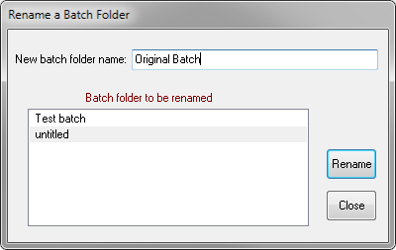

## View batch folder

This will open the current batch folder in a Windows Explorer dialog.

# Batch functions

The follow commands act on the batch list as a whole.

## Add Waits between batch protocols

Allows a WaitTime command to be automatically added between protocols. This provides time for the sample to reach equilibrium. Some editing may be required afterwards to remove unnecessary WaitTime commands.

## Remove Waits from batch list

Removes all WaitTime commands from the current batch list.

## Change comments in batch list

A dialog appears allowing old comments in the batch list to be modified.

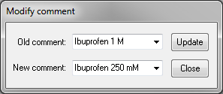

Note that all comments on the batch list will be considered – not just the currently selected ones.

## Change parameters in batch list

This will modify the specified parameter in all *selected* entries in the batch list to the new value. (In this case the receiver gain will be set to 19.)

# Batch Commands

The following commands can be added to the batch list

## ReturnSample

Only relevant if you have an automatic sample changer.

This adds the ReturnSample command to the user interface so it can be added to the batch list or run directly in history mode. This command returns the current sample from the spectrometer back to the sample change rotor. There are no user defined parameters.

## SelectSample

Only relevant if you have an automatic sample changer, although if you don’t have one you will be prompted to change the sample manually.

This adds the SelectSample command to the user interface so it can be added to the batch list or run directly in history mode.

When run, this command will return the current sample (if any) in the spectrometer to the sample change rotor and then select a new sample, as specified in the parameter list. The parameter should be an integer between 1 and 20 corresponding to the rotor position of the new sample or the name of the sample as defined in the Samples interface. It can also be a loop counter, e.g. lc1, as long as that loop counter covers this valid range of numbers (1 to 20). Note that the SelectSample comment cannot be modified and is set by the parameter.

## StartAtTime

This adds a command which will cause the program to wait until the specified time. This command can be used in either batch or history mode.

The format of the parameter should be as follows:

day.hour. minute.second (dd.hh.mm.ss)

Note that 24 hour time is used. Colons are not possible in a windows folder name hence the use of the period/full stop (.) as a delimiter.

Note that the StartAtTime comment cannot be modified and is set by the parameter.

While the command is waiting, the progress bar will be changed.

## WaitTime

This adds a command which will cause the program to wait until the specified time (in seconds). This command can be used in either batch or history mode.

Note that the StartAtTime comment cannot be modified and is set by the parameter.

While the command is waiting, the progress bar will be changed.