**The Spinsolve-Expert Edit Menu**

Contents

Copy Plot 1

Copy all plots 1

Edit plot/image parameters 1

Edit plot trace settings 1

Clear CLI 1

This menu has options for editing the current plot or image, defining the preferences for the plot or images and clearing the CLI.

|  |  |
| --- | --- |
| *The Edit menu when a plot (1D) window has the keyboard focus* | *The Edit menu when an image (2D) window has the keyboard focus* |

Note that the options here will depend on which user interface element has been last selected. If the CLI or a text box has the keyboard focus, then the different menu shown below is displayed.

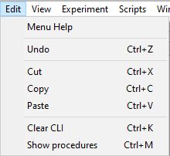

*The Edit menu when the CLI or other text window has the keyboard focus*

# Copy Plot

This copies the current plot and places it on the Windows clipboard. It can then be pasted into another Expert plot window (see Windows menu for how to make new plot windows), or an image of the plot can be pasted into another application such as MS Word. Note that when pasting 1D plots into MS Word it is a good idea to choose the ‘paste special’ option and choose a bitmap rather than the default Metafile option. The former will paste a higher quality image since it uses antialiasing.

# Copy all plots

This will copy an image of all the visible plots onto the clipboard. In this case the only paste option is a bitmap.

# Edit plot/image parameters

This opens the plot or image parameter dialog depending on whether a 1D or 2D plot has been selected.

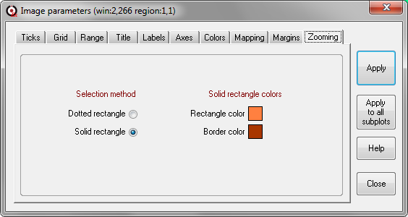

*The 2D image parameters dialog*

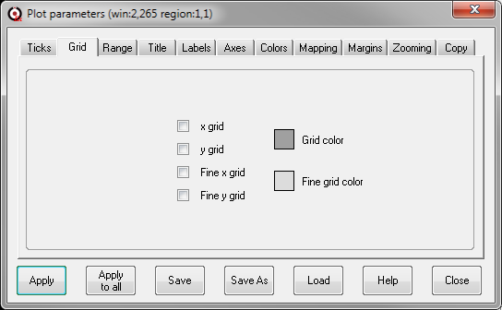

*The 1D plot parameters dialog*

These dialogs allows a wide range of plot parameters to be adjusted, including axes tick spacing, grids, titles, labels, the zoomed region and plot colours. Please refer to the Help for this dialog for more details.

# Edit plot trace settings

This allows the plot trace to be modified e.g. changing the color, type (solid or dotted) or whether symbols should be displayed at each data point.

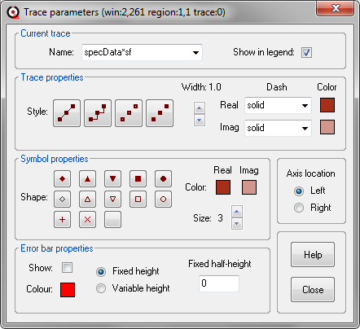

This dialog also controls the trace label names which appear in the plot legend if it is displayed (see the View menu for this option). More information can be found by using the Help button in this dialog.

# Set dark plot colors

This changes the plot background color to black and then modifies any trace (1D) or contour (2D) colors to be more visible with this background. A grid is also added to non-stacked plots. These colors are defined in the macro darkMode.mac found here: ‘<prospa>\Macros\Spinsolve-Expert\Processing Macros\xD\View’ where x is 1 or 2.

# Set light plot colors

This changes the plot background color to white and then modifies any trace (1D) or contour (2D) colors to be more visible with this background. A grid is also added to non-stacked plots. These colors are defined in the macro lightMode.mac found here: ‘<prospa>\Macros\Spinsolve-Expert\Processing Macros\xD\View’ where x is 1 or 2.

# Set default plot colors

This changes the plot background color to white and then modifies any trace colors to the defaults for this background. A grid is also added to non-stacked plots. These colors are defined in the macro defaultMode.mac found here: <prospa>\Macros\Spinsolve-Expert\Processing Macros\1D\View

# Clear CLI

This clears the contents of the command line interface. This should be done regularly as too many entries here can slow down the program.

# Show Procedures

This will display all the procedures in a macro file as a list. This option only works if the insertion point is over a macro or class name. For example if you type the following into the CLI or and editor

> gData->

and then select this option you will see all the procedures in the gData class (which is also the seData macro)

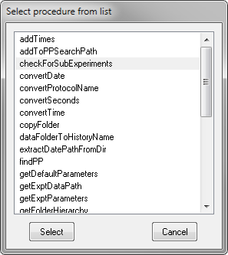

You can then select one of these and it will be appended to the class name e.g.

> gData->checkForSubExperiments()